mRModN:Mixture of Hierarchical Experts mechanism with a self-adaptive balanced sampler for multi-site mRNA modification detection
Firstname-1 Lastname-1, Firstname-2 Lastname-2, Firstname-3 Lastname-3 & Firstname-4 Lastname-4*

Abstract
Background
RNA modifications are essential regulators of biological functions and represent critical targets for drug development. A major challenge in the field is accurately pinpointing modification sites within long sequences. Existing methods mainly rely on short sliding-window strategies, which fragment sequence context, weaken long-range dependency modeling, and often limit localization precision. Therefore, there is a need for a framework that can model variable-length RNA inputs and support precise nucleotide-level localization.
Results
We developed mRModN, a biologically-inspired Mixture of Experts framework designed for multi-label co-occurrence classification and precise nucleotide-level localization. mRModN supports variable-length RNA inputs and integrates Multi-view Motif Discovery module to combine sequence motifs with structural information. Crucially, it features a Mixture of Hierarchical Experts module, which acts as a sparse routing mechanism to exclusively activate specific modification experts based on biologically informed nucleotide backgrounds. In addition, an attention pooling strategy enables mRModN to process the full sequence in a single pass and generate nucleotide-resolution attention weights for site localization. Evaluated on human (HRMD-m), plant (PRMD-m), and 3 generation (direct ONT) datasets, mRModN significantly outperforms window-based benchmarks. It achieves a Top-1 localization accuracy of 86.9% and demonstrates robust zero-shot transfer capability on 3 generation sequencing data.
Conclusions
mRModN mitigates the information loss introduced by window-based fragmentation by preserving long-range contextual information across each input sequence. Its joint classification and localization capability makes it a promising framework for high-resolution epitranscriptomic analysis and RNA modification site discovery.
Keywords
Cross-Attention, Graph Convolution, Attention Pooling, Detection Task, RNA Modification

Introduction
RNA modifications are a central component of epitranscriptomic regulation[1-3], introducing a critical layer of post-transcriptional control through chemical alterations of RNA nucleotides[4]. More than 170 distinct RNA modifications have been reported to date[5, 6], including N6-methyladenosine (m⁶A), pseudouridine (Ψ), 5-methylcytosine (m⁵C), N4-acetylcytidine (ac⁴C), and N7-methylguanosine (m⁷G). Among these, m⁶A is the most abundant and extensively studied modification in eukaryotic mRNA[7], whereas ac⁴C remains the only acetylated RNA modification currently known in mRNA[8]. These modifications influence multiple aspects of RNA metabolism, including stability, translation, splicing, and nuclear export, and are closely associated with immunity, human disease, and plant stress adaptation[9].
Advances in sequencing technologies, ranging from next-generation sequencing to native nanopore-based direct RNA sequencing, have greatly expanded the ability to profile RNA modifications at both transcriptome-wide and site-specific resolution[10]. In parallel, the rapid growth of specialized databases, such as RMBase[11], PRMD, and DirectRMDB[12], has provided increasingly rich resources for large-scale computational analysis of the epitranscriptome.
RNA modification prediction methods have undergone a clear transition from task-specific single-modification models to unified multi-modification prediction frameworks[13-15]. Early models, such as m6Anet[16] and DeepAc4C[17], were primarily designed for individual modification types and achieved encouraging performance on specific tasks. However, these methods were generally limited to one modification type at a time, making them less suitable for the complex transcriptomic setting in which multiple modifications may coexist within the same RNA molecule. More recent studies, represented by models such as MultiRM[18], ModX[19], MSCAN[20] and EvoRMD[21], have shifted toward the parallel prediction of multiple RNA modification types, thereby improving the scalability and practical utility of computational epitranscriptomic analysis.
Despite this progress, several important challenges remain. First, most existing multi-modification prediction methods, including MultiRM, RNA-ModX, and EvoRMD, are not designed to fully support end-to-end multi-label co-occurrence classification together with nucleotide-level localization across extended sequence contexts. This limitation largely stems from their reliance on sliding-window or candidate-site-centered local input strategies, which fragment sequence context and weaken the modeling of long-range dependencies. Compared with MultiRM and RNA-ModX, EvoRMD improves the flexibility of multi-modification prediction by enabling simultaneous prediction of modification types across multiple RNA sequence fragments and by removing the need for explicitly paired empty or background samples for comparison. However, these improvements are still made within a local-context prediction paradigm. EvoRMD remains built around candidate-site-centered sequence fragments and primarily prioritizes modification types within fixed local windows. Therefore, these methods do not explicitly address the biological reality that multiple modification sites and multiple modification types may coexist within the same long RNA region. This limitation becomes particularly evident when multiple modification signals co-occur within the same RNA segment or when accurate localization and prioritization of candidate sites are required over long-range transcript regions.
Second, many current approaches rely primarily on one-dimensional sequence encoding and do not fully incorporate RNA structural topology or potential spatial regulatory effects. Third, under the extremely long-tailed class distributions commonly observed in RNA modification datasets, feature-weighting or loss-reweighting strategies alone are often insufficient to achieve robust class balancing, especially when the frequency differences among modification types span several orders of magnitude. Finally, existing multi-modification models still lack an effective mechanism for stable parallel optimization across diverse modification-related features, which may lead to feature interference or representation collapse during learning.
To address these challenges, we developed mRModN (mRNA Modification Detection Network), a multi-label, transferable, and interpretable framework for RNA modification detection. mRModN supports variable-length RNA inputs and enables end-to-end multi-label co-occurrence classification together with precise nucleotide-level localization. By avoiding window-based fragmentation, mRModN preserves long-range contextual information and improves the joint modeling of classification and localization within each input sequence. In addition, we implemented mRModN as a user-friendly web server to facilitate its practical application. The main contributions of this study are summarized as follows:
- Developed mRModN, a cross-attention-based detection network that supports variable-length RNA inputs and enables joint multi-label co-occurrence classification and nucleotide-level localization.
- Proposed Multi-view Motif Discovery (M²D) module, which integrates one-dimensional sequence information with structural topology to improve feature representation and predictive performance.
- Designed Mixture of Hierarchical Experts (MoHE) module. Inspired by the MoE paradigm, this module functions as a sparse routing mechanism that incorporates biological nucleotide-to-modification hierarchies. By selectively activating specific modification experts, it substantially improves the scalability and stability of multi-feature learning while maintaining high parameter efficiency.
- Introduced multi-Anchor Attention Pooling (A²P) mechanism, which formulates site localization as a distribution alignment task supervised by KL-divergence. This mechanism facilitates the automatic identification of multiple co-occurring modification anchors within a single sequence, thereby enhancing multi-site localization precision and model interpretability.

Materials and methods

Overview
Detection of RNA modification sites is formulated as a joint task comprising multi-label co-occurrence classification and nucleotide-level localization. To tackle this problem, we propose mRModN, a cross-attention-based detection network [22-24] for RNA modification. The framework consists of three primary phases: 1) multi-scenario data preparation, including experimental, benchmark, and real-world application datasets (Fig. 2a); 2) architecture design and model construction, enabling simultaneous classification and localization (Fig. 2b); and 3) visual analytics, which improves model interpretability[25-27] and provides intuitive explanations of prediction results (Fig. 2c). mRModN is designed to support the detection of 12 types of mRNA modifications, including m⁶A, m¹A, m⁵C, m⁶Am, m⁷G, ac⁴C, Am, Cm, Gm, Tm, Ψ, and I.

Data source
Model development set
To train and evaluate mRModN, we constructed the Human RNA Modification Dataset for mRModN (HRMD-m). Modification sites were aggregated from distinct sources: MODOMICS[28], RMBase, m7GHub V2.0[29], and the MultiRM dataset (spppl H). We implemented a rigorous pre-processing pipeline at the mRNA transcript level. For each annotated modification site, we extracted a symmetric RNA sequence context centred on the target site. The maximum sequence was capped at 1001 nucleotides (nt) to enable long-range contextual modelling. To accommodate sites located near transcript termini where sufficient flanking regions were unavailable, we retained the longest possible contiguous sequence. Consequently, the final inputs varied in length, with an upper limit of 1001 nt. Finally, to eliminate homologous redundancy introduced by merging multiple data sources, HRMD-m was further clustered using CD-HIT[30] (v4.8.1) with the parameters -c 0.8 -T 30 -M 70000 -mask N.
After redundancy removal, the final HRMD-m dataset yielded high-quality RNA sequences， exhibiting a highly complex multi-modification landscape (Fig. 1b, supp). Substantial class imbalance exists among different RNA modification types[31]. The dataset is indeed markedly imbalanced: m⁶A is the most abundant (114,195 sequences), followed by Atol (49,435) and Ψ (36,944), whereas m⁷G (1,508), Am (1,935), and Gm (2,196) are scarcely represented. Substantial overlap exists among these modifications. For instance, while 75.19% of the sequences contain a single modification site, nearly 25% harbor multiple sites (up to eight more) (Fig. 1a). Notably, 28,286 sequences contain both Ψ and m⁶A, meaning nearly half of all Ψ sequences co-occur with m⁶A and 589 sequences contain a Gm-Ψ-m⁶A combination. Consequently, the model must not only detect presence but also disentangle co-existing modification signals within the same RNA context. Ultimately, HRMD‑m provides a robust, non‑redundant, and length‑variable resource ideal for long‑context modeling and evaluation.
To systematically train and evaluate the mRModN model, we randomly partitioned this final dataset into three independent subsets: a training set (60% sequences) for model optimization, a validation set (10% sequence) for hyperparameter tuning and early stopping, and a distinct test set (30% sequences) for final performance assessment. The detailed distribution of modification types is provided in Table 1.
Datasets for performance benchmark and model generalization
To comprehensively benchmark the baseline detection performance, cross-species transfer capability, and cross-platform generalization ability of mRModN, we conducted experiments using one publicly available benchmark dataset (MultiRM) alongside three specialized evaluation datasets: PRMD-m (Plant RNA Modification Dataset for mRModN), MetaAc4c[32] and direct ONT dataset[33-35].
MultiRM is a widely recognized benchmark for RNA multi-modification prediction, providing sequence-level annotations for 12 RNA modification types. Because MultiRM was also included as one of the sources used to construct HRMD-m, it was not used as an external validation set for the HRMD-m-trained model. Instead, MultiRM was used as an independent public benchmark protocol to evaluate the architecture-level performance of mRModN under a standardized setting. In this benchmark experiment, mRModN was initialized from scratch and trained and evaluated using the official MultiRM training and testing scripts under the 51-nt input setting. No HRMD-m-trained parameters, validation thresholds, or augmented samples were transferred to the MultiRM benchmark experiment. The PRMD-m dataset was constructed to facilitate cross-species transfer experiments. Modification sites for Arabidopsis thaliana were sourced from the PRMD database[36], while the reference genome and corresponding annotation files (TAIR10 version [37]) were downloaded from Ensemble Plants. The extraction pipeline of transcripts and modification sites was identical to that use for HRMD‑m. To further evaluate mRModN's performance on third-generation sequencing data, we employed the MetaAc4c dataset specifically for ac4C detection assessment. Since the evaluation protocol largely parallels that of HRMD-m, these results are deferred to the Supplementary Material. Furthermore, the Direct ONT dataset was derived from the SG-NEx data resource [38]. Specifically, data extraction from SG-NEx resource was limited to m⁶A, from which the corresponding transcript sequences were derived. Nucleotide-level modification sites were subsequently identified by comparing nanopore current signals via xPore. Following appropriate trimming, the resulting samples were organized as mRNA sequences with nucleotide-resolution annotations.
After applying the aforementioned extraction and filtering pipelines, we established the final subsets for independent evaluation. Specifically, the public MultiRM benchmark comprises 248262 sequences across 11 modification types. For cross-species assessment, PRMD-m yielded 87534 Arabidopsis thaliana sequences., while the Direct ONT dataset yielded 4656 m6A-modified sequences (Table 1).
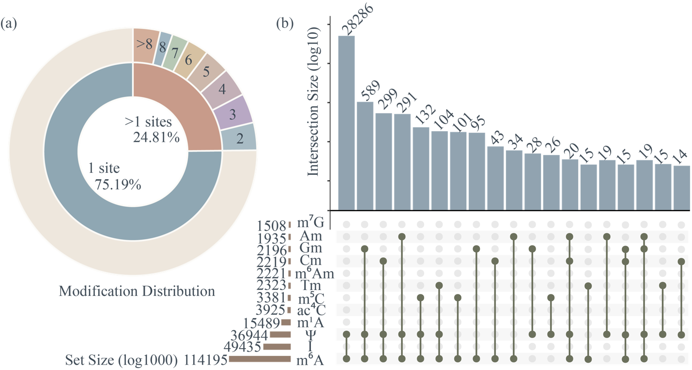
Fig. 1 Characterization of modification sites across HRMD-m datasets.
(a) Nested donut chart of modification site distribution in the HRMD-m dataset. (b) UpSet plot of the HRMD-m dataset; bar lengths are log-scaled, while the numeric labels represent the actual sequence distribution.

Table 1 Distribution of Sequences Containing Specific Modification Types
 | m⁶A | Ψ | m⁵C | I | m¹A | ac⁴C | Tm | Cm | Gm | m⁶Am | Am | m⁷G
HRMD-m | 114195 | 49435 | 3381 | 49435 | 15489 | 3925 | 2323 | 2219 | 2196 | 2221 | 1935 | 1,508
PRMD-m | 73051 | 9211 | 5272 | - | - | - | - | - | - | - | - | -
direct ONT | 4,656 | - | - | - | - | - | - | - | - | - | - | -

self-Adaptive Balance Sampler
To address class imbalance, we developed a self-Adaptive Balance Sampler (ABS) that combines dynamic class-aware sampling with minority-class data augmentation. During training, the sampler dynamically adjusts sampling probabilities of different modification classes, allowing the model to learn from both majority and minority classes in a more balanced manner. To further reduce overfitting to minority-class samples, we introduced a Generative Adversarial Network (GAN)[39-42] as a sequence generator for underrepresented classes. The GAN generates pseudo-samples that preserve key characteristics of authentic rare-modification sequences, which are used for data augmentation. To avoid limiting exposure to the full sequence diversity of abundant classes, we set a training-epoch threshold $θ$. Once the epoch count exceeds $θ$, class-weighted sampling is turned off and full-dataset traversal resumes. This design enables the model to first learn more balanced features across modification types and latter capture the complete diversity of abundant classes. No data augmentation was applied to the test set, ensuring all evaluations reflect realistic conditions.

Model architecturere
mRModN is composed of four modules (Fig. 2b). 1) Embedding module transforms each RNA sequence into a joint numerical–structural representation by combining one-hot sequence encoding with RNAFold-derived structural information and packaging them as a PyTorch Geometric object. 2) Multi-view Motif Discovery (M²D) module then integrates positional encoding, planar sequence features, and structural topology to capture multi-view contextual patterns. On top of this representation, 3) Mixture of Hierarchical Experts (MoHE) module learns modification-specific features in parallel by explicitly modeling the hierarchical relationships between nucleotides and RNA modification types. 4) multi-Anchor Attention Pooling (A²P) module highlights modification-relevant nucleotides and produces nucleotide-level localization scores from the attention distribution. Collectively, the M²D, MoHE, and A²P modules represent the core methodological innovations of mRModN.
Given input sequences $X∈A^{B×L}$ from data process module, $A^{ }=\left\{A,U,G,C\right\}$ is the character set, $B$ denotes the batch size, and $L$ is the length of the RNA sequence, the embedding module first converts the original $X$ into a high-dimensional feature representation:
$$\begin{aligned}X_{emb}=Embedding\left(X\right)\#\left(1\right)\end{aligned}$$
Here, $X_{emb}=[x_{n},x_{e},x_{b}]$, where $x_{n}$ represents node features derived from one-hot encoding of the RNA sequence; $x_{e}$ denotes edge weights, generated by extracting structural information via the RNAFold algorithm[43-47]; and $x_{b}$ serves as the graph identifier.
$X_{emb}$ is then passed to the M²D module, which jointly captures local sequential motif patterns and global topological structure to produce refined latent representations:
$$\begin{aligned}X_{ctx}=M^{2}D\left(X_{emb}\right)\#\left(2\right)\end{aligned}$$
The extracted contextual features $X_{ctx}$ are subsequently processed by the MoHE module. To incorporate biological prior knowledge into the feature extraction process, this module employs hierarchically structured query vectors to compute attention distributions over four nucleotide groups and twelve RNA modification subtypes, yielding hierarchical representations $H_{group},H_{class}$:
Hgroup,Hclass,Aatten=MoHEXctx#4
Following the feature extraction, the model outputs predictions for the four nucleotide groups predict Ygroup and twelve modification subtypes predict Yclass through specialized expert-level classifiers. When a modification is detected, the A²P module maps the attention distribution Aatten into site-resolution localization scores Yloc:
Ygroup,Yclass=ClassifierHgroup,HclassYloc=A2PAattenClassifierXc1,Xc2#45
Yloc=Attention PoolingXc2#5

Multi-view Motif Discover Module
The occurrence of RNA modifications is governed not only by local sequence information but also significantly by the spatial neighbourhood defined by the RNA molecule's three-dimensional structure[48, 49]. To address this, we designed the Multi-view Motif Discovery (M²D) module, which combines parallel one-dimensional convolution and graph convolution to jointly model planar sequence features and structural topology.
Specifically, for the input $X_{emb}$ (a PyTorch Geometric[50, 51] object) derived from the embedding module[52, 53], we utilize a set of parallel 1D convolutional layers[54, 55] with distinct receptive fields to capture multi-scale local sequence patterns. Unlike approaches relying on a single kernel size, $X_{emb}$ is processed using a set of kernel sizes $K=\left\{1,3,5,7\right\}$. This allows the model to simultaneously capture single-nucleotide variations, short motifs, and long-range sequence dependencies. The outputs from these branches are finally concatenated along the feature dimension to yield the local feature representation $H_{local}$.
$$\begin{aligned}H_{local}=LN\left(\bigcup_{k∈K}{σ\left({Conv}_{k}\left(X_{emb}\right)\right)}\right)\#\left(6\right)\end{aligned}$$
Here, denotes the concatenation operation along the feature dimension, and $σ$ represents the activation function. To incorporate the spatial structural perspective, we utilize $H_{local}$ as the initial node features for the GCN. Leveraging the secondary structure adjacency matrices $x_{e},x_{b}$, the GCN aggregates spatial neighborhood information via a message-passing mechanism to update the node representations. The graph convolution update formula is defined as follows:
$$\begin{aligned}H^{\left(l+1\right)}=σ\left(D^{-\frac{1}{2}}\hat{A}D^{-\frac{1}{2}}H^{\left(l\right)}W^{\left(l\right)}\right)+H_{res}^{\left(l\right)}\#\left(7\right)\end{aligned}$$
Here, $\hat{A}$ denotes the adjacency matrix constructed from $x_{e},x_{b}$, while $D$ represents the degree matrix. $W^{\left(l\right)}$ is the learnable weight matrix for laye, and $H_{res}^{\left(l\right)}$ refers to the residual connection. In this study, the number of GCN layers is set to $l=3$. Following the graph convolution operations, the model yields the deep node representation $X_{ctx}$. This representation integrates both sequence and structural perspectives, providing rich contextual information for the subsequent hierarchical classification task.

Mixture of Hierarchical Experts
Inspire by MoE architecture[56], the Mixture of Hierarchical Experts (MoHE) module is one of the core innovations of this study. It consists of three consecutive and functionally coordinated blocks: Hierarchy Query Router (HQR), Experts Pool, and Hierarchy Cross Attention (HCA). Specifically, HQR generates and activates expert queries according to the input sequence context and nucleotide-level hierarchical prior; Experts Pool maintains modification-specific expert queries corresponding to different RNA modification types; and HCA performs cross-attention between the activated expert queries and the Key–Value representations derived from contextual sequence features. Through this process, MoHE produces modification-specific representations, sequence-level classification outputs, and nucleotide-level attention distributions.
A fundamental biological property of RNA modifications is that specific modification types are associated with specific nucleotide backgrounds. For example, m⁶A, m¹A, m⁶Am, and Am are mainly associated with adenosine, whereas m⁵C and ac⁴C are closely related to cytidine. However, conventional RNA modification detection models usually treat different modification types as independent prediction targets, while overlooking the intrinsic hierarchical dependency between modification types and their underlying nucleotide backgrounds. To explicitly incorporate this biological prior, MoHE formulates RNA modification detection as a biologically constrained hierarchical expert activation problem, rather than directly maintaining fully independent query vectors for all modification types. Specifically, the model first maintains four nucleotide-level queries:
Qbase=qA,qC,qG,qU, Qbase∈R4×d#8
where qA, qC, qG, and qUcorrespond to the four canonical RNA nucleotides A, C, G, and U, respectively. MoHE uses these four nucleotide queries as hierarchical routing queries. Together with the contextual sequence representation Xctx produced by the M²D module, these nucleotide queries are fed into the HQR block. HQR then adaptively derives and activates modification-specific expert queries from the Experts Pool according to the current sequence context and the predefined nucleotide-to-modification hierarchy:
Qexpertact,Hgroup=HQRQbase,Xctx,τYgroup=LinearHgroup#9
where τ denotes the predefined nucleotide-to-modification hierarchy, Ygroup represents nucleotide groups predict, Hgroup represents the nucleotide-level group representations derived from the four base queries, and Qexpertact denotes the set of expert queries derived and activated by HQR. For any modification type cbelonging to nucleotide group g, its expert query activation is constrained by the hierarchical relationship c∈Childreng. Thus, HQR activates modification experts only within biologically valid child sets, rather than indiscriminately invoking all modification experts. This design allows MoHE to preserve modification-specific expert representations while avoiding unnecessary activation of experts that are biologically irrelevant to the current nucleotide background.
After obtaining the activated expert queries, MoHE further employs the HCA block to perform modification-specific cross-attention:
Hclass,Aatten=SoftmaxQexpertactKTdkVYclass=LinearHclass#10
where Hclass denotes the modification-specific class representations aggregated by the activated expert queries, Yclass denotes specialized expert-level classifiers, and Aatten represents the attention distribution of expert queries over the input sequence. Expert queries that are not activated by HQR are masked during the current forward pass and do not participate in subsequent cross-attention computation or prediction. Finally, Hgroup is used for nucleotide-level group prediction, Hclass is used for modification-level classification, and Aatten is further passed to the A²P module to generate nucleotide-resolution localization scores.
Through this design, MoHE enables hierarchical modeling from coarse-grained nucleotide backgrounds to fine-grained modification experts. HQR transforms biological prior knowledge into an explicit expert activation constraint; Experts Pool preserves the specificity of different RNA modification types; and HCA extracts modification-relevant attention responses from long sequence contexts. Compared with directly maintaining fully independent queries for all 12 modification types, MoHE reduces unnecessary expert activation while preserving modification specificity. Compared with standard cross-attention, MoHE further introduces biologically constrained hierarchical expert activation, thereby improving the scalability, parameter efficiency, and feature learning stability of multi-modification co-occurrence detection in long RNA sequences.

Qbase=qA,qC,qG,qUcgc=m6Ag=Ac∈Childrengqc
qc=MLPqg,qg∈Qbase#8
ChildrenggQclsQclsXctxKeyValue
AttenQcls,Xctx=SoftmaxQclsKTdkV#9
HgroupHcls

multi-Anchor Attention Pooling
To achieve end-to-end multi-label co-occurrence classification and nucleotide-resolution localization, mRModN introduces a Multi-Anchor Attention Pooling (A²P) module instead of the global average pooling[57] strategy commonly used in conventional models. Unlike global pooling, which compresses the entire sequence into a single representation and may dilute position-specific modification signals, A²P operates on the class-specific attention matrix Aatten produced by the MoHE module. In this way, A²P transforms modification-specific attention responses into nucleotide-level localization distributions, thereby bridging multi-label co-occurrence classification and site-level localization within a unified attention-based framework. Given an attention matrix Aatten∈RB×Ncls×L from MoHE module, A²P first masks padding positions and re-normalizes the attention scores along the sequence dimension:

Yloc=A2PAatten,M#11

where M denotes the padding mask. The resulting Yloc is treated as the nucleotide-level localization distribution for each modification class. To explicitly guide localization, A²P aligns Yloc with the normalized multi-anchor ground-truth site distribution Ysite using KL divergence:Aatten∈RB×Ncls×LSoftmaxBNclsLaiAatteni
Lloc=1C+c∈C+DKLPc∥Qc#12
where C+ denotes the set of modification types present in the current batch, Pc is the normalized ground-truth distribution, and Qc is the predicted attention distribution. This constraint is applied only to positive classes, allowing A²P to supervise multiple modification anchors while avoiding misleading localization signals from negative labels.
Through this design, A²P does not require an additional localization decoder. Instead, it refines the attention distribution generated by MoHE into explicit nucleotide-resolution localization scores. The resulting Yloc can also be directly rendered by the visualization module, providing interpretable evidence for predicted modification sites in long RNA sequences.

Yloc=MaskAatten=MaskSoftmaxQclsKTdk#10
Mask()HclsYcls
Ycls=LinearHcls#11
Yloc
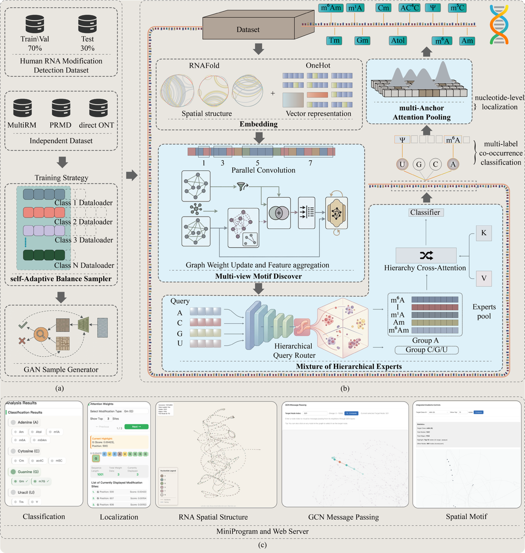
Fig. 2 mRModN Model Architecture Diagram.
(a) Overview of the datasets and preprocessing pipeline. (b) Architecture of mRModN. Modules highlighted in blue represent the key methodological innovations of this study. Embedding module converts raw RNA sequences into joint numerical and structural representations and organizes them as PyTorch Geometric objects. Multi-view Motif Discovery (M²D) module integrates positional encoding, sequential features, and structural topology to learn multi-view contextual representations. Mixture of Hierarchical Experts (MoHE) module introduces a biologically informed hierarchical routing mechanism: four nucleotide-level queries are used by the Hierarchy Query Router (HQR) block to derive and selectively activate modification-specific expert queries from the Experts Pool block, which are then processed by the Hierarchy Cross Attention (HCA) block to generate modification-specific representations and class-specific attention maps. multi-Anchor Attention Pooling (A²P) module further refines the MoHE-derived attention distribution into nucleotide-level localization scores and aligns it with the ground-truth multi-anchor site distribution through KL-divergence supervision, thereby improving multi-site localization accuracy and interpretability. (c) Visualization module for intuitive interpretation of prediction results.

Loss functions
Considering the characteristics of RNA multi-modification detection, including extreme class imbalance and multi-label nature, we design a hybrid loss function combining classification and localization objectives. We employ binary cross-entropy (BCE) loss with logits as the base loss for multi-label co-occurrence classification. To alleviate class imbalance, we introduce a smoothed positive class weighting strategy:
wc=1nc+ℇ#123
where $n_{c}$ denotes the number of positive samples for class $c$, and $ℇ$ is a small constant to avoid division by zero. The weights are further normalized to ensure numerical stability, and the final classification loss is defined as:
Lcls=1Bb=1Bi=112wc∙BCEyi,c,yi,c#143
where $B$ is the batch size, $c$ is the number of modification types, $y_{i,c}$ is the ground-truth label, and ${\hat{y}}_{i,c}$ is the predicted probability after sigmoid activation.
For nucleotide-level localization, we use the A²P attention-alignment loss Lloc defined in Eq.12. The final objective of mRModN is:

Lloc=1C+c∈C+DKLPc∥Qc#14
C+PcQc
L=Lcls+Lloc#155

Training detail
All experiments were conducted on a unified hardware platform equipped with an NVIDIA GeForce RTX 3090 GPU (manufactured in the People’s Republic of China) and an Intel Core i9-14900K CPU, running the Ubuntu 20.04 operating system. Implementation was carried out using the PyTorch 2.1.0 framework with CUDA 12.1. The datasets were partitioned into training, validation, and testing sets in 6:1:3 ratio. Data augmentation was applied was exclusively during the training stage. For the self-Adaptive Balanced Sampler, the epoch threshold $θ$was set to 90% of the total number of training epochs. The model was trained on the HRMD-m dataset for 10 epochs until convergence. For the transfer-learning experiments on the PRMD-m and direct ONT datasets, the model was trained for 3 epochs under each shot setting. For the MultiRM and MetaAc4c datasets, model training and evaluation were conducted using the same experimental settings as described above.

Evaluation metrics
To comprehensively evaluate the performance of both classification and localization tasks, we adopt a set of metrics. For the multi-label classification task involving 12 RNA modification types, we employ the following metrics: Accuracy (Acc), Precision, Recall, Sensitivity (Sn), Specificity (Sp), F1-score, Matthews Correlation Coefficient (MCC), Area Under the ROC Curve (AUC), and Area Under the Precision-Recall Curve (AUPRC). Among them, AUPRC is particularly informative for long-tailed datasets and is regarded as a key indicator of classification performance.
We used several evaluation metrics to assess the performance of localization and classification task. For classification, we used Acc, Precision, Recall, AUC, F1, MCC, AUPRC, Sn and Sp. For localization, we used Top-K Recall (Recall@K) as evaluation metrics. Those metrics are calculated as follows:
$$\begin{aligned}Accury=\frac{TP+TN}{TP+TN+FP+FN}\#\left(16\right)\end{aligned}$$
$$\begin{aligned}Precision=\frac{TP}{TP+FP}\#\left(17\right)\end{aligned}$$
$$\begin{aligned}Recall,Sn=\frac{TP}{TP+FN}\#\left(18\right)\end{aligned}$$
$$\begin{aligned}Sp=\frac{TN}{TN+FP}\#\left(19\right)\end{aligned}$$
$$\begin{aligned}F1=\frac{2×TP}{2×TP+FP+FN}\#\left(20\right)\end{aligned}$$
$$\begin{aligned}MCC=\frac{TP×TN-FP×FN}{\sqrt{\left(TP+FP\right)\left(TP+FN\right)\left(TN+FP\right)\left(TN+FN\right)}}\#\left(21\right)\end{aligned}$$
$$\begin{aligned}AUC=\int_{0}^{1}{TPR\left(t\right)d\left(FPR\left(t\right)\right)}\#\left(22\right)\end{aligned}$$
$$\begin{aligned}F1=\frac{2×TP}{2×TP+FP+FN}\#\left(23\right)\end{aligned}$$
These metrics are defined based on the confusion matrix, where $TP,TP,FP,FN$ denote true positives, true negatives, false positives, and false negatives, respectively. For the localization task, we adopt Top-K Recall (Recall@K) as the primary evaluation metric. It measures the proportion of true modification sites that are successfully identified within the top K predicted positions:
$$\begin{aligned}Recall@K=\frac{\left|P∩R_{K}\right|}{\left|P\right|} \#\left(24\right)\end{aligned}$$
Where $\left|P∩R_{K}\right|$ denotes the number of relevant items correctly retrieved within the top K predictions, and $\left|P\right|$ denotes the total number of relevant items for the given sample.
To validate the effectiveness of the model's feature learning, this study introduces Purity and the Silhouette Coefficient in the ablation experiments to evaluate the discriminative ability of the feature space between positive and negative samples:
$$\begin{aligned}Purity=\frac{1}{N}\sum_{k=1}^{K}{max_{j}\left|C_{k}∩L_{j}\right|}\#\left(25\right)\end{aligned}$$
$$\begin{aligned}Silhouette=\frac{1}{N}\sum_{i=1}^{N}{s\left(i\right)}\#\left(26\right)\end{aligned}$$
where $N$ denotes the total number of samples, $C_{k}$ represents the set of samples in the $k$-th cluster, and $L_{j}$denotes the set of samples with the $j$-th ground truth label. $s(i)$ is the silhouette coefficient for an individual sample, ranging from -1 to 1. A higher value indicates higher intra-cluster similarity and better inter-cluster separation.

Results

Performance of multi-label co-occurrence classification
To evaluate the multi-label co-occurrence classification performance of mRModN, we conducted experiments on the HRMD-m. mRModN demonstrated strong classification capability at the sequence level. As illustrated in Fig. 3, mRModN demonstrated robust classification capabilities. Specifically, the model achieved consistently high performance across most modification types, indicating strong discriminative ability within a complex, multi-modification setting.
Fig. 3a and Fig. 3b summarize the detail classification results. mRModN exhibited strong multi-label co-occurrence classification performance across individual modification types, with the majority achieving high AUC and AUPRC values. Notably, 10 of the 12 modification types yielded best performance. In terms AUCs exceeding 90, including I (99.89), Cm (97.26), Gm (96.54), Tm (98.57), ac⁴C (96.39), m¹A (97.38), m⁵C (98.48), m⁶A (98.45), and m⁷G (97.51). Only Am and Ψ presented relatively lower AUCs of 88.95 and 77.58, respectively. Furthermore, when AUPRC, a critical metric for class-imbalanced settings, mRModN maintained strong robustness. For instance, the AUPRC values for m⁶A, m⁵C, m¹A, and m⁷G reached 97.89, 97.31, and 96.43, respectively. This indicates that the model not only establishes clear decision boundaries but also stably recognize positive samples. In particular, medications such as I and m⁶Am reached near-saturated performance in both AUC and AUPRC, suggesting that the model successfully captures their highly discriminative sequence patterns.
While AUC reflects the overall separability between positive and negative samples, AUPRC is more sensitive to long-tailed distributions and better evaluates the model’s ability to identify minority positive instances. This distinction is clearly observed with the Ψ modification. Although mRModN yielded a moderate AUC of 77.58 for Ψ, it achieved a remarkable recall of 97.80, alongside a precision of 61.51, an F1-score of 75.52, and an MCC of 45.33. These metrics suggest that mRModN is a highly sensitive in detecting Ψ -positive samples and recovers the vast majority of true positives, but at the expense of a relatively high false-positive rate, which inherently lowers precision and AUC. In other words, the feature boundary for Ψ appears to less distinct compared to other modification types, leading to a high-recall, lower-precision classification pattern. In contrast, modifications such as I, m⁶Am, and m⁵C simultaneously achieve high AUC, precision, and recall, indicating that their feature distributions are more tightly concentrated and that mRModN can learn more stable decision boundaries for these categories.
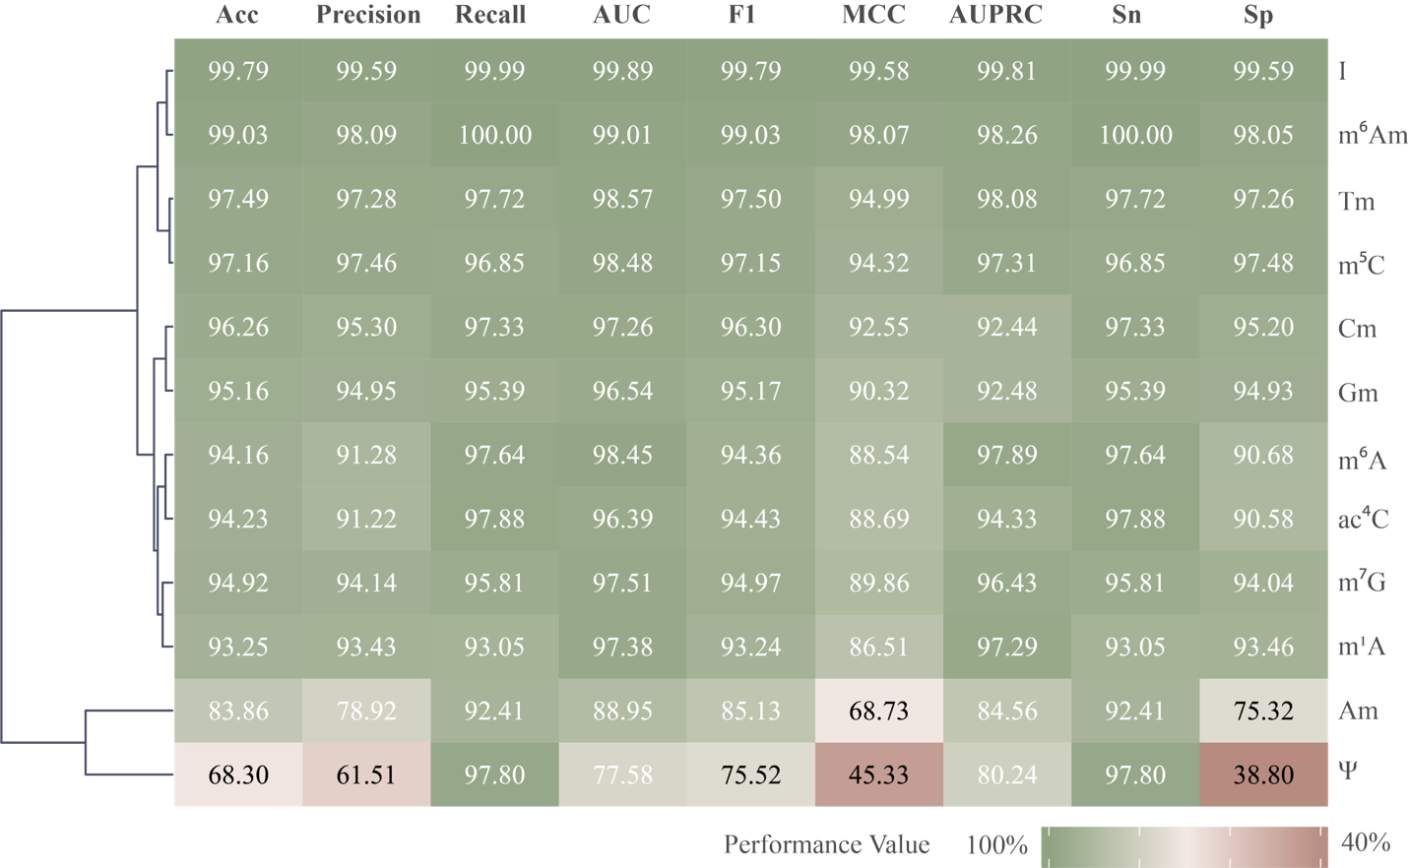
Fig. 3
Detailed multi-label co-occurrence classification report of mRModN on the HRMD-m dataset. The heatmap color gradient from red to green indicates increasing performance, and the dendrogram groups modification types with similar performance profiles. mRModN achieves high AUC and AUPRC values for most modification types, indicating strong discriminative ability in a complex multi-modification setting.

Performance of nucleotide-resolution spatial localization
As shown in Fig. 4, mRModN achieves strong nucleotide-level localization performance on the HRMD-M dataset, demonstrating high Top-K recall across most modification types. For modification such as I, m¹A, and m⁶Am, the Top-1, Top-3, Top-5, and higher-order Top-K metrics are all nearly 1.00. This indicates that the model consistently identifies the true modification site at the first-ranked position and that its localization output is highly stable. Furthermore, mRModN demonstrates strong Top-1 localization ability for modifications such as Am, Cm, Tm, m⁵C, and Gm, achieving Top-1 recall values reach 0.96, 0.99, 0.99, 0.97, and 0.98, respectively. Combined with the site-distribution statistics shown in Fig. 4a, these results suggest that the true sites of these modification types are typically sparse within each sequence, with the a close to 1. This sparsity make accurate localization within a limited candidate region more achievable. In contrast, the Top-1 recall values for Ψ, m⁶A, ac⁴C, and m⁷G are relatively lower, at 0.44, 0.76, 0.69, and 0.65, respectively. However, their Top-K recall increases markedly as K becomes larger. For example, the Top-3 and Top-5 recall values of Ψ rise to 0.86 and 0.94, respectively, while those for m⁶A reach 0.81 and 0.85. Similarly, the Top-20 recall for ac⁴C increases to 0.81, and for m⁷G the, it reaches 0.73. These findings indicate that while mRModN may not always rank the true site first for these modification types, it consistently places thme among the top high-confidence candidates.
Importantly, modifications such as Ψ and m⁶A frequently contain multiple true sites within a single sequence; therefore, their localization performance should not be evaluated solely based on the Top-1 metric. For multi-site modifications, Top-1 recall only evaluates whether the the single highest-ranked position matches one of the true sites, making this criterion intrinsically more stringent. Furthermore, a limited Top-K window may still fail to cover all true sites within the same sequence. Consequently, the lower Top-1 values observed for these modification types primarily reflect the constraints of the evaluation metric in multi-site settings, rather than an inability of the model to identify relevant modification regions.
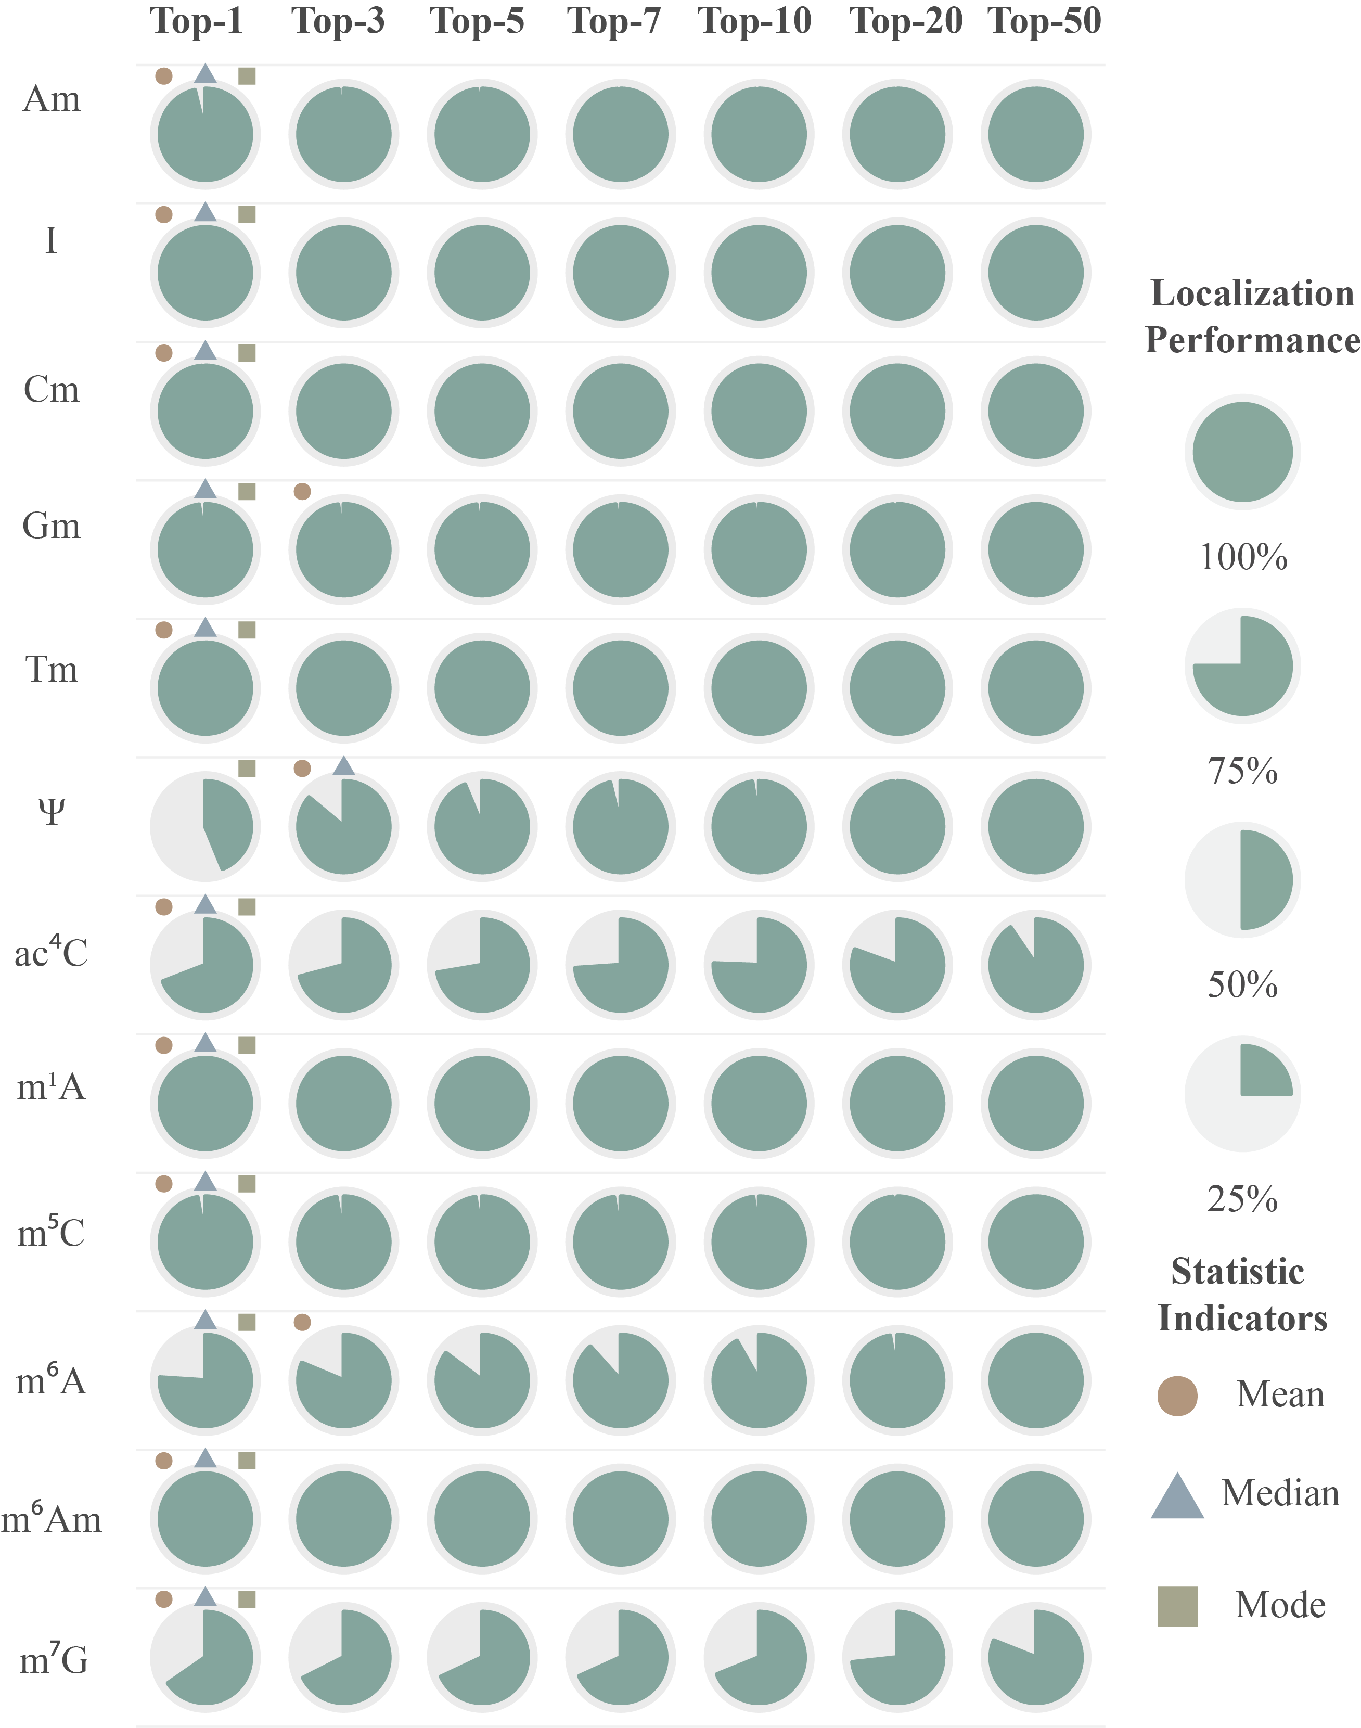
Fig. 4 Detailed localization report of mRModN on the HRMD-m dataset. Pie charts closer to a full circle indicate higher retrieval performance. mRModN achieves strong Top-K recall across most modification types, with near-saturated localization performance for I, m¹A, and m⁶Am. For multi-site modifications such as Ψ and m⁶A, Top-1 recall provides a stringent evaluation because only the highest-ranked position is considered, whereas multiple true sites coexist within the same sequence. The substantial improvement observed at higher K values therefore indicates that mRModN can recover multiple high-confidence modification anchors rather than relying on a single-site prediction.

Comparison with stat-of-the-art methods
Fig. 5a presents the classification results on the HRMD-m dataset. mRModN achieved the best overall performance among the compared methods, with average Acc, AUC, AUPRC, F1, and MCC values of 92.80, 95.50, 94.09, 93.55, and 86.46, respectively. These results were higher than those of RNA-ModX, MultiRM, and EvoRMD, indicating that mRModN provides a more robust sequence-level multi-label classification framework under the highly imbalanced HRMD-m setting. RNA-ModX also showed competitive classification performance, whereas MultiRM and EvoRMD achieved lower overall scores in this benchmark. Together, these results suggest that the combination of multi-view motif discovery, hierarchical expert routing, and self-adaptive balanced sampling contributes to stable classification
Fig. 5b urther compares mRModN with existing methods under the public MultiRM benchmark protocol. Based on the AUCb metric, mRModN achieved the best overall performance, with an average AUCb of 96.69, outperforming RNA-ModX (90.22) and MultiRM (83.75). Notably, mRModN achieved the highest AUCb in 9 of the 12 modification categories, demonstrating strong and balanced classification capability across diverse RNA modification types. Particularly strong performance was observed for I (98.99), m6Am (99.08), Gm (99.00), m6A (98.70), and m5C (98.63), indicating that mRModN can effectively capture discriminative patterns for these modifications. Although RNA-ModX achieved the highest AUCb in a few individual categories, including Am, Tm, and m7G, mRModN showed the most consistent overall performance across modification types. These results further support the robustness of mRModN in both the newly constructed HRMD-m dataset and the established MultiRM benchmark.
Further comparison using Fig. 5c and the detailed results provided in the Supplementary Material shows that mRModN substantially outperforms RNA-ModX, MultiRM, and EvoRMD in nucleotide-level localization. On the HRMD-m dataset, mRModN achieved an average Top-1 recall of 86.94, clearly surpassing RNA-ModX (26.30), EvoRMD (2.59), and MultiRM (2.58). The advantage of mRModN was also maintained across broader Top-K settings, with average Top-5 and Top-20 recalls of 92.67 and 95.37, respectively. By comparison, RNA-ModX achieved higher localization performance than MultiRM and EvoRMD, especially under larger Top-K settings, but remained consistently lower than mRModN. EvoRMD and MultiRM showed relatively limited Top-K localization performance on most modification types. The localization results show a clear association between localization performance and the extent to which each model preserves long-range sequence context. mRModN is designed to process full-length RNA sequence inputs and therefore maintains broader contextual information when assigning nucleotide-level localization scores. RNA-ModX, whose original design supports 101-nt sequence contexts, achieved the second-best localization performance, further supporting the importance of extended sequence context for candidate-site ranking. By contrast, EvoRMD was originally optimized for shorter 41-nt local contexts. In addition, its token-based representation reduces the continuity of nucleotide-level positional information when adapted to full-length localization. This difference in contextual scope and positional continuity is consistent with the lower localization performance of EvoRMD observed in this experimental setting, while EvoRMD remains a valuable framework for multi-modification classification within local sequence contexts
The localization advantage of mRModN can be attributed to its task-oriented design. By replacing traditional global pooling with multi-anchor attention pooling, mRModN unifies multi-label co-occurrence classification and nucleotide-level localization within a single framework. The KL-divergence constraint further aligns the learned attention distribution with the ground-truth site distribution, guiding the model to focus on regions surrounding true modification sites. In addition, the multi-view motif discovery module and the hierarchical expert mechanism enhance the representation of local motifs, contextual dependencies, and nucleotide-modification relationships. Together with the comparative results in Fig. 5c and the detailed statistics in the Supplementary Material, these findings indicate that mRModN more effectively enables end-to-end identification of modification sites in long RNA sequences.

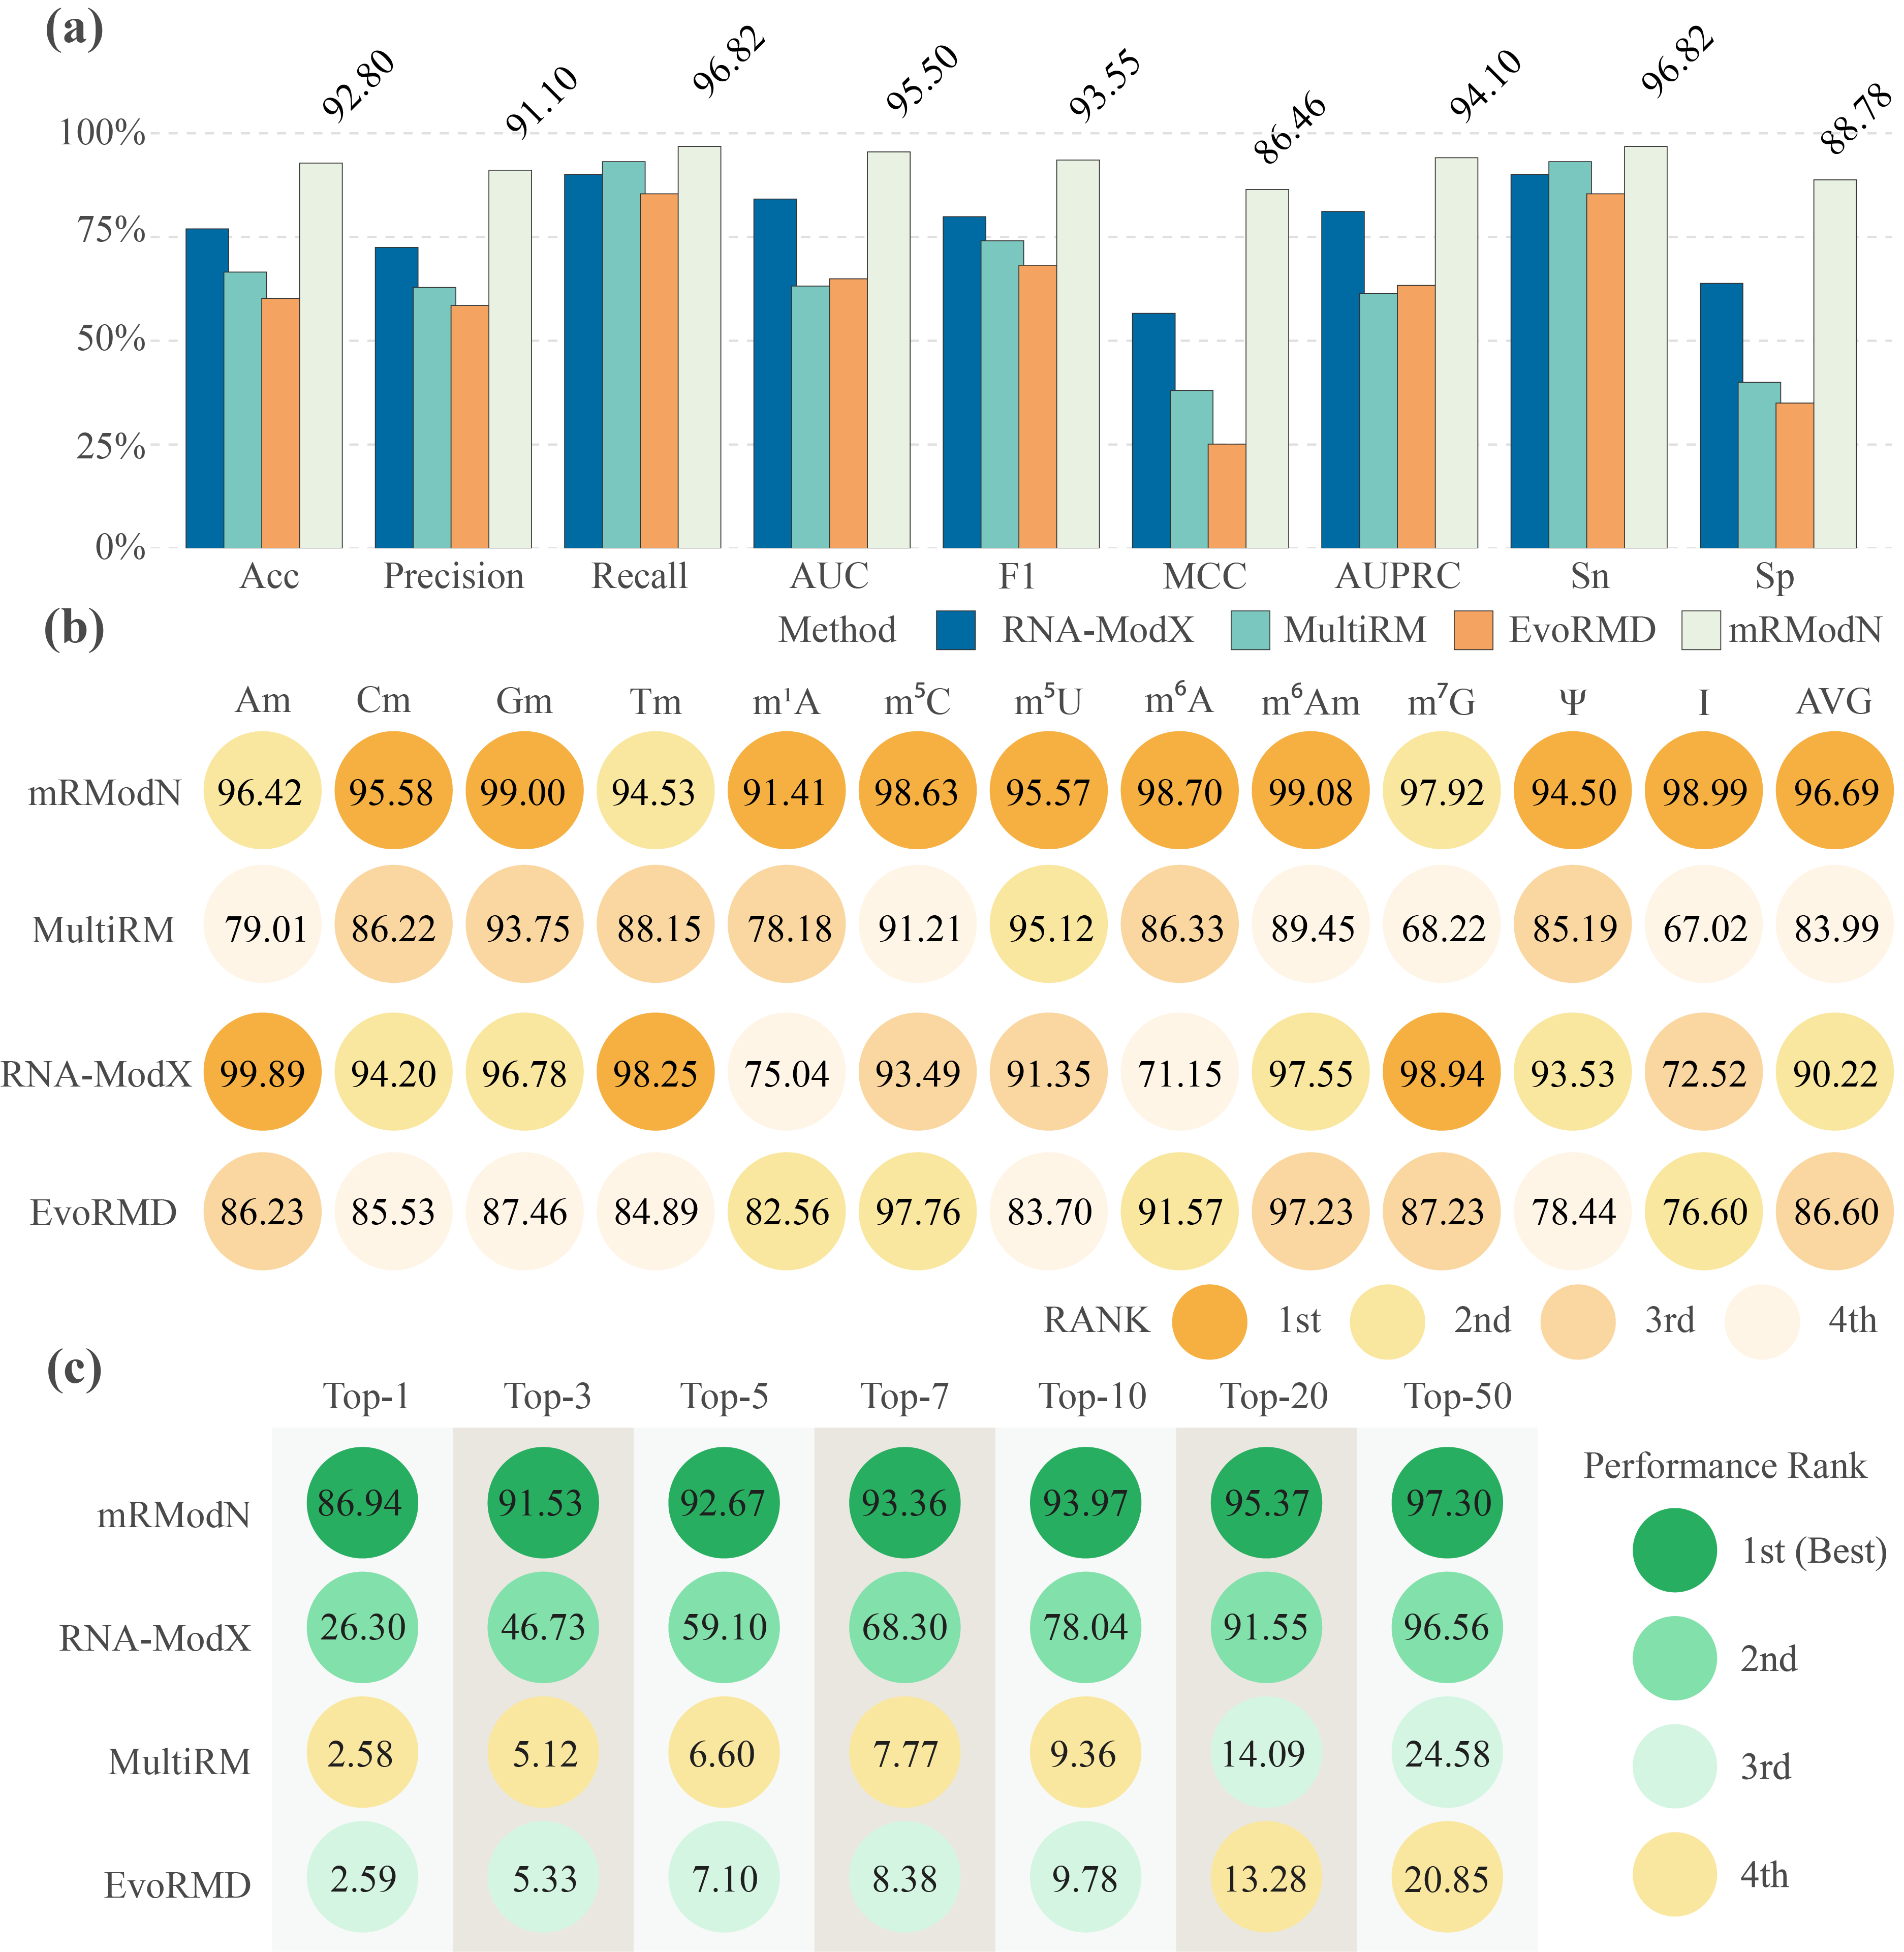
Fig. 5 Classification and localization performance comparison with stat-of-the-art methods. (a) Comparison of classification performance on the HRMD-m dataset. mRModN outperforms competing methods across most evaluation metrics, demonstrating robust sequence-level multi-label co-occurrence classification capability under class-imbalanced conditions. (b) Comparison of classification performance on the MultiRM benchmark dataset. Different background colors of the circles indicate the performance ranking among methods. The performance values of MultiRM are taken from the original MultiRM publication, whereas the results of RNA-ModX, EvoRMD, and mRModN were reproduced using the training and testing scripts provided by MultiRM with 51-nt RNA input sequences. mRModN maintains strong overall performance on this external benchmark, supporting its generalization ability across modification classification tasks. (c) Comparison of localization performance on the HRMD-m dataset. The background color of each bubble indicates the performance ranking, with darker green representing better performance. In this experiment, all competing models were minimally adapted to accept full-length sequence inputs while preserving their original backbone designs as much as possible. mRModN shows clear advantages over competing methods across most Top-K settings, demonstrating its ability to identify and prioritize true modification sites in long RNA sequences. These results suggest that localization performance is associated with the capacity of a model to preserve and process long-range sequence context. Because mRModN is designed to handle full-length RNA sequences, it can more effectively maintain contextual information required for precise modification-site localization. RNA-ModX, which was originally designed to process 101-nt sequence contexts, achieves the second-best localization performance. By comparison, EvoRMD was originally optimized for shorter local sequence contexts of 41 nt, and its token-based representation may be less suited to preserving continuous nucleotide-level positional information across full-length inputs. This may partly explain its relatively lower localization performance in this experimental setting.

Supporting effective few-shot transfer capability
Having established the strong discriminative and localization capabilities of mRModN on the primary HRMD-m dataset, we next sought to evaluate its cross-species transfer capability. To this end, we present the few-shot transfer learning results of mRModN on the plant-derived PRMD-m dataset. Since this dataset exclusively contains three types of modifications, namely m⁵C, m⁶A, and Ψ. Our evaluation is focused solely on these specific categories.
mRModN shows promising cross-species transfer capability, although the transferability differs substantially across modification types. This suggests that the success of knowledge transfer depends largely on the degree of conservation and pattern similarity of each modification across species. The zero-shot transfer performance of mRModN on the m⁵C task remains moderate (Fig. 6a,). Under the zero-shot setting, the model achieves an AUC of 71.93, indicating that it has already acquired some cross-species discriminative ability, although the overall decision boundary is still not sufficiently stable (Fig. 6a). When the number of target-domain samples increases to 1 shot and 5 shot, the AUC does not improve immediately, remaining at 70.56 and 71.36, respectively (Fig. 6a). This suggests that extremely limited supervision is insufficient to substantially refine the model’s boundary. Only when the target-domain sample size reaches 10 shot does the performance improve markedly, with the AUC increasing to 86.65, the AUPRC reaching 54.14, and the accuracy recovering to 78.46 (Fig. 5a). These results indicate that once the target-domain sample size reaches a certain threhold, mRModN can adapt more effectively to the m⁵C feature distribution in plant data.
In contrast, mRModN exhibits stronger transferability on the m⁶A task (Fig. 6b). Under the zero-shot setting, the model already achieves an AUC of 78.37 and an AUPRC of 94.38 (Fig. 6b), suggesting that the m⁶A features learned from the human dataset can be transferred well to the plant domain. As the number of labeled samples increases, the performance improves steadily: the AUC rises from 78.94 at 1shot to 79.19 at 5 shots, and further to 82.87 at 10 shots (Fig. 6b). Meanwhile, the F1-score increases from 70.07 in the zero-shot setting to 87.96, recall rises from 56.23 to 83.99, and accuracy improves from 59.91 to 80.81 (Fig. 6b). These results suggest that mRModN already possesses relatively strong initial recognition ability for m⁶A under zero-shot transfer, and that a small number of target-domain samples primarily contributes to boundary refinement and threshold calibration. A plausible explanation is that m⁶A is the most extensively studied RNA modification and is supported by the richest data resources. Furthermore, its local motifs and contextual patterns are relatively conserved across species, enabling the pre-trained model to learn more highly transferable common features.
The transfer behaviour of Ψ differs substantially from that of m⁵C and m⁶A. Under the zero-shot setting, mRModN achieves an AUC of only 39.21, an AUPRC of 10.96, and an F1-score of 11.07 (Fig. 6c), indicating that the Ψ-related features learned from human data cannot be directly transferred to the plant domain. However, once a small number of target-domain samples is introduced, the model performance improves rapidly: the AUC increases to 59.78 at 1 shot, 73.64 at 5 shots, and 76.55 at 10 shots, while the F1-score rises from 11.07 to 21.35, 38.97, and 34.62, respectively (Fig. 6c). These results indicate that although Ψ shows weak zero-shot transferability, it is highly sensitive to limited target-domain supervision, and the model can adapt quickly once fine-tuning data become available. Notably, the F1-score at 5 shots is higher than that at 10 shots, whereas the AUC continues to improve to 76.55 at 10 shots (Fig. 6c). This suggests that although the model’s overall ranking ability continues to improve with more training samples, the balance between precision and recall at a fixed decision threshold may still fluctuate, meaning that not all evaluation metrics increase synchronously. Overall, the Ψ results suggest that this modification type exhibits stronger cross-species distributional divergence and therefore requires a small amount of target-domain data for effective domain adaptation.
Taken together, these results indicate that mRModN achieves robust overall performance in cross-species few-shot transfer learning, although the degree of transfer difficulty varies across modification types. Specifically, m⁶A already exhibits strong transferability under the zero-shot setting, indicating that its cross-species features are relatively stable. Meanwhile, m⁵C requires a moderate number of target-domain samples before its performance improves substantially, suggesting an intermediate level of transfer difficulty. By contrast, Ψ yields the lowest performance in the zero-shot setting but improves most rapidly upon introduction a small number of target-domain samples, indicating greater sensitivity to target-domain calibration. Overall, these findings demonstrate that mRModN can not only learn modification-recognition patterns in the source domain but can also achieve sucdessful transfer with limited target-domain supervision, highlighting its strong potential for cross-species applications.
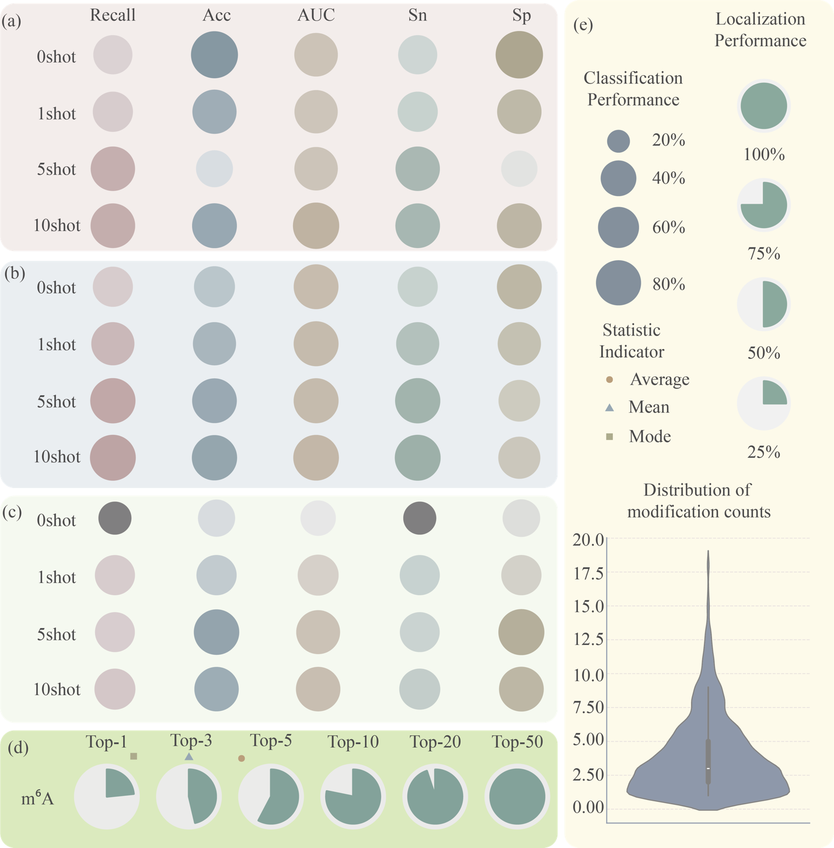
Fig. 6 Application Performance of mRModN on RNA Modification Datasets.
(a)(b)(c): Few-shot transfer learning classification performance of mRModN on the plant-derived PRMD-m dataset for m5C, m6A, and Ψ, respectively. The bubble size is positively correlated with the performance metric value. For m5C, mRModN shows moderate zero-shot transferability, while substantial performance improvement emerges only when the number of target-domain samples reaches 10 shots, indicating an intermediate level of transfer difficulty. For m6A, mRModN already exhibits strong zero-shot transfer performance and improves steadily with additional labeled samples, suggesting that m6A-associated features are relatively conserved across species. For Ψ, mRModN shows weak zero-shot transferability but improves rapidly under few-shot fine-tuning, indicating high sensitivity to limited target-domain supervision and a stronger need for domain adaptation.(d): Zero-shot localization performance of mRModN on the third-generation sequencing dataset (direct ONT). Pie charts closer to a full circle indicate higher Recall values. Even without downstream fine-tuning, mRModN achieves strong localization performance, with Recall increasing markedly at larger Top-K thresholds, demonstrating robust generalization to nanopore-based m6A site localization. (e): Illustration of the legend and distribution of RNA modification sites in the direct ONT dataset. The violin plot depicts the distribution, frequency, and density of modification sites, and the white dot indicates the median number of modification sites per sequence. The plot shows that multiple m6A sites frequently coexist within a single third-generation sequencing read, with up to 20 modification sites observed in one sequence, while most sequences contain more than two modified nucleotides.

Implementation of mRModN in third-generation sequencing data
Third-generation single-molecule sequencing technology, namely Direct RNA Sequencing (DRS)[58-61], enables real-time monitoring of ionic current fluctuations as nucleotides pass through nanopores, thereby directly capturing the native RNA modification states. Compared with second-generation sequencing technologies based on chemical treatments, DRS exhibits significant advantages in both detection accuracy and preservation of modification signals. However, because nanopore sequencing technology is continuously evolving and experimental costs remain relatively high, the large-scale applications of third-generation sequencing are currently constrained by economic and technical barriers in most research institutions. Motivated by this, we applied the mRModN model to a third-generation sequencing dataset (direct ONT) to evaluate its few-shot transfer capability in modification localization tasks, aiming to explore a -cost-efficiency and high efficient solution for modification detection.
Notably, the third-generation sequencing dataset exclusively comprises m⁶A modifications. This dataset is characterized by a large number of modification sites and substantial heterogeneity in their distribution across sequences (Fig. 6e). In the experimental setup, the mRModN model pre-trained on the HRMD-m dataset was directly transferred to the direct ONT dataset without any downstream fine-tuning.
Specifically, mRModN achieved a Top-5 recall exceeding 50% (Fig. 6d). When the evaluation threshold was extended to Top-10, the recall increased significantly to 78.16, and it further reached 94.93 under the Top-20 criterion (Fig. 6d). Considering that this task was conducted in a strict zero-shot transfer setting without any fine-tuning, these results strongly demonstrate the excellent generalization capabilities and robustness of mRModN. Therefore, the model is highly capable of accurately localizing RNA modification sites in third-generation nanopore sequencing data.

Motif Interpretation of mRModN
This study aims not only to enable mRModN to perform classification and localization tasks, but also to uncover the underlying factors that govern the occurrence of RNA modifications. To this end, we systematically explore both sequence-based (planar) motifs and structure-aware (spatial) motif representations. For planar motif extraction, we follow the analysis strategy adopted in MultiRM. Specifically, RNA sequences from the MultiRM dataset are first segmented into subsequences of length. Candidate motifs are then constructed using clustering algorithms, and Integrated Gradients are employed to identify the most contribute feature patterns. Finally, the motifs identified by the model are compared with standard motifs extracted by the STREME[62] tool, and their statistical significance is evaluated using TomTom[63]. The results show that the extremely small p-values indicate a high consistency between the features captured by mRModN and established biological motif patterns. However, the planar motif approach has inherent limitations: the selected subsequences do not guarantee the inclusion of true modification anchors, and this strategy completely ignores the cooperative regulatory effects of long-range nucleotides arising from RNA spatial folding.
To address these limitations, we further propose a novel spatial motif discovery framework. In this approach, feature embeddings at each nucleotide position are first clustered in the feature space. For each cluster, taking the modification site as the physical centre, we combine Integrated Gradients with statistical analysis to identify the top-key positions with the highest contributions. Subsequently, Otsu’s method[64] is applied in the statistical domain to separate foreground from background signals, highlighting nucleotides that play critical roles in modification while filtering out statistically insignificant noise. This spatial motif strategy not only ensures that true modification anchors are directly involved in motif construction, but also successfully captures the allosteric effects of distal nucleotides on modification sites.
The planar motif results in Fig. 7a demonstrate that the top motifs identified by Integrated Gradients for each modification achieve p-values lower than 0.05 in the TomTom evaluation. This confirms that the model effectively captures authentic sequence patterns. In contrast, the spatial motif results in Fig. 7b reveal deeper biological insights. For instance, the Atol modification is primarily driven by local motifs, whereas modifications such as Gm exhibit strong regulation by spatial motifs. In addition, certain modifications, such as Ψ, show a strong dependency on specific fixed nucleotides. These findings indicate that mRModN is capable of not only matching known biological motifs but also uncovering novel spatial regulatory patterns from a multi-view perspective.
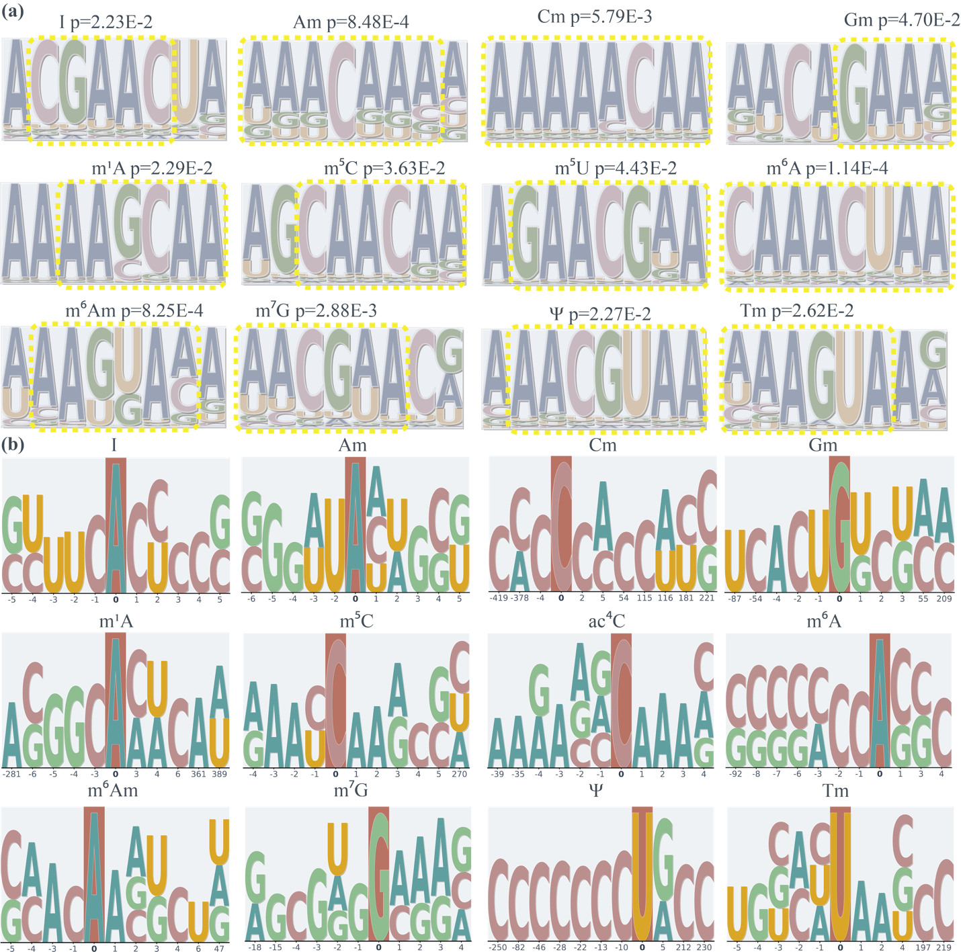
Fig. 7 Motif Analysis of mRModN on MultiRM Dataset. (a) Planar motifs identified by mRModN. The p-values, calculated using the TomTom tool, indicate the statistical significance of the similarity between the motifs captured by mRModN and those identified by STREME. All matched motifs shown in the figure have p<0.05, indicating statistically significant agreement. This result suggests that mRModN is able to learn biologically meaningful and evolutionarily conserved sequence patterns associated with RNA modifications. (b) Spatial motifs identified by mRModN. Centered on true modification sites, the spatial motif analysis uses Integrated Gradients to identify nucleotide positions in the spatial structural context that contribute most strongly to modification prediction from the perspective of the deep learning model. Compared with planar motifs, spatial motifs provide deeper biological insights by capturing the influence of distal nucleotides and structure-aware regulatory patterns, revealing that some modifications are mainly driven by local motifs, whereas others exhibit stronger spatial dependence.

Ablation Study
- Impact of M²D Module

To incorporate RNA secondary-structure information, we used RNAFold to predict RNA secondary structures and represented the resulting data as PyTorch Geometric objects. However, PyTorch Geometric adopts a topology-first data structure, in which node organization is mainly determined by structural edge connections. This representation may weaken or obscure the original nucleotide order of the RNA sequence. Since conventional one-hot encoding does not explicitly encode positional information in the graph domain, models that rely solely on graph-based representations may fail to capture critical sequence-order features. To address this issue, the proposed Multi-view Motif Discovery (M²D) module combines convolutional neural networks (CNN) with graph convolution networks (GCN), allowing the CNN branch to pre-encode positional and sequential features before graph convolution is performed.
The ablation results of the M²D module are shown in Fig. 9e, where the outer boundary of the radar chart represents the best-performing configuration. The results demonstrate that only the M²D module, which integrates both sequence-order information and structural topology, achieves the best performance across all evaluation metrics. Notably, when only the CNN branch was retained to capture sequential and positional information, model performance decreased only slightly. In contrast, when only the GCN branch was retained and sequence-order information was removed, model performance dropped substantially. This pattern indicates that sequence-order information plays a more dominant role than structural topology in RNA modification detection.
Specifically, the full M²D module achieved the best overall performance, with an Accuracy of 0.88, an AUC of 0.92, an AUPRC of 0.90, an F1-score of 0.88, and an MCC of 0.76, outperforming both single-view variants. When only the CNN branch was retained, the model still achieved an Accuracy of 0.85 and an AUPRC of 0.88, suggesting that sequence-order information alone already provides strong discriminative capacity. However, its AUC and F1-score decreased to 0.82 and 0.79, respectively, indicating that its overall performance remained inferior to that of the full M²D module. By contrast, when only the GCN branch was retained, the decline was much more pronounced, with Accuracy, AUPRC, and F1-score decreasing to 0.63, 0.46, and 0.55, respectively.
These results reveal that RNA modification detection cannot rely solely on spatial topology. Instead, sequence-order features remain the primary basis for model discrimination, while structural topology provides complementary information when integrated with sequential features. Therefore, by jointly modeling sequence-order information and structural topology, the M²D module further improves the overall classification performance of mRModN.

- Impact of Hierarchy Cross-Attention within Mixture of Hierarchical Experts
To evaluate the contribution of the Hierarchy Cross-Attention (HCA) block within the Mixture of Hierarchical Experts (MoHE) module, we replaced the HCA block with representative sequence modeling architectures, including LSTM, CNN, and conventional self-attention, and compared their performance under different input sequence lengths. As shown in Fig. 9b, the HCA-based MoHE variant maintained stable and strong classification performance as the sequence length increased. When the input length increased from 51 to 101 and then to 1001 nucleotides, the AUC of the HCA-based model reached 93.94, 93.98, and 96.07, respectively.
In contrast, the performance of the baseline architectures was less stable under longer input contexts. At sequence lengths of 51, 101, and 1001, the AUC values were 84.53, 79.23, and 79.23 for LSTM; 69.13, 68.13, and 63.89 for CNN; and 91.22, 92.12, and 94.52 for conventional self-attention, respectively. These results show that HCA consistently achieved the best classification performance across different sequence lengths, indicating its robustness in long-context RNA modification prediction.
We further compared the parameter scale of HCA with that of conventional self-attention. As shown in Fig. 9d, the parameter count of HCA increased only from 1762945 to 2006145 as the sequence length increased, whereas the parameter count of conventional self-attention increased from 2063500 to 2306600. Thus, HCA achieved superior classification performance while maintaining a smaller parameter budget. These ablation results demonstrate that HCA improves long-sequence classification performance and provides a more parameter-efficient alternative to conventional attention mechanisms.
- Impact of multi-Anchor Attention Pooling
To evaluate the contribution of multi-Anchor Attention Pooling (A²P) to nucleotide-level localization, we compared it with two conventional pooling strategies, average pooling and max pooling. As shown in Fig. 9f, A²P achieved the strongest Top-1 localization performance across most RNA modification types, indicating that attention-based multi-anchor alignment is more effective for identifying true modification sites than global feature aggregation.
For modification types with relatively sparse and easily distinguishable modification sites, A²P achieved near-saturated localization performance. For example, the Top-1 scores of Am, I, Tm, m¹A, m⁵C, and m⁶Am were close to or reached 1.000 under A²P, whereas average pooling and max pooling showed substantially lower performance. These results demonstrate that A2P can effectively preserve highly concentrated site-specific signals for modification types with clear localization patterns.
The advantage of A²P was also evident for more challenging modification types. For Ψ, ac⁴C, m⁶A, and m⁷G, A²P achieved Top-1 scores of 43.82, 69.10, 76.02, and 65.34, respectively. In comparison, average pooling yielded 23.42, 51.55, 28.98, and 37.69, while max pooling yielded 27.87, 42.93, 27.99, and 30.51 for the same modification types. The large improvements observed for m⁶A and m⁷G suggest that A²P is particularly beneficial when multiple candidate sites or complex sequence contexts are present.
Overall, the ablation results demonstrate that A²P substantially improves nucleotide-level localization performance compared with conventional pooling strategies. By directly leveraging class-specific attention distributions, A²P provides a more effective mechanism for prioritizing true modification anchors in long RNA sequences.
- Impact of self-Adaptive Balanced Sampler
To evaluate the effect of the self-Adaptive Balanced Sampler (ABS) on feature learning under class-imbalanced conditions, we compared three training strategies: standard sampling, static balanced sampling, and self-adaptive balanced sampling. Standard sampling preserved the original class distribution throughout training, static balanced sampling maintained class balance across all training epochs, and self-adaptive balanced sampling applied class-balanced training in the early stage before switching back to full-dataset traversal. The resulting feature spaces were evaluated using Purity and the Silhouette Coefficient, which measure intra-class compactness and inter-class separation, respectively.
As shown in Fig. 8b, standard sampling produced the weakest feature-space organization, with an average Silhouette Coefficient of 0.14 and an average Purity of 0.81. Both balanced sampling strategies substantially improved these metrics. Static balanced sampling increased the average Silhouette Coefficient to 0.26 and the average Purity to 0.90, while self-adaptive balanced sampling achieved the best average Silhouette Coefficient of 0.27 and maintained an average Purity of 0.90. At the level of individual modification types, standard sampling showed clear performance imbalance. Although the majority class m⁶A achieved relatively high Purity and Silhouette values of 0.96 and 0.32, minority modifications such as Am, I, m⁵C, and m⁷G showed lower values, with Purity/Silhouette values of 0.69/0.03, 0.88/0.10, 0.83/0.12, and 0.82/0.15, respectively. In contrast, static balanced sampling improved the representation quality of several minority or underrepresented modifications. For example, the Purity values for I, Cm, Tm, m⁵C, and m⁷G increased to 0.99, 0.90, 0.96, 0.93, and 0.94, with corresponding Silhouette Coefficients of 0.46, 0.34, 0.28, 0.42, and 0.25, respectively.
ABS provided the most balanced overall outcome. Compared with static balanced sampling, it achieved slightly higher Silhouette Coefficients for Am, I, Cm, Gm, ac⁴C, m¹A, and m⁶A, and increased the Purity of m⁶A from 0.84 to 0.91. Although static balanced sampling produced marginally higher Purity for a few categories, such as Tm, m⁵C, and m⁷G, these differences were relatively small. Overall, the results in Fig. 8b demonstrate that ABS improves feature-space organization under long-tailed class distributions and provides a better balance between minority-class discrimination and majority-class representation.

Discussion
To gain deeper insight into the design rationale of mRModN, we further examined the contribution of its key modules on both the HRMD-m dataset and the MultiRM benchmark dataset. HRMD-m served as the primary dataset for performance evaluation and was particularly well suited for localization analysis because it consists of variable-length RNA sequences with precise nucleotide-level annotations. In contrast, MultiRM includes multiple sequence-length settings and was therefore used to evaluate model robustness and feature extraction ability across different input lengths. In addition to AUC, we considered Purity and the Silhouette Coefficient to characterize the learned feature space in terms of inter-class separation and intra-class compactness. These analyses help explain how individual design choices shape the predictive performance and representation quality of mRModN.

Multi-view Motif Discover Module find motif in multi view
The ablation results of the M²D module provide important insight into how sequential and structural views contribute to RNA modification detection. As shown in Fig. 9e, the full M²D module outperformed both CNN-only and GCN-only variants, whereas the CNN-only model showed only a moderate decline and the GCN-only model exhibited a much larger performance drop. This pattern suggests that sequence-order information forms the primary discriminative basis for RNA modification classification, while structural topology alone is insufficient for robust prediction.
This observation is consistent with the biological nature of RNA modification signals. Many RNA modifications are associated with local nucleotide contexts and sequence motifs; therefore, preserving the original nucleotide order is critical for effective motif recognition. In graph-based representations, however, structural connectivity is emphasized, and the original linear sequence order may be weakened. As a result, relying only on GCN-based topology aggregation may cause the model to lose critical motif-related information. In M²D, the CNN branch first encodes positional and sequential features, while the GCN branch subsequently incorporates structure-aware neighborhood information. This design enables the model to capture motifs from both planar sequence and spatial structural views.

The contribution of M²D is further supported by the feature-space analysis shown in Fig. 9c. Compared with the standard GCN, M²D achieved better Purity and Silhouette Coefficient values, indicating stronger intra-class compactness and better inter-class separation. These results suggest that integrating sequence-order information with structural topology improves not only classification performance but also the organization of the learned representation space.
In addition, the motif matching comparison in Fig. 9a shows that mRModN equipped with the M²D module matched more motifs than MultiRM. This result further suggests that multi-view modeling improves the biological relevance of the learned features. Taken together, the results from Fig. 9ace support the conclusion that M²D does not simply combine two feature extractors, but instead enhances RNA modification detection by using sequence motifs as the dominant signal and structural topology as complementary spatial context.

Mixture of Hierarchical Experts enables scalable learning of modification-specific features
The ablation results indicate that Hierarchy Cross Attention (HCA) block in Mixture of Hierarchical Experts (MoHE) is particularly effective for long-sequence RNA modification prediction. As shown in Fig. 9b and Fig. 9d, HCA maintained strong classification performance as input length increased while requiring fewer parameters than conventional self-attention. This reveal that the advantage of HCA is not simply derived from increasing model complexity, but from a more efficient organization of modification-specific feature learning. A key reason for this improvement is that MoHE incorporates a biologically meaningful hierarchy between nucleotide backgrounds and RNA modification types. Instead of learning all modification-specific representations independently, MoHE first organizes attention queries according to the four nucleotide groups and then derives modification-level queries from the corresponding nucleotide-level representations. This design allows related modification types to share coarse-grained nucleotide information while still preserving fine-grained modification-specific discrimination.
This hierarchical organization is especially important for multi-modification detection in long RNA sequences. As the input sequence becomes longer, the model must distinguish true modification-related signals from an increasing amount of background context. Conventional CNN or LSTM architectures have limited capacity to capture long-range dependencies, whereas standard self-attention can model global interactions but often introduces greater parameter growth. HCA provides a more balanced solution by using structured cross-attention queries to focus on biologically relevant modification-specific patterns without learning fully independent representations for every modification type.
The performance trend observed in the ablation study supports this interpretation. HCA remained stable across increasing sequence lengths, whereas LSTM and CNN showed weaker or declining performance, and conventional self-attention required a larger parameter budget. Therefore, HCA improves not only predictive performance but also scalability, making it suitable for variable-length RNA sequences containing multiple coexisting modification signals. Taken together, these findings suggest that MoHE enables scalable learning of modification-specific features by combining biological hierarchy, long-context attention, and parameter-efficient representation learning.

Multi-Anchor Attention pooling for precise modification localization
High-precision localization requires the model not only to classify whether a modification type is present, but also to identify the nucleotide positions most likely to correspond to true modification sites. Conventional pooling strategies, such as average pooling and max pooling, are not naturally designed for this objective. Average pooling compresses all nucleotide representations into a global summary, which dilutes the positional signals of true modification anchors. Max pooling preserves only the strongest response, thereby limiting its ability to capture additional true sites when multiple modification anchors coexist within the same sequence. A²P addresses this limitation by treating localization as a distribution alignment problem. Instead of generating a single global representation, A²P operates on the class-specific attention distribution produced by MoHE and aligns it with the normalized multi-anchor ground-truth site distribution using KL-divergence supervision. This design allows the model to learn not only which modification type is present, but also how attention should be distributed across one or more true modification anchors.
The ablation results in Fig. 9f support this interpretation. A²P consistently outperformed average pooling and max pooling across most modification types, with especially large improvements for complex categories such as m⁶A and m⁷G. These modifications often involve multiple potential candidate positions or more heterogeneous contextual patterns, making them difficult for conventional pooling strategies. By preserving the full attention distribution rather than collapsing sequence information into a single vector, A²P can maintain positional salience and improve candidate-site ranking. The advantage of A²P is particularly relevant to the multi-site setting of RNA modification detection. In long RNA sequences, multiple true modification sites may coexist, and a localization module should therefore avoid forcing the model to focus on only one position. Through multi-anchor distribution alignment, A²P encourages the learned attention map to cover multiple true sites when they are present. This makes the localization output more consistent with the biological structure of the task and improves the interpretability of predicted modification regions.
Taken together, these findings support that A²P improves both localization precision and representation learning by transforming class-specific attention maps into biologically meaningful nucleotide-level localization distributions. Rather than serving as a simple pooling operation, A²P functions as a task-specific alignment module that connects multi-label co-occurrence classification with multi-site nucleotide-resolution localization.

Self-Adaptive Balanced Sampler facilitates balanced feature learning across RNA modification types
RNA modification datasets exhibit a pronounced long-tailed distribution, in which abundant modifications such as m⁶A dominate the training process, whereas rare modifications such as m7G, Am, and Gm contribute far fewer samples. Under standard sampling, model optimization is therefore driven primarily by majority classes. This leads to a feature space in which abundant modifications are represented more compactly, while minority-class features remain less separable and more easily overwhelmed by background signals.
The comparison among standard, static balanced, and dynamic balanced sampling strategies provides insight into how sampling affects representation learning. Standard sampling preserves the original data distribution, but this also preserves the optimization bias toward high-frequency classes. The low average Silhouette Coefficient and Purity observed under standard sampling indicate that the learned feature space lacks sufficient compactness and separation for minority modifications. In this setting, the model learns stronger representations for abundant classes such as m6A, while the decision boundaries of rare classes remain less stable.
Static balanced sampling alleviates this problem by increasing the exposure of underrepresented classes throughout training. This explains why it substantially improves Purity and Silhouette values for several minority modifications. However, maintaining strict class balance for the entire training process also reduces the model’s exposure to the full diversity of abundant classes. This limitation is reflected by the lower m6A Purity and Silhouette values under static balanced sampling compared with dynamic balanced sampling.
The self-Adaptive Balanced Sampler provides a more flexible solution. In the early training stage, class-balanced sampling increases the visibility of rare modification types and helps the model establish more stable preliminary boundaries for minority classes. In the later training stage, switching back to full-dataset traversal allows the model to recover the complete diversity of abundant classes and refine the overall feature space. In addition, GAN-based augmentation increases the diversity of rare-class samples, reducing the limitations of naive oversampling.
Taken together, the results indicate that ABS does not simply rebalance sample counts. Instead, it shapes the learning trajectory: early-stage rebalancing improves minority-class sensitivity, while later full-distribution training preserves majority-class feature completeness. This dynamic strategy explains why ABS achieves the best overall trade-off between minority-class discrimination and majority-class representation, thereby facilitating more balanced feature learning across RNA modification types.

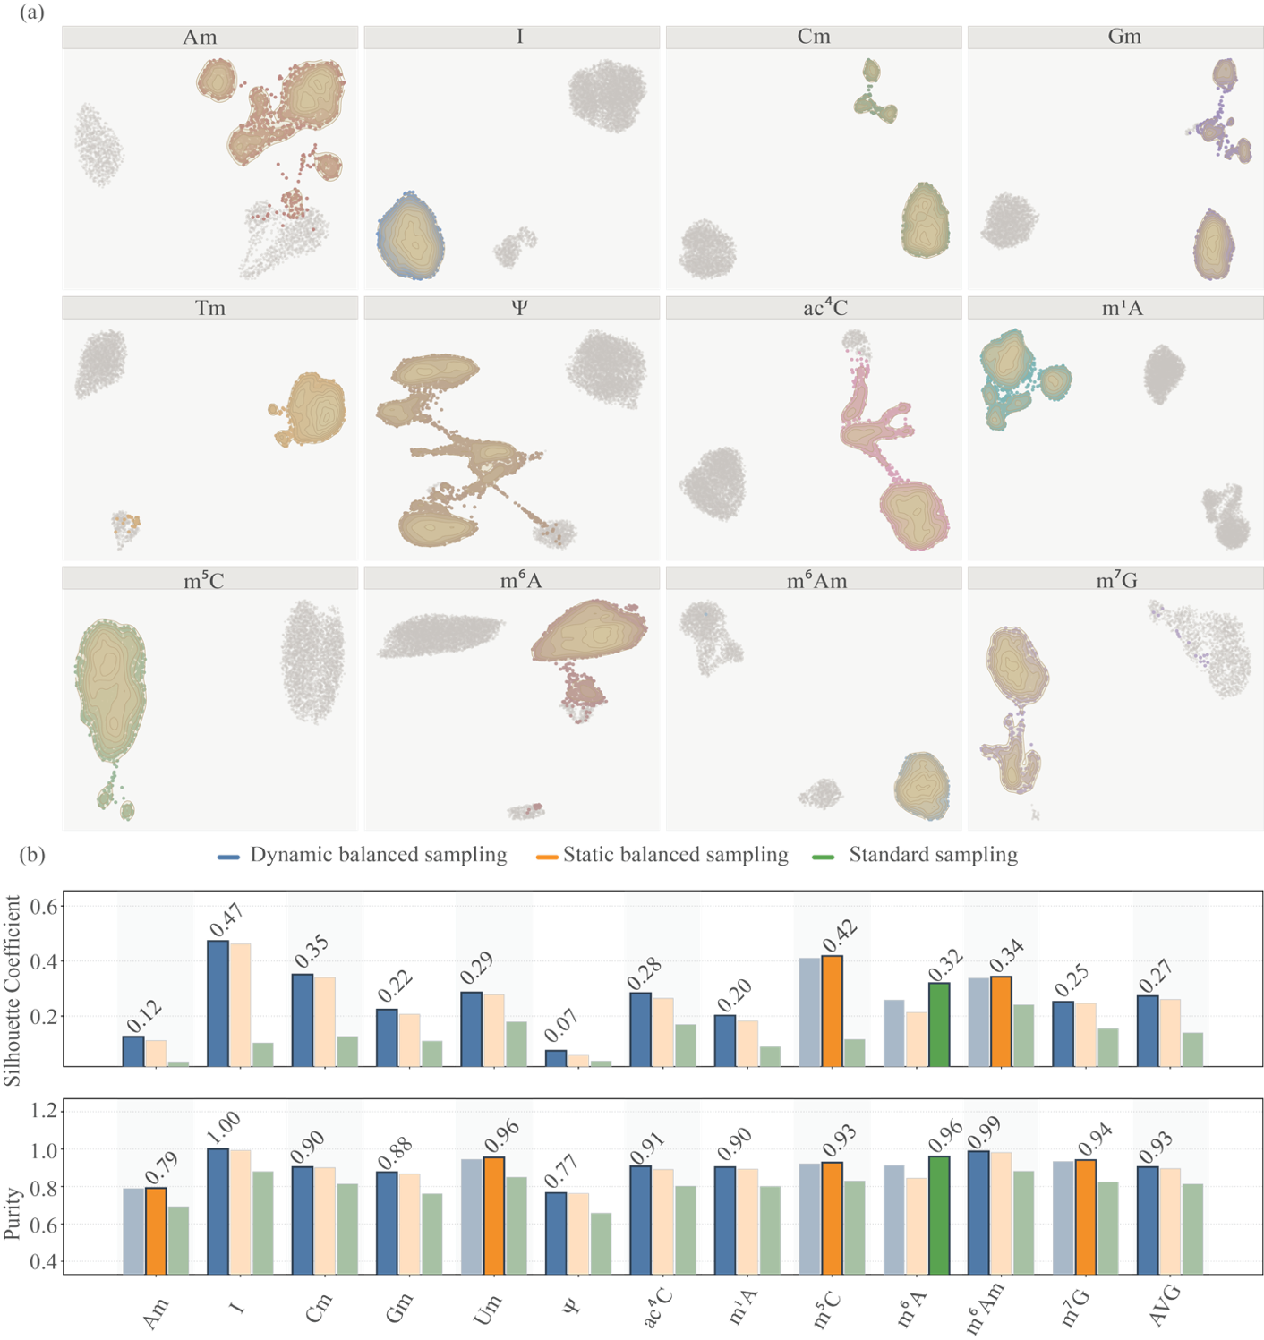
Fig. 8 Feature Space Visualization and Performance Analysis of mRModN.
(a) Feature-space visualization of each modification-specific classification head in mRModN. Thin contour lines indicate probability density levels. Samples located closer to the density center correspond to higher classification confidence for the associated modification type. Across the feature spaces of all modification types, most positive samples form compact clusters and remain clearly separated from negative samples, indicating that mRModN learns discriminative and well-structured modification-specific representations. (b) Performance comparison of three sampling strategies for the sequence-level classification task. The results further confirm that the learned feature space maintains high cluster purity and clear spatial separation between positive and negative samples. Self-adaptive balanced sampler achieves a more favourable balance between minority-class discrimination and majority-class feature completeness, supporting more stable and evenly distributed feature representations across RNA modification types.
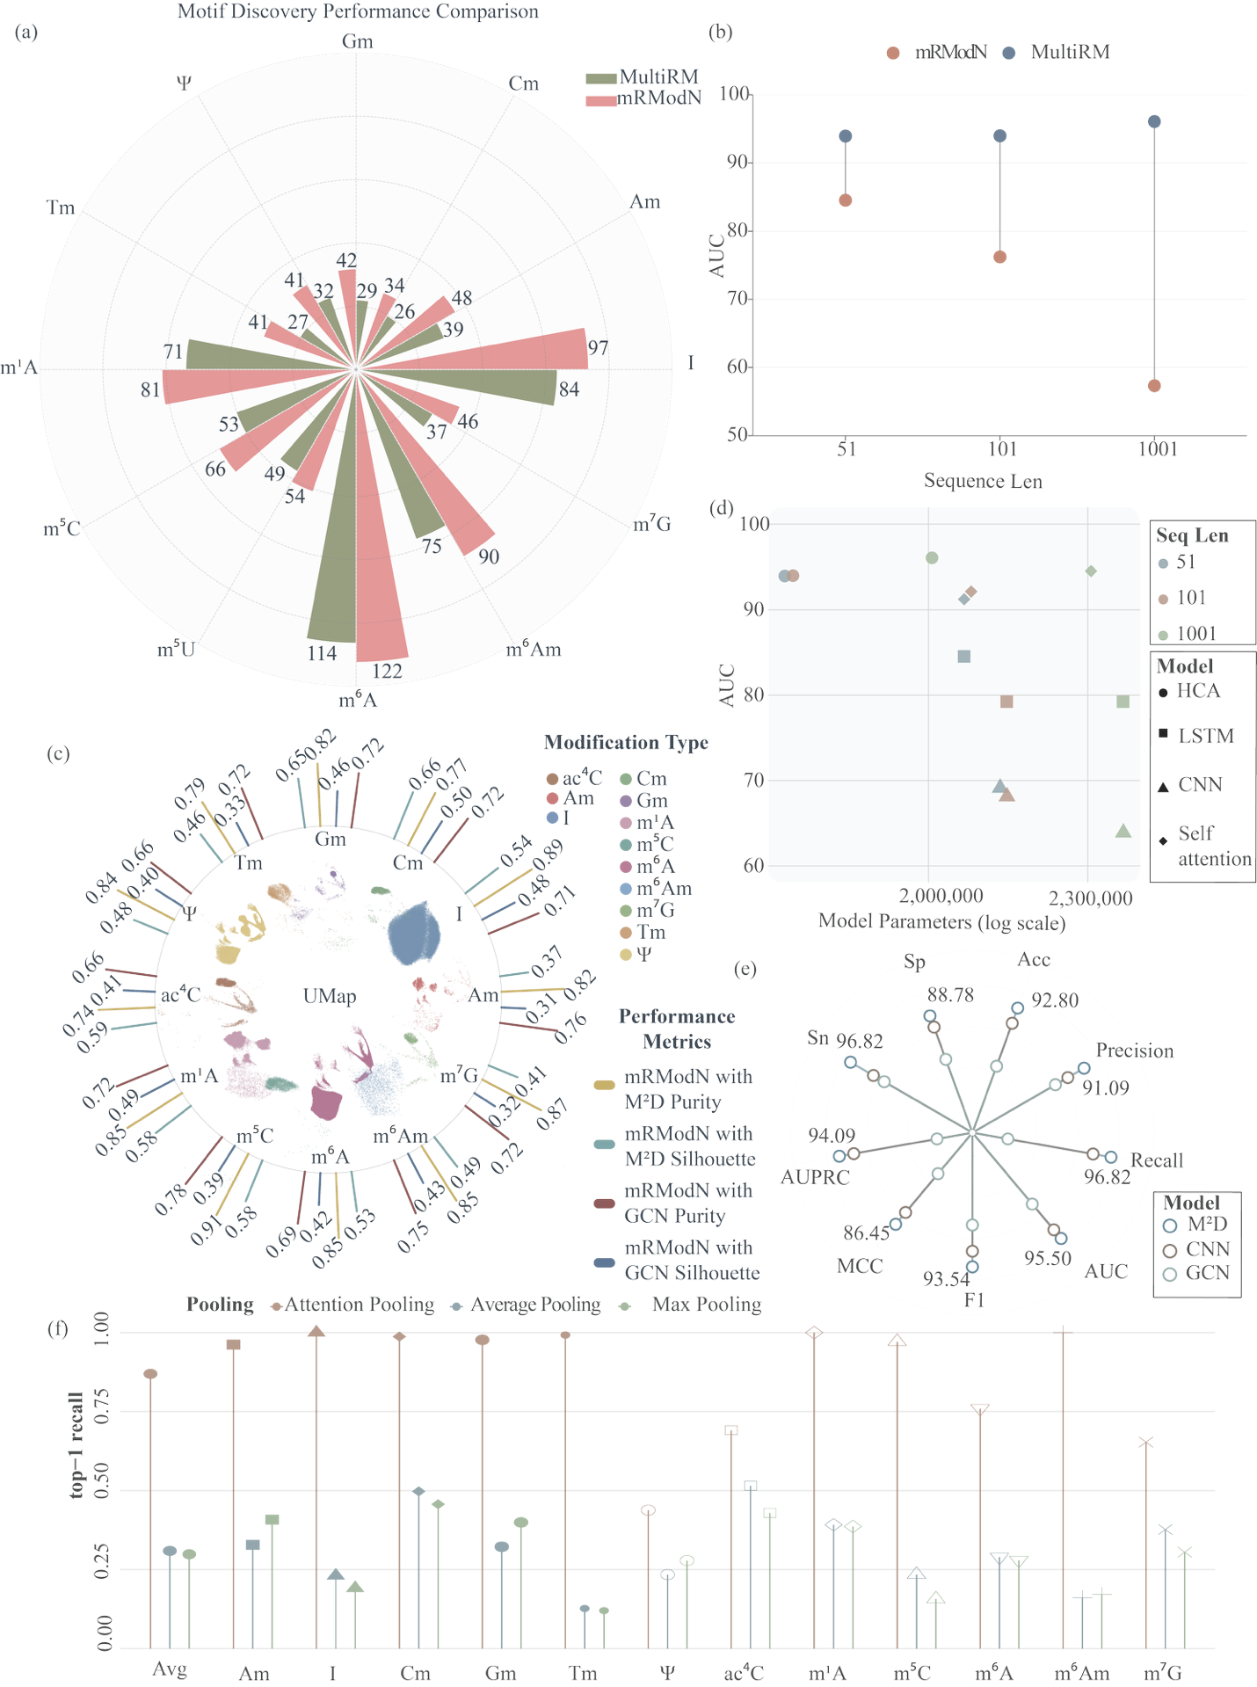
Fig. 9 Ablation Experiments of mRModN.
(a) Motif discovery performance comparison. (b) Comparison of classification performance across different sequence lengths on the mRModN dataset. (c) Comparison of clustering performance between the M²D module and the GCN model. The central UMAP plot illustrates the overall sample distribution learned by mRModN; (d) Comparison of classification performance and parameter scale under different attention mechanisms on the MultiRM dataset. (e) Ablation study of the M²D module on the HRMD-m dataset. (f) Impact of different pooling strategies on localization performance on the HRMD-m dataset.

Feature-Space Analysis of Few-Shot Transfer Learning
To further investigate the factors associated with performance improvements under few-shot conditions, we introduced feature-space drift evaluation metrics, including Distance to HRMD-m Centroid Gain, Compactness Gain, Separation Margin Gain, and Separation Ratio Gain (Fig. 10 b). In the PRMD-m plant dataset, as the number of fine-tuning samples increased from zero-shot to 10-shot, all modification types showed a marked increase in Compactness Gain, suggesting that even a small number of plant samples encouraged tighter clustering of same-class targets in the feature space. At the same time, Distance to HRMD-m Centroid Gain exhibited a substantial negative shift, indicating that fine-tuning reshaped the feature space to better accommodate distributional differences between the human and plant domains. Together, these results suggest that the HRMD-m-pretrained model captured partially transferable cross-domain features, while domain-specific differences remained between the two datasets. Motif recognition results in Fig. 10c further show that the modification-context sequence patterns learned in the plant dataset differ noticeably from those observed in the human dataset. This observation is consistent with previous reports that plant m⁵C sites may exhibit distinct sequence-context preferences, including C/U-rich enrichment in some contexts[65, 66]. Therefore, a plausible interpretation is that few-shot fine-tuning helps the model adapt to plant-specific sequence features, thereby improving domain transfer performance.
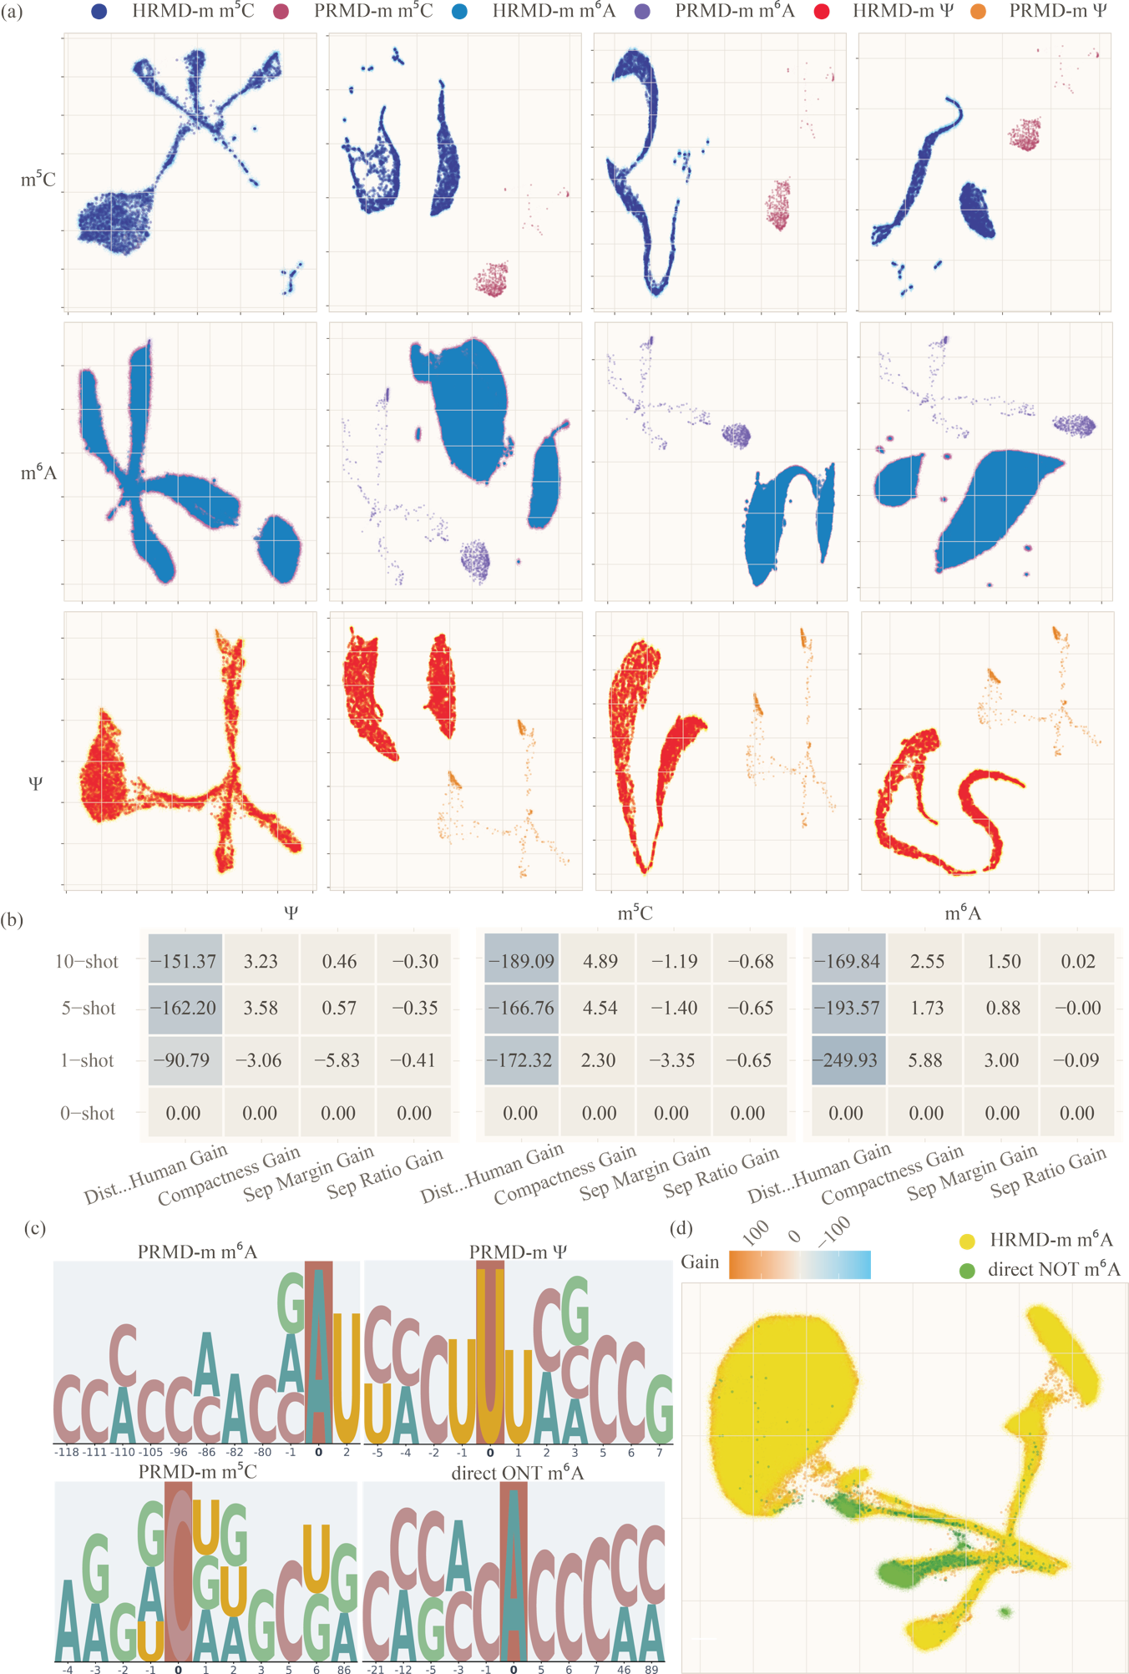
Fig. 10 Feature Space Drift Evaluation.
(a) Feature-space visualization from 0-shot to 10-shot transfer experiments. (b) Feature-space metrics, from left to right, the y-axis representing Distance-to-HRMD-m-Centroid Gain, Compactness Gain, Separation Margin Gain, and Separation Ratio Gain. (c) Spatial motif visualization for PRMD-m and direct ONT datasets. (d) Feature-space visualization for the direct ONT dataset in the 10-shot transfer experiment. Since the clusters in the direct ONT dataset exhibited no significant shifts from 0-shot to 10-shot, only the 10-shot visualization is shown.

Limitation of this study
This study focuses on detecting multiple modifications in long RNA sequences. We proposed mRModN, a deep learning model based on tree-structured cross-attention, and tested its classification performance, localization ability, transfer learning, and interpretability. To solve common problems in current methods—such as short input limits, relying only on planar sequence data, and the difficulty of doing both classification and localization at once—we designed the Multi-view Motif Discovery (M²D) module, the Hierarchy Cross-Attention (HCA) mechanism, an attention pooling layer, and a dynamic balanced sampler. These components allow the model to combine sequence and spatial structural information to find relationships and long-range connections between different RNA modifications.
The results demonstrate that mRModN achieves superior performance on the HRMD-m dataset. In sequence-level classification, the model reached high AUC scores for most modification types, significantly outperforming mainstream models like MultiRM and ModX. For Nucleotide-level localization, mRModN uses its attention pooling mechanism to enable end-to-end identification. It achieved a high Top-1 Recall, proving its ability to accurately pinpoint modification sites within long 1001-bp RNA sequences. Additionally, the model showed strong knowledge transfer in few-shot tests on the plant dataset (PRMD-m) and zero-shot tests on third-generation sequencing data (direct ONT). This shows that mRModN is not only effective for benchmark detection but also holds great potential for real-world research applications.
However, we acknowledge several limitations in this study. First, although mRModN supports variable-length RNA inputs, the current implementation is limited to sequences up to 1001 nt. RNA molecules longer than this threshold must be truncated, which may still lead to the loss of distal contextual or structural information. In future work, we plan to explore BERT-based[67-69] architectures to better support longer RNA inputs. In addition, we aim to extend mRModN beyond detection toward mechanistic modeling of the relationship between environmental factors and RNA modifications.

Reference
[1] J. Cerneckis, G.-L. Ming, H. Song, C. He, and Y. Shi, "The rise of epitranscriptomics: recent developments and future directions," Trends in pharmacological sciences, vol. 45, no. 1, pp. 24-38, 2024.
[2] B. He et al., "Advancing DNA and RNA Modification Detection via Nanopore Sequencing," ACS nano, vol. 19, no. 43, pp. 37468-37483, 2025.
[3] Y. Yan et al., "M6A RNA modification: focusing on non-small cell lung cancer progression, therapeutic strategies and challenges," Frontiers in Oncology, vol. 15, p. 1622359, 2025.
[4] B.-Y. Yu and H. Ueda, "RNA modifications in cancer and their detection: a review," Japanese Journal of Clinical Oncology, p. hyag018, 2026.
[5] I. M. Artika, R. Arianti, M. Á. Demény, and E. Kristóf, "RNA modifications and their role in gene expression," Frontiers in Molecular Biosciences, vol. 12, p. 1537861, 2025.
[6] P. G. Adamopoulos, K. Athanasopoulou, G. N. Daneva, and A. Scorilas, "The repertoire of RNA modifications orchestrates a plethora of cellular responses," International Journal of Molecular Sciences, vol. 24, no. 3, p. 2387, 2023.
[7] J. Hong, K. Xu, and J. H. Lee, "Biological roles of the RNA m6A modification and its implications in cancer," Experimental & molecular medicine, vol. 54, no. 11, pp. 1822-1832, 2022.
[8] S. Schiffers and S. Oberdoerffer, "ac4C: a fragile modification with stabilizing functions in RNA metabolism," Rna, vol. 30, no. 5, pp. 583-594, 2024.
[9] S. Li, P. Luo, J. Fan, Y. Li, J. Tu, and X. Long, "RNA modifications in health and disease," MedComm, vol. 6, no. 9, p. e70341, 2025.
[10] Y. Liu, Y. Li, and Q. Sun, "Advances in Detecting RNA Modifications Using Direct RNA Nanopore Sequencing," Advanced Genetics, vol. 6, no. 4, p. e00041, 2025.
[11] J. Xuan et al., "RMBase v3. 0: decode the landscape, mechanisms and functions of RNA modifications," Nucleic Acids Research, vol. 52, no. D1, pp. D273-D284, 2024.
[12] Y. Zhang et al., "DirectRMDB: a database of post-transcriptional RNA modifications unveiled from direct RNA sequencing technology," Nucleic acids research, vol. 51, no. D1, pp. D106-D116, 2023.
[13] R. Azad, M. Heidari, Y. Wu, and D. Merhof, "Contextual attention network: Transformer meets u-net," in International workshop on machine learning in medical imaging, 2022: Springer, pp. 377-386.
[14] Y. Cao, F. Yang, Q. Tang, and X. Lu, "An attention enhanced bidirectional LSTM for early forest fire smoke recognition," IEEE Access, vol. 7, pp. 154732-154742, 2019.
[15] A. Vaswani, "Attention is all you need," Advances in Neural Information Processing Systems, 2017.
[16] C. Hendra, P. N. Pratanwanich, Y. K. Wan, W. S. Goh, A. Thiery, and J. Göke, "Detection of m6A from direct RNA sequencing using a multiple instance learning framework," Nature methods, vol. 19, no. 12, pp. 1590-1598, 2022.
[17] C. Wang, Y. Ju, Q. Zou, and C. Lin, "DeepAc4C: a convolutional neural network model with hybrid features composed of physicochemical patterns and distributed representation information for identification of N4-acetylcytidine in mRNA," Bioinformatics, vol. 38, no. 1, pp. 52-57, 2022.
[18] Z. Song et al., "Attention-based multi-label neural networks for integrated prediction and interpretation of twelve widely occurring RNA modifications," Nature communications, vol. 12, no. 1, p. 4011, 2021.
[19] C. C. Yuge et al., "RNA-ModX: a multilabel prediction and interpretation framework for RNA modifications," Briefings in Bioinformatics, vol. 26, no. 1, p. bbae688, 2025.
[20] H. Wang, T. Huang, D. Wang, W. Zeng, Y. Sun, and L. Zhang, "MSCAN: multi-scale self-and cross-attention network for RNA methylation site prediction," BMC bioinformatics, vol. 25, no. 1, p. 32, 2024.
[21] B. Wang, H. Zhang, T. Cui, X. Wang, J. Song, and H. Xu, "EvoRMD: Integrating Biological Context and Evolutionary RNA Language Models for Interpretable Prediction of RNA Modifications," bioRxiv, p. 2026.03. 22.713386, 2026.
[22] O. Ronneberger, P. Fischer, and T. Brox, "U-net: Convolutional networks for biomedical image segmentation," in Medical image computing and computer-assisted intervention–MICCAI 2015: 18th international conference, Munich, Germany, October 5-9, 2015, proceedings, part III 18, 2015: Springer, pp. 234-241.
[23] Z. Zhou, M. M. Rahman Siddiquee, N. Tajbakhsh, and J. Liang, "Unet++: A nested u-net architecture for medical image segmentation," in Deep Learning in Medical Image Analysis and Multimodal Learning for Clinical Decision Support: 4th International Workshop, DLMIA 2018, and 8th International Workshop, ML-CDS 2018, Held in Conjunction with MICCAI 2018, Granada, Spain, September 20, 2018, Proceedings 4, 2018: Springer, pp. 3-11.
[24] B. Yu, H. Yin, and Z. Zhu, "St-unet: A spatio-temporal u-network for graph-structured time series modeling," arXiv preprint arXiv:1903.05631, 2019.
[25] I. Notarnicola, M. Bin, L. Marconi, and G. Notarstefano, "The gradient tracking is a distributed integral action," IEEE Transactions on Automatic Control, vol. 68, no. 12, pp. 7911-7918, 2023.
[26] J. V. Burke, T. Hoheisel, and C. Kanzow, "Gradient consistency for integral-convolution smoothing functions," Set-Valued and Variational Analysis, vol. 21, no. 2, pp. 359-376, 2013.
[27] R. Benoit, "On the integral of the surface layer profile-gradient functions," Journal of Applied Meteorology and Climatology, vol. 16, no. 8, pp. 859-860, 1977.
[28] A. Cappannini et al., "MODOMICS: a database of RNA modifications and related information. 2023 update," Nucleic Acids Research, vol. 52, no. D1, pp. D239-D244, 2024.
[29] X. Wang et al., "m7GHub V2. 0: an updated database for decoding the N7-methylguanosine (m7G) epitranscriptome," Nucleic Acids Research, vol. 52, no. D1, pp. D203-D212, 2024.
[30] L. Fu, B. Niu, Z. Zhu, S. Wu, and W. Li, "CD-HIT: accelerated for clustering the next-generation sequencing data," Bioinformatics, vol. 28, no. 23, pp. 3150-3152, 2012.
[31] R. d. C. A. Tavares, G. Mahadeshwar, H. Wan, and A. M. Pyle, "MRT-ModSeq–Rapid detection of RNA modifications with MarathonRT," Journal of Molecular Biology, vol. 435, no. 22, p. 168299, 2023.
[32] Z. Li, B. Jin, and J. Fang, "MetaAc4C: a multi-module deep learning framework for accurate prediction of N4-acetylcytidine sites based on pre-trained bidirectional encoder representation and generative adversarial networks," Genomics, vol. 116, no. 1, p. 110749, 2024.
[33] X. Chen, Y. Liu, K. Lv, M. Wang, X. Liu, and B. Li, "FASTdRNA: a workflow for the analysis of ONT direct RNA sequencing," Bioinformatics Advances, vol. 3, no. 1, p. vbad099, 2023.
[34] Y. Wu et al., "Simultaneous profiling of ac4C and m5C modifications from nanopore direct RNA sequencing," International Journal of Biological Macromolecules, vol. 305, p. 140863, 2025.
[35] S. Cruciani and E. M. Novoa, "The new era of single-molecule RNA modification detection through nanopore base-calling models," Nature Reviews Molecular Cell Biology, vol. 27, no. 1, pp. 10-18, 2026.
[36] X. Lang et al., "PRMD: an integrated database for plant RNA modifications," Nucleic Acids Research, vol. 52, no. D1, pp. D1597-D1613, 2024.
[37] L. Reiser et al., "Recent major changes to TAIR: updates to the database, website, and Arabidopsis genome," Genetics, p. iyaf248, 2026.
[38] Y. Chen et al., "A systematic benchmark of Nanopore long-read RNA sequencing for transcript-level analysis in human cell lines," Nature methods, vol. 22, no. 4, pp. 801-812, 2025.
[39] C. Duan and R. Li, "Multi-head linear attention generative adversarial network for thin cloud removal," arXiv preprint arXiv:2012.10898, 2020.
[40] A. Creswell, T. White, V. Dumoulin, K. Arulkumaran, B. Sengupta, and A. A. Bharath, "Generative adversarial networks: An overview," IEEE signal processing magazine, vol. 35, no. 1, pp. 53-65, 2018.
[41] K. Wang, C. Gou, Y. Duan, Y. Lin, X. Zheng, and F.-Y. Wang, "Generative adversarial networks: introduction and outlook," IEEE/CAA Journal of Automatica Sinica, vol. 4, no. 4, pp. 588-598, 2017.
[42] I. Goodfellow et al., "Generative adversarial networks," Communications of the ACM, vol. 63, no. 11, pp. 139-144, 2020.
[43] R. Lorenz et al., "ViennaRNA Package 2.0," Algorithms for molecular biology, vol. 6, no. 1, p. 26, 2011.
[44] I. L. Hofacker, W. Fontana, P. F. Stadler, L. S. Bonhoeffer, M. Tacker, and P. Schuster, "Fast folding and comparison of RNA secondary structures," Monatshefte für Chemie/Chemical Monthly, vol. 125, no. 2, pp. 167-188, 1994.
[45] L. Huang et al., "LinearFold: linear-time approximate RNA folding by 5'-to-3'dynamic programming and beam search," Bioinformatics, vol. 35, no. 14, pp. i295-i304, 2019.
[46] D. Deng, K. Zhao, D. Hendrix, D. H. Mathews, and L. Huang, "Linearfold: Linear-time prediction of rna secondary structures," bioRxiv, p. 263509, 2018.
[47] A. Malik et al., "LinearAlifold: Linear-time consensus structure prediction for RNA alignments," Journal of molecular biology, vol. 436, no. 17, p. 168694, 2024.
[48] C. Bernard, "Computational methods based on deep learning for the prediction of RNA 3D structures," Université Paris-Saclay, 2025.
[49] P. D. Dans, D. Gallego, A. Balaceanu, L. Darre, H. Gomez, and M. Orozco, "Modeling, simulations, and bioinformatics at the service of RNA structure," Chem, vol. 5, no. 1, pp. 51-73, 2019.
[50] M. Fey and J. E. Lenssen, "Fast graph representation learning with PyTorch Geometric," arXiv preprint arXiv:1903.02428, 2019.
[51] B. Rozemberczki et al., "Pytorch geometric temporal: Spatiotemporal signal processing with neural machine learning models," in Proceedings of the 30th ACM international conference on information & knowledge management, 2021, pp. 4564-4573.
[52] J. Chai and G. Shi, "Module: Module embedding for knowledge graphs," arXiv preprint arXiv:2203.04702, 2022.
[53] W. Zheng, L. Yin, X. Chen, Z. Ma, S. Liu, and B. Yang, "Knowledge base graph embedding module design for Visual question answering model," Pattern recognition, vol. 120, p. 108153, 2021.
[54] M. Lou, H.-Y. Zhou, S. Yang, and Y. Yu, "TransXNet: learning both global and local dynamics with a dual dynamic token mixer for visual recognition," arXiv preprint arXiv:2310.19380, 2023.
[55] R. Wang, H. Jiang, and Y. Li, "UPerNet with ConvNeXt for Semantic Segmentation," in 2023 IEEE 3rd International Conference on Electronic Technology, Communication and Information (ICETCI), 2023: IEEE, pp. 764-769.
[56] S. Rajbhandari et al., "Deepspeed-moe: Advancing mixture-of-experts inference and training to power next-generation ai scale," in International conference on machine learning, 2022: PMLR, pp. 18332-18346.
[57] F. Bieder, R. Sandkühler, and P. C. Cattin, "Comparison of methods generalizing max-and average-pooling," arXiv preprint arXiv:2103.01746, 2021.
[58] F. Ozsolak et al., "Direct RNA sequencing," Nature, vol. 461, no. 7265, pp. 814-818, 2009.
[59] A. Leger et al., "RNA modifications detection by comparative Nanopore direct RNA sequencing," Nature communications, vol. 12, no. 1, p. 7198, 2021.
[60] P. N. Pratanwanich et al., "Identification of differential RNA modifications from nanopore direct RNA sequencing with xPore," Nature biotechnology, vol. 39, no. 11, pp. 1394-1402, 2021.
[61] D. R. Garalde et al., "Highly parallel direct RNA sequencing on an array of nanopores," Nature methods, vol. 15, no. 3, pp. 201-206, 2018.
[62] T. L. Bailey, "STREME: accurate and versatile sequence motif discovery," Bioinformatics, vol. 37, no. 18, pp. 2834-2840, 2021.
[63] J. Schreiber, "Tomtom-lite: accelerating Tomtom enables large-scale and real-time motif similarity scoring," Bioinformatics, vol. 41, no. 11, p. btaf577, 2025.
[64] D. Liu and J. Yu, "Otsu method and K-means," in 2009 Ninth International conference on hybrid intelligent systems, 2009, vol. 1: IEEE, pp. 344-349.
[65] X. Cui et al., "5-Methylcytosine RNA methylation in Arabidopsis thaliana," Molecular plant, vol. 10, no. 11, pp. 1387-1399, 2017.
[66] R. David et al., "Transcriptome-wide mapping of RNA 5-methylcytosine in Arabidopsis mRNAs and noncoding RNAs," The Plant Cell, vol. 29, no. 3, pp. 445-460, 2017.
[67] Y. Ji, Z. Zhou, H. Liu, and R. V. Davuluri, "DNABERT: pre-trained Bidirectional Encoder Representations from Transformers model for DNA-language in genome," Bioinformatics, vol. 37, no. 15, pp. 2112-2120, 2021.
[68] V. Badrinarayanan, A. Kendall, and R. Cipolla, "Segnet: A deep convolutional encoder-decoder architecture for image segmentation," IEEE transactions on pattern analysis and machine intelligence, vol. 39, no. 12, pp. 2481-2495, 2017.
[69] A. Kendall, Y. Gal, and R. Cipolla, "Multi-task learning using uncertainty to weigh losses for scene geometry and semantics," in Proceedings of the IEEE conference on computer vision and pattern recognition, 2018, pp. 7482-7491.

