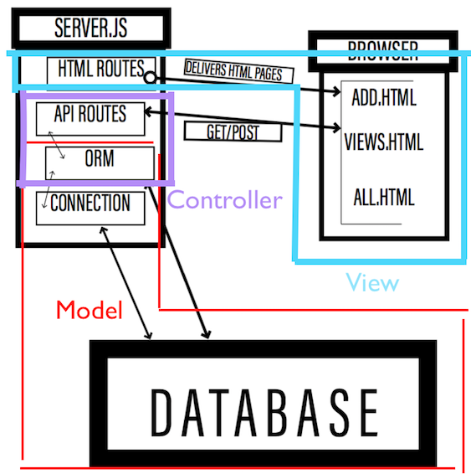

**[EXAMPLE]**

Server: Self-explanatory, sets up server.

↑

Controller: Routes, callback function to send to model and a res.send or a res.render, for example. Calls the necessary model methods to get the data ready to be passed to the view.

↑

Model: Should not have connection, should be decoupled from the data store technology (mysql in this case).

↑

Orm: Maps the model to the database and vice versa. Mysql queries are here.

↑

Connection: Self-explanatory, sets up connection to mysql.

//////////////////////////////////////////////////////////////////////////////////////////////////////////////

Data Path: Server(server.js) → Controller(catsController.js) → Model(cats.js) → Orm(orm.js) → Connection(connection.js)