React Native Basic Guide (Mac and iOS)

**Note: This guide is intended to work for nearly all users and *should* work on most Macs upgraded to the latest OS (El Capitan, as of writing).**

**Parts:**

1. Installing and Configuring Xcode
2. Installing and Running the React Native CLI
3. Understanding React Native

**Part 1: Downloading and Installing Xcode**

(Note: if you already have Xcode, move onto Part 2.)

Xcode provides the simplest way for Mac users to test their React Native apps. This Apple coding suite comes packed with features, not the least of which is an iOS emulator—that component’s going to make your programming life much easier this week.

1. Open up the App Store on your Mac machine, then search for Xcode. Download and install it (it’s free).

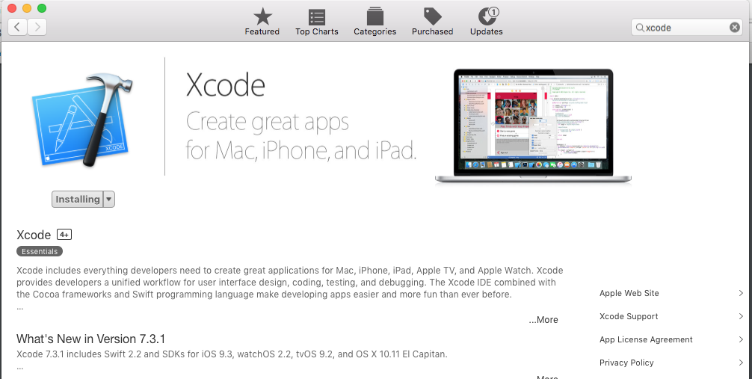

* 1. Stick with the App Store version for now and avoid Xcode 8 on Apple’s website. That version only works with developers who pay Apple’s yearly license fee (mainly to publish apps on iOS). If you create an app that you think the world must bear witness to, feel free to pay the fee.

1. Once Xcode finishes downloading, open the program. Agree to the terms of service and wait for the remaining components to install.
2. When you see the window below, you’re done! Go to Part 2.

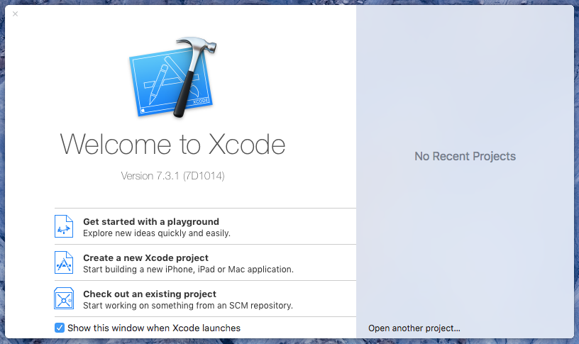

**PART 2: Installing and Using the React Native CLI**

1. Open up terminal and run this command:
   1. npm install –g react-native-cli
2. Now cd your way to any directory where you’d like to place your React Native apps.
3. Once in that directory, run this command.
   1. react-native init AhmedsApp

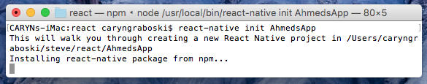

1. This will take a few minutes to finish. If you ran the right command, you’ll end up with an AhmedsApp directory, boilerplate code included.

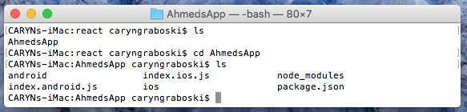

1. Once it finishes, cd to AhmedsApp and run this command:
   1. react-native run-ios
2. If an iPhone 6 window pops up, wait a few minutes until the window displays the default React Native app. When it does, you’re ready for step 3.

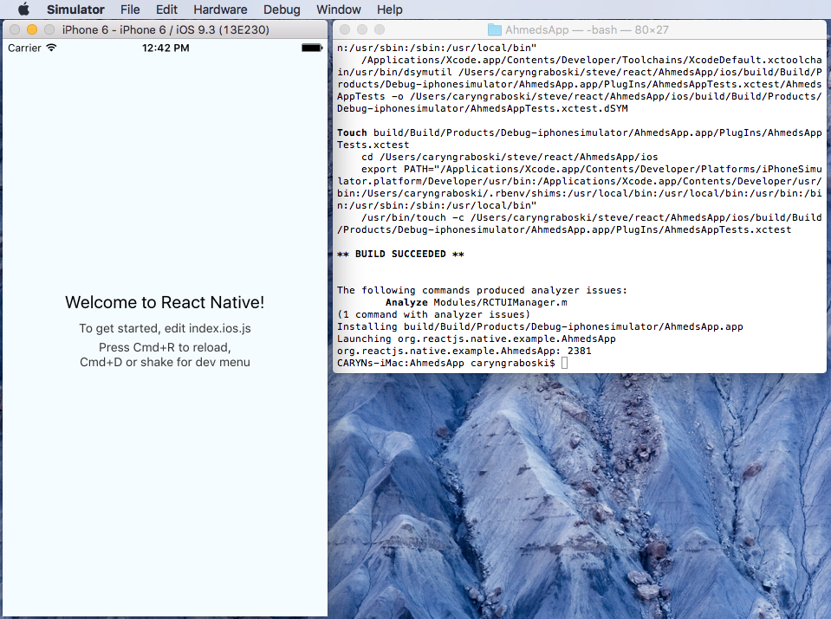

* 1. If the window doesn’t show up or five minutes passes without the test app displaying, talk to a TA or your instructor, who will help you along.

**Part 3: Understanding React Native**

1. In your directory, you’ll spot the following files:

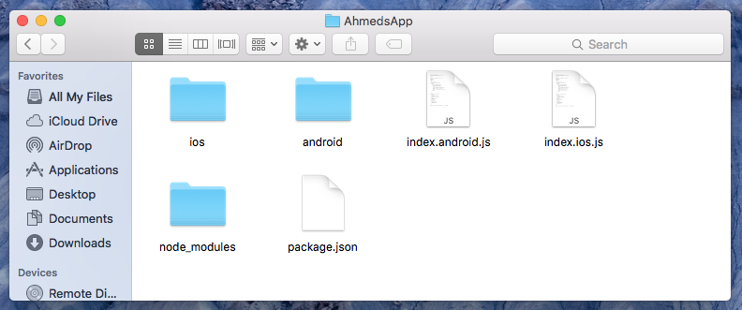

1. Open up index.ios.js. Play around a bit with the code here to see how it works. It’s very similar to the vanilla React code you worked on last week, with a few exceptions. When you alter the file, press command+r in the iPhone simulator to reload your project and view your changes.

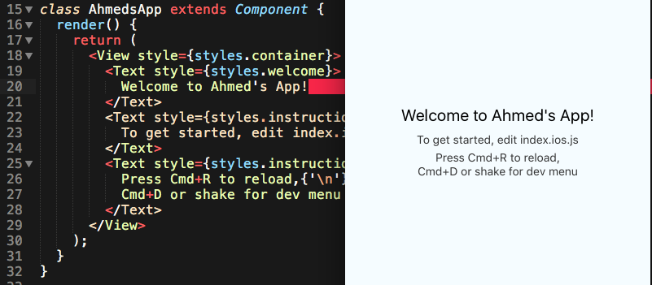

1. When you feel comfortable working with the boilerplate code, check out Facebook’s documentation on React Native’s core components. Think about how you would use these components in your project. (<https://facebook.github.io/react-native/docs/tutorial-core-components.html>).
2. Over the next two days, you’ll be attempting to make an app similar to this. <https://github.com/bonniee/learning-react-native/tree/master/WeatherProject>
3. There’s a caveat: this app was designed with an older JavaScript syntax that React Native no longer supports. For instance, you’ll be using imports instead of requires to bring in React packages. Take a look at the class syntax in the AhmedsApp boilerplate code—this will likely differ from how you used React last week, but it’s the standard for React Native.
4. You and your classmates should work together to create your own individual apps, with some working on front-end code and some on back-end. As a suggestion, look into handling form input, flex boxes, backgrounds, API calls with fetch. In the end, aim to have something functional and creative. Your instructor will provide you with more detailed guidelines.

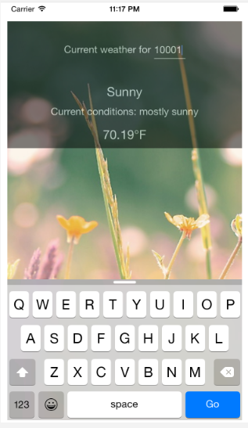

Good luck!