**At Work Industrial Robots**

**Team Description Paper**

|  |  |
| --- | --- |
| League Name: | @Work (industrial robots) |
| Age Group: | Major |
| Team Name: | I.K.I.U |
| Team Website: |  |
| Participants Name: | Farhan Daemi Mojdehi,  Taha Ahmadzadeh  Amir Ali Eskandari |
| Mentor Name: | Dr. Mahmood Roboti |
| Institution: | Imam Khomeini International University |
| Country: | Iran |
| Contact Person: | Farhan Daemi |
| Contact Email: | [fdmxfarhan@yahoo.com](mailto:fdmxfarhan@yahoo.com) |
| Date: |  |

**At Work Industrial Robots**

**Team Description Paper**

Imam Khomeini International University

“Farhan Daemi Mojdehi, Taha Ahmadzadeh, Amir Ali Eskandari”

**Abstract.** In this paper we present and describe I.K.I.U @work team for Robocup 2023, Paris, France. As an industrial robot, it should detect objects which placed on a table and carry them to the right place which is what we, humans, want from robots to do. Making these robots can be divided in particular steps. Mechanic, hardware, software and artificial intelligence. Motion mechanism use four motors and four Mecanum wheels to have omnidirectional movement.

**Introduction**

In last few years, I.K.I.U team Participated in Iran Open and world Robocup competition. I.K.I.U team started working on industrial robots from 2018. Some requirements to reach this target are achieved by redesigning the electrical and mechanical mechanisms. Moreover, simple learning and optimization approaches are employed in the way of more dynamic play. This paper is organized as follows: First of all, the software architecture which includes our approaches in high level strategies, The Electrical design including ARM microcontrollers, and other accessories. [1]

**Mechanical Design**

One of the main parts of our robot was mechanical systems. Motors and Omni wheels designed on the circle that can be motion all the place. We used Solid Works software for designing the main plat form of the robot. [2]

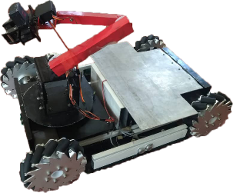 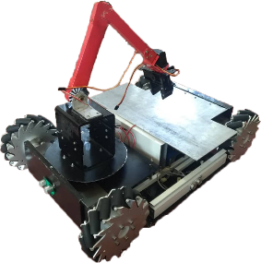

Figure Mechanic Design

The wheels that we used are a kind of Omni wheels. We used that because at have tow moving. It has very good velocity. [3]

We have four “Maxon” motors. “Maxon” is a germane company. We used this motors because it has very good velocity. This is our motors trait:

|  |  |  |  |  |  |  |
| --- | --- | --- | --- | --- | --- | --- |
| Max. efficiency | Starting current | No load current | Nominal speed | No load speed | Nominal voltage | Type |
| 89% | 5.7A | 270 mA | 130 rpm | 150 rpm | 24V | BUHLER |

As you know, the linear velocity is quickly moving on a circle of radius r and rotates at a constant velocity v. The speed at any moment is perpendicular to the direction of motion. Angular velocity is the speed at time t1 and t2 which animates the circle and the angle is θ1 to θ2 period. Angular velocity and linear velocity obtained from the following relationships:

To calculate the actual speed of the engine must respect and apply them to our gearboxes. As you know, the task of slowing down the transmission of torque. The engine and gearbox are increasing. For other movements, as well as the outcome is speed.

*r* = linear velocity

*w* = angular velocity

A round rev=*rev* *v*=*rw*

|  |  |  |
| --- | --- | --- |
| $\overline{ w}$ = $\frac{Δθ}{Δt}$ $\frac{rad or rev}{s}$ |  | |
| 1 rev*= $2π rad$ $→$ $1\frac{rev}{min}=2π \frac{rad}{min}$* |  |

The above equation can be concluded that the average angular velocity is equal to:

Rpm= round per minute

*Nominal Speed*=*655.1 rpm*

|  |  |
| --- | --- |
|  | $$w=\frac{rpm}{60}×2π$$ |

$w=\frac{655.1}{60}×2π$

$π≈3.14$ $w=\frac{655.1}{60}×2π$*=10.9183×2.8*

|  |
| --- |
| $$v=\sqrt{{(2v)}^{2}+ {(2v)}^{2} =}2v\sqrt{2=}2.88m/s$$ |

$v=1.02m/s$*v=10.2850 $\frac{cm}{s}$* *= 68.5667 $\frac{m}{s}$* *r=0.15 cm* *v=0.15×68.5667*=*10.2850*

We couldn’t find mecanum wheels in our country, so we designed it with solid works and then cut it from an aluminum plate.

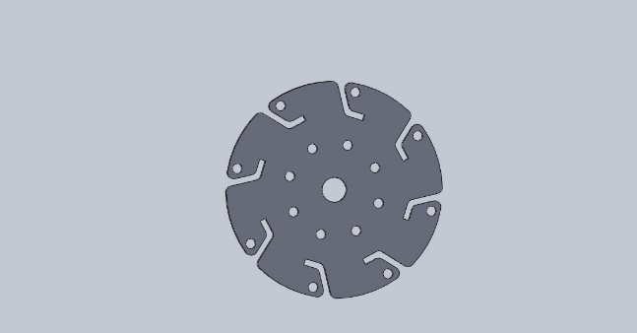

Figure 2 mecanum wheels

**Hardware/ Electrical Design**

We designed a PCB with Altium Designer software and then we printed it and soldered the electronic parts of the robot. The most important part was AVR processor AT mega 64. It has so many options like timers, Analog digital convertor and serial port and other things. For switch the motors we used L6203 drivers. Because it can ferry 4 Ampere electrical current.

**The grain(arm) and griper**

For design and construction, the arm with three degrees of freedom we used three DC motor with worm gearboxes and for the griper we used a servo motor.

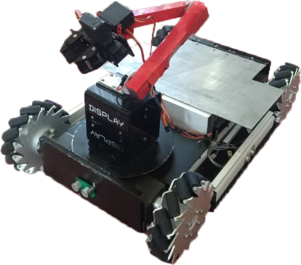

Figure 3 robot's griper and lever

Compass Module can show us deviate from the North Pole / South (magnetic field) as a number from 0 to 255. With some play on this value we made it a number from -128 rights to +128 left and 0 for center. CMPS11 was our compass sensor called a three-axial magnetic sensor, a three-axis gyroscope and a three-axis accelerometer is formed using a Kalman filter, tilt the board will be compensated compass automatically. The I2C module registers with different addresses to which we have access to different information. The compass microcontroller serial I2C the SCL and SDA by two base AT-Mega16 microcontroller is connected to two arbitrary bases. For detecting the distance of the walls and other things we used four SRF-05 ultrasonic sensors. This sensors can detect distance from 1 to 300cm. actually we send a 10 micro second pulse to it and then it send us a pulse and with measure this pulse we can convert it to inch or centimeter.

We used a USB to serial convertor module for communication to the main program in visual studio software. The visual studio program is by C# programing language. All commands come from this program and then the other part do this commands. Our AVR micro controller has two serial ports but we used only one serial port for this communication.

**Image processing/Vision System**

In [imaging science](https://en.wikipedia.org/wiki/Imaging_science), image processing is processing of images using mathematical operations by using any form of [signal processing](https://en.wikipedia.org/wiki/Signal_processing) for which the input is an image, a series of images, or a video, such as a [photograph](https://en.wikipedia.org/wiki/Photograph) or [video frame](https://en.wikipedia.org/wiki/Video_frame); the output of image processing may be either an image or a set of characteristics or  [parameters](https://en.wikipedia.org/wiki/Parameter) related to the image.[[1]](https://en.wikipedia.org/wiki/Image_processing#cite_note-GonzalezWoods2008-1) Most image-processing techniques involve treating the image as a [two-dimensional](https://en.wikipedia.org/wiki/Two-dimensional) [signal](https://en.wikipedia.org/wiki/Signal_(electrical_engineering)) and applying standard signal-processing techniques to it. Images are also processed as [three-dimensional](https://en.wikipedia.org/wiki/Three-dimensional) signals with the third-dimension being time or the z-axis. Image processing usually refers to [digital image processing](https://en.wikipedia.org/wiki/Digital_image_processing), but [optical](https://en.wikipedia.org/wiki/Optical_engineering) and [analog image processing](https://en.wikipedia.org/wiki/Analog_image_processing) also are possible. This article is about general techniques that apply to all of them. The *acquisition* of images (producing the input image in the first place) is referred to as imaging.[[2]](https://en.wikipedia.org/wiki/Image_processing#cite_note-hornak2002-2) Closely related to image processing are [computer graphics](https://en.wikipedia.org/wiki/Computer_graphics) and [computer vision](https://en.wikipedia.org/wiki/Computer_vision). In computer graph-ices, images are manually *made* from physical models of objects, environments, and lighting, instead of being acquired (via imaging devices such as cameras) from *natural* scenes, as in most animated movies. Computer vision, on the other hand, is often considered *high-level* image processing out of which a machine/computer/ software intends to decipher the physical contents of an image or a sequence of images (e.g., videos or 3D full-body magnetic resonance scans). In modern sciences and technologies, images also gain much broader scopes due to the ever growing importance of [scientific visualization](https://en.wikipedia.org/wiki/Scientific_visualization) (of often large-scale complex scientific/experimental data). Examples include [microarray](https://en.wikipedia.org/wiki/Microarray) data in genetic research, or real-time multi-asset portfolio trading in finance.

The most important part of programing in this robot is image processing. To do this we used Open-CV library in C# language. The Open-CV library for C# is Emgu-CV. The commands are the same but the names have some differences. At first the robot should get to the object’s table and then process on images that are getting from the webcam camera. After detect the object and find the place it is, it should catch it with its arm. For doing that it send’s some commands to the AVR microprocessor with serial communication and the micro controller do them. After getting the objects it should carry them to somewhere else. Moving system is with distance detecting. We have some distance sensors around our robot that can detect the walls,

**Navigation**

We used a different camera under our robot that can detect the landmarks. To arriving the landmarks we have a laser scanner that give us a 2D plan of the land and the robot can move to the landmarks with process this plans. Most laser scanners use moveable mirrors to steer the laser beam. The steering of the beam can be *one-dimensional*, as inside a laser printer, or *two-dimensional*, as in a laser show system. Additionally, the mirrors can lead to a *periodic* motion - like the rotating *mirror polygons* in a barcode scanner or so-called *resonant galvanometer* scanners - or to a *freely addressable* motion, as in servo-controlled galvanometer scanners. One also uses the terms [*raster scanning*](https://en.wikipedia.org/wiki/Raster_scan) and *vector scanning* to distinguish the two situations. To control the scanning motion, scanners need a [rotary encoder](https://en.wikipedia.org/wiki/Rotary_encoder) and control electronics that provide, for a desired angle or phase, the suitable electric current to the motor or galvanometer. A software system usually controls the scanning motion and, if 3D scanning is implemented, also the collection of the measured data. In order to position a laser beam in *two dimensions*, it is possible either to rotate one mirror along two axes - used mainly for slow scanning systems - or to reflect the laser beam onto two closely spaced mirrors that are mounted on orthogonal axes. Each of the two flat or polygonal mirrors is then driven by a galvanometer or by an electric motor. Two-dimensional systems are essential for most applications in material processing, confocal microscopy, and medical science.

**References**

[1] P.de Kok,N. Girardi, A. Gudi, C. Kooijman, G. Methenitis, S. Negrijn, N. Steenbergen, D. ten Velthuis, C. Verschoor, A. Wiggers, and A.Visser,“Teamdescription for RoboCup 2013 in Eindhoven, the Netherlands,” Dutch Nao Team, Universiteit van Amsterdam & TU Delft, May 2013.

[2] N. Dijkshoorn, H.Flynn,O.Formsma, S. van Noort, C. van Weelden, C. Bastiaan, N. Out, O. Zwennes, S. S. Ot´arola, J. de Hoog, S. Cameron, and A. Visser, “Amsterdam oxford joint rescue forces - team description paper -virtual robot competition - rescue simulation league - RoboCup 2011,” Universiteit van Amsterdam & Oxford University, July 2011.

[3] C. R. Verschoor, A. J. Wiggers, H. R. Oosterhuis, and A. Visser, “Maneki-neko - team description for iran open uav 2013 - teheran, iran,” Intelligent Robotics Lab, Universiteit van Amsterdam, February 2013.

[4] S. Negrijn, J. Haber, S. van Schaik, and A. Visser, “UvA@Work customer agriculture order - mid-term report,” Intelligent Robotics Lab, Universiteit van Amsterdam, Science Park 904 1098 XH Amsterdam, January 2014.

[5] J. van Enk, “Navigating youbot through a rose ﬁeld with A*,”Project Report,Universiteit van Amsterdam, Science Park 904 1098 XH Amsterdam, August 2013.

[6] S. Koenig and M. Likhachev, “D* lite.” in AAAI/IAAI, 2002, pp. 476–483

[7] L. Dorst, I. Mandhyan, and K. Trovato, “The geometrical representation of path planningproblems,”Roboticsand utonomous Systems, vol. 7, no. 2, pp. 181–195, 1991.

[8] M. Phillips, A. Dornbush, S. Chitta, and M. Likhachev, “Anytime incremental planning with e-graphs,” in Robotics and Automation (ICRA), 2013 IEEE International Conference on. IEEE, 2013, pp. 2444–2451.

[9] E. Corten and E. Rondema, “Team des-cription of the windmill wanderers,” in Proceedings on the second RoboCup Workshop, 1998, pp. 347–352.

[10] P. Jonker, B. van Driel, J. Kuznetsov, and B. Terwijn, “Algorithmic foundation of the clockwork orange robot soccer team,” in Algorithmic Foundations of Robotics VI. Springer, 2005, pp. 17–26.

[11] A. Visser, J. Sturm, P. van Rossum, J. Westra, and T. Bink, “Dutchaiboteam: Technicalreportrobocup2006,”December 2006.

[12] V. Spirin, S. Sofﬁa Ot´arola, and A. Visser, “Amsterdam oxford joint rescue forces - team description paper - virtual robot competition - rescue simulation league - robocup 2014, jo˜ao pessoa - brazil,” 2014.