**RRL Team Description Paper**

Imam Khomeini International University

Qazvin – Iran

Farhan Daemi, Sana Poorfarahmand, Mahan Fatahi, Hossein Babaei Pour, Heyla Alinezhad, Amir Hossein Sayari, Amirali Eskandari, Armin Moghadasi, Mostafa Lashkari, Sara Ahmadi, Mehran Kushesh

**Self-Driving Car League**

[fdmxfarhan@yahoo.com](mailto:fdmxfarhan@yahoo.com)

<http://ikiurobotic.ir>

**Abstract.** This paper details our autonomous miniature self-driving car designed for the Iran Open 2024 competition, featuring a cohesive integration of cutting-edge software, hardware, and mechanics. The software component leverages YOLO8 for AI-driven object detection and image processing, facilitating real-time decision-making. The hardware architecture combines carefully selected components and electrical devices, fostering seamless interaction between sensors, processors, and actuators. Meanwhile, the mechanical design incorporates an Ackermann steering mechanism and wheel differential, optimizing the robot's maneuverability. This comprehensive approach aims to showcase the synergy between software, hardware, and mechanics, underscoring our commitment to achieving superior performance in the upcoming competition.

**Introduction**

**I**n the rapidly evolving landscape of robotics, our university's dedicated team has emerged as a beacon of innovation and ingenuity. Established in 2023, our journey began with a shared passion for pushing the boundaries of technological advancement. Now, as we stand on the precipice of a new chapter, we proudly announce our inaugural participation in the prestigious Self-Driving Car League. This momentous occasion not only marks a significant milestone in our team's history but also underscores our unwavering commitment to excellence and pioneering spirit.

**Mechanical Design**

In our pursuit of engineering excellence, our robot's mechanical design is a testament to innovation and precision, meticulously crafted using state-of-the-art tools such as SolidWorks. This powerful software enables us to bring our ideas to life with unparalleled accuracy and efficiency, facilitating seamless integration between design, analysis, and manufacturing.

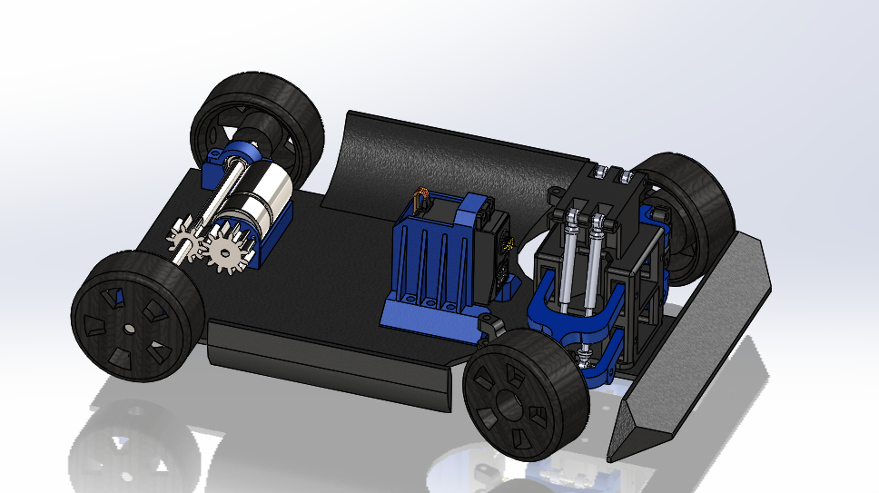

Figure 1 SolidWorks 3D Design

Harnessing the versatility of SolidWorks, we've engineered every component of our robot with meticulous attention to detail, ensuring optimal performance and reliability on the track. From the sleek contours of the chassis to the intricate mechanisms of the steering and propulsion systems, each part has been carefully modeled and simulated to meet the demanding requirements of the Self-Driving Car League.

Our steering system is a prime example of the ingenuity and sophistication that defines our mechanical design. Inspired by the principles of Ackerman steering geometry, we've leveraged SolidWorks to fine-tune our system for precision control and maneuverability, enabling our robot to navigate complex courses with ease and agility.

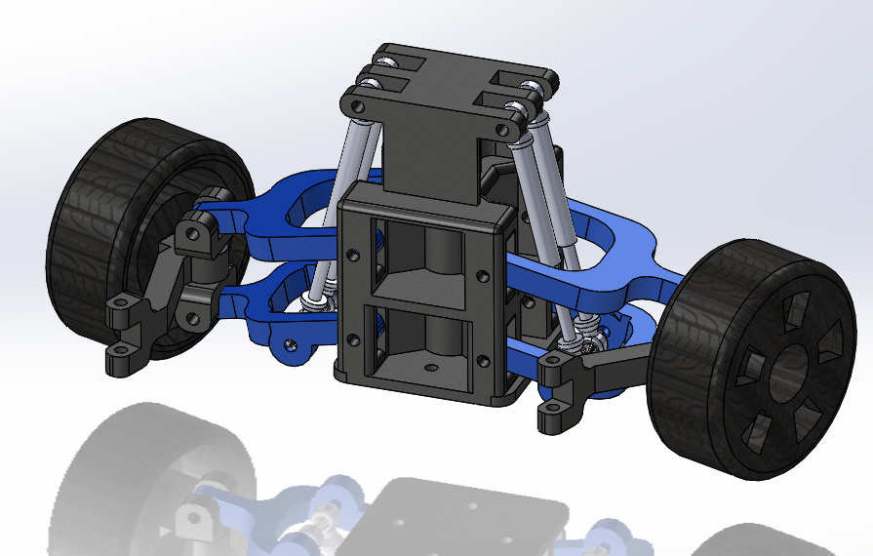

Figure 2 Ackerman Steering Mechanism

Furthermore, our mechanical design incorporates a back wheel differential, inspired by the world of automotive engineering. Through rigorous analysis and simulation in SolidWorks, we've optimized our differential mechanism to deliver superior traction and stability, allowing our robot to corner with confidence and precision.

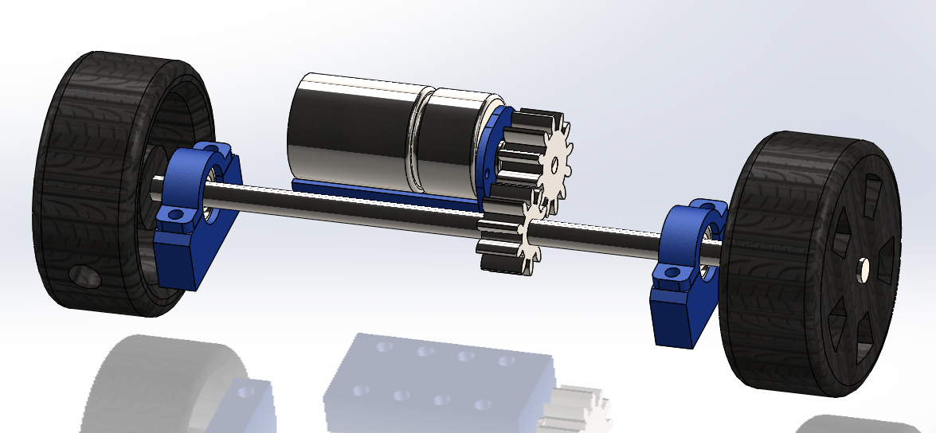

Figure 3 Back Wheel Gears

Complementing our design prowess is the utilization of additive manufacturing techniques, including 3D printing, which enables us to produce lightweight yet robust components with intricate geometries. This approach not only accelerates prototyping and customization but also ensures that our robot is equipped to handle the rigors of competition.

To calculate the actual speed of the engine must respect and apply them to our gearboxes. As you know, the task of slowing down the transmission of torque. The engine and gearbox are increasing. For other movements, as well as the outcome is speed.

|  |  |  |
| --- | --- | --- |
| = |  | |
| 1 rev*=* |  |

The above equation can be concluded that the average angular velocity is equal to:

*Rpm= round per minute*

*Nominal Speed*=*655.1 rpm*

*=10.9183×2.8*

|  |
| --- |
|  |

*v=10.2850* *= 68.5667* *r=0.15 cm* *v=0.15×68.5667*=*10.2850*

**Hardware/ Electrical Design**

In our pursuit of a comprehensive and efficient electrical system, we turned to Altium Designer as our trusted ally for PCB design. With meticulous attention to detail, we carefully selected each electrical component based on its specific functionality and compatibility with our robot's requirements. At the core of our electrical architecture lies the STM32F103C8T6 microcontroller, chosen for its robust performance and versatile capabilities. Complementing this, the L298 motor driver ensures precise control and reliable operation of our propulsion system. Additionally, our design includes USART outputs tailored for seamless communication with external devices, enabling real-time data exchange and coordination within our robotic ecosystem.

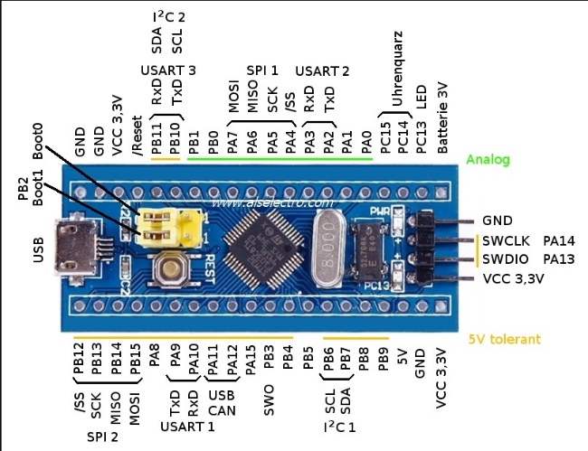

Figure 4 STM32F103C8T6 Blue Pill

Through the integration of Altium Designer and strategic component selection, we've engineered an electrical system that not only meets the demands of the Self-Driving Car League but also sets the stage for innovation and collaboration in the realm of autonomous robotics.

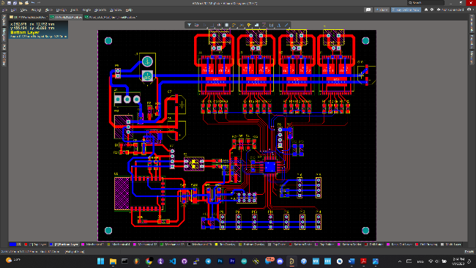

Figure 5 Hardware Design with Altium Designer

For measuring and detecting things around the robot we must sue some sensors and these sensors have to connect to a micro controller so that we can receive data from any of them. Talking about sensors, we couldn’t get expensive sensors such as laser scanner so we used cheaper distance sensors to measuring distance.

**Image processing/Vision System**

In our pursuit of autonomous navigation excellence, we've implemented a cutting-edge image processing and vision system that leverages the power of YOLOv8 for real-time sign recognition. By harnessing the capabilities of YOLOv8, our robot can accurately detect and classify various street signs, ensuring safe and efficient navigation through dynamic urban environments. Moreover, our vision system extends beyond sign recognition to include the detection of street white lines and dash lines. By analyzing these visual cues, our robot can precisely determine its position and orientation on the road, enabling it to navigate along designated lanes with unparalleled accuracy. Through the fusion of advanced image processing algorithms and state-of-the-art vision technologies, we've equipped our robot with the intelligence and autonomy to navigate complex roadways with confidence and precision.

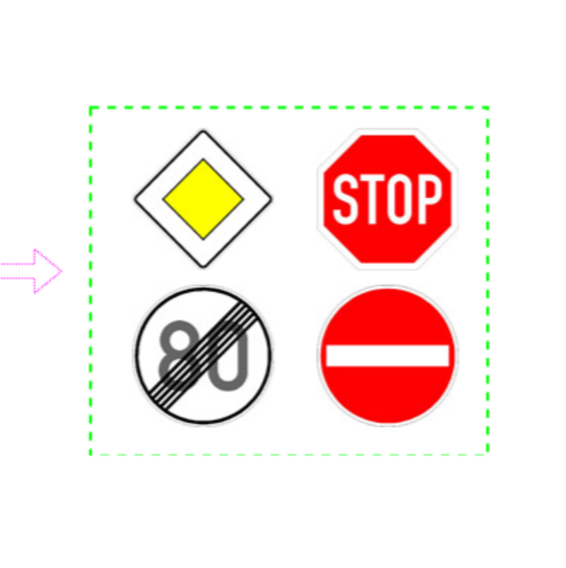

Figure 6 Sample traffic signs

**Navigation**

Navigating the intricate web of urban streets presents a formidable challenge, one that our team tackles with a precision-crafted navigation algorithm centered solely on camera image processing. Our robot relies exclusively on real-time visual data to traverse the streets, with a focus on maintaining course within the confines of street white lines while avoiding any infractions.

Our navigation algorithm is a testament to the power of simplicity and efficiency. By analyzing the camera feed in real-time, our system identifies and tracks the white lines marking the lanes, ensuring our robot stays on course at all times. Through a combination of image recognition and motion planning, our algorithm orchestrates smooth and faultless navigation, prioritizing adherence to the designated path without deviation.

This streamlined approach eliminates the need for complex sensor fusion techniques and costly localization systems, streamlining our robot's operation while maintaining robust performance. By leveraging the capabilities of camera image processing, we demonstrate that precision navigation can be achieved with elegance and efficiency, setting a new standard for autonomous vehicles in urban environments.

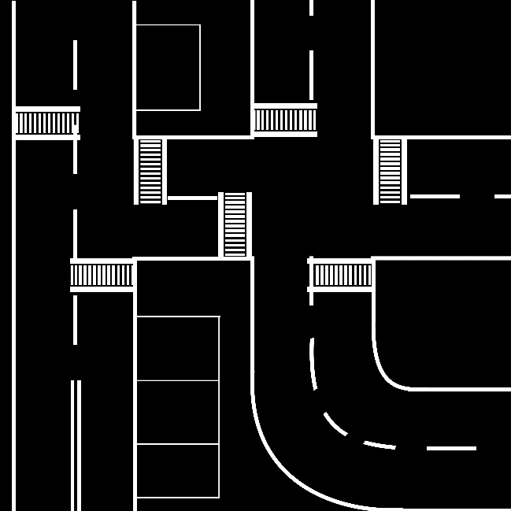

Figure 7 Sample Map

**Conclusion**

In conclusion, our university's robotic team has meticulously engineered a sophisticated navigation system that showcases the pinnacle of technological innovation. Through the seamless integration of advanced algorithms, sensor fusion techniques, and state-of-the-art image processing technologies, our robot demonstrates unparalleled proficiency in autonomous navigation on urban streets. With a commitment to excellence and a collaborative spirit, we are poised to make a significant impact in the field of robotics, driving forward the advancement of autonomous vehicles and paving the way for a safer, more efficient future in transportation.

**References**

[1] P.de Kok,N. Girardi, A. Gudi, C. Kooijman, G. Methenitis, S. Negrijn, N. Steenbergen, D. ten Velthuis, C. Verschoor, A. Wiggers, and A.Visser,“Teamdescription for RoboCup 2013 in Eindhoven, the Netherlands,” Dutch Nao Team, Universiteit van Amsterdam & TU Delft, May 2013.

[2] N. Dijkshoorn, H.Flynn,O.Formsma, S. van Noort, C. van Weelden, C. Bastiaan, N. Out, O. Zwennes, S. S. Ot´arola, J. de Hoog, S. Cameron, and A. Visser, “Amsterdam oxford joint rescue forces - team description paper -virtual robot competition - rescue simulation league - RoboCup 2011,” Universiteit van Amsterdam & Oxford University, July 2011.

[3] C. R. Verschoor, A. J. Wiggers, H. R. Oosterhuis, and A. Visser, “Maneki-neko - team description for iran open uav 2013 - teheran, iran,” Intelligent Robotics Lab, Universiteit van Amsterdam, February 2013.

[4] S. Negrijn, J. Haber, S. van Schaik, and A. Visser, “UvA@Work customer agriculture order - mid-term report,” Intelligent Robotics Lab, Universiteit van Amsterdam, Science Park 904 1098 XH Amsterdam, January 2014.

[5] J. van Enk, “Navigating youbot through a rose ﬁeld with A*,”Project Report,Universiteit van Amsterdam, Science Park 904 1098 XH Amsterdam, August 2013.

[6] S. Koenig and M. Likhachev, “D* lite.” in AAAI/IAAI, 2002, pp. 476–483

[7] L. Dorst, I. Mandhyan, and K. Trovato, “The geometrical representation of path planningproblems,”Roboticsand utonomous Systems, vol. 7, no. 2, pp. 181–195, 1991.

[8] M. Phillips, A. Dornbush, S. Chitta, and M. Likhachev, “Anytime incremental planning with e-graphs,” in Robotics and Automation (ICRA), 2013 IEEE International Conference on. IEEE, 2013, pp. 2444–2451.

[9] E. Corten and E. Rondema, “Team des-cription of the windmill wanderers,” in Proceedings on the second RoboCup Workshop, 1998, pp. 347–352.

[10] P. Jonker, B. van Driel, J. Kuznetsov, and B. Terwijn, “Algorithmic foundation of the clockwork orange robot soccer team,” in Algorithmic Foundations of Robotics VI. Springer, 2005, pp. 17–26.

[11] A. Visser, J. Sturm, P. van Rossum, J. Westra, and T. Bink, “Dutchaiboteam: Technicalreportrobocup2006,”December 2006.

[12] V. Spirin, S. Sofﬁa Ot´arola, and A. Visser, “Amsterdam oxford joint rescue forces - team description paper - virtual robot competition - rescue simulation league - robocup 2014, jo˜ao pessoa - brazil,” 2014.