**RRL Team Description Paper**

Imam Khomeini International University

Qazvin – Iran

Farhan Daemi, Mahdi Aghaie, Arash javaheri daryan, Amirhossin Damavandi, Mahtab Taghipour

**Flying Robots League**

[fdmxfarhan@yahoo.com](mailto:fdmxfarhan@yahoo.com)

<http://ikiurobotic.ir>

**Abstract.** In the realm of robotics, the University Robotic Team stands as a beacon of innovation and ingenuity. Our current mission? To pioneer the development of a flying robot capable of navigating a known workspace with precision and agility. This ambitious endeavor brings together a diverse team of passionate individuals, each contributing their expertise in mechanics, hardware, and software to push the boundaries of technological possibility.

**Introduction**

In the dawn of 2023, a collective vision ignited within the halls of our university — a vision of crafting innovation that transcends boundaries and defies gravity. Thus, the University Robotic Team was born, with a singular mission: to construct a flying robot capable of maneuvering within a known workspace. As we stand on the cusp of a new era, poised to participate in our inaugural competition, our team's composition of seasoned professionals in software, hardware, and mechanics heralds a journey marked by expertise, determination, and the relentless pursuit of excellence. In this introductory section, we invite you to embark with us on our maiden voyage, as we navigate the complexities of robotics and soar towards uncharted skies.

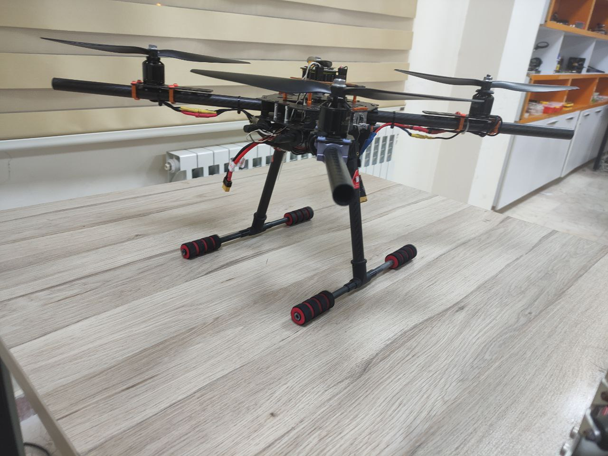

Figure 1 Flying Robot Made by Team Members

**Mechanical Design**

In the realm of mechanical design, precision and innovation converge to sculpt the physical embodiment of our flying robot. Under the meticulous guidance of our professional mechanical engineers, every component is meticulously crafted and refined using industry-leading software such as SolidWorks. This digital playground serves as our canvas, where ideas take shape and concepts materialize into tangible realities.

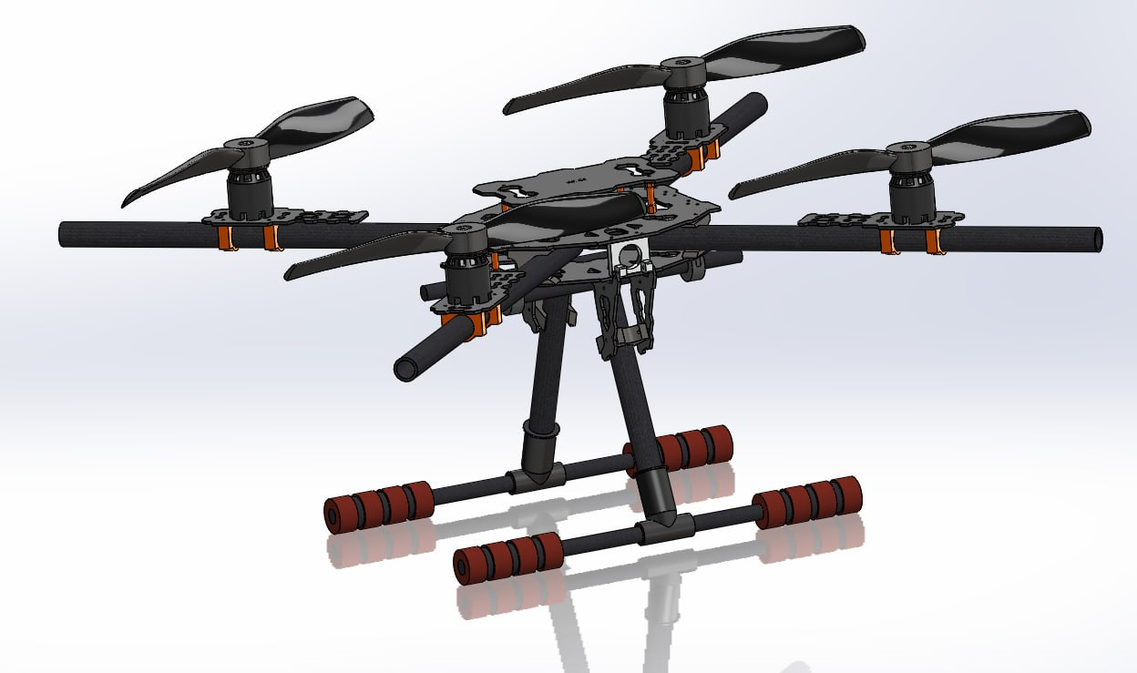

Figure 2 Designed Robot in SolidWorks Software

Central to our mechanical architecture is the ingenious design of the main plate. Serving as the backbone of our flying robot, this masterfully engineered component serves as the nexus, holding together all other parts with steadfast resilience. Through strategic placement and meticulous engineering, every element finds its place upon this foundational cornerstone, ensuring structural integrity and optimal functionality.

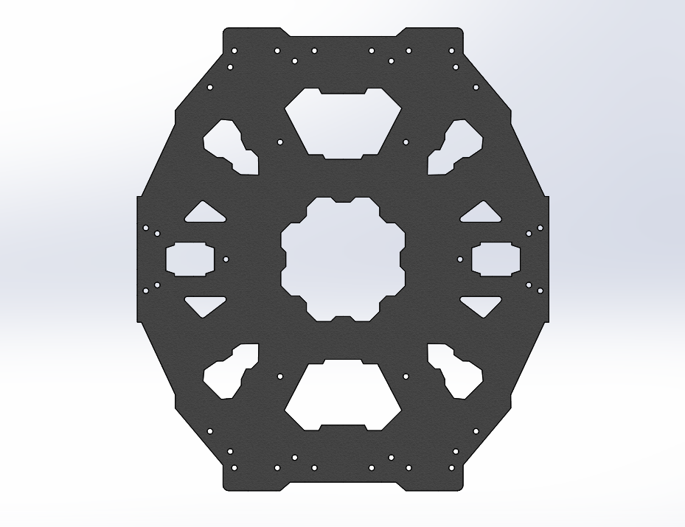

Figure 3 Main Plate Design

Beyond the main plate, our mechanical prowess extends to the creation of a purpose-built stand, meticulously crafted to cradle our flying robot during assembly and testing. This essential fixture provides stability and support, allowing us to fine-tune our creation with precision and confidence, as we prepare for its maiden flight.

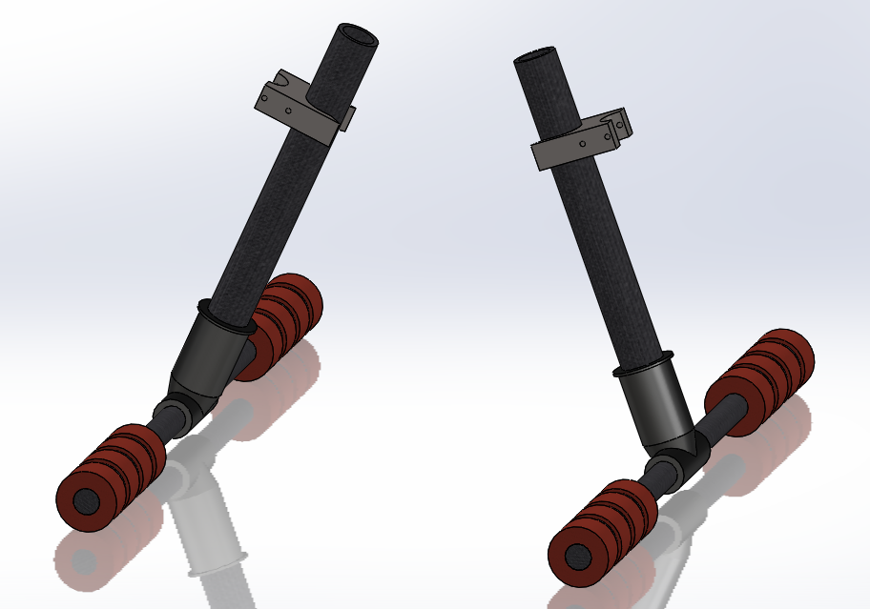

Figure 4 Robot Fixture Stand

At the heart of our propulsion system lies the symbiotic marriage of brushless motors and 8-inch blades. Selected for their unparalleled efficiency and power-to-weight ratio, these meticulously chosen components imbue our flying robot with the thrust and agility needed to navigate its designated workspace with grace and precision. Strategically positioned upon each of the four arms, these motors and blades form the beating heart of our creation, propelling it towards new heights with unwavering determination and poise.

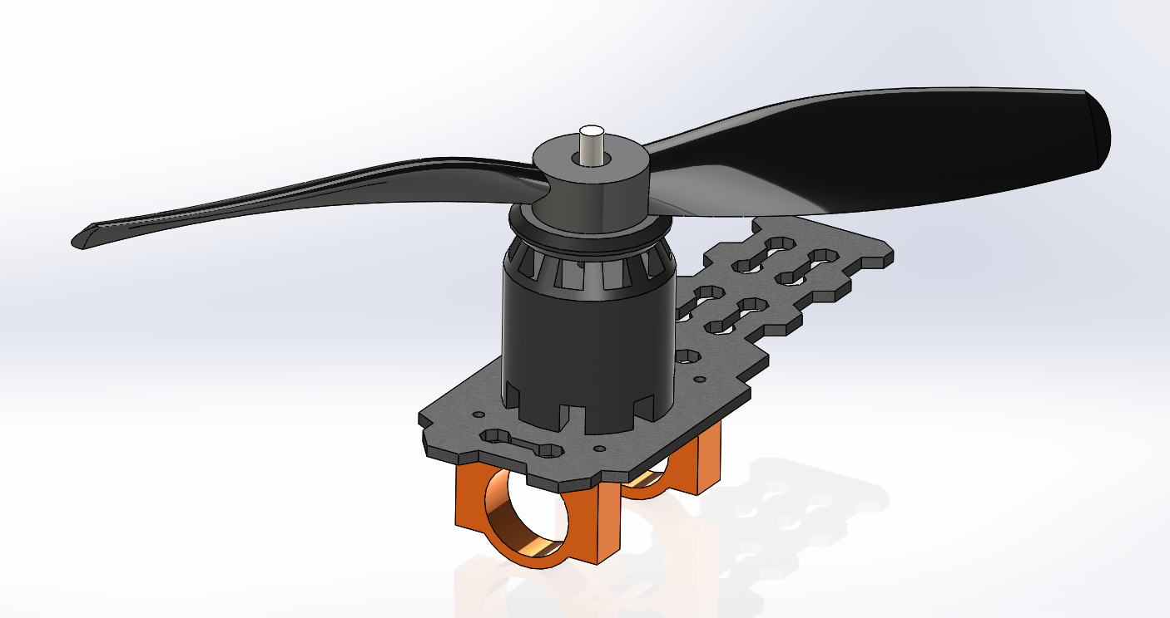

Figure 5 Brushless Motor and Blade

**Hardware / Electrical Design**

In the realm of hardware design, the University Robotic Team leverages cutting-edge technologies to create a robust and intelligent control system that forms the neural network of our flying robot. At the heart of this intricate network lies the STM32F103C8T6 Blue Pill microcontroller, meticulously selected as the central processing unit to orchestrate the symphony of motion and intelligence. As the main processor of our system, the STM32F103C8T6 Blue Pill is imbued with the capability to execute complex algorithms and commands with precision and efficiency. Programmed to regulate and synchronize the speed of each motor, this formidable microcontroller serves as the conductor of our robotic orchestra, choreographing every movement within the three-dimensional expanse of our workspace. Furthermore, the STM32F103C8T6 Blue Pill serves as the hub for sensory input, seamlessly integrating data from an array of sensors to provide real-time feedback on ambient conditions and spatial orientation. From gyroscopes and accelerometers to altimeters and GPS modules, these sensors serve as the eyes and ears of our flying robot, allowing it to perceive and adapt to its environment with acute precision and responsiveness. In this way, the hardware design of our flying robot epitomizes the seamless integration of cutting-edge technology and meticulous engineering, culminating in a control system that empowers our creation to navigate and explore the boundless realms of three-dimensional space.

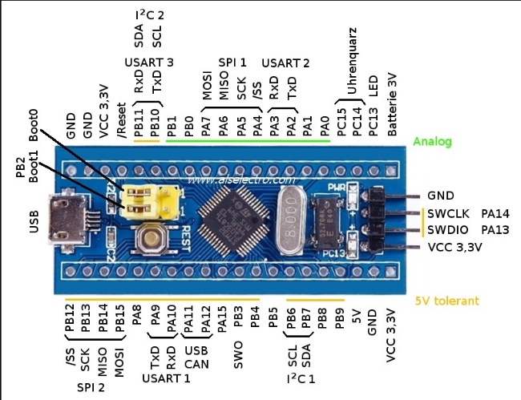

Figure 6 STM32F103C8T6 Blue Pill

In our quest for dynamic stability and precise control in three-dimensional space, the integration of the GY-25 sensor emerges as a pivotal component within our hardware architecture. Specialized in gyroscope and accelerometer functionalities, the GY-25 sensor serves as a vital tool in maintaining equilibrium and enhancing maneuverability. Utilizing the data gleaned from the GY-25 sensor, our control system implements sophisticated algorithms to continuously monitor the orientation and angular velocity of our flying robot. By harnessing this invaluable feedback, we can dynamically adjust motor speeds and control surfaces to counteract disturbances and maintain optimal stability throughout the flight. Through meticulous calibration and tuning, we have leveraged the capabilities of the GY-25 sensor to imbue our flying robot with an inherent sense of balance and agility, enabling it to gracefully navigate the complexities of three-dimensional space with unparalleled precision and poise. In this way, the integration of the GY-25 sensor represents a cornerstone of our hardware design, elevating the performance and versatility of our robotic platform to new heights.

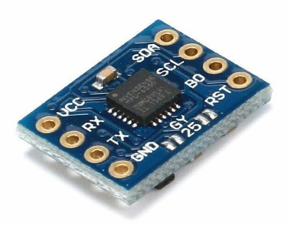

Figure 7 Hardware Design with Altium Designer

In our pursuit of safety and autonomy, we have integrated ultrasonic sensors into our hardware arsenal, specifically employing the SRF05 sensor to provide our flying robot with advanced obstacle detection capabilities. These sensors emit ultrasonic pulses and measure the time it takes for the signals to bounce back, enabling precise distance measurements to be obtained from surrounding objects. By continuously scanning the environment in all directions, our robot can anticipate potential collisions and autonomously adjust its trajectory to avoid obstacles, ensuring smooth and obstacle-free navigation through its designated workspace. The integration of SRF05 ultrasonic sensors represents a pivotal advancement in our hardware design, enhancing the safety, efficiency, and overall autonomy of our flying robot.

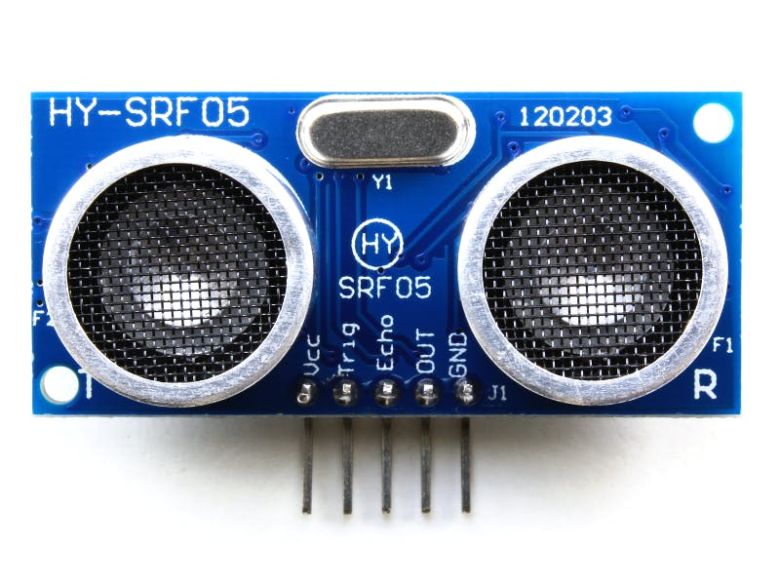

Figure 8 Hardware Design with Altium Designer

To empower our flying robot with agile and responsive propulsion, we have implemented 30-ampere speed controllers tailored specifically to drive our brushless motors and regulate their speeds with precision. These speed controllers serve as the vital link between our microcontroller and the propulsion system, translating commands into dynamic adjustments in motor speed. Engineered to handle the demands of our high-performance motors, these controllers ensure smooth and efficient operation, allowing us to finely control each motor's speed and thrust output. With this advanced control mechanism in place, our flying robot is equipped to navigate its designated workspace with unparalleled agility and responsiveness, setting the stage for seamless maneuverability and optimal performance.

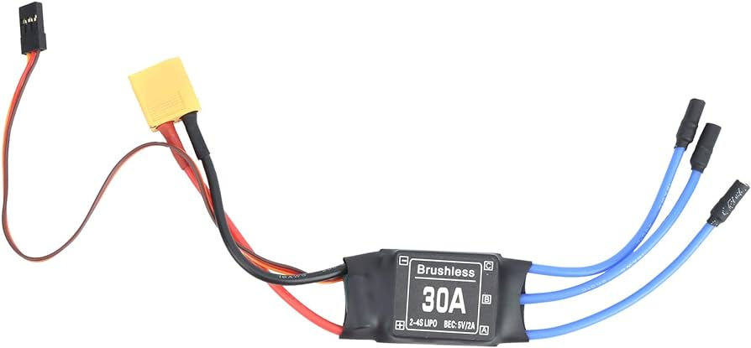

Figure 9 Speed Controller

To streamline our electronic architecture and ensure optimal performance, our team of professional electrical engineers has meticulously designed a printed circuit board (PCB) using Altium Designer software. This PCB serves as the nerve center of our robotic system, housing and interconnecting all electronic components with precision and efficiency. Through meticulous layout and routing, our electrical engineers have optimized signal integrity and minimized interference, ensuring seamless communication and reliable operation throughout our flying robot. From microcontrollers to motor controllers, every electronic part finds its designated place on the PCB, forming a cohesive and robust electrical infrastructure that underpins the functionality and performance of our innovative creation.

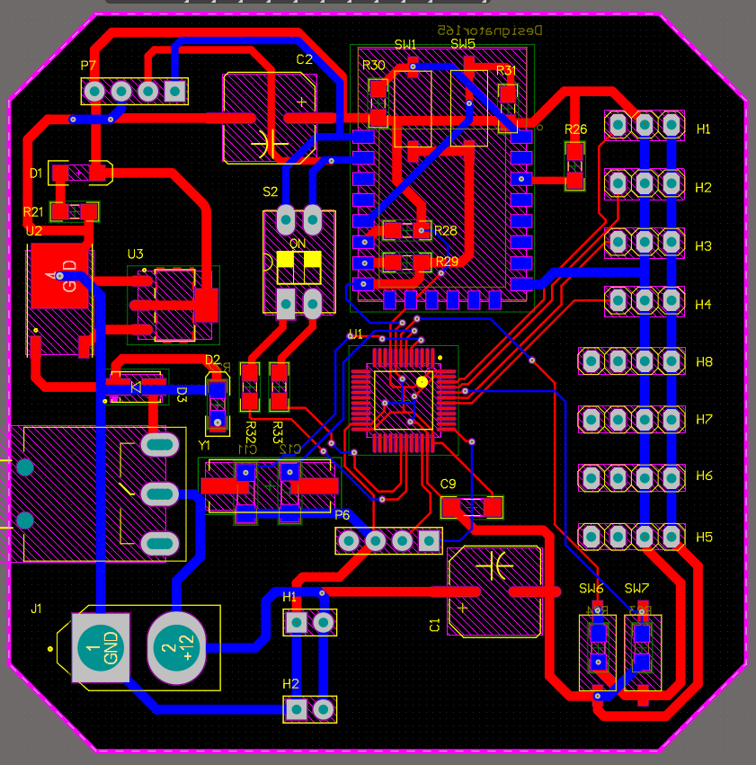 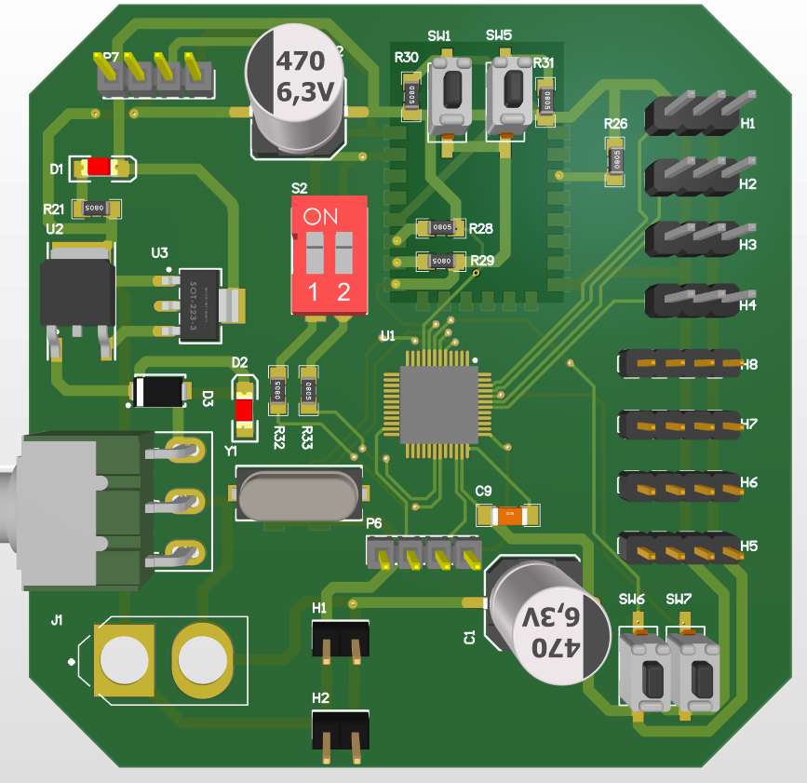

Figure 10 Hardware Design with Altium Designer

**Image processing/Vision System**

At the forefront of our quest for enhanced perception and autonomy, we harness the computational prowess of a Raspberry Pi version 3 to drive our image processing endeavors, coupled with a standard camera as our visual input source. With this dynamic duo at our disposal, our vision system embarks on a multifaceted mission: to detect both the landing position and potential obstacles within our robot's path. Through a carefully crafted pipeline of image processing algorithms, we analyze incoming visual data in real-time, extracting valuable insights to inform our robot's decision-making processes.

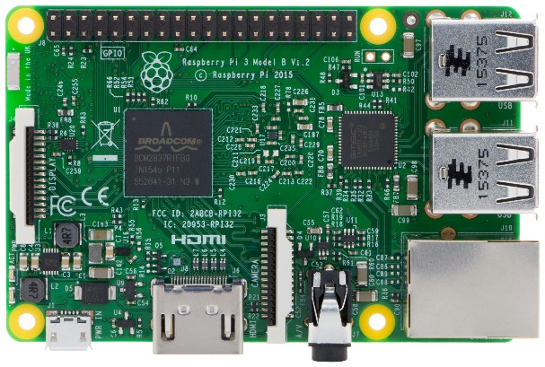

Figure 11 Hardware Design with Altium Designer

The primary objective of our image processing task lies in identifying the optimal landing position within our workspace, a critical requirement for successful mission completion. By leveraging techniques such as edge detection, feature extraction, and template matching, we pinpoint suitable landing zones with pinpoint accuracy, ensuring safe and precise touchdown maneuvers. In addition to landing site detection, our vision system serves as a vigilant sentinel, scanning the surrounding environment for potential obstacles that may impede our robot's progress. Through a combination of object detection algorithms and depth estimation techniques, we identify and classify obstacles in our path, enabling our robot to navigate around them with ease and confidence. In essence, our image processing and vision system represent the eyes and brains of our flying robot, imbuing it with the situational awareness and intelligence needed to navigate its environment with grace and precision. Through relentless innovation and meticulous algorithmic design, we strive to push the boundaries of what is possible, ushering in a new era of autonomous aerial exploration.

**Conclusion**

In conclusion, our university's robotic team has meticulously engineered a sophisticated navigation system that showcases the pinnacle of technological innovation. Through the seamless integration of advanced algorithms, sensor fusion techniques, and state-of-the-art image processing technologies, our robot demonstrates unparalleled proficiency in autonomous navigation on urban streets. With a commitment to excellence and a collaborative spirit, we are poised to make a significant impact in the field of robotics, driving forward the advancement of autonomous vehicles and paving the way for a safer, more efficient future in transportation.

**References**

[1] P.de Kok,N. Girardi, A. Gudi, C. Kooijman, G. Methenitis, S. Negrijn, N. Steenbergen, D. ten Velthuis, C. Verschoor, A. Wiggers, and A.Visser,“Teamdescription for RoboCup 2013 in Eindhoven, the Netherlands,” Dutch Nao Team, Universiteit van Amsterdam & TU Delft, May 2013.

[2] N. Dijkshoorn, H.Flynn,O.Formsma, S. van Noort, C. van Weelden, C. Bastiaan, N. Out, O. Zwennes, S. S. Ot´arola, J. de Hoog, S. Cameron, and A. Visser, “Amsterdam oxford joint rescue forces - team description paper -virtual robot competition - rescue simulation league - RoboCup 2011,” Universiteit van Amsterdam & Oxford University, July 2011.

[3] C. R. Verschoor, A. J. Wiggers, H. R. Oosterhuis, and A. Visser, “Maneki-neko - team description for iran open uav 2013 - teheran, iran,” Intelligent Robotics Lab, Universiteit van Amsterdam, February 2013.

[4] S. Negrijn, J. Haber, S. van Schaik, and A. Visser, “UvA@Work customer agriculture order - mid-term report,” Intelligent Robotics Lab, Universiteit van Amsterdam, Science Park 904 1098 XH Amsterdam, January 2014.

[5] J. van Enk, “Navigating youbot through a rose ﬁeld with A*,”Project Report,Universiteit van Amsterdam, Science Park 904 1098 XH Amsterdam, August 2013.

[6] S. Koenig and M. Likhachev, “D* lite.” in AAAI/IAAI, 2002, pp. 476–483

[7] L. Dorst, I. Mandhyan, and K. Trovato, “The geometrical representation of path planningproblems,”Roboticsand utonomous Systems, vol. 7, no. 2, pp. 181–195, 1991.

[8] M. Phillips, A. Dornbush, S. Chitta, and M. Likhachev, “Anytime incremental planning with e-graphs,” in Robotics and Automation (ICRA), 2013 IEEE International Conference on. IEEE, 2013, pp. 2444–2451.

[9] E. Corten and E. Rondema, “Team des-cription of the windmill wanderers,” in Proceedings on the second RoboCup Workshop, 1998, pp. 347–352.

[10] P. Jonker, B. van Driel, J. Kuznetsov, and B. Terwijn, “Algorithmic foundation of the clockwork orange robot soccer team,” in Algorithmic Foundations of Robotics VI. Springer, 2005, pp. 17–26.

[11] A. Visser, J. Sturm, P. van Rossum, J. Westra, and T. Bink, “Dutchaiboteam: Technicalreportrobocup2006,”December 2006.

[12] V. Spirin, S. Sofﬁa Ot´arola, and A. Visser, “Amsterdam oxford joint rescue forces - team description paper - virtual robot competition - rescue simulation league - robocup 2014, jo˜ao pessoa - brazil,” 2014.