Project 1 – DNS and Basic Tools

Project Overview
- This project is a group project.
- Each group can have three to four students.
- In this project, you will need to learn DNS by yourself.
- In this project, you will need to use two software: Wireshark and OBS (see details below).
- Each group shall submit a project report in ecourse. Only one submission is required.
- Each group shall prepare an in-class demonstration.

Required Steps
- Learn DNS and find answers for the following questions:
  - What is the full term of DNS?
    - Domain Name System
  - Which organization or organizations specify the standards for DNS?
    - Internet Engineering Task Force (IETF)
  - What are the main standards for DNS
    - Standards
    - The Domain Name System is defined by Request for Comments (RFC) documents published by the Internet Engineering Task Force (Internet standards). The following is a list of RFCs that define the DNS protocol.

    - RFC 1034, Domain Names - Concepts and Facilities
    - RFC 1035, Domain Names - Implementation and Specification
    - RFC 1123, Requirements for Internet Hosts—Application and Support
    - RFC 1995, Incremental Zone Transfer in DNS
    - RFC 1996, A Mechanism for Prompt Notification of Zone Changes (DNS NOTIFY)
    - RFC 2136, Dynamic Updates in the domain name system (DNS UPDATE)
    - RFC 2181, Clarifications to the DNS Specification
    - RFC 2308, Negative Caching of DNS Queries (DNS NCACHE)
    - RFC 2672, Non-Terminal DNS Name Redirection
    - RFC 2845, Secret Key Transaction Authentication for DNS (TSIG)
    - RFC 3225, Indicating Resolver Support of DNSSEC
    - RFC 3226, DNSSEC and IPv6 A6 aware server/resolver message size requirements
    - RFC 3596, DNS Extensions to Support IP Version 6
    - RFC 3597, Handling of Unknown DNS Resource Record (RR) Types
    - RFC 4343, Domain Name System (DNS) Case Insensitivity Clarification
    - RFC 4592, The Role of Wildcards in the Domain Name System
    - RFC 4635, HMAC SHA TSIG Algorithm Identifiers
    - RFC 5001, DNS Name Server Identifier (NSID) Option
    - RFC 5011, Automated Updates of DNS Security (DNSSEC) Trust Anchors
    - RFC 5452, Measures for Making DNS More Resilient against Forged Answers
    - RFC 5890, Internationalized Domain Names for Applications (IDNA):Definitions and Document Framework
    - RFC 5891, Internationalized Domain Names in Applications (IDNA): Protocol
    - RFC 5892, The Unicode Code Points and Internationalized Domain Names for Applications (IDNA)
    - RFC 5893, Right-to-Left Scripts for Internationalized Domain Names for Applications (IDNA)
    - RFC 6891, Extension Mechanisms for DNS (EDNS0)
    - RFC 7766, DNS Transport over TCP - Implementation Requirements
    - Proposed security standards
    - RFC 4033, DNS Security Introduction and Requirements
    - RFC 4034, Resource Records for the DNS Security Extensions
    - RFC 4035, Protocol Modifications for the DNS Security Extensions
    - RFC 4509, Use of SHA-256 in DNSSEC Delegation Signer (DS) Resource Records
    - RFC 4470, Minimally Covering NSEC Records and DNSSEC On-line Signing
    - RFC 5155, DNS Security (DNSSEC) Hashed Authenticated Denial of Existence
    - RFC 5702, Use of SHA-2 Algorithms with RSA in DNSKEY and RRSIG Resource Records for DNSSEC
    - RFC 5910, Domain Name System (DNS) Security Extensions Mapping for the Extensible Provisioning Protocol (EPP)
    - RFC 5933, Use of GOST Signature Algorithms in DNSKEY and RRSIG Resource Records for DNSSEC
    - RFC 7830, The EDNS(0) Padding Option
    - RFC 7858, Specification for DNS over Transport Layer Security (TLS)
    - RFC 8310, Usage Profiles for DNS over TLS and DNS over DTLS
    - RFC 8484, DNS Queries over HTTPS (DoH)

  - What is the computing model for DNS service?
    - a hierarchical and decentralized naming system for computers,
  - What is the basic procedure of DNS?
    - Iterative query procedure
  - What is the scale of the network for DNS servers?
    - WAN ??? idk lol
  - What is the structure of the network for DNS servers?
    - Consists of a tree data structure
  - In a DNS response, it is possible to have multiple answers. What are the reasons for multiple answers? Yes, one typical example is if you have multiple webservers, each with a different IP address, that should serve traffic for a given domain
- Analyze the layers for the basic DNS service based on the five-layer model introduced in class, and find answers for the following questions:
  - What are the protocols in each layer?
Layer Number | Layer Name | Protocol
5 | Application Layer | HTTP ,SMTP, etc.
4 | Transport Layer | TCP, UDP
3 | Network Layer | IP
2 | Data Link Layer | Ethernet, Wifi
1 | Physical Layer | 10 Base T, 802.11

  - What are the IDs in each layer?

Layer ID | Layer Name
5 | Application Layer
4 | Transport Layer
3 | Network Layer
2 | Data Link Layer
1 | Physical Layer

- Wireshark exercise
  - Download the latest version from site: https://www.wireshark.org/
  - Install Wireshark in your PC
  - Start capturing packets using Wireshark
  - In a browser, visit a website (any website you want)
  - Stop capturing packets
  - Use filter to quickly find two DNS packets:
    - Query for the website from your PC
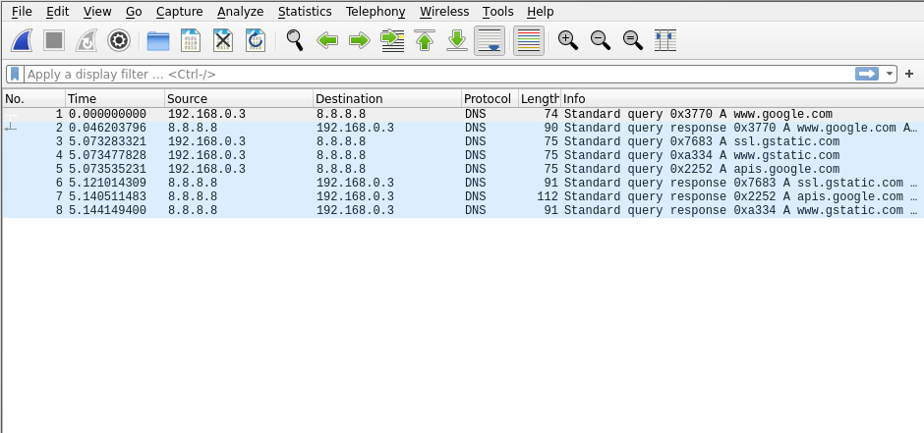
    - Answer from a DNS server

- OBS exercise
  - Download the latest version from site: https://obsproject.com/
  - Install OBS in your PC
  - Use OBS to record screen and your explanation for all steps in the Wireshark exercise
  - Upload a video to YouTube using your upr account
    - Set its access to private
    - Share it to me: kejie.lu@upr.edu
- Write a report (See the instruction below)
- Prepare for an in-class demonstration (PC, necessary software, report, etc.)

Content in the report
- Cover page with the following information
  - Logo of UPRM
  - Title
  - Course
  - Names of team members with Student IDs
  - Name of Professor
  - Department
- Table of content
- Section 1: Introduction
  - Overview of the project
  - Contributions of each team member in a table
  - Outline of the rest of this report
- Section 2: Basics of DNS
  - Answers for all questions in Step 1
  - Use figures to illustrate
- Section 3: Layered Model Analysis for DNS
  - Based on the website you visited in the Wireshark exercise, answer questions in Step 2.
  - Used a table to summarize the protocol, ID, etc. for each layer
  - Used screenshots to:
    - Show the website URL in the DNS packet
    - Show the IP address you find from the DNS answer
- Section 4: More exercises about DNS and Wireshark
  - Visit the following websites in your browser and use Wireshark to capture the DNS answers
    - www.uprm.edu
    - www.upr.edu
    - www.google.com
    - www.amazon.com
    - www.facebook.com
    - www.netflix.com
    - www.ets.org
  - Every team member must visit at least two websites and capture packets
  - For each website, find the first IP address in the DNS answer, then
    - Find the physical location (e.g., 136.145.x.x is located in Puerto Rico) of the IP address
      - There are many IP location tools
    - Find the owner (e.g., 136.145.x.x is owned by UPR) of the IP address
  - Use a table to summarize the website, IP address, location of IP address, owner of the IP address, team member who visit this website, etc.
- Section 5: Conclusions
- References
  - Need at least 10 references for software used, standards, research papers, etc.

