**Project 5 – Shortest Path Routing**

**Project Overview**

* This project is an individual project.
* In this project, you will need to investigate the shortest path routing problem.
* In this project, you will need to implement a shortest routing algorithm in Python, using Jupyter notebook.
* You shall record and upload a youtube video for walkthrough.
* You shall submit a single zip file that includes the Jupyter notebook file, and the report for this project.

**ABET evaluation**

* This project will be used to evaluate the following ABET outcomes:

|  |  |  |  |  |
| --- | --- | --- | --- | --- |
| **Performance Indicators** | **Unsatisfactory**  **(F)** | **Developing**  **(C)** | **Satisfactory**  **(B)** | **Exemplary**  **(A)** |
| **1. The student can formulate a clear problem statement.** | The student is unable to provide a problem statement. | Problem statement contains a general idea but lacks key aspects. | Problem statement is adequate but misses a few aspects. | Problem statement that captures the most relevant details of the underlying problem. |
| **2. The student can identify a proper solution strategy for a given problem.** | The student is unable to identify a proper solution strategy to the problem. | The proposed solution contains a general idea but lacks key aspects. | The proposed solution is adequate but misses a few aspects. | The proposed solution complies with the problem statement missing perhaps small details. |
| **3. The student can justify the feasibility of the solution within given constraints.** | The student cannot justify the feasibility of the solution. | The solution is not properly justified or fails to meet several key constraints. | The solution is justified but fails on a few key constraints. | The solution is justified and complies with all key constraints. |

**Network and Shortest Paths for Testing**

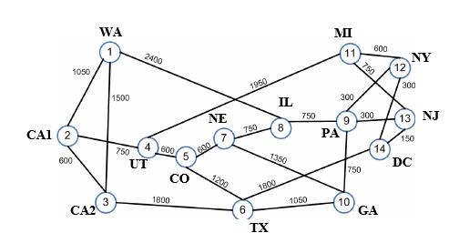

* The shortest path from NY to CA2
* The shortest path from WA to GA
* The shortest path from CA1 to NJ

**Content in the report**

* Cover page with the following information
  + Logo of UPRM
  + Title
  + Course
  + Names
  + Student ID
  + Name of Professor
  + Department
* Table of content
* Section 1: Introduction
  + Overview of the project
  + Link to youtube video.
  + Outline of the rest of this report
* Section 2: Basics of the shortest path routing problem
  + What is a graph (data structure)?
  + How to represent a network using a graph?
  + What is the shortest path routing problem?
* Section 3: Formulation of the shortest path routing problem
  + Define all necessary variables
  + Define an objective function
  + Define all constraints
  + This section will be evaluated using ABET performance indicator (1).
* Section 4: Shortest Path Algorithms
  + What is the Dijkstra algorithm?
  + What is the Floyd-Warshall algorithm?
  + What is the Bellman-Ford algorithm?
  + What is the algorithm you want to implement in this project?
  + Why you choose this algorithm?
  + This section will be evaluated using ABET performance indicator (2) and indicator (3).
* Section 5: Implementation of a shortest path routing algorithm
  + The pseudo code of a shortest path algorithm
    1. The inputs include the network, the source nodes, and the destination node.
    2. The output is a sequence of nodes 0n the shortest path
  + The complexity analysis of the algorithm using big-O notation
  + This section will be evaluated using ABET performance indicator (3).
* Section 6: Conclusions
* References
  + Need **at least 15 references** for relevant software, standards, webpages, videos, research papers, etc.