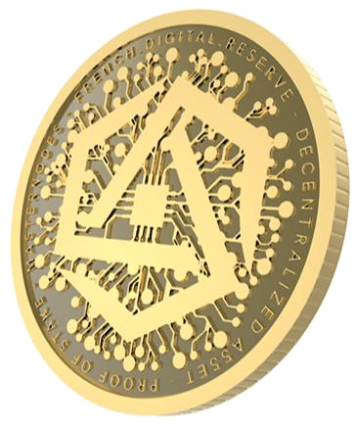

French Digital Reserve

Lite Paper v1.0

French Digital Reserve - Lite Paper v1.0

Table of contents

Introduction | 3
Problem with current available information | 4
A jungle of information | 4
The disparity of information | 4
The proliferation of single-use coin | 5
A cryptocurrency in the heart of an ecosystem | 6
An all-in-one platform "FindYourMasternodes.com" | 6
FDR use cases | 7
Project roadmap* | 8
Coin Specification | 9
Technical Aspect | 9
Masternode/Staking Information | 9
Conclusion | 10
Disclaimer | 10

French Digital Reserve - Lite Paper v1.0

Introduction

FDR is a decentralized cryptocurrency designed to offer multiple financial services such as cash transfers, payments, savings, project audits and review as well as community votes.

The high cost of financial transactions (administrative paperwork, delays of international transfers), the banking infrastructure in certain part of the world, high inflation of certain currencies, pose many problems in the world economy.

FDR represents a real solution to this situation. In fact, a non-governmental currency not issued by a central bank, would preserve its assets in case of economic crisis.

This innovative project would benefit everyone by accelerating and reducing the transaction cost of economic trades.

In order to make the use of the FDR currency concrete in everyday life, we have established partnerships to make available to the public and projects alike essential tools such as online portfolio, listing, hosting and the study as well as modules for online commerce to create a ‘one stop shop’ ecosystem.
French Digital Reserve - Lite Paper v1.0

Problem with current available information

A jungle of information

Since the beginning of 2018, we can see new platforms offering all kinds of information available for the acquisition, hosting and monitoring of projects with the consensus of PoS (Proof of Stake). This has led to a decentralization of information and a saturation of the market that is not conducive for mass adoption.

The disparity of information

An experienced potential investor must do his own research without being influenced by the hype. For this purpose, it will be necessary for him to verify the following information:

- legitimacy of the project, this includes use case(s)

- visibility of the team

- in-depth analysis of the whitepaper

- coin metrics

- where the crypto currency is tradable

- activity on social networks

- road map

- source code

To do so, there is a large number of online resources available. It can become tedious to gather all the necessary information. Unfortunately, in this sector that is decentralized, a more efficient access to the information becomes necessary.
French Digital Reserve - Lite Paper v1.0

The proliferation of single-use coin

It is a fact, at the moment to benefit from a service on one platform to another we must exchange one currency against another. This is clearly detrimental to mass adoption.

Also, the trend of single-use cryptocurrencies poses a major risk for the latter to have a very short life, due to the impossibility or the inability to adapt in a sector in constant evolution. They have been defined as soon as they are issued to a single and precise function, without flexibility.
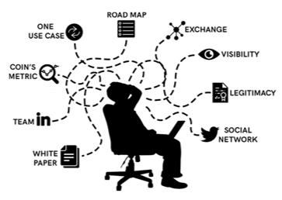
French Digital Reserve - Lite Paper v1.0

A cryptocurrency in the heart of an ecosystem

An all-in-one platform "FindYourMasternodes.com"

A solution that provides users with a platform with the following features related to projects:

- statistics

- review

- rating

- videoconferences (in 'AskMeAnything' format)

- masternodes Hosting

- monitoring

- B2B microservice markets

- useful links (website, social networks, block explorer, etc.)

- audit of the github code

Those features have been designed to guarantee a transparent and objective information so that the user can make an objective decision for his investment.
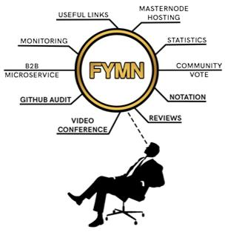
French Digital Reserve - Lite Paper v1.0

FDR use cases

First use case: www.findyourmasternodes.com

- Listing fees

- Hosting of masternodes

- Payment for microservices

- Community vote

Second use case: Partnerships

- Listing fees on Poslist.org

- Listing fees on blocknodes.live

- Other platforms under study

Third use case: Purchase of e-vouchers

- Netflix

- Amazon

- Itunes

- Playstation store

- PCS

- Neo surf …
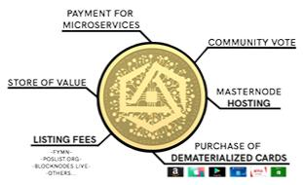
French Digital Reserve - Lite Paper v1.0

Project roadmap*

Q1 2019

- Update white paper and website

- Findyourmasternodes.com live

- Launch of the project review service

- Online wallet

Q2 2019

- Android wallet

- Masternode hosting activation

- MN collateral of 25k FDR

Q3 / Q4 2019

- Launch of microservices

- Transition to the last MN collateral of 30k FDR

*Road map adapted for Light Paper, full road map available in White Paper
French Digital Reserve - Lite Paper v1.0

Coin Specification

Technical Aspect

Algo:

Ticker:

Maximum Supply:

Premine:

4 Levels Collateral:

Block Time:

Block Size:

Reward:

Minimum stake age:

Coin maturity:

Quark(POS/MN)

FDR

24,000,000 FDR

1,249,999

FDR 10 000 / 20 000 / 25 000 / 30 000

60 sec (1440 blocks/day)

2MB (154 transactions/sec)

See tables below

1 hr

20

Masternode/Staking Information

Collateral | Blocks | Rewards | Masternode | Stake
10000 | 1-43200 | 4 FDR | 75% (3 FDR) | 25% (1 FDR)
20000 | 43201-302400 | 3 FDR | 75% (2.25 FDR) 25% (0.75 FDR)
25000 | 302401-561600 | 4 FDR | 75% (3 FDR) | 25% ( 1 FDR)
30 000 | 561601-infinite | 2 FDR | 75% (1.5 FDR) | 25% (0.5 FDR)

French Digital Reserve - Lite Paper v1.0

Conclusion

Ethereum will democratize the consensus Proof of Stake in 2019, just like Dash did with the masternodes in its day. We will see the recognition of the projects based on the proof of stake compare to the proof of work.

To facilitate this growth, we must offer to novice or experienced investors all the tools to allow them to make an objective judgment while facilitating the technical aspect of masternodes. FDR, with a complete ecosystem meets this expectation and wants to lead the way towards mass adoption of masternodes.

Disclaimer

The content of this document has been prepared by FDreserve.com. The information it including forecast financial information, should not be considered as advice or recommendation to investors or potential investors in relation to holding, purchasing or selling securities or other financial products or instruments and does not take into account your particular investment objectives, financial situation or needs. Before acting on any information given in this document, you should seek independent financial advice. All securities and financial product or instrument transactions involve risks, which include (among others) the risk of adverse or unanticipated market, financial or political development and, in international transactions, currency risk.

