# Inleiding

Conceptvoorstel voor het opstellen van een gedeeld schema voor het structureren van data met betrekking tot schuldhulpverlening. Uitgangspunt is dat zoveel mogelijk wordt aangesloten bij bestaande schema’s zoals bijvoorbeeld schema.org.

# PaymentDuelList

Canonical URL: <http://www.wijgaanhetfikksen.nl/PaymentDueList>

|  |  |  |
| --- | --- | --- |
| **Property** | **Expected Type** | **Description** |
| description | Text | A description of the item. |
| payable | http://schema.org/Invoice | The Invoice(s) that are payable. |

# Voorbeeld

Voorbeeld op basis van een ZieZo zorgverzekering van Zilveren Kruis.

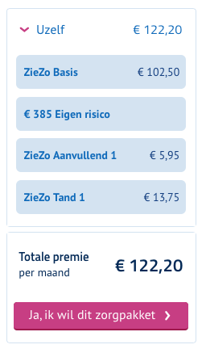

JSON-LD:

{

"@context": "http://www.wijgaanhetfikksen.nl",

"@type": "PaymentDueList",

"description": "Overzicht bijgewerkt tot en met 3-1-2018",

"payable": [

{

"@context": "http://schema.org/",

"@type": "Invoice",

"provider": {

"legalName": "Zilveren Kruis Zorgverzekeringen N.V.",

"leiCode": "724500UF2OB0JOKVS184",

"contactPoint": {

"contactType": "Klantenservice",

"telephone": "0900 040 03 09"

}

},

"description": "ZieZo zorgverzekering premie december 2017.",

"url": "https://www.zilverenkruis.nl/consumenten/mijnzilverenkruis/facturen/2017/factuur-12.pdf",

"paymentDueDate": "2017-12-15",

"minimumPaymentDue": {

"@type": "PriceSpecification",

"price": 122.20,

"priceCurrency": "EUR"

},

"totalPaymentDue": {

"@type": "PriceSpecification",

"price": 122.20,

"priceCurrency": "EUR"

},

"billingPeriod": "2017-12-01/12-31",

"paymentStatus": "http://schema.org/PaymentPastDue",

"referencesOrder": [

{

"@type": "Order",

"description": "ZieZo Basis",

"orderDate": "2017-01-01",

"acceptedOffer": {

"@type": "Offer",

"description": "maandelijkse premie",

"price": 102.50,

"priceCurrency": "EUR",

"paymentMethod": "http://purl.org/goodrelations/v1#DirectDebit"

},

"orderStatus": "http://schema.org/OrderPaymentDue",

"paymentDueDate": "R12/2017-01-15/P1M"

},

{

"@type": "Order",

"description": "ZieZo Aanvullend 1",

"orderDate": "2017-01-01",

"acceptedOffer": {

"@type": "Offer",

"description": "maandelijkse premie",

"price": 5.95,

"priceCurrency": "EUR",

"paymentMethod": "http://purl.org/goodrelations/v1#DirectDebit"

},

"orderStatus": "http://schema.org/OrderPaymentDue",

"paymentDueDate": "R12/2017-01-15/P1M"

},

{

"@type": "Order",

"description": "ZieZo Tand 1",

"orderDate": "2017-01-01",

"acceptedOffer": {

"@type": "Offer",

"description": "maandelijkse premie",

"price": 13.75,

"priceCurrency": "EUR",

"paymentMethod": "http://purl.org/goodrelations/v1#DirectDebit"

},

"orderStatus": "http://schema.org/OrderPaymentDue",

"paymentDueDate": "R12/2017-01-15/P1M"

}

]

}

]

}