*HW 1.5: Time Management, Plan- ning, Scheduling, Tracking* COMP4009/ICOM4009/INSO4101

Prof. Marko Shütz

INSO 4101

Assigned on: August 17, 2018 Due on: August 24, 2018

Problem 1 Create a time log starting no later than Monday, the 20th of August 2018 to gain an understanding of what you do with your time. In order to do this you’ll need to come up with an initial set of categories that you want to use. Task descriptions should be concise, but rich enough to allow *some* later re-categorization. Submit your time log together with a brief description of the categories you have chosen.

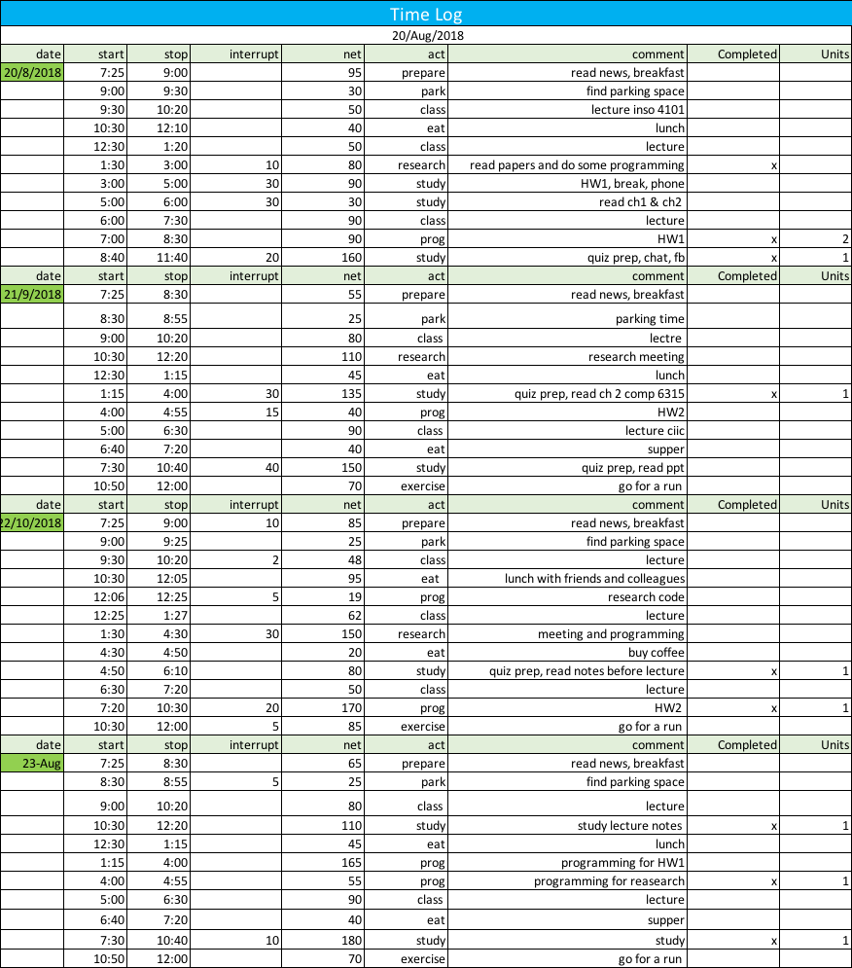

Problem 2 Create a weekly activity summary up to and including Thursday, the 23rd of August 2018 (normally, this would cover an entire week of 7 days, but since Friday is submission date...).

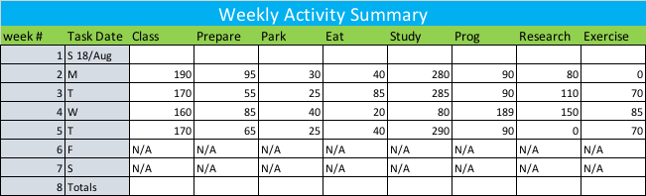

Problem 3 Identify 2 or 3 projects or major tasks that you will need to do and plan (product/task plan as well as a schedule) for each.

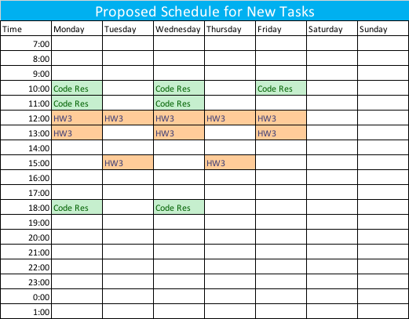

Problem 4 At the end of this (partial) week, what is the percentage of your total time that each category accounts for? Should you decompose the largest category? Why or why not? Should the smallest category be merged with (part of) another category? Why or why not?

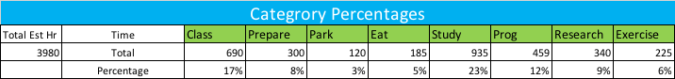

Yes, the largest category should be decomposed, perhaps into 3 different parts: study, homework and quiz prep. This would be done in order to make the task time distribution more uniform. No, the smallest category shouldn’t be merged. I spend almost a constant amount of time on it and do on a daily basis.

Problem 5 Evaluate your personal priorities. What are you most interested in? What haven’t you done in a while and you feel it’s missing? What do you consider essential for a well-rounded day/week/weekend/holidays/month/year?

Do some soul-searching! If you feel that your answers are too personal to share, keep the concrete version to yourself and submit a “translated” more generic version. For example, if you do not want to reveal that one of your favorite activities is creating collages with your 7 year old niece, report it as “arts/crafts with family”.

I believe that balance is key. I believe that being a student one should prioritize study above all, however one must also spend some quality time with family, friends and most importantly some time for your physical and mental well-being. Thus it is important to socialize, have good sleep and do some exercise.

1. “research/programming”
2. “quality time with my family”
3. “leisure time/movies and video games”

Problem 6 Create a schedule for the next week immediately following submission dead- line of this assignment.

From now on track your time, plan your tasks, and schedule your days/weeks/months at least for this course. Choose your week start and end days and use them consistently,

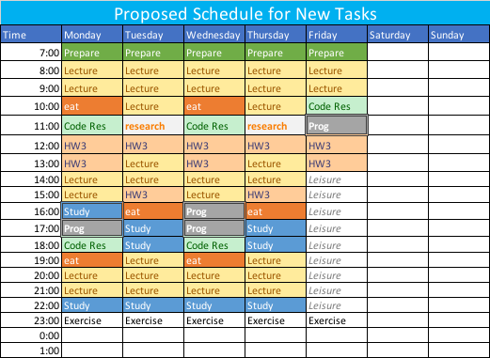

Assigned: August 17, 2018 1 Due: August 24, 2018

HW 1.5: Time Management, Planning, Scheduling, Tracking

some people prefer Monday as the start of the week and this is the ISO standard, others prefer Sunday to be the start of the week.

page2image3689568