INSO 4101

Prof: Marko Schutz

HW5

1. Problem 8

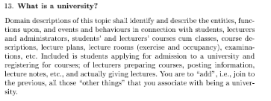

_9' (___ __ _ ___7_____!M

A_____ ___$________ _ ____ ____$ _____ ______ ) ___ ___$__!_ ___ _________ _$

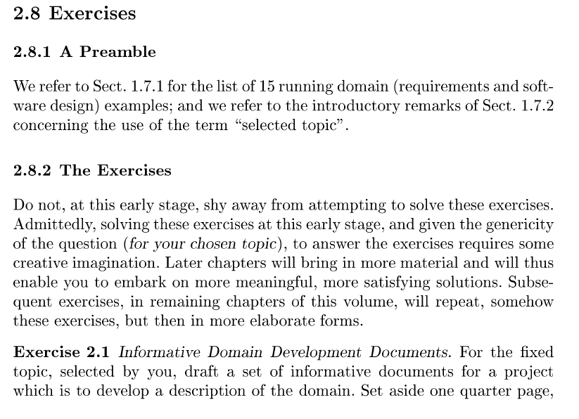

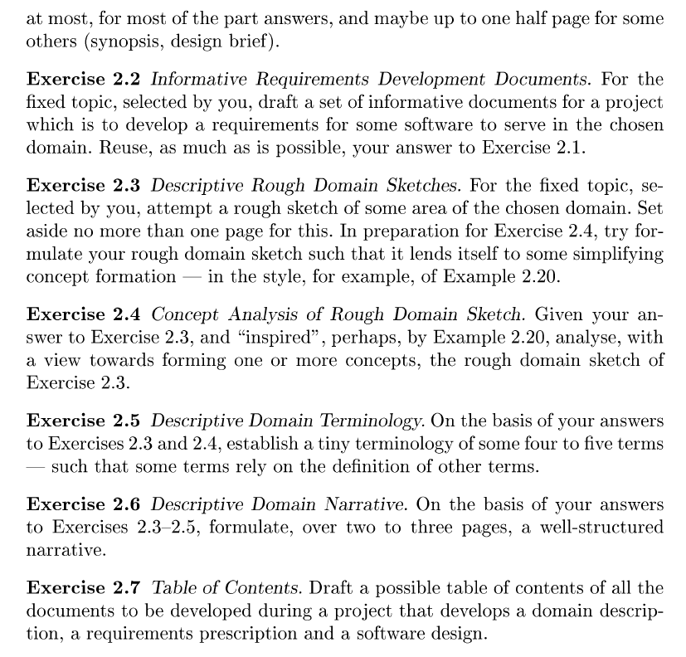

The University of Wakanda was established in 1700 A.D by T’Chua. The university contracted, this past July 2018, Wakanda Tech Solutions to develop a better enrollment system for the university. The new enrollment app will allow students to enroll using mobile devices in a painless way. The project is intended to be finished no later than this year. The list of partners are:

1. T’Challa (President of the University)
2. Shuri (Senior Software Engineer)
3. T’Chaka (CEO )

What does the project have to tackle?

* Partners: developers and also clients
* Current situation: Outdated enrollment system
* Scope: University System, Students, Professors
* Current Situation: People have criticized the system as inefficient and outdated.
* Span: Software system that enables student and university actions
* Assumptions: things that belong to the domain of a university and not the requirements
* Dependencies: fulfillment of assumptions. Using the software as intended.
* Goals: Student satisfaction and a robust system.

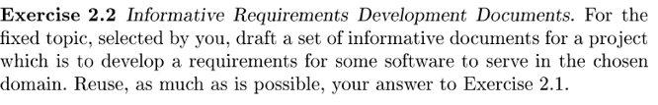

2.1 - 2.2 Informative Document Parts:

1. Name, Place and date:

* Student University App for Enrollment
* University of Wakanda.
* Aug 28, 2018Pare

2. Listing of Partners:

- University of Wakanda (client)

- Wakanda Tech Solutions (consultant)

- LulzSec (security subcontractor)

3. Current Situation:

The current situation of the University is that the information of the students account can only be accessed when using an archaic and buggy system to the bank. There is a need to develop a mobile application to access the account information remotely. The idea is to create a mobile application that will let the customer access account’s information, perform enrollments, do transfers, make payments, check grades, etc. The concepts to be address in the project it’s a platform are the successful functionality of student needs with valid accounts, remote access to information of the account. The scope of the project is university system mobile application. The span will be the successful availability of account information near real time and allow for ease of use without sacrificing functionality.

4. Needs:

* Therefore, there is a need to create a new updated system to modernize the university enrollment system.

5. Ideas:

* Some ideas had been presented to update the system. Say a new general use web application
* The new system will be reliable, intuitive and functional

6. Concepts:

* Given that each student will have a device with connection to the internet, he or she could sign in using his valid student id to access all information and functionality pertinent to university system. The system will be both accessible to any student with a modern user interface that is both intuitive and versatile.

7. Scope:

* The scope involves the characterization of student necessities for an updated system within the University.
* Rough sketch of the scope:
  + The problem in general is to understand the domain of a University central system:
  + Such as the major entities in the such a system which will include: students, professors, classes, internet, mobile devices, etc.

8. Span:

* Span of University central system: To build a theory of the domain of the university related to enrollment or similar student necessities within the University system.
* Rough sketch of the span:
  + University web system: student id, professor id, central planning and monitoring of the system, sys-admins, etc.

9. Synopsis:

* We see Universities as a whole and they have functioned without such applications for centuries. However, in order to build a more efficient system there is a constant need to update the university system to keep track of school management systems and optimize every aspect of it. This project is to develop and research the methodologies that best qualify for this specific domain. The domain model is expected to cover such phenomena as: Student enrollment, accessing student information and reliability of the system. New ways to present an intuitive platform that is both fast, reliable and functional.
* The domain model is expected to cover such phenomena as:
  + The student subsystem: its static and dynamic properties such as grades or id
  + The professor subsystem: its static and dynamic properties such as classes and rating
  + The enrollment section for students: the management of available classes and student prerequisites
  + Administrator: Privileges granted to alter or improve overall system
  + And so on.

10. Assumptions and dependencies:

a. A domain description will be presented to client and make sure that there is mutual

acceptance of this description.

b. It is assumed that project developers will have access to documentation,

protocols, consultants with the necessary knowledge about respective parts of

requirements.

11. Implicit / derivatives goals:

1. Enhanced features and functionality. Students can complete any university related query using the application.
2. The new intuitive user interface should encourage both student usage as well as optimization in the processing of student and employee related queries. Thus, helping the university save money.

12. Standards

* NIST Cryptographic Standards and Guidelines Development Process (NISTIR 7977)

13. Contract:

a. Who, What, How, When and Where will be described in a legal accordance with the client. It will be signed be both counter parts (client and supplier), and any other third-party contributor associated with project.

14. Design brief:

a. Wakanda Tech Solutions co. is the developer of the University system Financial Services for Wakanda University, by Dec 31, 2018, using LulzSec principles, manuals and standards provided by NIST Standards catalogue as illustrated in NISTIR 7977.

15. Logbook:

a. 8/29/18: First meeting with client (university representative). We discussed the problem and

needs the university is having. A simple list of overall requirements was given.

b. 8/30/18: Second meeting with client. Requirements were discussed again to make sure

they are clear. An overall solution was presented to the client to see if it meets

requirements.

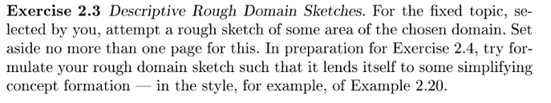

Let us imagine a university that promises a system that does the following: enroll/drop, check grades, pre-enrollment, professor rating, etc.

* Student: access system with the specified functionalities of students. Students will be prioritize accordingly
  + A student with a valid id or account can sign in into his account and perform the actions a typical would want to do related to the university.
  + The university has pledged this will be an intuitive system that does not sacrifice functionality. Students are able to perform all previous actions that were done either manually or using an archaic system. Such a system will be decentralized according to the department, yet it will be sync with one another for inter-departmental actions.
* System: A decentralized system allows for a more robust system that guarantees reliability for student necessities.
* Professor: access system with the specified functionalities of a Professor.

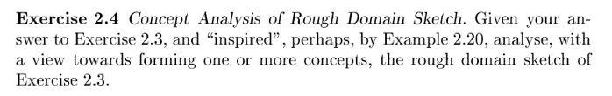

It is possible for a student to have drop and enroll the same class but with different sections. To enroll a class the system must check for pre-requisites unless enrolled by the department director, who will retain special administrative privileges. The grades will have a read/write functionality for professors only and read functionality for students. The professor rating section can only be accessed if you’re a student.

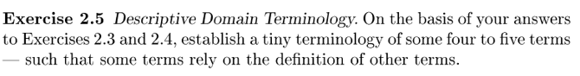

* Student ID: Unique ID that only activate students can use to enter the system. The functionalities of a student are given by his student id code. Most students will have the same kind of functionalities, although there will be some exceptions.
* Professor ID: Unique ID that only professors from the university can use to enter the system. The functionalities of a professor (given by professor id) will be completely separate from functionalities.
* Enrollment Log.: Log that keep tracks of available spaces for classes and class prerequisites.
* Grades: Table of grades by Student ID
* Sign in: Valid user sign in function

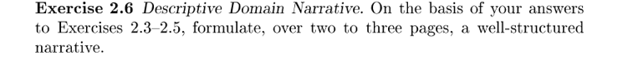

The following is based on the university domain. The university offers many services for students, some essential to the university to operate in a modern environment. Most of these services are targeted towards students. Such student must fulfill the following characteristics.

Entities: Students, Computer System, Professor, Grades,etc

1. Student must be a regular student
   1. If a student 🡪 use student permission protocol
   2. If professor 🡪 use professor permission protocol
   3. Other 🡪 evaluate exception
2. Student can only access information pertinent to the courses he/she has taken
   1. If a student meets prerequisites 🡪 Enroll
   2. Else 🡪 Cannot enroll
   3. Also consider valid exceptions
3. Grades
   1. If student 🡪 only has a read operation.
   2. Else if Professor 🡪 Read/Write operation
4. Computer System
   1. Check user type 🡪 Determine functionality
   2. If exception 🡪 contact admin
5. Professor
   1. Professor cannot review their own performance.

The application will have the following:

Mobile application

* The mobile app will have the same functionality as the web-based application

Web application

* Modern, easy to use interface that will not sacrifice functionality
* Must be well organized.

Creation account based on student or employee ID

Create password

Identification procedure

* Email confirmation
* id confirmation

Forgot password system

Forgot username system

Enroll/Drop Course

* Enrolling will be subject to the student prerequisites
* Dropping a course will be independent

Effective payment to services listed on the offered services

* Services such as paying for tuition
* Transcripts
* Certifications
* Admission
* Etc.

Availability of free account information at all time.

* Some of the services that are freely available must available to student

The university system will have access to all user information and will allow certain users, depending on which kind of user they are, the ability to perform processes such as enrollment, etc. The write operation changes will be reflected immediately in the user account. Once done the user will be able to continue do other functionalities the system allows him to do. The only requirement to have access to the system is to have a valid university account. This implies that you are either an employee of the university or an active student in the university.

A student’s system access will be revoked if and only if he is no longer an active university student. Any former employee will also have his/her system access revoked. All transactions must be done through the internet in order to remain consistent with functionality and avoid as much as possible manual work. The system will also contain informative data from both students, professors and other employees. Some of this information will be freely available, other will be paid information. For example, an official student transcript will be available to any active student however he or she will have to pay for it. On the other hand, there will also be freely available data that anyone could access in real time. For example, a student’s grades, professor ratings, admission information, etc.

The system will also allow any employee to access his or her information. As a system that is able to manage the financial operations within the university, some employees will able to see financial information. For example, any employee including professors, deans, janitors etc., will be able to see salary information. The purpose of such a system would be to make information within the university as transparent and available as possible, while at the same eliminating bureaucratic procedures that delay the handling of information and overall user experience. The system will have several verifications, however since most of these verifications will be done electronic it will eliminate both paper work, more efficient, save money and improve user experience.

Another important feature of the system will be reliability. The system will operate over a blockchain like structure. Meaning it will be as decentralized as possible. This will ensure That if one of the computer servers fail, there will be other nodes to backup it. The system is intended to operate by within departments. However, the fact that an instance of the system will be one department will not imply that it will not display information of another department if so needed. One of the most important problems this new system will try to address is system reliability.

In order to accomplish the user satisfaction and the proficiency over the competitors this platform has to work in different devices, OS, and at different internet velocities. The most important aspect that the board has concern on is the effectivity of it and the security of the information provided by the customers.

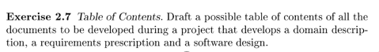

1. Introduction
2. Name, place and date
3. Partners
   1. Users
   2. Investors
   3. Developers
   4. Sub-contractors
4. Needs
5. Ideas
6. Concepts
7. Scope
8. Span
9. Synopsis
10. Assumptions and dependencies
11. Software requirements
12. Implicit/derivative goals
13. Standards
14. Design of the Distributed File System dependencies
15. List of permissions the developers and the customer will have over the application
16. Contract
17. Design of the web application
18. Design of the mobile application
19. Logs
20. List of software dependencies on updates

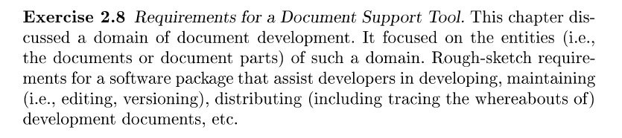

The software will require commodity hardware to run the servers. As mentioned previously one of the most important aspects will be reliability. The software must be able to create several documents and store it in a Distributed File System, some of these documents will be available to the user and there will be multiple copies of the document in the distributed system. Documents could as simple as tables or any other file type necessary for system implementation.

Logs and Schedule

