First of all, there were particular questions that I want to answer here.
1. are any of the constants or equations reported incorrectly in your paper? (I have used the following values: M1=0.10, M2=0.16, M3=25.7, M4=125.3, N1_t0=912, N2_t0=250, N3_t0=4, N4_t0=2, a0=0.1, c0=1.0, Ropt=100; gamma=0.5, h0=7.5, x0=exp(23.05))
None of the parameters is incorrect. However, the reported masses were rounded to two digits during the revision process without being changed in the simulations. Indeed, we used a higher accuracy for initialising the simulations: M1 = 0.104, M2 = 0.157, M3 = 25.69, M4 = 125.3; N1= 911.8,N2 = 350,N3 = 4,N4 = 2
2. Would it be possible for you to extract the actual values for attack rates (aij), handling times (hij), interference factors (cj) and conversion efficiences (eij) that you used so that I can compare these values with the ones I obtain (see table 3 in attched file for the values I obtain when applying eqs 2-8)?
Of course:
 | Jonsson | Schneider et al. 2013 |  |  | Jonsson | Schneider et al. 2013
a₁₂ | 0.0074 | 0.0072 |  | x₂ | 0.0085 | 0.0086
a₁₃ | 0.0926 | 0.0963 |  | x₃ | 0.0018 | 0.0018
a₁₄ | 0.0021 | 0.0026 |  | x₄ | 0.0011 | 0.0011
a₂₃ | 0.1333 | 0.1319
a₂₄ | 0.0195 | 0.0181 |  | e₁₂ | 0.5312 | 0.5631
a₃₄ | 0.2676 | 0.2677 |  | e₁₃ | 0.0033 | 0.0034
 |  |  |  | e₁₄ | 0.0007 | 0.0007
c₂ | 0.4000 | 0.3962 |  | e₂₃ | 0.0053 | 0.0052
c₃ | 5.0695 | 5.0685 |  | e₂₄ | 0.0011 | 0.0011
c₄ | 11.1937 | 11.1937 |  | e₃₄ | 0.1743 | 0.1743
h₁₂ | 6.6685 | 6.7662
h₁₃ | 1.8732 | 1.8918
h₁₄ | 1.2606 | 1.2730
h₂₃ | 2.1067 | 2.0970
h₂₄ | 1.4178 | 1.4111
h₃₄ | 5.0473 | 5.0468
The slight difference in your body masses caused by the rounding fully explains your deviation in the functional response parameters aij, hij, cj, xj, eij. The same is true for the slight difference in feeding rates.
3. Did any of your populations go extinct (simulated or real) and in what treatments?
In the experiment: yes, some replicates did not sustain the spiders until the end of the experimental time. We did not re-introduce spider individuals. However, they were having an effect on the other populations. For the calculations of per capita Interaction strengths, we assumed they declined linearly during the experiment, by dividing by the mean of the initial (N = 4) and final (N = 0) density. This is for certain one of the major differences between the simulations and the experiment.
In the simulations, all populations sustained the period simulated except the centipedes in the treatment lacking spiders. Apparently, the lack of profitable prey is fatal for them. This is why the positive Interaction strength of spiders on centipedes is highly overestimated by the simulation.
4. How did you handle the stocking of mites in the simulations? You report in the paper that initially 250 mites were added to each mesocosm, and another 100 added after one week. Thus, did you follow this procedure in the simulations (i.e. using N2_t0=250 and adding another 100 at t=168 h), or did you simply use N2_t0=350? (In my simulations this only has a minor effect, but I would like to know anyhow...)
We simplified that in the simulations to a starting density of 350 mites at t0. As you say, this has only little effect.
However, all of this is not causing the populations to crash, but should produce very much the same IS. By re-writing my own simulation code, I was able to reproduce exactly the dynamics that you were observing. This is good news for you but bad news for us, since it means that my original simulation that produced the interaction strengths published in Ecology Letters was wrong. Indeed, I found a serious error in the definition of the differential equations in the code.
However, I needed to refine the parameters only slightly to reproduce interaction strengths matching the experiment similarly well as in the original publication. This changes the parameters of the Ricker function (eq 2 , success) R_{opt} = 200, γ = 1, as well as the normalisation constants a₀ = 0.15 and h₀ = 8.0. Anything else remains unchanged.
This gives me the following new values for the attack rates, handling times, efficiencies and metabolic rates:
a12 | 0.0012 | h12 | 7.1131 | e12 | 0.5312 | c2 | 0.4000
a13 | 0.1835 | h13 | 1.9981 | e13 | 0.0033 | c3 | 5.0695
a14 | 0.0091 | h14 | 1.3446 | e14 | 0.0007 | c4 | 11.1937
a23 | 0.2089 | h23 | 2.2472 | e23 | 0.0053 | x2 | 0.0085
a24 | 0.0673 | h24 | 1.5123 | e24 | 0.0011 | x3 | 0.0018
a34 | 0.0731 | h34 | 5.3838 | e34 | 0.1743 | x4 | 0.0011
For the interaction strengths we obtain the following new result:
 | experiment |  |  |  |  |  |  | simulation
 | IS ±st. dev. |  | p |  | per capita IS ±st. dev. |  |  | IS |  | per capita IS
lith>pard | -0.0050 | ± 0.0047 | 0.098 | . | -0.0031 | ± 0.0030 |  |  | -0.0387 | -0.0241
lith>hypo | -0.0206 | ± 0.0600 | 0.519 |  | -0.0126 | ± 0.0381 |  |  | 0.0099 | 0.0061
lith>het | 0.0398 | ± 0.0453 | 0.180 |  | 0.0227 | ± 0.0256 |  |  | 0.0494 | 0.0307
pard>lith | 0.0237 | ± 0.0264 | 0.124 |  | 0.0118 | ± 0.0132 |  |  | 0.0096 | 0.0048
pard>hypo | 0.0375 | ± 0.0462 | 0.156 |  | 0.0188 | ± 0.0231 |  |  | -0.0055 | -0.0028
pard>het | 0.0190 | ± 0.0537 | 0.530 |  | 0.0095 | ± 0.0268 |  |  | -0.0175 | -0.0087
hypo>lith | -0.0106 | ± 0.0235 | 0.413 |  | 0.0000 | ± 0.0000 |  |  | 0.0034 | 0.0000
hypo>pard | -0.0018 | ± 0.0037 | 0.374 |  | 0.0000 | ± 0.0000 |  |  | 0.0000 | 0.0000
hypo>het | -0.1490 | ± 0.0989 | 0.024 | * | -0.0002 | ± 0.0001 |  |  | -0.1491 | -0.0005
The interaction strength that we focused on in the interpretation remain basically the same: Lithobius on Heteromurus, as well as Hypoaspis on Heteromurus. The spiders’ effect on Heteromurus is estimated weaker now and matches the experiment even better. However, the other Interaction strengths between the predators are hardly matching. In fact, most end up with a different sign as the experimental IS. However, most of them can be considered “weak” or insignificant.
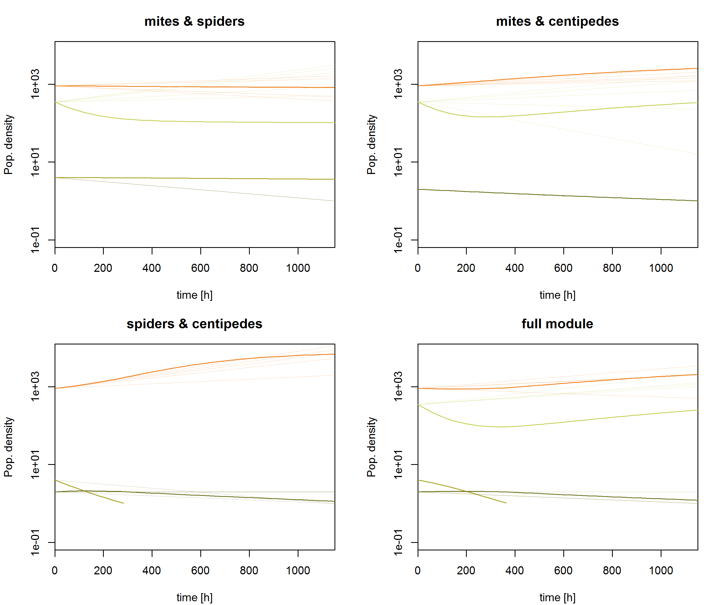
Fig 1 | showing the simulated population dynamics of Springtails (orange), mites (light green), spiders (green) and centipedes (dark green). In pale colors you see the observed development of densities in the experiment (just as straight lines between initial and final density).

We believe that the conclusions of our manuscript are not affected by that mistake and the suggested correction is adequate.

