Import XLS

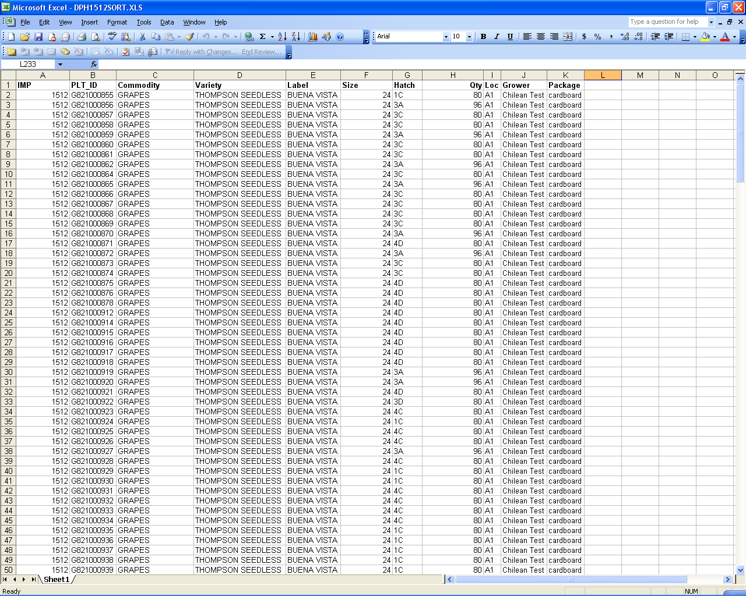

For this page to function properly, you MUST upload a properly-formatted XLS file.

The first line must be exactly as shown.

A) “IMP”
B) “PLT_ID”
C) “Commodity”
D) “Variety”
E) “Label”
F) “Size”
G) “Hatch”
H) “Qty”
I) “Loc”
J) “Grower”
K) “Package”

Then, for the rest of the file, the format is:

A) Your customer Identification (this is clerical; the pallet’s owner is not changed)
B) The Barcode
C) Commodity Type (this is clerical; the pallet’s commodity is not changed)
D) Product Variety (Optional)
E) Product “Label” (Optional)
F) Product’s size identification (Optional)
G) Ship’s Hatch/Deck
H) Case Count of Pallet
I) Destination Warehouse (Optional)
J) Grower name (Optional)
K) Packaging Type (Optional)

Each line must be valid. Any line that does not match up precisely will cause the program to cancel the update, and no changes to the database will be made. In this event, you will receive a message stating what occurred, so it can be corrected and re-uploaded.

Field Requirements:

All) The only allowable characters are letters, numbers, spaces, dashes and colons.

B) Pallet Barcodes cannot be longer than 32 characters, and must be unique per uploaded file.
F) A pallet’s “size identifier” can not be longer than 6 characters
G) A valid Ship’s Hatch and Deck cannot be longer than 5 characters
H) The case count of a pallet must be numeric, and no more than 6 digits
K) The Packaging Type cannot be longer than 10 characters

Field preferences:

G) While not required, it eases pallet identification if a ship’s hatch/deck is number first, letter second (for example, “1A” instead of “A1”).
I) While not required, it is HIGHLY recommended that, if a specific Destination Warehouse Location is entered, it is letter first, numbers after (examples, “B2”, or “B2 120-140”, but not “2B”). This does not apply for non-location entries, such as “HotLoad” or “QC”.

