Seth Morecraft
December 3, 2002
Diamond State Port Corp.

Ceridian Payroll Import into Oracle GL Instructions

Your goal is to import payroll data from Ceridian into our Oracle General Ledger. You will need to be able to:
* Copy & Edit text files.
* Use a browser.
* Copy data using Excel in Oracle ADI.

All set? Lets import some data!

First step is to copy the file you received from HR to a directory of your choosing.
Right-click on the file from Outlook and choose copy.
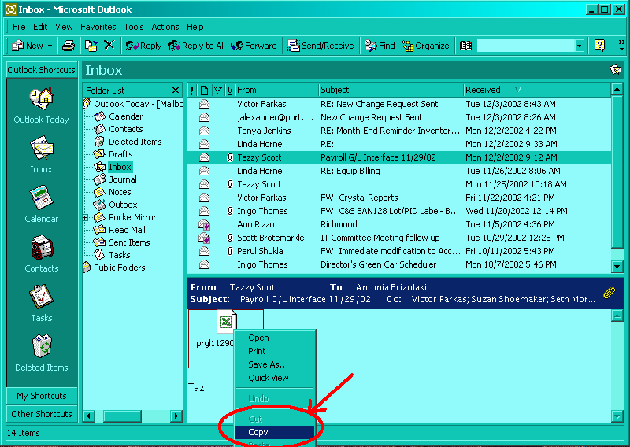

Once you have copied the file, you should paste it into your temporary directory.
From Windows Explorer, choose a directory and paste the file there.
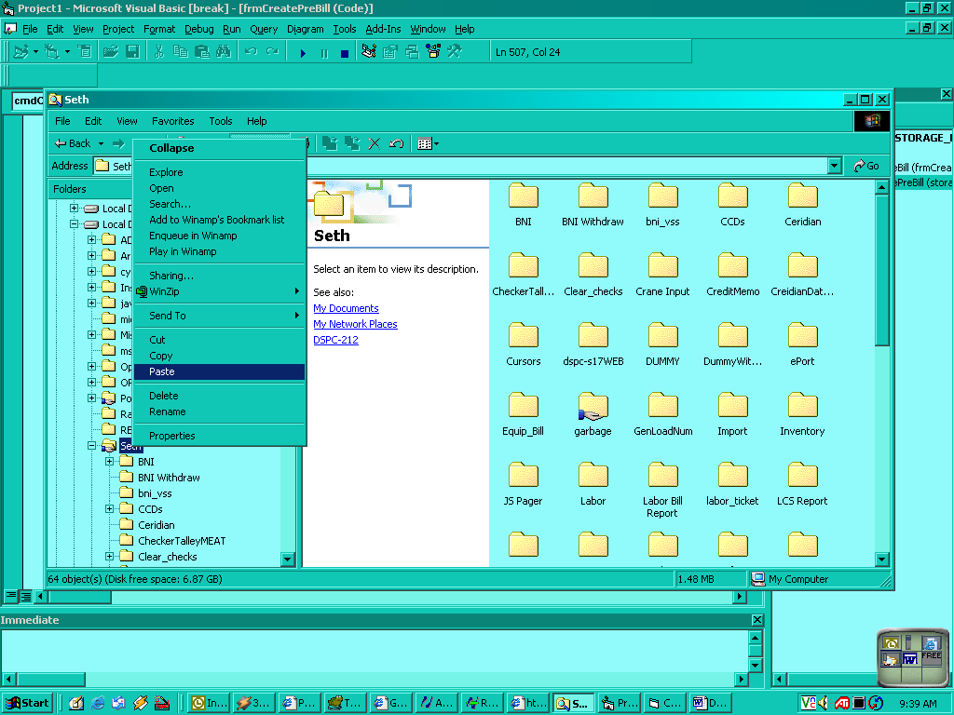

Now double-click on the file to Edit it using NotePad. If there is an account code that is 9999, you MUST research the values to assign the correct account code- then save the file.
Now open Internet Explorer and go to the DSPC accounting main page:
http://dspc-s17.dspc/accounting_login.php
Log in and go to the Ceridian Import:

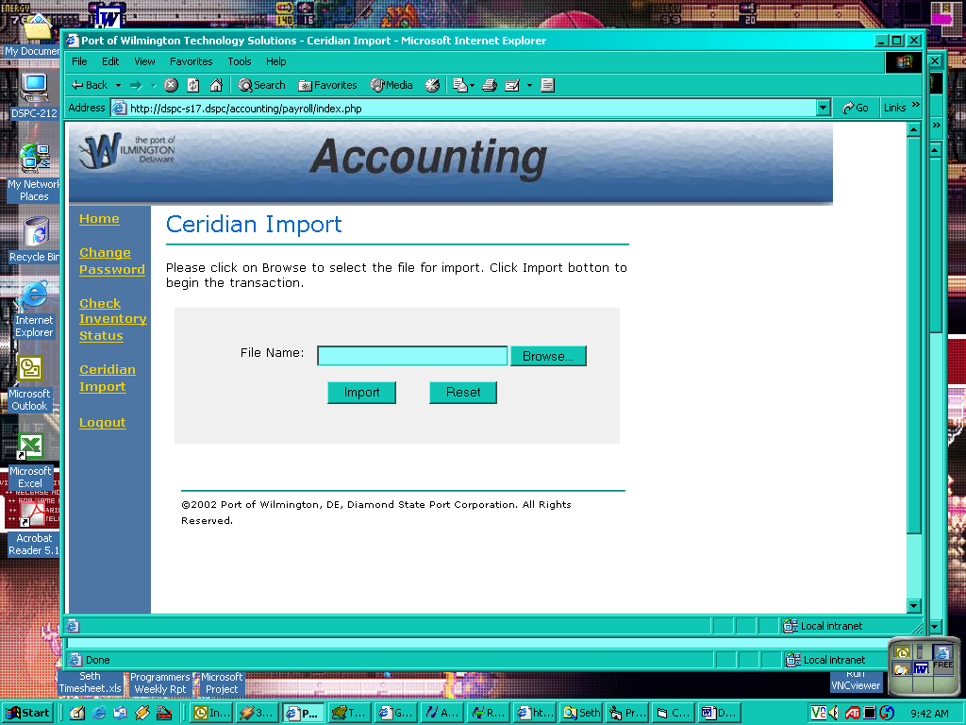
Choose your file using the Browse button and click import.

After you have processed the file, a new window will appear- you should save this file in some directory as a text file.
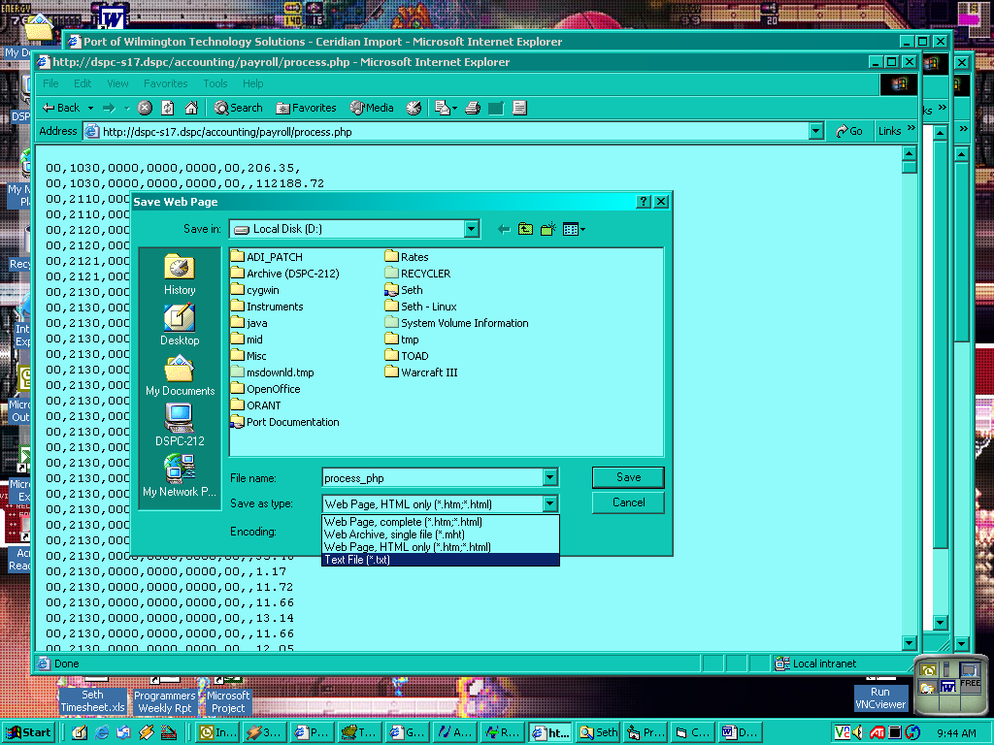

Once you have saved the file, open it in Excel (import the file using a Comma as the delimiter).
Now copy the values from this spreadsheet into the Oracle ADI standard Journal Import.
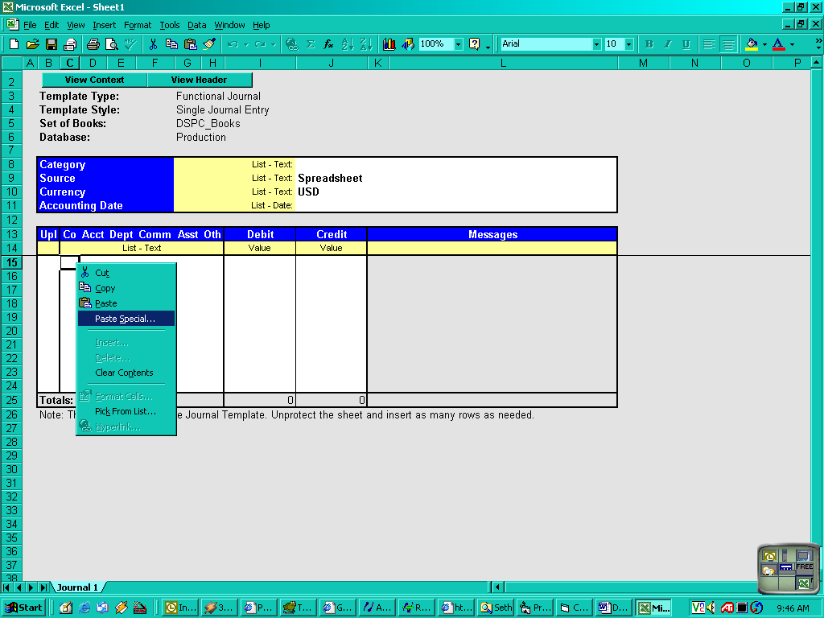
Choose Paste Special and your data should come in as values.
Import using ADI validation and return to Oracle to Post this Batch!

