Seth Morecraft
January 3, 2002
Diamond State Port Corp.

Fork Lift Expense Import into Oracle GL Instructions

Your goal is to import Fork Lift Expense data from LCS into our Oracle General Ledger. You will need to be able to:
* Copy & Edit text files.
* Use a browser.
* Copy data using Excel in Oracle ADI.

All set? Lets import some data!

Open Internet Explorer and go to the DSPC accounting main page:
http://dspc-s17.dspc/accounting_login.php
Log in and go to the Fork Lift Expense Import:

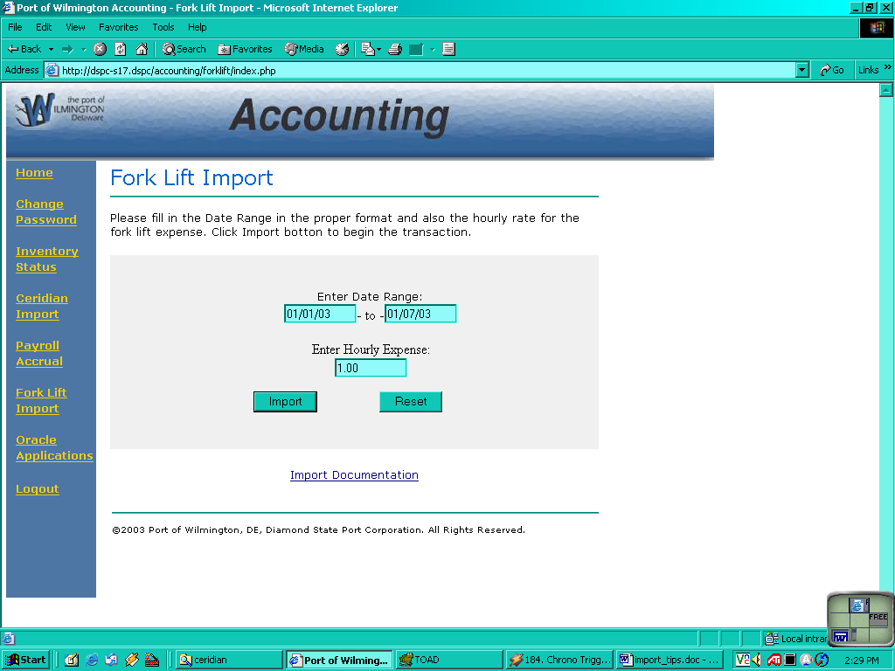

Enter the proper information the form requires. You will need a date range and a dollar amount for the Fork Lift Expense per hour. Please note the given format for the date and the dollar amount- this is a required format!

After you have processed the file, a new window will appear- you should save this file in some directory as a text file.
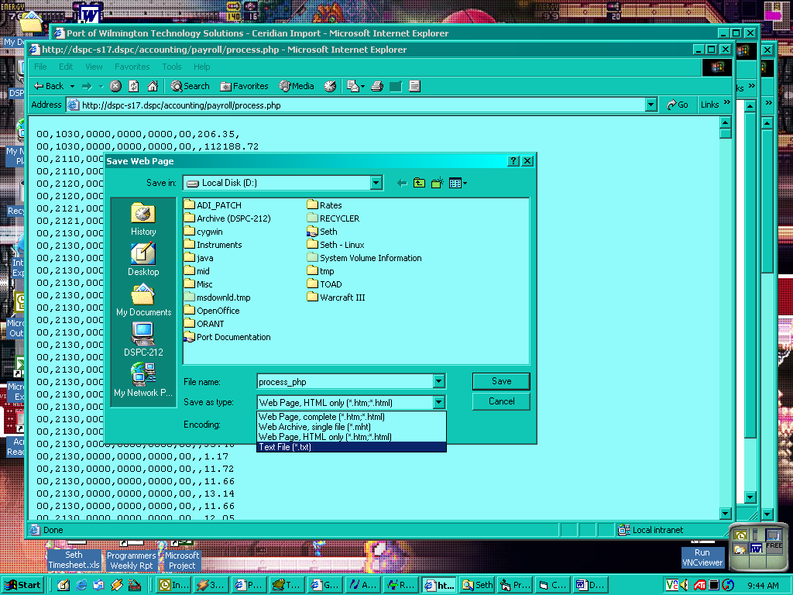

Once you have saved the file, open it in Excel (import the file using a Comma as the delimiter).
Now copy the values from this spreadsheet into the Oracle ADI standard Journal Import.

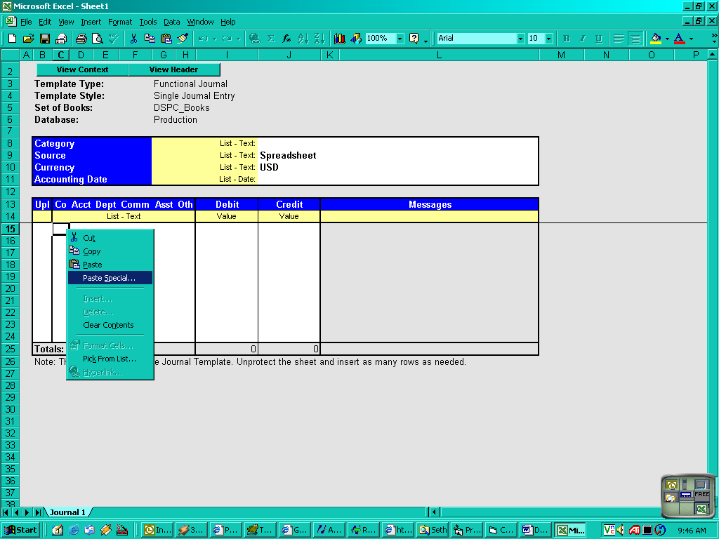
Choose Paste Special and your data should come in as values.
Import using ADI validation and return to Oracle to Post this Batch!

