Seth Morecraft
Port of Wilmington
December 2003

Claims System Documentation

Welcome to the Claims System. From this application you will be able to Enter / Modify / Complete and Track all Claims to the Port of Wilmington.

To Begin, you must Log into the Applications homepage and Select Claims:
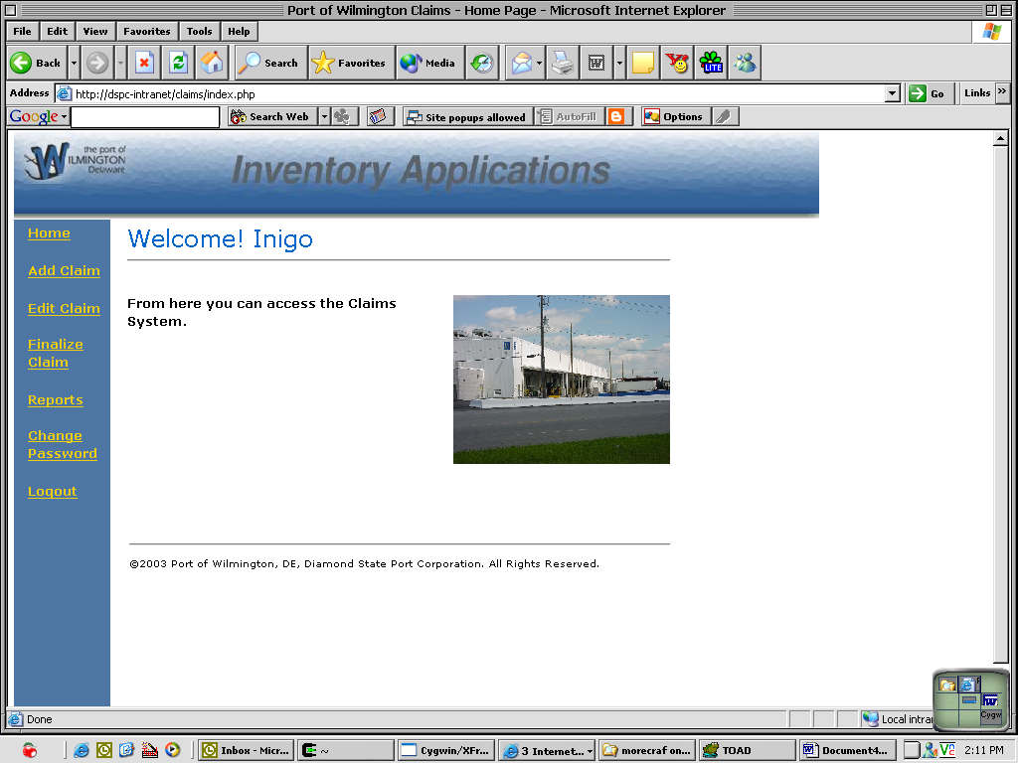

From here, you will want to begin by adding a Claim to the system.

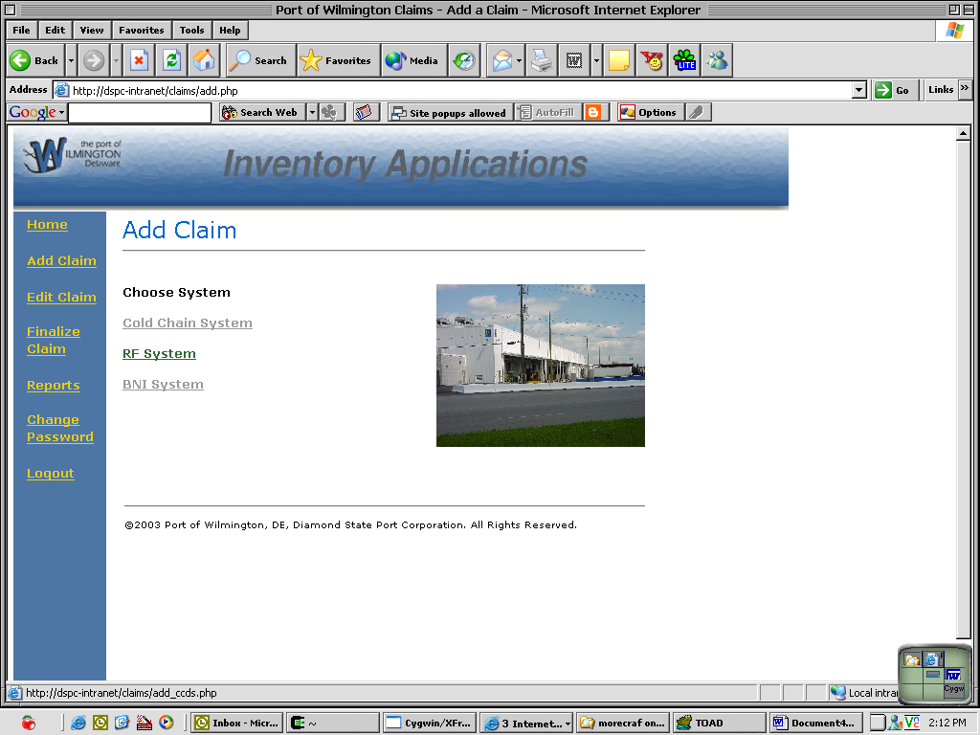

From the Add screen, select the system from which the cargo claimed came from.
Your options are: CCDS – Meat, RF – Chilean Fruit (Scanned), BNI – Juice and other cargos.

Once you select the system, navigate to the Unique Identifier for the Pallet / Lot / BOL that is claimed on.
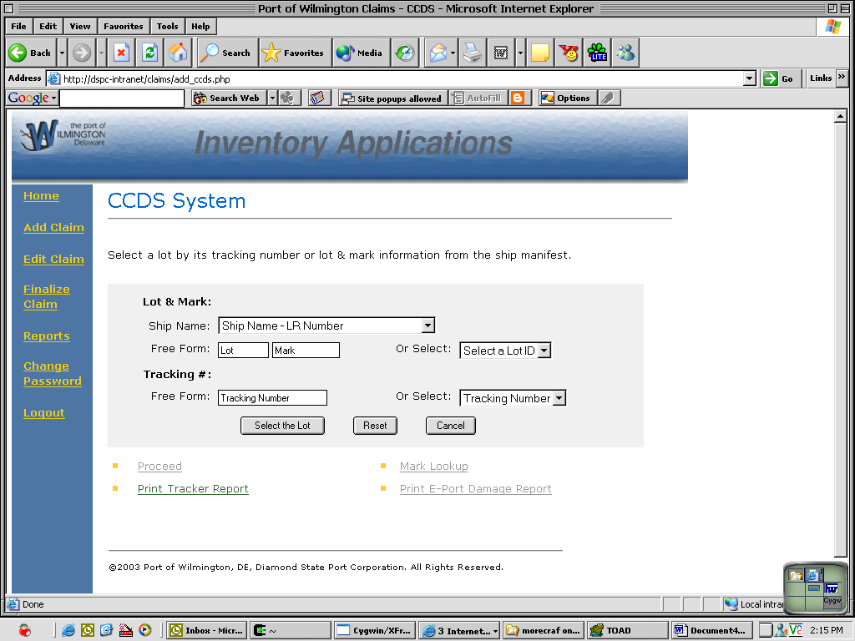

For Example, for CCDS, you will navigate to the Lot ID and then choose your options.
From here, you can print out a Tracker Report to see what happened to the pallet- or you can see if the damage was from the shipping line by looking at the E-Port damage report.
Once you have finished with the initial research, you may click proceed to create the claim in the system:

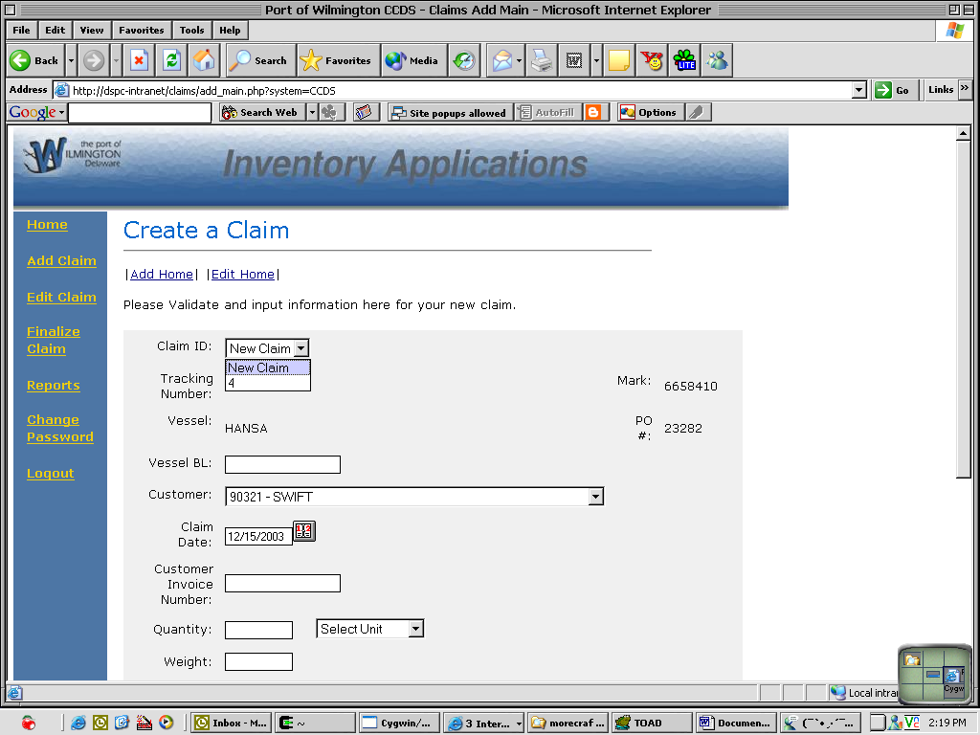

To enter a new Claim, leave Claim ID selected to “New Claim”, otherwise, you may append this line item to another open claim to make multiple line item claims.
Enter all other relevant information to save this claim.

The edit process is exactly the same to make changes to existing claims.

To complete the claim, enter the Finalize Claim menu:
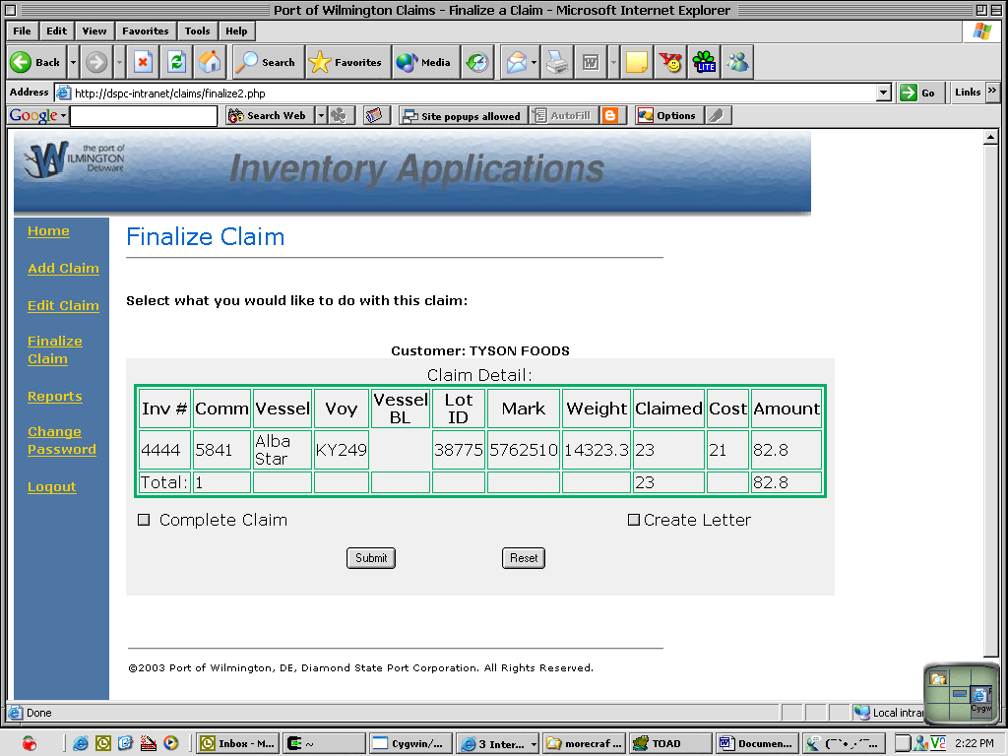

From this screen, you are given two options:
- Complete Claim- Once you hit Submit, your claim will be filed away and marked as completed and paid.
- Create Letter- Create a claim invoice letter as follows:
