- Open Internet Browser
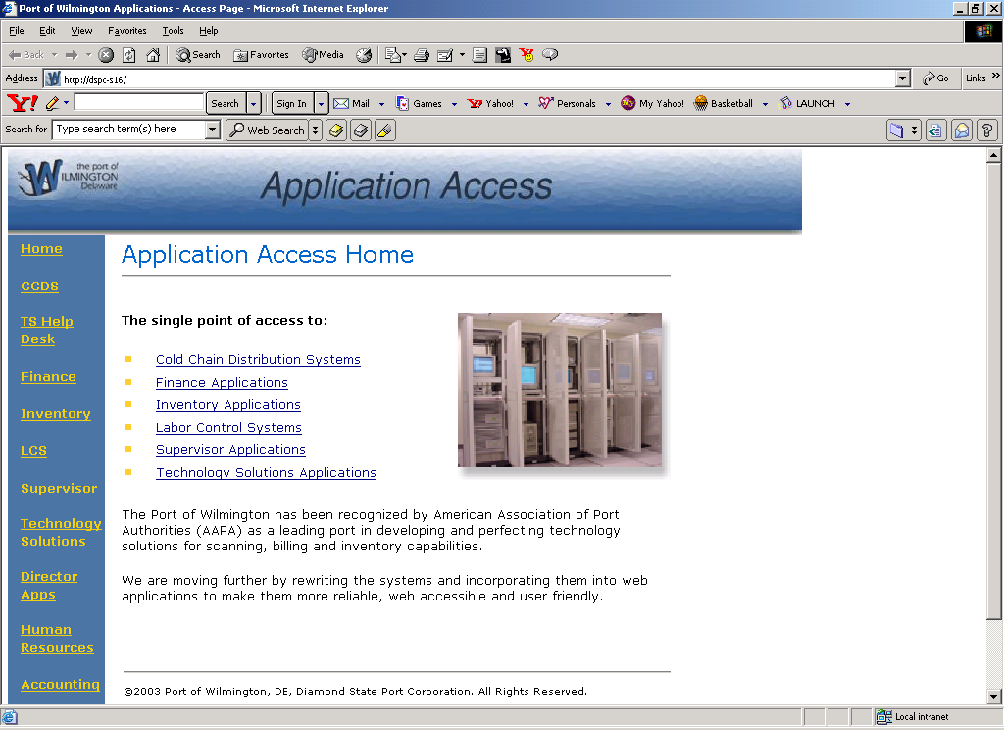
Click Director Apps

- Log onto Directors webpage
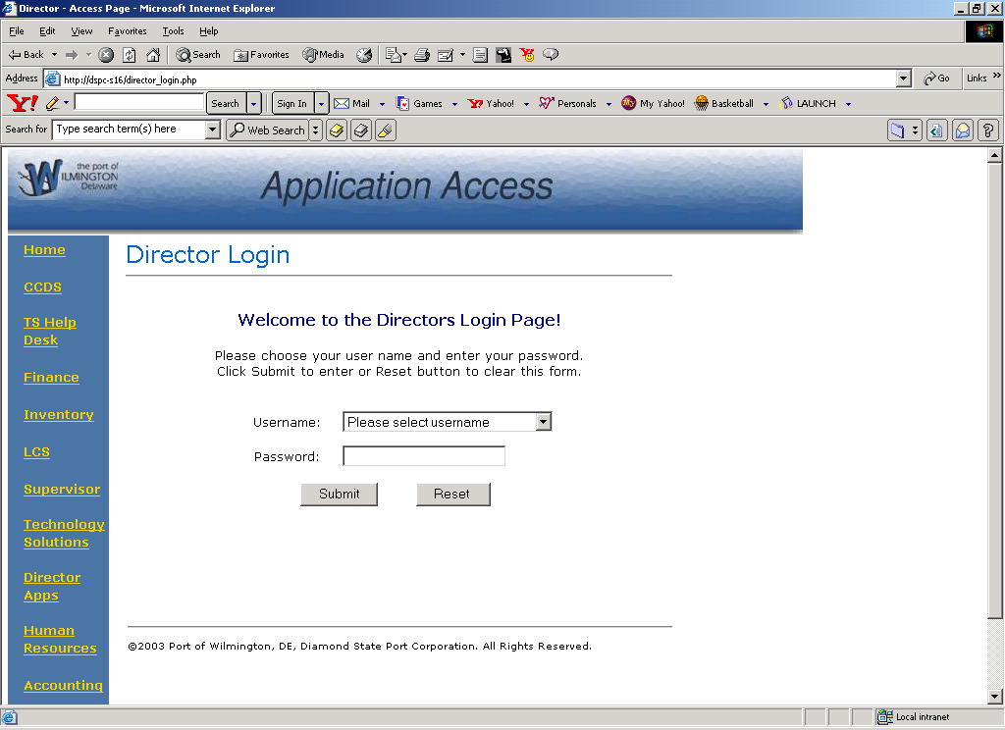
Login

- Click on Directors Meeting link
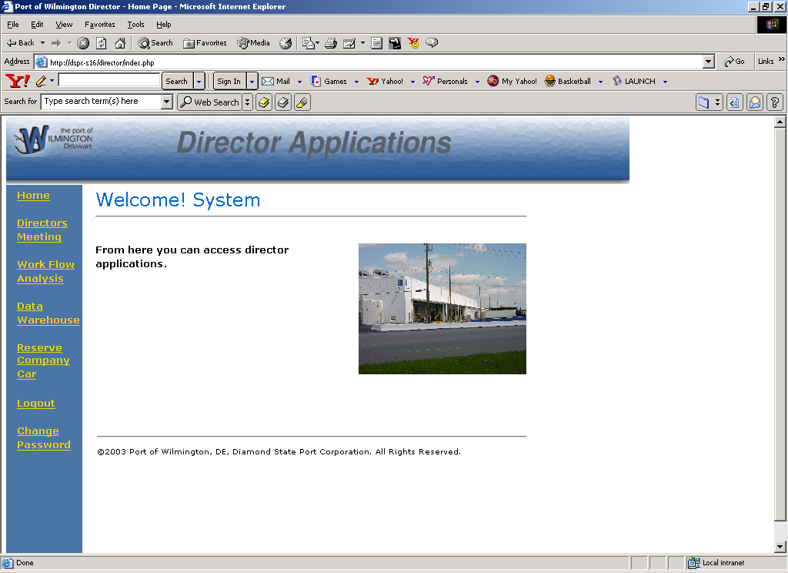
Click on Directors Meeting link

- Enter your Agenda Items
- Click on the "Save Agenda" button.
If you DO NOT click the "Save Agenda" button your agenda will NOT BE saved.
6. Click on the "Print Agenda" button to get a hardcopy.
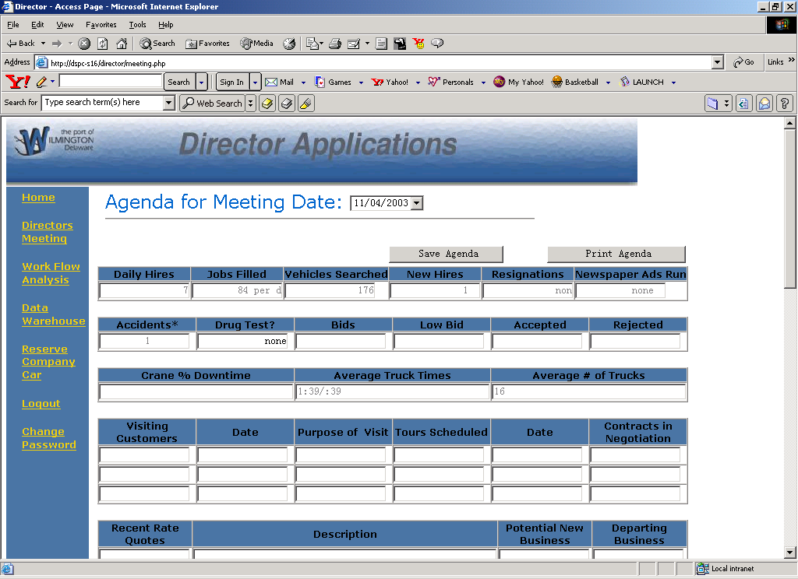
Save Agenda
Print agenda

