Update Invoices

This section of BNI Financial System enables you to update the commodity code, service code, GL code and asset code of invoices that have not been imported into the Oracle Financial System.

From this screen, you can either enter an invoice number into the Free Form input box or select one from the dropdown list and then click on Select the Invoice button to start working on this invoice.

The invoice number you entered will be checked to see whether it belongs to a valid invoice that is not imported into Oracle Financial. The system will report to about the error if it is not a valid invoice number to work on.

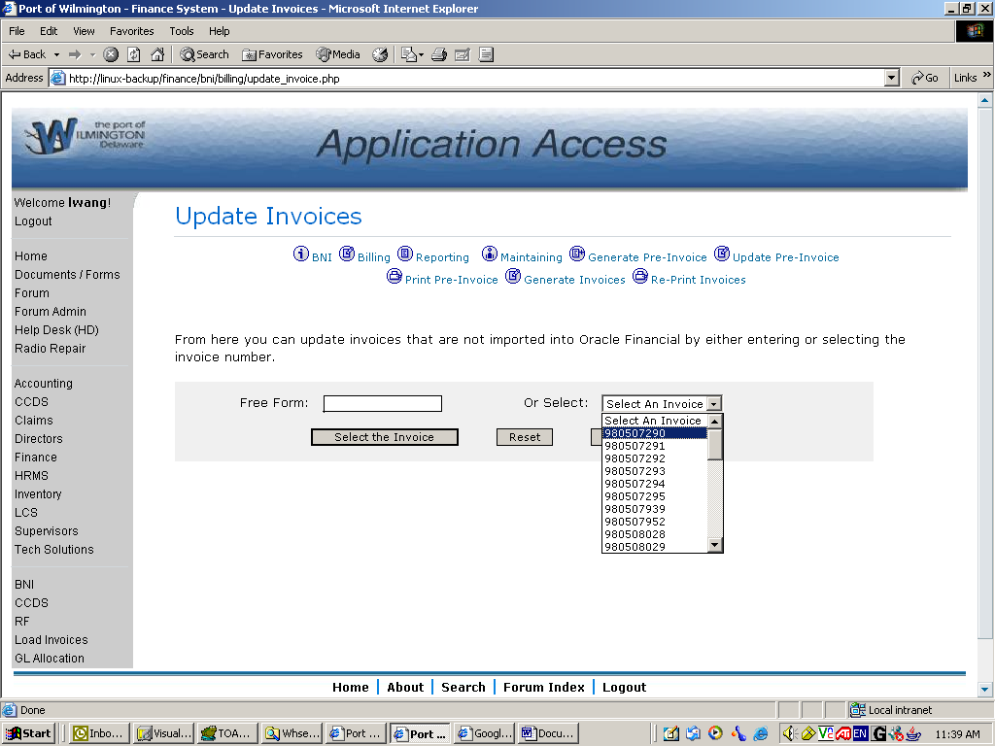

Once you select an invoice, the screen refreshes to show the current information of this invoice, as in the following screen shot.

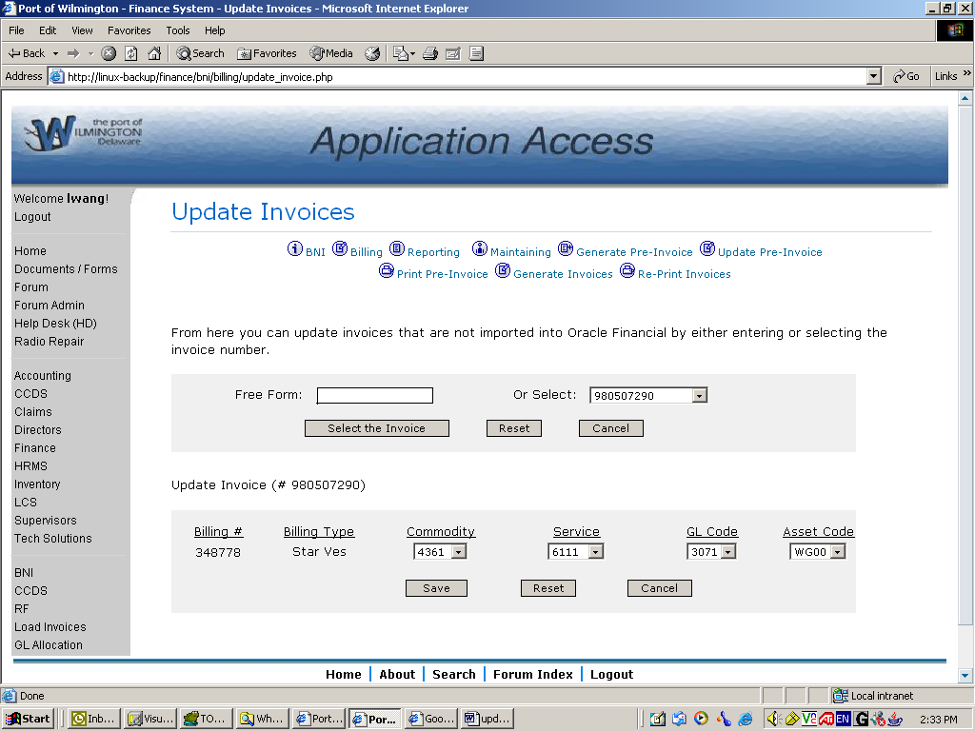

It shows the billing number, billing type, commodity code, service code, GL code and asset code of every bill of this invoice. For each of the codes, there is a drop-down list of valid codes from Oracle Financial.

Here are possible values of the selection boxes:

- If all the codes of a bill are valid, the codes will show on the screen, as in the previous screen shot.
- In the case the GL code is not available for a bill, the system will assign to it the GL code that is mapped to the service code if a valid service code presents, otherwise the GL code selection box will appear as blank. It will also be blank if the GL code of this bill is invalid, as shown in the following screen.
- In the case any other code is missing or invalid, its selection box will appear as blank so you know what to fix.

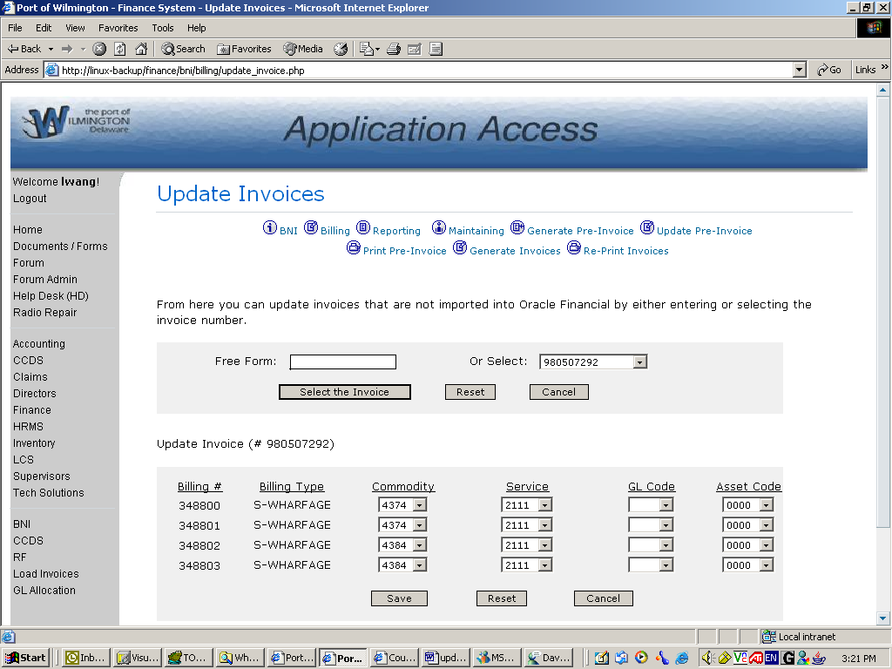

While you are making changes, you can always click on Reset button to reset the values to their original values and Cancel to stop working on this invoice. After you are satisfied with all the changes you made, click on the Save button and the system will save the changes you made and send you back to the Update Invoices screen with a message telling you that you have successfully updated the invoice.

You are done then!

