Import CSV
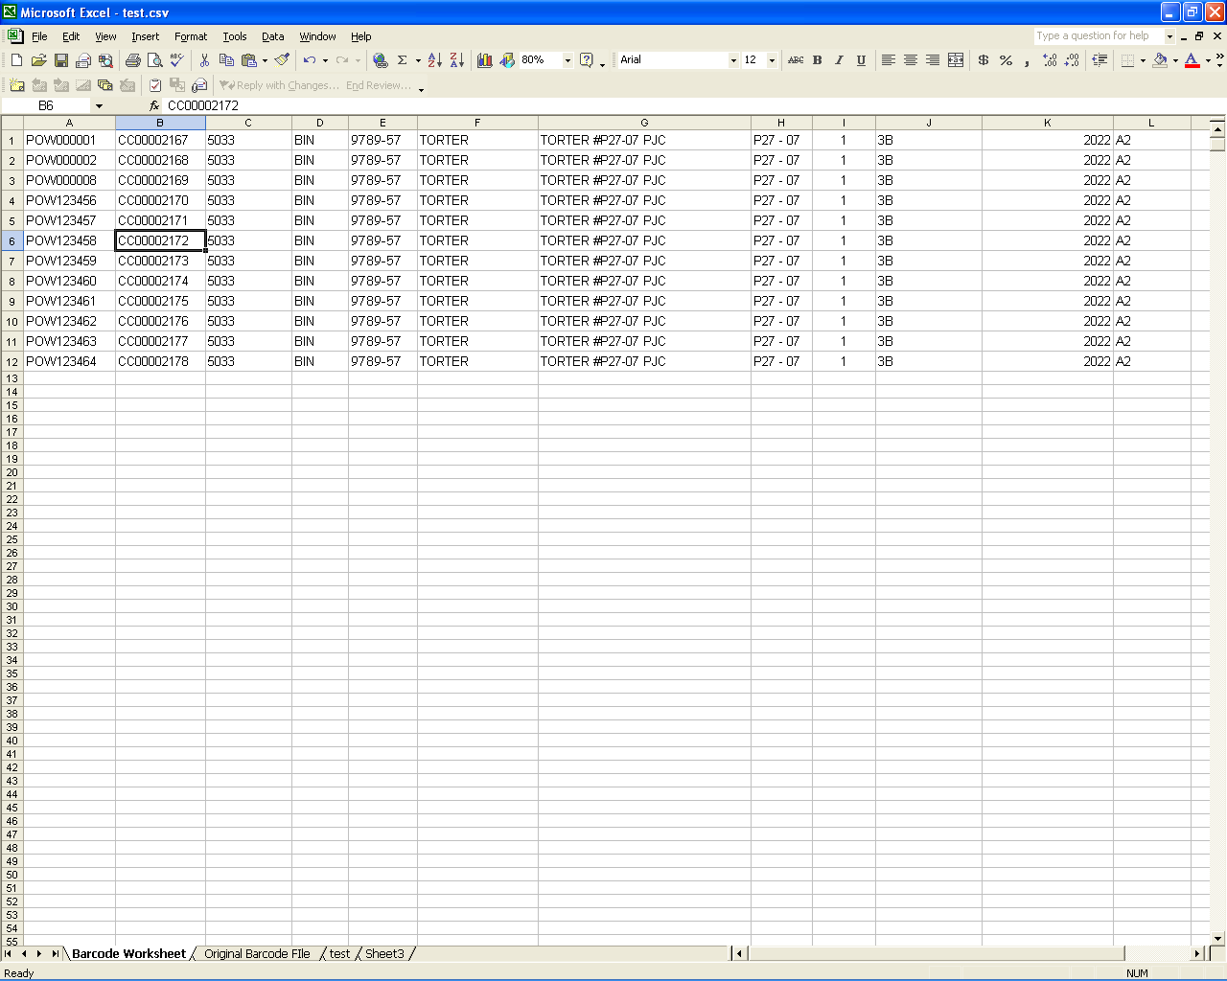

For this page to function properly, you MUST upload a properly-formatted CSV file.

The format is this:

A) The new POW label (example: POW000001)
B) The old barcode (example: ZU00033123)
C) The 4-digit commodity code
D) The storage unit (example: BIN)
E) The Bill of Lading
F) The Head Mark
G) The Full BNI inventory mark
H) The shipper’s lot number
I) The shipped quantity (normally 1)
J) The hatch on the ship the cargo was shipped in
K) The 4-digit customer number
L) The warehouse location the pallet is stored (do NOT put the word “WING” in this field, use only 2 character descriptions such as A2 or C7
M) The warehouse location code (please see the Inventory Control Manager for specific details)
Each line must be valid. Any line that does not match up precisely will cause the program to cancel the update, and no changes to the database will be made. In this event, you will receive a message stating what occurred, so it can be corrected and re-uploaded.

Once you have entered the above information into Microsoft Excel (similar to the sample picture above), save as a .csv file (choose File, Save As…, and in the Save as Type box, choose CSV (comma delimited) (*.csv). Then use this intranet page, choose the vessel, click the “Browse” button, and select the file you just created.

Tips:

-) To prevent database problems, do not use commas, quotes, apostrophes, or backslashes anywhere in the CSV file (I.E. don’t use , ‘ “ or \ ).

-) If this page is being used to update an existing pallet rather than to convert a barcode to a new POW label, you may enter “NEW” as the old barcode value (make sure the word NEW is in all capital letters)

