Import CSV for Booking Paper

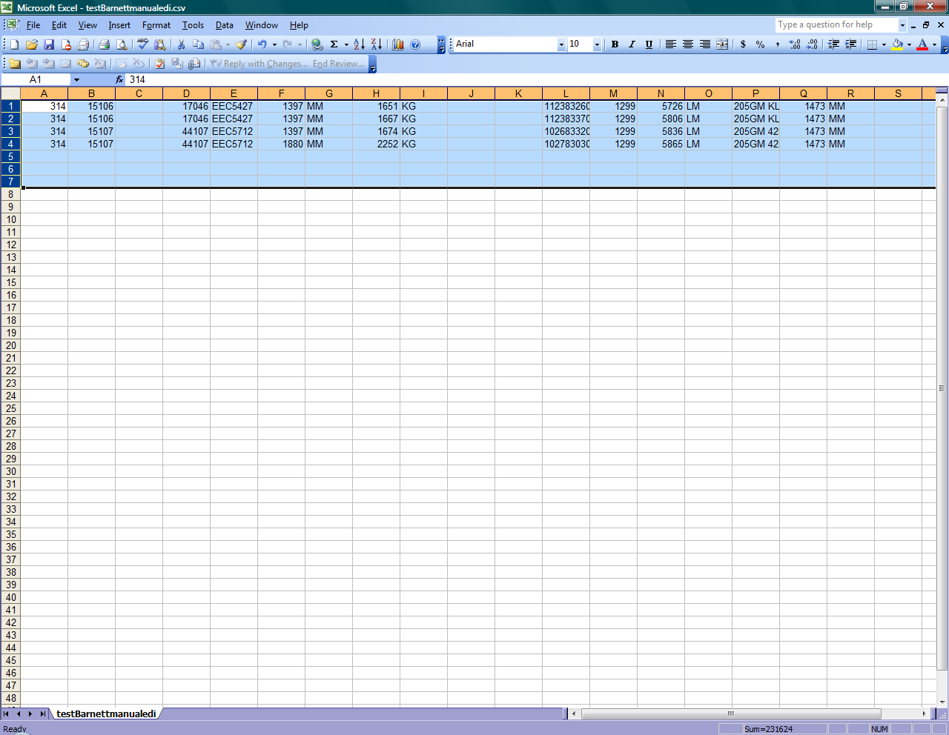

For this page to function properly, you MUST upload a properly-formatted CSV file.

The format is this:

A) The customer number (example: 314)
B) The P.O. number (example: 15106)
C) ---blank column---
D) The BOL number (example: 44107)
E) The LR Number (example: EEC5427)
F) The Cargo Width (example: 1397)
G) The Width Unit (example: MM)
H) The Weight (example: 1651)
I) The Weight Unit (example: KG)
J) ---blank column---
K) ---blank column---
L) The Barcode
M) The commodity code
N) Linear Feet (example: 21974)
O) Linear Measure (example: LM)
P) SSCC Code (example: KL115G)
Q) Diameter
R) Diameter Unit (example: MM)

Each line must be valid. Any line that does not match up precisely will cause the program to cancel the update, and no changes to the database will be made. In this event, you will receive a message stating what occurred, so it can be corrected and re-uploaded.

Once you have entered the above information into Microsoft Excel (similar to the sample picture above), save as a .csv file (choose File, Save As…, and in the Save as Type box, choose CSV (comma delimited) (*.csv). Then use this intranet page, click the “Browse” button, and select the file you just created.

Tips:

-) To prevent database hiccups, do not use commas, quotes, apostrophes, or backslashes anywhere in the CSV file (I.E. don’t use , ‘ “ or \ ). To quote IBM, results of using these characters “may vary”.

