Import CSV

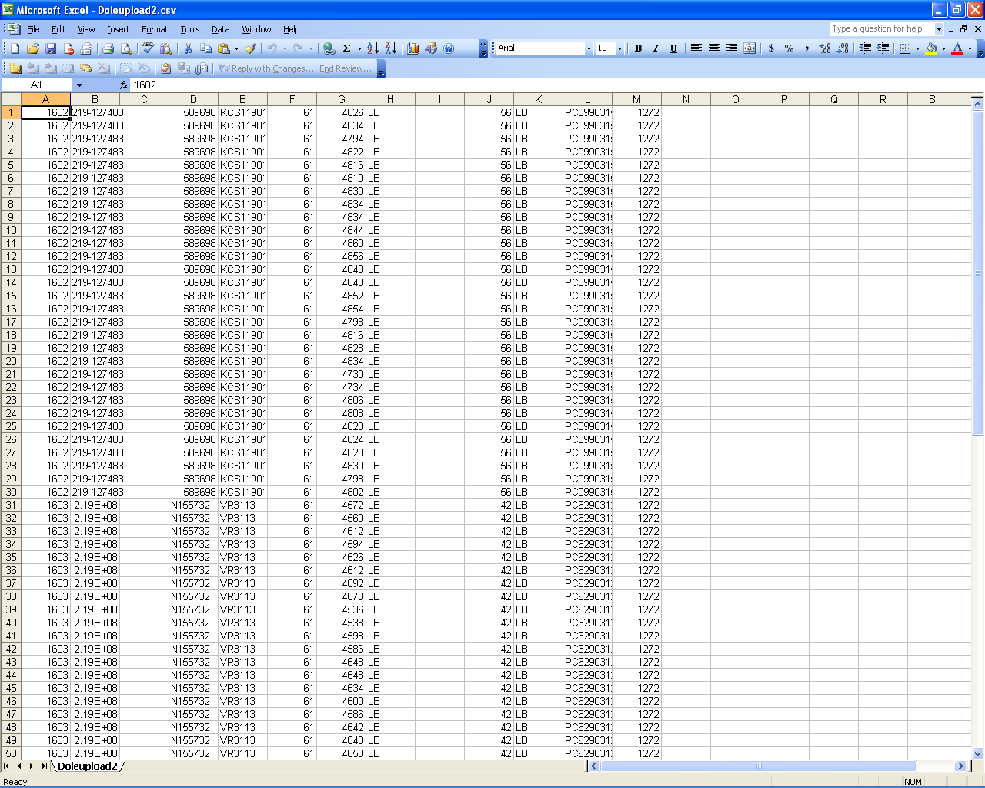

For this page to function properly, you MUST upload a properly-formatted CSV file.

The format is this:

A) The customer number (example: 1602)
B) The Dole P.O. number (example: 219-127483)
C) ---blank column---
D) The Dole Load number (example: N155732)
E) The Arrival Number (example: CSXT192034)
F) The Cargo Size (example: 55.5)
G) The Weight in pounds
H) The letters “LB”
I) ---blank column---
J) The basis weight (example: 42)
K) The letters “LB”
L) The Barcode
M) The commodity code
N) Linear Feet (example: 21974)
Each line must be valid. Any line that does not match up precisely will cause the program to cancel the update, and no changes to the database will be made. In this event, you will receive a message stating what occurred, so it can be corrected and re-uploaded.

Once you have entered the above information into Microsoft Excel (similar to the sample picture above), save as a .csv file (choose File, Save As…, and in the Save as Type box, choose CSV (comma delimited) (*.csv). Then use this intranet page, click the “Browse” button, and select the file you just created.

Tips:

-) To prevent database hiccups, do not use commas, quotes, apostrophes, or backslashes anywhere in the CSV file (I.E. don’t use , ‘ “ or \ ). To quote IBM, results of using these characters “may vary”.

-) The script will automatically assign dock ticket numbers per row; for 2 barcodes to have the same dock ticket number, OR for an existing dock ticket number to be used with any of the newly imported codes, columns B, C, F, and J must match EXACTLY to an existing barcode; otherwise, the cargo gets a new dock ticket number. Be very careful not to add spaces, decimals, or other things that you do not intend to.

