Transfer to Port Account CSV

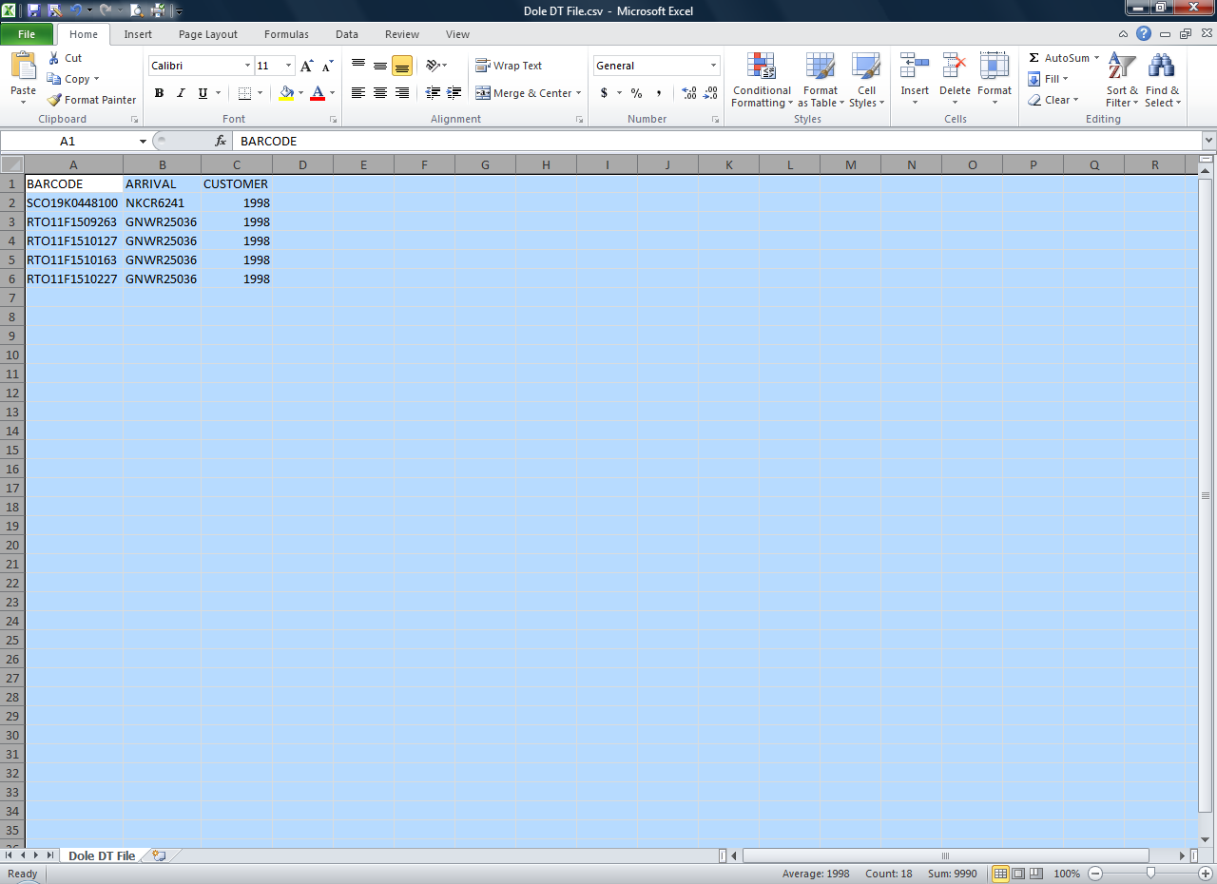

For this page to function properly, you MUST upload a properly-formatted CSV file.

The format is this:

A) BARCODE (the pallet number being transferred)
B) ARRIVAL (the arrival number of the pallet being transferred)
C) CUSTOMER (the customer ID being transferred from)

Each line must be valid. Any line that does not match up precisely will cause the program to cancel the update, and no changes to the database will be made. In this event, you will receive a message stating what occurred, so it can be corrected and re-uploaded.

Once you have entered the above information into Microsoft Excel (similar to the sample picture above), save as a .csv file (choose File, Save As…, and in the Save as Type box, choose CSV (comma delimited) (*.csv). Then use Paper-To-Port-Account Transfer intranet page, click the “Browse” button, and select the file you just created. Once selected, click on the Upload File button and you will see the file information plus any error messages.

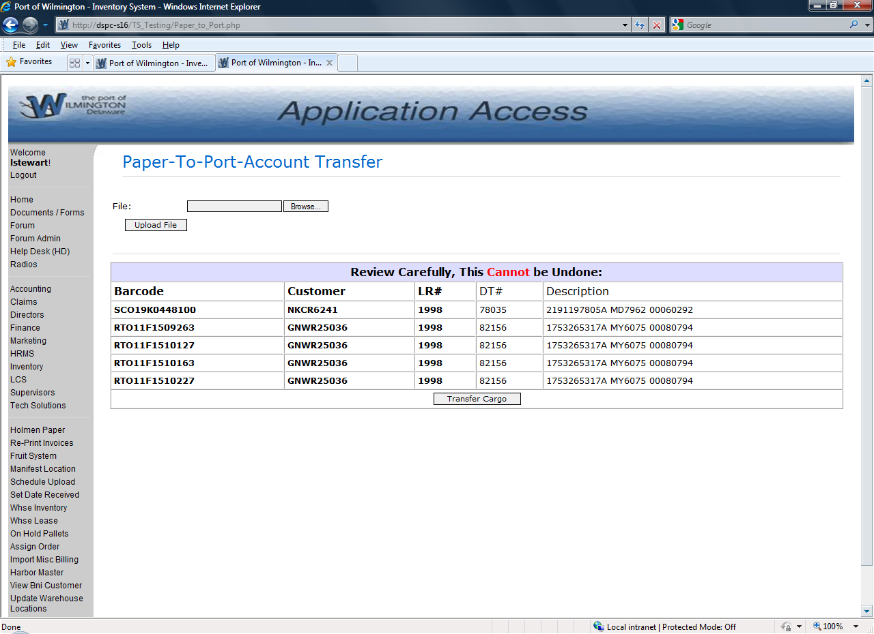

Once the Transfer Cargo button has been selected, the changes cannot be undone.

