Import XLS

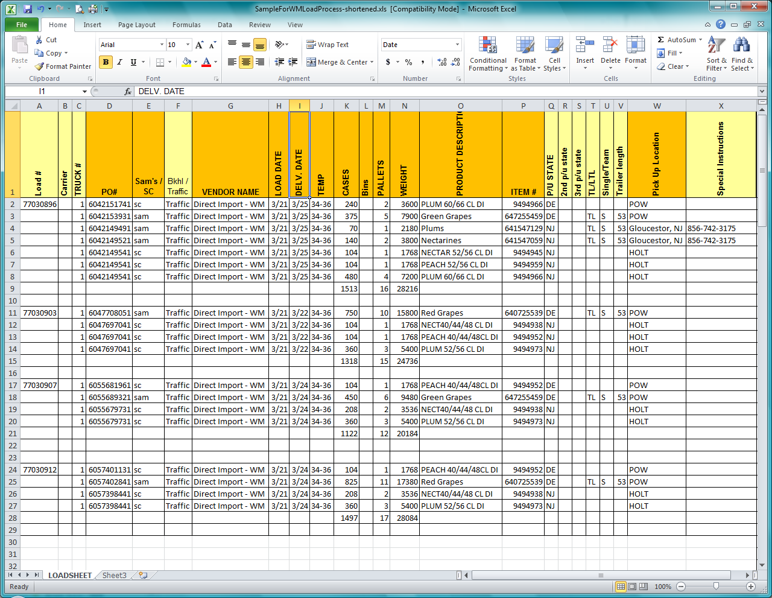

For this page to function properly, you MUST upload a properly-formatted XLS file.

Column headings are required and must be in the format shown. The field requirements are defined below.

A) Load number cannot be longer than 12 characters and must be alphanumeric
B) Carrier cannot be longer than 6 characters and must be **Note 1**
C) Truck number cannot be longer than 2 characters and must be numeric
D) PO number cannot be longer than 15 characters and must be numeric
E) Sam’s club cannot be longer than 5 characters and must be **Note 1**
F) Bkhl/Traffic cannot be longer than 10 characters and must be alphanumeric
G) Vendor cannot be longer than 25 characters and must be **Note 1**
H) Load Date must be MM/DD/YYYY format
I) Delivery Date must be MM/DD/YYYY format
J) Temperature cannot be longer than 6 characters and cannot contain letters
K) Cases count cannot be longer than 5 characters, must be numeric and cannot be blank
L) Bin count cannot be longer than 5 characters and must be numeric
M) Pallet count cannot be longer than 5 characters, must be numeric and cannot be blank
N) Weight cannot be longer than 7 characters and must be numeric
O) Product Description cannot be greater than 30 and **Note 2**
P) Item Number cannot be longer than 10 characters and must be numeric
Q) PU State cannot be longer than 2 characters and must be letters only
R) PU State2 cannot be longer than 2 characters and must be letters only
S) PU State3 cannot be longer than 2 characters and must be letters only
T) TLL/TL cannot be longer than 4 characters and must be **Note 1**
U) Single/Team cannot be longer than 2 characters and must be **Note 1**
V) Trailer Length cannot be longer than 4 characters and must be **Note 1**
W) PU Location cannot be longer than 15 characters and must be **Note 1**
X) Special Instructions cannot be greater than 50 and **Note 2**

Note 1: Can only be 0-9, a-z, A-Z, _ - space
Note 2: Can only be 0-9, a-z, A-Z, _ - space ` /
The ` is the tick mark found below the tilde on the keyboard (the key to the left of the number 1).

Field Requirements:

The PU State fields must be DE AND the PU Location field must be POW for the line to be uploaded.

There must be a value in the first Load Number field or the file will be ignored.

The Load and Delivery dates (columns H and I) are sent to us by Wal-Mart in a strange Excel format. The program has been designed to account for this. However, if someone here at DSPC creates a new file and uses a format such as m/d only, the program will error out. The format must be mm/dd/yyyy only.

