**Sort a WIP file spreadsheet format for importing.**

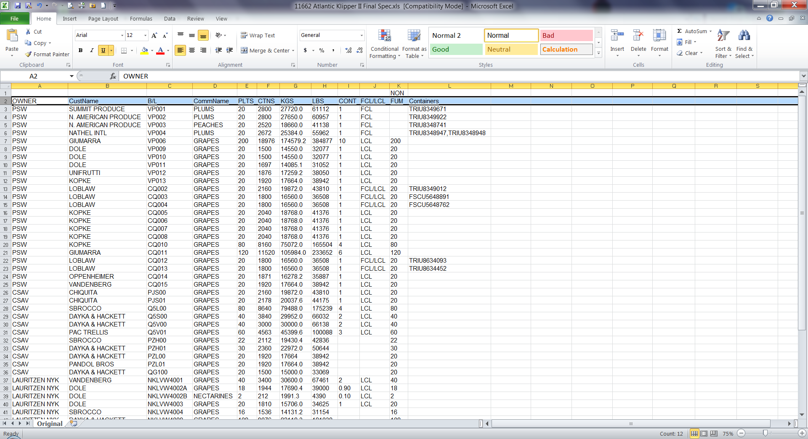

For this page to function properly, you MUST upload a properly-formatted XLSX file.

There are no column headings. The ones shown in this example are for clarity only. The column information must be in this order:

1. Shipping Line/Owner
2. Customer Name
3. Bill of Lading
4. Commodity Name
5. Number of pallets
6. Number of cartons
7. KGS
8. LBS
9. Containers count
10. FCL/LCL
11. Non-Fumed
12. Container numbers (Maximum of 30 entries)

Field Requirements:

All) To prevent data misinterpretation, do not use quotes, apostrophes, or backslashes anywhere in the file (I.E. don’t use ‘ “ or \).

1. Owner Name cannot be longer than 40 alphanumeric characters
2. Customer name cannot be longer than 40 alphanumeric characters
3. Bill of Lading cannot be longer than 20 alphanumeric characters
4. Commodity name cannot be longer than 20 alphanumeric characters
5. Pallet count cannot be longer than 4 numeric characters
6. Cartons cannot be longer than 6 numeric characters
7. KGS cannot be longer than 10 numeric characters in the format xx.x (one decimal position allowed)
8. LBS cannot be longer than 10 numeric characters in the format xx.x (one decimal position allowed)
9. Container count cannot be longer than 10 numeric characters in the format xx.xx (two decimal positions allowed)
10. FCL/LCL cannot be longer than 20 alphanumeric characters
11. Non-fumigated cannot be longer than 4 numeric characters
12. Container name cannot be longer than 14 alphanumeric characters

A table has been created but will need to be modified to have all the fields noted above. The table name is BNI.Excel_Manifest_Sort. This table will also contain the following derived fields:

Customer Number (look up name from RF.Chilean_customer_map)

Commodity Number (look up name from RF.Chilean_commodity_map)

These 2 fields are not entered by Inventory but will be shown on the reports.