0V

3.3V
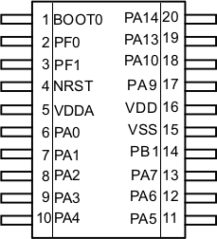
BMP180+HMC5983
Module
(includes pull-up
resistors on SDA
and SCL)
SDA
SCL
0V
3.3V
0V
PWR
CE
CSN
SCLK
MISO
MOSI
TXEn
DR
NRF905
Module
STM32F030
22k

