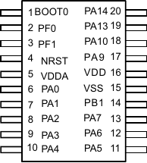
OpenSmart RM68130
DB7
DB0
DB0
To PA0-PA7
0V
LED
RST
WR
RD
RS
0V
3.3V
3.3V
3.3V
0V
0V
STM32F030F4P6
CS

