The €5 Dublin Maker badge

Image of badge needed here
Introduction
In the past number of years conference badges have become increasingly complex (e.g. DefCon 2018 badge). Not wishing to be left out, some attendees of Dublin Maker have decided to put together their own badge. The aims for this badge are as follows:
It must be cheap (€5 or less)
It must be fully open source (hardware design and code)
It must be within the reach of the average electronic maker to put one together.
It must be fun to use.

Costs were kept down by sourcing all components from online Chinese suppliers (AliExpress).

The starting point for the software for the project is “Breadboard Games” (www.ioprog.com/bbg). In particular it makes use of the BBG graphics library and some of it’s games.

In order to making the badge “makable” it was decided not to go down the route of a custom PCB and to use proto board instead. One surface mount component was used but this was mounted on an off-the-shelf breakout board (TSSOP-20 to DIL). This approach also makes the badge more amenable to breadboard construction.

As mentioned above, some games were sourced from the Breadboard Games project however it was decided to add a multiplayer game also as Dublin Maker tends to be quite a social event.

One additional consideration was that it should be easy to repurpose the badge for some other event. This affected how the logo was implemented. Rather than painfully figure all of the co-ordinates and colours for the logo it was decided to make use of Inkscape as an image design tool. A helper python program takes the svg output from Inkscape and converts it into a header file suitable for use with the badge. This should help others change the logo to suit their own needs.

Costing.
The table below shows the cost breakdown for the badge. Pricing for components varied from day to day so average figures are shown in the table. The display is by far the most expensive part but still pretty cheap as far as these things go. It’s a 240x240 colour LCD (IPS?) display with an ST7789 controller chip. This chip has a SPI interface which greatly simplifies wiring. The interface can be run at 24MHz allowing for pretty fast drawing. In theory the display interface is bi-directional (half-duplex SPI). This is not something I have done and it does have an impact on game design (I can’t read video memory so the movement of sprites assumes that the background is a fixed colour – usually black).

The core of the badge is the MCU – in this case an STM32F030F4P6 which has 16kB of flash memory and 4kB of RAM. Some more flash memory would have been useful for bitmaps and texture storage but at 36 cents each this MCU still represents good value for money. This device runs at 48MHz and can idle at very low power – important for prolonging battery life.

Power for the badge could have come from a pair of AA or AAA batteries. These would have supplied 3V when they were new but it was noticed that as they drained the display backlight would become so dim as to make it hard to read in daylight. An alternative solution was used instead involving a low cost boost converter. This converter operates with an input voltage in the range 0.9V to 3V and outputs 3.3V. It appears to be quite efficient (> 80%) and allows the badge to be run off a single AA (or AAA) cell.

The second most expensive item of the build is a “lanyard”. While this may seem odd, it is not just a simple cord or ribbon. This lanyard is a 3.5mm stereo audio cable which plugs in to a socket on each side of the badge. Using this cable, badges can be chained together for multiplayer games. A radio solution for multi-player games was considered however it was decided to take the wired approach as it involved no firmware binary blobs and was understandable down to the bit level by most programmers/hackers.

The remaining components include buttons, switches, boards etc and are likely to change if some other group builds on this design.

Badge component costs (all prices in Euro). Supplier AliExpress.

Electronic design

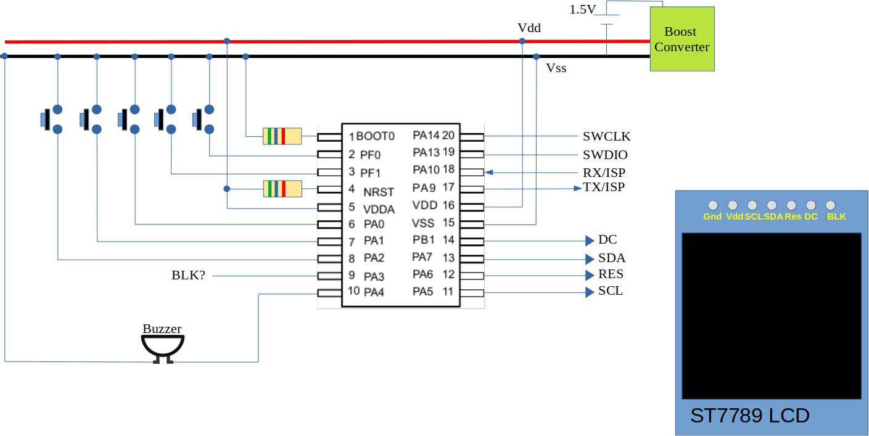
The figure below outlines the basic circuit design.

All components are supplied from a boost converter module with an output voltage of 3.3V. This module seems to be based on a Nanjing Micro One Electronics component (2108A 1549/50) with an input voltage range of between 0.9V and 3V. The full load current consumption of the badge is approx 35mA @ 3.3V (115mW). This equates to about 100mA from a 1.5V battery (assuming efficiency is about 80%). A current of this level is probably a little too much to ask of a AAA battery so it was decided to use an AA battery instead. A “good” alkaline AA should give a continuous running time of about 24 hours.
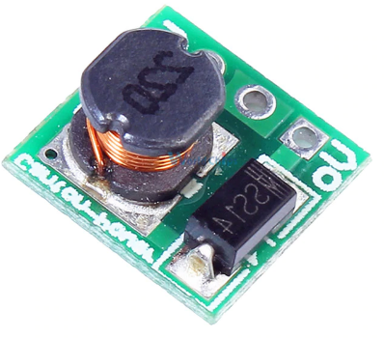

Five buttons are used for user input : Left, Right, Up, Down, Fire. These are connected to inputs that are internally pulled up inside the MCU. A piezo transducer is used for sound output.
The display uses a half duplex SPI connection along with a “D/C (data/command”) select input and a reset input. A backlight input is also available. This floats high so can be left unconnected however it may be used to shut the display (or dim it) when it is idle.
Software design

