佛 山 科 学 技 术 学 院

《机器学习》实训报告

专 业 数据科学与大数据技术 姓 名 陈荣辉 成 绩

班 级 17大数据3 学 号 20170060316 日 期 2020/5/27

一、目的和要求
1、理解k-近邻算法的原理，掌握k-近邻算法的应用开发。

二、主要内容
实例：糖尿病预测
任务：预测Pima 印度安人的糖尿病
数据来源：
1. https://www.kaggle.com/uciml/pima-indians-diabetes-database
2. 随书代码里，code/datasets/pima-indians-diabetes

三、数据清洗
1、使用Pandas加载数据
%matplotlib inline
import matplotlib.pyplot as plt
import numpy as np
import pandas as pd

# 加载数据
data = pd.read_csv('diabetes.csv')
print('dataset shape {}'.format(data.shape))
data.head()

输出：dataset shape (768, 9)
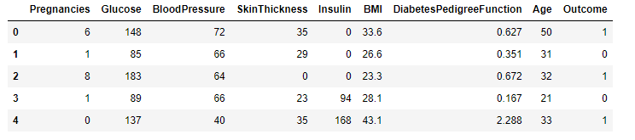

data.groupby("Ou tcome").size()
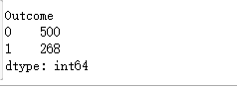

2、将特征值分离出来，把数据集划分成训练数据集（0.8）和测试数据集（0.2）

X = data.iloc[:, 0:8]
Y = data.iloc[:, 8]
print('shape of X {}; shape of Y {}'.format(X.shape, Y.shape))

from sklearn.model_selection import train_test_split
X_train, X_test, Y_train, Y_test = train_test_split(X, Y, test_size=0.2);

四、模型训练和测试
1、模型比较：普通的K-均值算法，带权重的K-均值算法，指定半径的K-均值算法
from sklearn.neighbors import KNeighborsClassifier, RadiusNeighborsClassifier

models = []
models.append(("KNN", KNeighborsClassifier(n_neighbors=2)))
models.append(("KNN with weights", KNeighborsClassifier(
n_neighbors=2, weights="distance")))
models.append(("Radius Neighbors", RadiusNeighborsClassifier(
n_neighbors=2, radius=500.0)))

results = []
for name, model in models:
model.fit(X_train, Y_train)
results.append((name, model.score(X_test, Y_test)))
for i in range(len(results)):
print("name: {}; score: {}".format(results[i][0],results[i][1]))

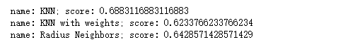
from sklearn.model_selection import KFold
from sklearn.model_selection import cross_val_score

results = []
for name, model in models:
kfold = KFold(n_splits=10)
cv_result = cross_val_score(model, X, Y, cv=kfold)
results.append((name, cv_result))
for i in range(len(results)):
print("name: {}; cross val score: {}".format(
results[i][0],results[i][1].mean()))
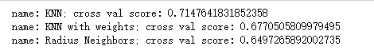

2、模型训练及训练：采用的是普通的K-均值算法
knn = KNeighborsClassifier(n_neighbors=2)
knn.fit(X_train, Y_train)
train_score = knn.score(X_train, Y_train)
test_score = knn.score(X_test, Y_test)
print("train score: {}; test score: {}".format(train_score, test_score))

from sklearn.model_selection import ShuffleSplit
from common.utils import plot_learning_curve

knn = KNeighborsClassifier(n_neighbors=2)
cv = ShuffleSplit(n_splits=10, test_size=0.2, random_state=0)
plt.figure(figsize=(10, 6), dpi=200)
plot_learning_curve(plt, knn, "Learn Curve for KNN Diabetes",
X, Y, ylim=(0.0, 1.01), cv=cv);

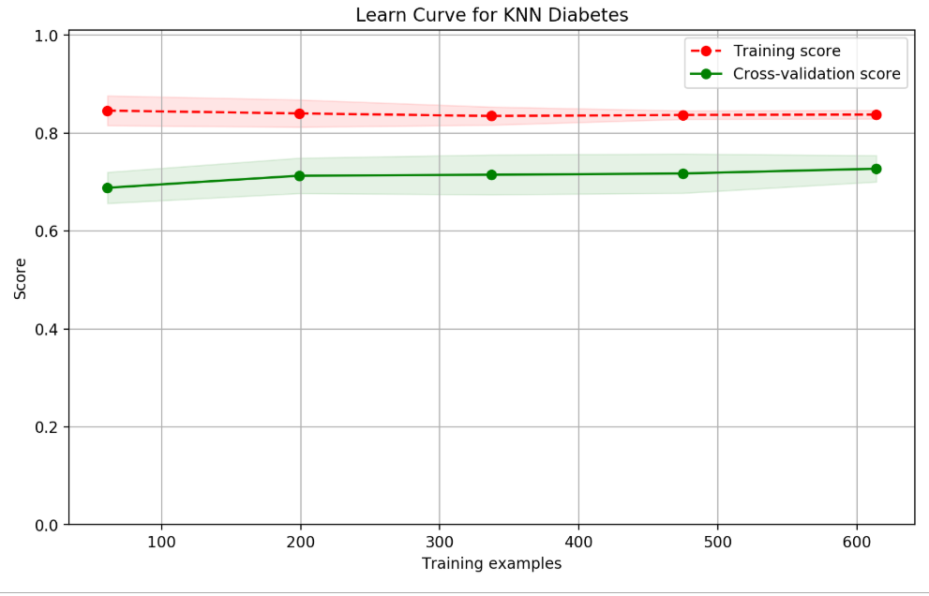
3、特征选择及数据可视化

from sklearn.feature_selection import SelectKBest

selector = SelectKBest(k=2)
X_new = selector.fit_transform(X, Y)
X_new[0:5]

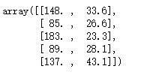
results = []
for name, model in models:
kfold = KFold(n_splits=10)
cv_result = cross_val_score(model, X_new, Y, cv=kfold)
results.append((name, cv_result))
for i in range(len(results)):
print("name: {}; cross val score: {}".format(
results[i][0],results[i][1].mean()))
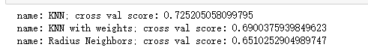
# 画出数据
plt.figure(figsize=(10, 6), dpi=200)
plt.ylabel("BMI")
plt.xlabel("Glucose")
plt.scatter(X_new[Y==0][:, 0], X_new[Y==0][:, 1], c='r', s=20, marker='o'); # 画出样本
plt.scatter(X_new[Y==1][:, 0], X_new[Y==1][:, 1], c='g', s=20, marker='^'); # 画出样本

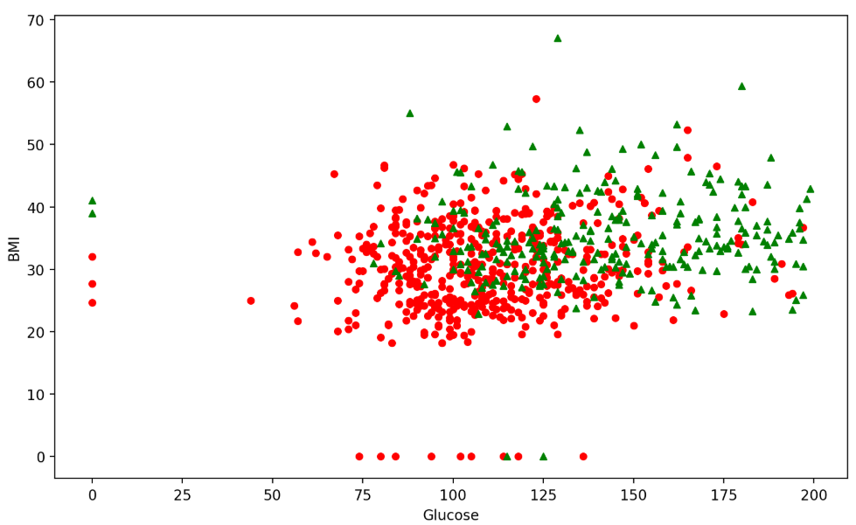
五、模型性能评估和优化
1、绘制ROC曲线
from sklearn.metrics import roc_curve
knn = KNeighborsClassifier(n_neighbors=2)
knn.fit(X_train,Y_train)
knn.score(X_test,Y_test)
y_pred_proba = knn.predict_proba(X_test)[:,1]
fpr, tpr, thresholds = roc_curve(Y_test, y_pred_proba)
plt.figure(1)
plt.plot([0,1],[0,1],'k--')
plt.plot(fpr,tpr, label='Knn')
plt.xlabel('fpr')
plt.ylabel('tpr')
plt.title('Knn(n_neighbors=2) ROC curve')
plt.show()
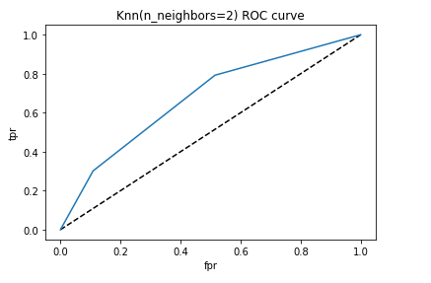

2、绘制PR曲线

from sklearn.metrics import precision_recall_curve
plt.figure(1)
precision_KNN, recall_KNN, th_KNN = precision_recall_curve(Y_test, y_pred_proba)
plt.plot([1, 0], [0, 1], 'k--')
plt.title('Precision vs. Recall')
plt.xlabel('Recall')
plt.ylabel('Precision')
plt.plot(recall_KNN, precision_KNN, label='KNN')
plt.show()
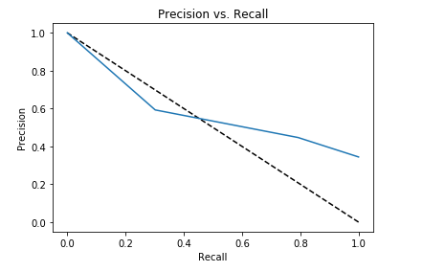

（1）

