ELE 402 — GRADUATION PROJECT II
INTERIM REPORT

Hacettepe University
Department of Electrical and Electronics Engineering
Cereyan Hacıları
Design and Implementation of a 5-Level Cascaded H-Bridge Multilevel Inverter with PWM-Based Control
Project Group Members
Ahmet Koçak • Furkan Emir Aksel • Mücahit Aydın • Faruk Gökhan Abay
Project Supervisor
Assoc. Prof. Dr. Rasim Doğan
Submission Date: 26 April 2026 | Spring 2025–2026

TABLE OF CONTENTS

TABLE OF CONTENTS i
1. INTRODUCTION 1
1.1 Inverter 1
1.2 PWM-Based Control 1
1.3 Multilevel Inverter 2
1.4 5-Level Output 2
1.5 Cascaded H-Bridge Topology 2
2. PROTOTYPE 3
2.1 System Architecture 3
2.2 Controller: STM32 Nucleo-F303RE 4
2.3 Power Stage: H-Bridge MOSFETs 4
2.4 Gate Drive: TLP250 with Isolated Bootstrap Supplies 5
2.5 Isolated Sensing Chain 5
2.6 Passive and Protection Components 6
3. DESIGN PROCESS & PROGRESS 7
3.1 Iteration 1 — Component Testing 7
3.1.1 Testing and Results 8
3.1.2 Evaluation 9
3.2 Iteration 2 — First H-Bridge and Manual Testing 10
3.2.1 Testing and Results 10
3.2.2 Evaluation 12
3.3 Iteration 3 — Modulation Strategy: LS-PWM to Unipolar SPWM 13
3.3.1 Testing and Results 13
3.3.2 Evaluation 16
3.4 Iteration 4 — PCB: Monolithic Layout to Modular Single-Bridge Boards 17
3.4.1 Testing and Results 18
3.4.2 Evaluation 21
REFERENCES 22

1. INTRODUCTION
This report explains the development of a 5-Level Cascaded H-Bridge (CHB) Multilevel Inverter with PWM control during the Spring 2025–2026 semester. It continues the project started in the ELE 401 term. During that term we defined the system, simulated it in MATLAB/Simulink, and designed its specific components. To meet the ELE 402 requirements, our main focus this semester was building, testing, and improving a physical prototype step by step. The report describes four design iterations. Each iteration includes finding a solution, applying it, and testing it to make improvements for the next version. Before explaining these stages, this section defines the key terms used in the rest of the report.

1.1 Inverter
At its core, an inverter is a power electronic device. Its main job is to change Direct Current (DC) into Alternating Current (AC). While a battery or a DC power supply provides a constant, straight-line voltage, home appliances and industrial machines need an AC voltage, which goes up and down in a smooth wave shape (a sine wave) at a specific frequency, like 50 Hz.

1.2 PWM-Based Control
To create that AC wave we need a "brain" to control the inverter. This is where PWM comes in. Instead of just turning the power on and off slowly, we turn the electronic switches (transistors) on and off very fast. By changing how long the switches stay on (the "width" of the pulse) we can control the amount of power that goes to the output. Microcontrollers, like our STM32 Nucleo-F303RE, can generate these precise, fast signals. By calculating the correct pulse widths the output voltage is shaped to look like a sine wave.

1.3 Multilevel Inverter
A traditional, basic inverter only creates two voltage levels: positive and negative. Because it only has two big steps, the output wave is very rough and blocky. This rough shape creates unwanted electrical noise (called harmonics) which can heat up or damage connected devices. A multilevel inverter solves this problem by building the AC wave using smaller "steps" or "stairs". By adding more steps the output looks much closer to a perfect, smooth sine wave. This means better power quality and smaller filters.

1.4 5-Level Output
This describes exactly how many "steps" our inverter will use to build the wave. A 5-level inverter creates five different voltage states. Usually these states are: +2Vdc, +Vdc, 0, –Vdc and –2Vdc. Because it uses five steps instead of just two large jumps, the shape of the output wave is much closer to a perfect, smooth sine wave. In engineering terms this means the Total Harmonic Distortion (THD) is significantly reduced. Lower THD provides much better power quality, prevents connected devices from overheating, and allows us to use much smaller and cheaper output filters.

1.5 Cascaded H-Bridge Topology
This is the physical circuit design (topology) used to create those five levels. An H-bridge is a simple circuit made of four switches (MOSFETs) shaped like the letter "H"; it can output positive, negative, or zero voltage. "Cascaded" means H-bridges are connected in series, one after the other. To get five levels, two H-bridges are connected in a line; their voltages add up to create the higher steps of the wave.

2. PROTOTYPE
The prototype is the concrete, physical realisation of the system that was specified in ELE 401. It consists of four major sub-systems: the controller, the power stage, the isolated gate drive, and the isolated sensing chain. They interact as shown in Figure 1.
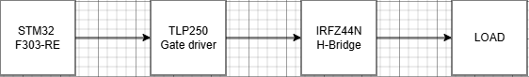
Figure 1. Top-level signal flow: the STM32 controller generates PWM, the TLP250 drivers amplify and isolate it, the MOSFET H-bridges switch the DC bus, and the load receives the resulting 5-level AC output.

2.1 System Architecture
Two identical single-phase H-bridge cells are connected in series at their AC terminals. Each cell is fed from its own 50 V DC source and is driven by four MOSFETs. By coordinating the eight switches as described in Table 1, the combined output produces the five discrete voltage levels of the 5-level staircase. The controller, gate drivers and sensing island are galvanically isolated from the high-voltage power stage so that the floating reference of the upper bridge does not propagate faults back into the control circuitry or into the USB-connected host PC.
Table 1. 5-Level CHB switching states for nominal Vdc = 50 V.
Level | Output | Bridge 1 | Bridge 2
+2Vdc | +100 V | Q1 + Q4 ON (+50 V) | Q1 + Q4 ON (+50 V)
+Vdc | +50 V | Q1 + Q4 ON (+50 V) | Q1 + Q3 ON (0 V)
0 | 0 V | Q1 + Q3 ON (0 V) | Q1 + Q3 ON (0 V)
–Vdc | –50 V | Q2 + Q3 ON (–50 V) | Q1 + Q3 ON (0 V)
–2Vdc | –100 V | Q2 + Q3 ON (–50 V) | Q2 + Q3 ON (–50 V)

2.2 Controller: STM32 Nucleo-F303RE
The STM32 Nucleo-F303RE was selected as the central controller because it contains two advanced-control timers (TIM1 and TIM8) that are specifically intended for power-conversion applications. Each timer can generate up to three complementary channel pairs with programmable dead-time insertion, so a single chip comfortably covers the eight gate signals required by the two bridges. The system clock is configured at 64 MHz; with the timers in centre-aligned mode and an ARR value of 6399, the resulting switching frequency is exactly 5 kHz, which leaves more than adequate timer resolution for the sinusoidal reference. The break-input feature provides a hardware path for killing all PWM outputs within one switching period in response to a fault signal. Both timers are synchronised through the master–slave feature so that the two bridges share a common carrier phase.

2.3 Power Stage: H-Bridge MOSFETs
Each H-bridge uses four N-channel power MOSFETs in the classical "H" configuration. The original ELE 401 design was built around the IRFZ44N (55 V VDSS, 49 A, ~17.5 mΩ RDS(on)), which was selected for its adequate voltage margin above the 50 V bus, its large current head-room for the expected ~7 A peak load current, and its low cost. All breadboard testing reported in this document was performed with IRFZ44N devices. During PCB procurement, however, IRFB4110 MOSFETs (100 V VDSS, 180 A continuous, ~4.5 mΩ RDS(on)) were obtained at a comparable price from a local supplier and were fitted to the project. The IRFB4110 is a mechanical and electrical drop-in replacement in the TO-220AB package and provides an additional 45 V of voltage head-room, which, as §2.6 explains, brings the 1.5KE62A TVS clamp voltage comfortably inside the MOSFET's safe operating area. The IRFB4110 also permits a later firmware increase of the switching frequency without exceeding the MOSFETs' switching losses.

2.4 Gate Drive: TLP250 with Isolated Bootstrap Supplies
Every MOSFET is driven by a TLP250 optically isolated gate driver. The TLP250 provides 2.5 kVrms of galvanic isolation between the low-voltage control signal and the gate terminal, and a peak output current of roughly 1.5 A, sufficient to charge the gate capacitance of the IRFZ44N at the target switching frequency. Each bridge requires a floating +15 V supply for its high-side drivers; this supply is generated by two paralleled B0515S-1W isolated DC–DC converters, balanced by 1 Ω series resistors and filtered by a combined 100 µF electrolytic plus 100 nF ceramic capacitor bank. The high-side drivers obtain their momentary VCC through a bootstrap arrangement: a UF4007 fast-recovery diode feeds a 10 µF capacitor between the TLP250 VCC (pin 8) and the MOSFET source. When the low-side MOSFET is conducting, the bootstrap capacitor charges to roughly 14.3 V (i.e. 15 V minus one diode drop); when the high-side MOSFET switches on, that capacitor becomes the floating VCC for the TLP250 during the on-time.

2.5 Isolated Sensing Chain
For closed-loop operation and fault protection, both DC bus voltages and the output current must be visible to the controller without breaking the isolation barrier. Each DC bus is sampled by an MCP3201 12-bit SPI ADC powered from an isolated 78L05 local regulator fed from the same 15 V drive rail. The SPI signals to and from each island travel through three 6N137 high-speed digital optocouplers per island. Output current is sensed on the safe side by an ACS712-20A Hall-effect sensor whose analogue output is divided down and sampled by a third, safe-side MCP3201. All three ADCs share SCK but have independent CS and MISO lines. The controller executes a complete three-channel scan in roughly 48 µs at 1 MHz SPI, giving more than four measurements per 5 kHz switching period.

2.6 Passive and Protection Components
A 1000 µF / 100 V electrolytic capacitor provides bulk energy storage on each bridge's DC bus, with a 100 nF ceramic capacitor in parallel to handle the high-frequency component of the switching currents. A 100 kΩ / 2 W bleeder resistor across the bus ensures the electrolytic discharges to a safe voltage in approximately eight minutes after power-down. Each bridge DC input is protected by a 15 A blade fuse in series with the + rail, a 1N5408 reverse-polarity diode, and a 1.5KE62A transient voltage suppressor that clamps any spikes to 84.5 V. This clamp voltage sits comfortably below the IRFB4110's 100 V VDSS rating, but would have been marginal with the original IRFZ44N (55 V VDSS); the MOSFET upgrade described in §2.3 was therefore a helpful side-effect of the component-procurement decision. At every MOSFET, a 22 Ω series gate resistor controls the switching speed, a 10 kΩ gate-source pull-down guarantees an OFF state during power-up, and an RC snubber of 22 Ω (2 W) in series with 2.2 nF (630 V film) damps the drain-source ringing.
A low-pass LC output filter, sized in MATLAB/Simulink at a 237 Hz / 325 Hz cut-off range during ELE 401, will be required between the cascaded bridges and the load to remove the residual switching components and produce a near-sinusoidal output voltage. To keep the as-fabricated PCB small and to allow the filter inductor to be wound and characterised independently, the filter has been de-scoped from the on-board components and is planned as a separate, optional pluggable add-on board scheduled for the final-term verification phase.
Table 2. Key component selection summary.
Function | Part | Key rationale
Controller | STM32 Nucleo-F303RE | Two advanced timers, complementary PWM, programmable dead-time, break input.
Main switches | IRFZ44N (breadboard) → IRFB4110 (PCB) | TO-220 N-channel power MOSFETs; IRFB4110 adds head-room (100 V, 180 A, ~4.5 mΩ) over the 55 V IRFZ44N.
Gate driver | TLP250 | 2.5 kVrms isolation, 1.5 A peak output, simple bootstrap-friendly topology.
Isolated +15 V supply | B0515S-1W (×2 paralleled) | Galvanic isolation for each floating bridge, 2 W combined headroom.
DC bus sensing | MCP3201 + 6N137 ×3 | 12-bit SPI ADC on an isolated island, high-speed digital isolation of SPI.
Output current sensing | ACS712-20A + MCP3201 | Hall-effect sensor on the safe side; no isolation needed.
Transient protection | 1.5KE62A TVS | Sharp 62 V clamp, nanosecond response, protects MOSFETs.

All components used in this project were procured exclusively from Turkish domestic suppliers in order to control lead time, shipping costs and customs uncertainty during a single-semester build. The ICs and active components (TLP250, MCP3201, 6N137, 78L05, ACS712) were obtained from Motorobit; passives (resistors, ceramic and electrolytic capacitors, MOV and TVS diodes) from Direnc.net; the diagnostic LEDs and pre-assembled resistor packs from komponentci.net; and mechanical items (terminal blocks, headers, fuses, heatsinks) from Robotistan. International sourcing channels (Mouser, DigiKey) were considered for the B0515S-1W modules in particular, but adequate Turkish stock was located before fall-back orders had to be placed.

3. DESIGN PROCESS & PROGRESS
In this project a bottom-up engineering design approach was adopted. Instead of building the entire 5-level cascaded inverter at once, the system is being developed and verified in stages. Each iteration focused on validating specific components before integrating them into larger subsystems. Initially, a single H-bridge was constructed and tested as a 3-level inverter to ensure operational stability before proceeding to the final 5-level cascaded topology.

3.1 Iteration 1 — Component Testing
During the initial phase of Iteration 1, the TLP250 opto-isolated gate drivers and the IRFZ44N MOSFETs were tested individually to verify their fundamental operating characteristics. The gate drivers were evaluated for proper signal isolation and voltage amplification, while the MOSFETs were checked to ensure correct gate switching behaviour.

3.1.1 Testing and Results
A TLP250 conducts when its internal LED is lit up by an applied voltage. For testing we used 3.3 V; a series resistor is needed for healthy operation. When the input voltage was applied the strip illuminated cleanly, confirming that the internal photodiode, comparator and totem-pole output stage were functional. The experiment is shown in Figure 2.
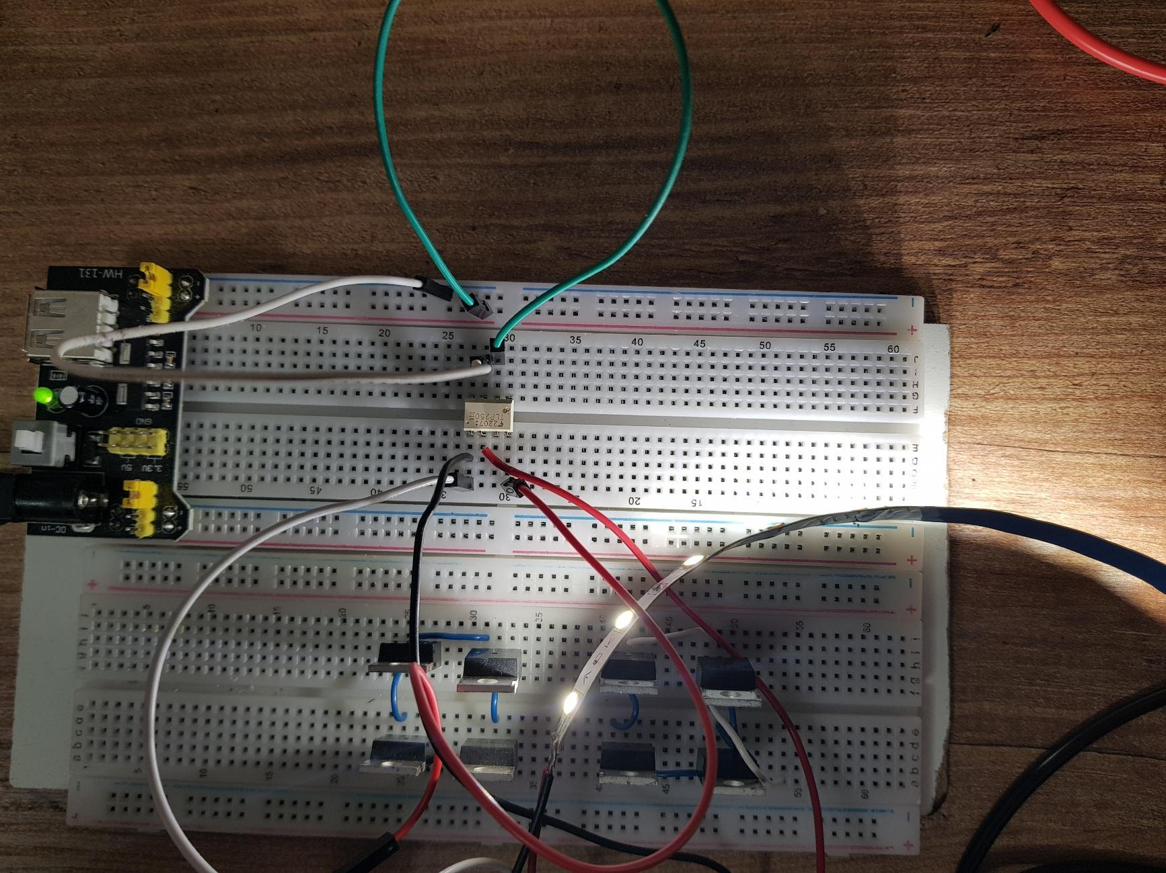
Figure 2. Tests of TLP250.
The circuit shown in Figure 3 demonstrates the physical layout of the H-bridge and the test setup for driving a single IRFZ44N MOSFET using a TLP250 optocoupler. Both the TLP250 and the load are powered by a single 12 V supply. In this configuration a 3.3 V control signal is applied to the input side of the TLP250. The output of the driver (Pin 6) is directly connected to the gate of the MOSFET. To verify the switching operation, an LED strip is used as a test load: the positive terminal of the strip is connected to the power supply and the negative terminal is connected to the MOSFET's drain. When the TLP250 is triggered we observe whether the strip lights up to confirm that the MOSFET is driving successfully. In this specific setup the other MOSFETs in the H-bridge only have their internal connections made and are not connected to any external load.
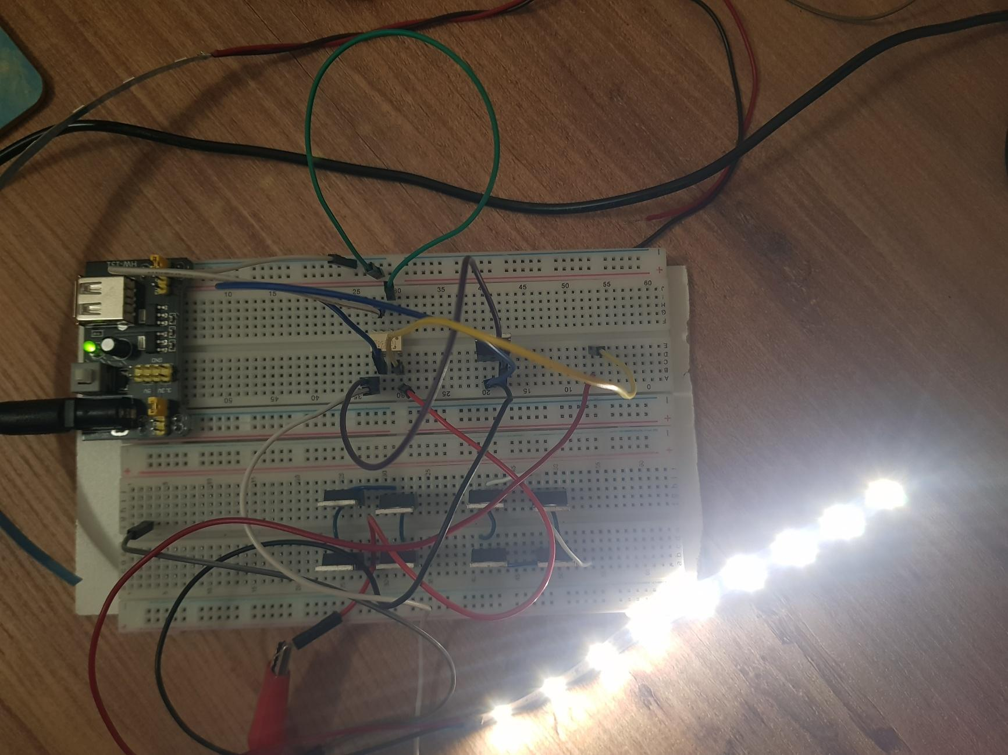
Figure 3. Layout of H-bridge and test of one MOSFET.

3.1.2 Evaluation
During the initial component testing a design weakness was identified when a TLP250 optocoupler burned out. The root cause of this failure was the absence of a current-limiting series resistor at the input side (pins 2 and 3). Without this resistor excessive forward current flowed through the internal LED of the TLP250, causing it to fail. Fortunately there were no issues related to the MOSFET driving stage. To resolve this problem for the next iteration a properly sized series resistor will be added to the input pins. Additionally, to further improve the overall reliability and protection of the circuit, a gate resistor will be included between the driver output and the MOSFET, alongside a bypass capacitor to stabilize the TLP250's power supply.

3.2 Iteration 2 — First H-Bridge and Manual Testing
Once the component-level verification was complete the components were integrated into a single H-bridge circuit. To guarantee hardware integrity the TLP250 gate drivers were manually triggered with a DC voltage prior to applying any high-frequency PWM signals; this step was crucial to verify that all components were correctly connected and the switching logic was functioning as intended. Furthermore, a specific power-up sequence was implemented in which the low-side MOSFETs were activated first to properly charge the bootstrap capacitors. After confirming the charging phase, the output voltages were tested step-by-step to ensure the safe and successful generation of the initial 3-level waveform.

3.2.1 Testing and Results
During the testing phase of a single H-bridge an automobile headlight bulb was connected as the load. The circuit topology is configured so that the source pin of the first high-side transistor (Q1) is connected to the drain pin of the third low-side transistor (Q3). Similarly, the source of the second high-side transistor (Q2) is connected to the drain of the fourth low-side transistor (Q4). To properly drive the high-side MOSFETs, a bootstrap capacitor was added to the circuit.
Regarding the test setup in Figure 4, we experienced a temporary component shortage due to the previously burned TLP250. To proceed with the H-bridge testing without delay we had to manually swap the remaining functional TLP250 ICs between the driver sockets to verify each channel. Following this troubleshooting phase, new replacement units were purchased to fully populate the driver circuit for the final implementation.
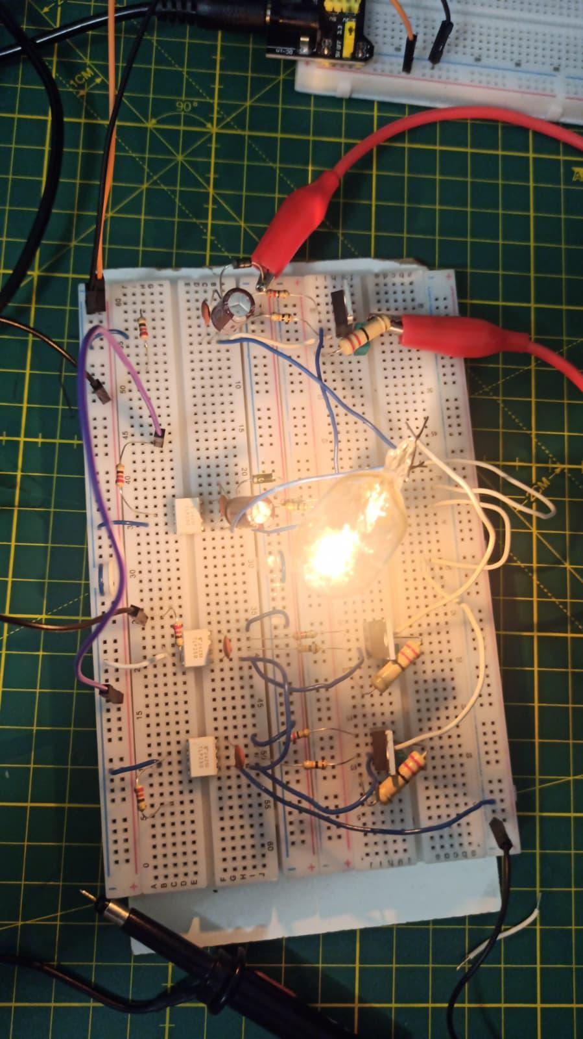
Figure 4. Manual test of H-bridge.

3.2.2 Evaluation
The testing phase of the single H-bridge successfully demonstrated the system's bipolar switching capability. However, it also revealed critical operational oversights and hardware limitations that must be addressed in the next iteration.
A primary operational weakness was discovered during the initial load test with the automobile bulb: the system failed to produce a reliable output and the bulb did not illuminate. The root cause was identified as the failure to pre-charge the bootstrap capacitors. To resolve this, a manual pre-charge sequence was applied by initially turning on only the low-side MOSFETs. Only after these capacitors were fully charged could we successfully pulse Q1 and Q4 simultaneously to deliver a positive voltage (+Vdc) and light the bulb brightly, or pulse Q2 and Q3 to supply a negative voltage (–Vdc).
This experience highlighted a strict requirement for the next design stage: the control logic must be updated to automatically execute a low-side pre-charge sequence before initiating the main PWM operation.
Furthermore, hardware limitations and component shortages were identified during the testing process. First, a single shared power supply was initially used for both the TLP250 optocouplers and the MOSFET power stage. This resulted in an insufficient gate-driving voltage, preventing the MOSFETs from turning on properly. To resolve this the power sources were separated and a dedicated 15 V power supply was implemented specifically for the drivers. Second, due to a previously damaged TLP250 IC we experienced a temporary component shortage. This missing driver forced us to manually swap the remaining functional ICs between the sockets to complete the verification tests for the full H-bridge.

3.3 Iteration 3 — Modulation Strategy: LS-PWM to Unipolar SPWM
For the third iteration the scope was strictly focused on control-signal generation and initial hardware integration. The primary objective was to generate PWM signals solely using an STM32 microcontroller, apply these signals to the physical circuit, and successfully observe a 3-level output voltage waveform. To ensure the proper operation of the high-side drivers a pre-charge sequence was executed first. This was achieved by turning on only the low-side MOSFETs for a few seconds to fully charge the bootstrap capacitors before applying the main high-frequency modulation signals.

3.3.1 Testing and Results
To achieve this, the initial approach utilised a level-shifted PWM technique. The microcontroller was programmed to generate two triangular carrier waves, which were then compared against a 50 Hz sinusoidal reference wave to produce the switching pulses. However, when applied to the circuit the resulting output waveform was highly noisy and unstable, as illustrated in Figure 5.
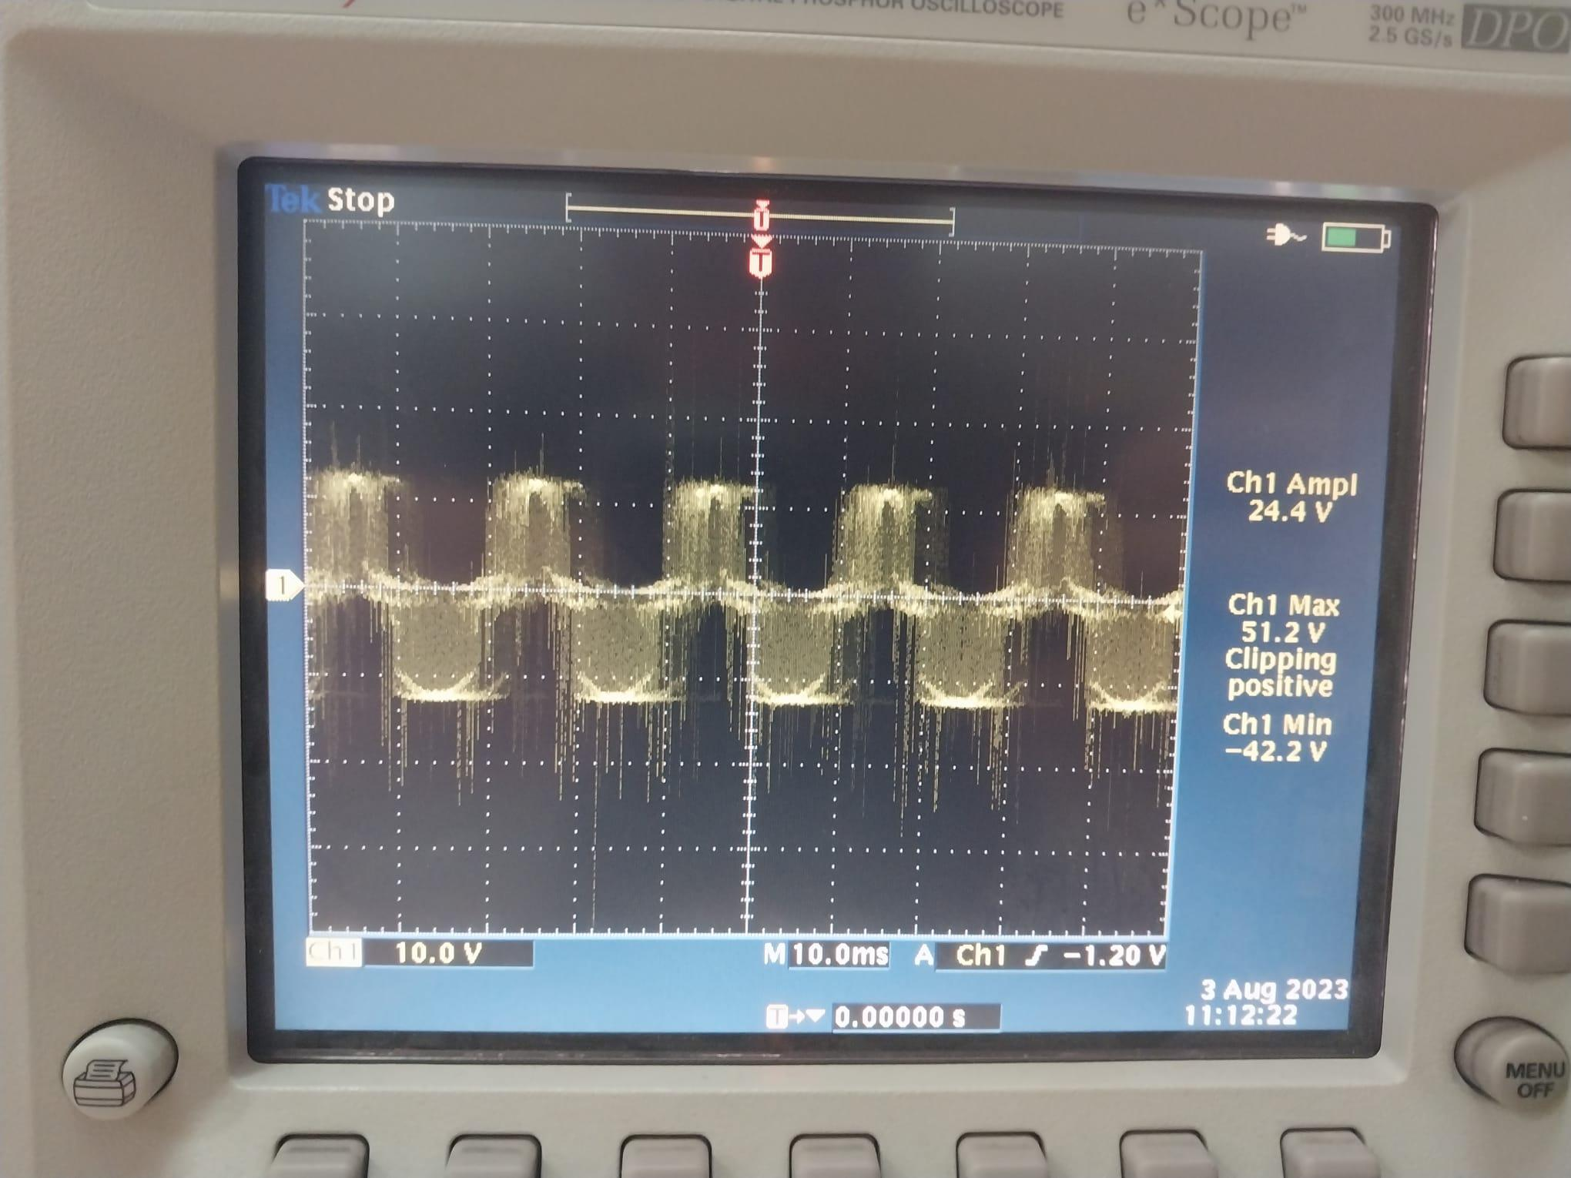
Figure 5. Output of the circuit with LS-PWM.
To resolve this issue and achieve the targeted 3-level output, the modulation strategy was transitioned to a unipolar Sinusoidal PWM (SPWM) technique. As shown in Figure 6, this unipolar SPWM approach successfully produced a much cleaner and more defined 3-level waveform. While this method yielded significantly better results, some high-frequency switching noise remains, indicating that an appropriate LC filtering circuit will be necessary for the final design.
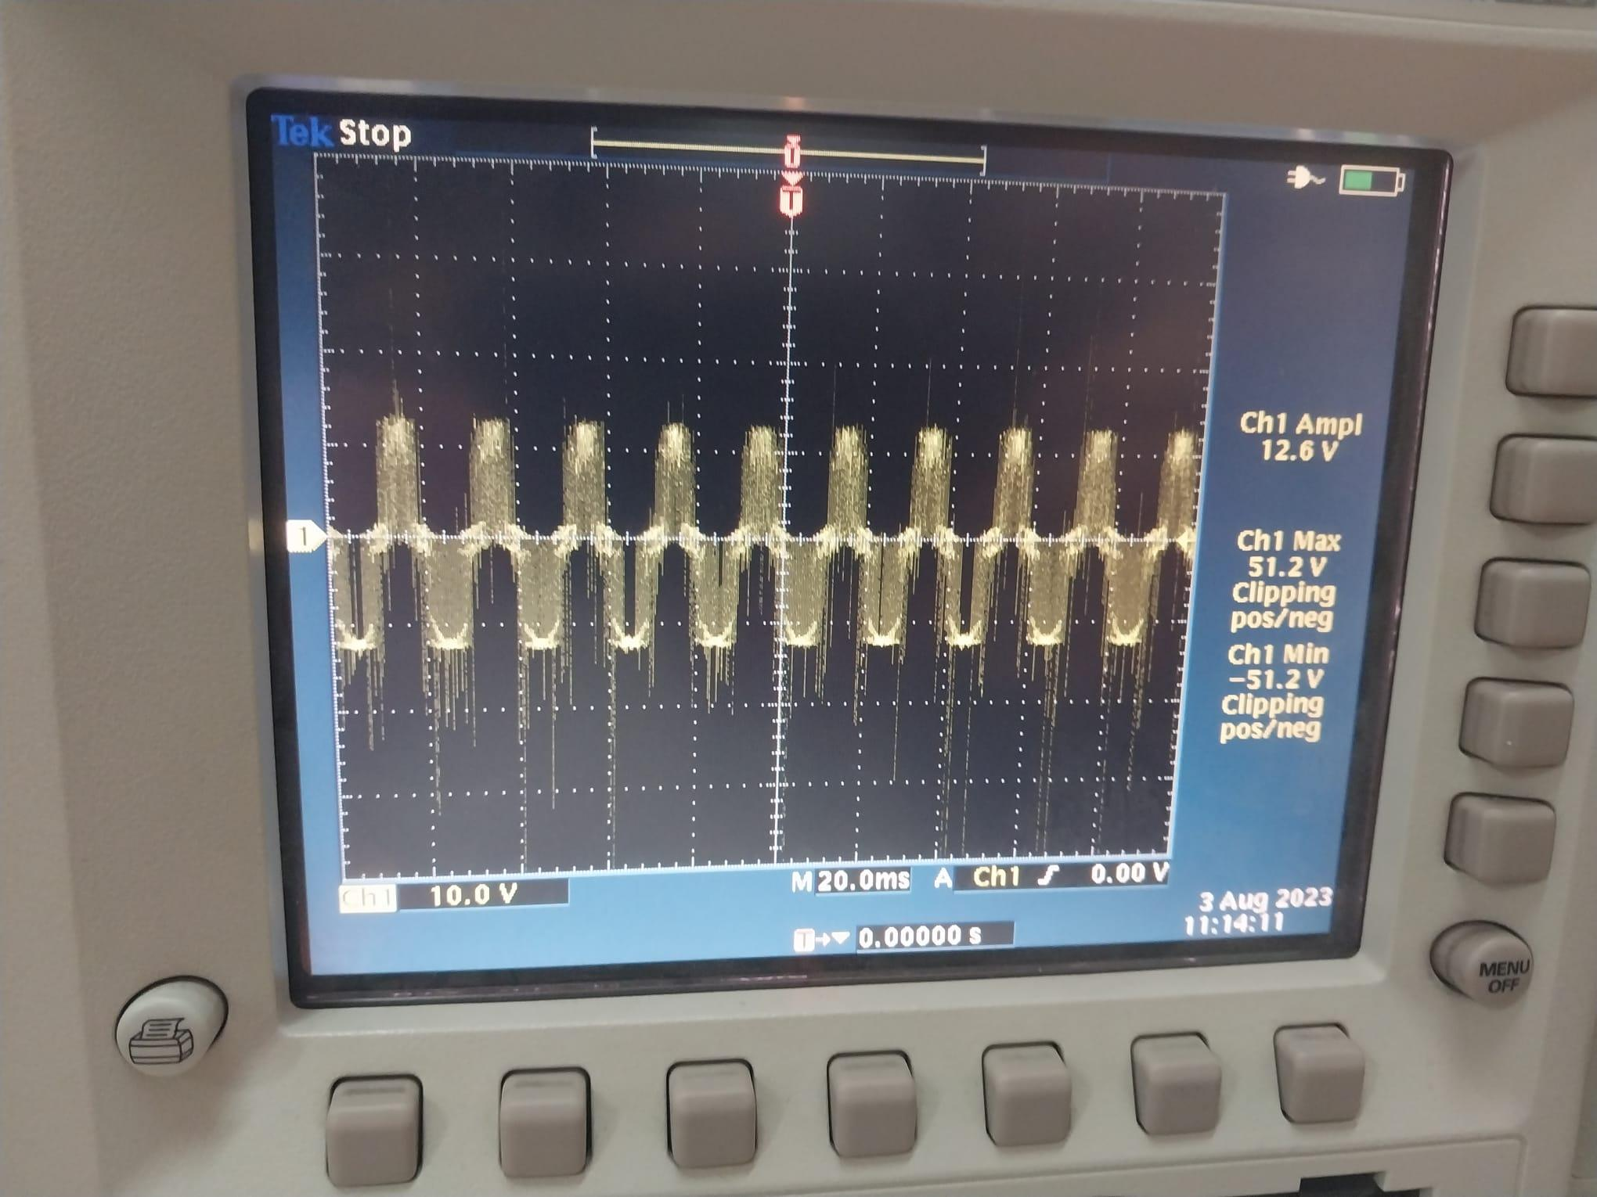
Figure 6. Output of the circuit with unipolar SPWM.
Figure 7 shows the physical bench setup used to capture these waveforms: the STM32 Nucleo board generates the PWM signals on its TIM1 channels; these drive the TLP250 inputs; the H-bridge output is loaded with the same automobile bulb used in Iteration 2; and the oscilloscope probe is attached across the bulb to capture the waveforms reproduced in Figures 5, 6 and 8. Figure 8 shows the same unipolar SPWM signal as Figure 6 captured on a second oscilloscope (an EZ OS-5020 analogue scope) where the dot-pattern of the persistence display makes the discrete output levels of the 3-level staircase even easier to discern. Figure 9 zooms in on the complementary gate-drive pair leaving the STM32, where the programmed dead-time of approximately 1 µs between the high-side and low-side outputs is clearly visible.

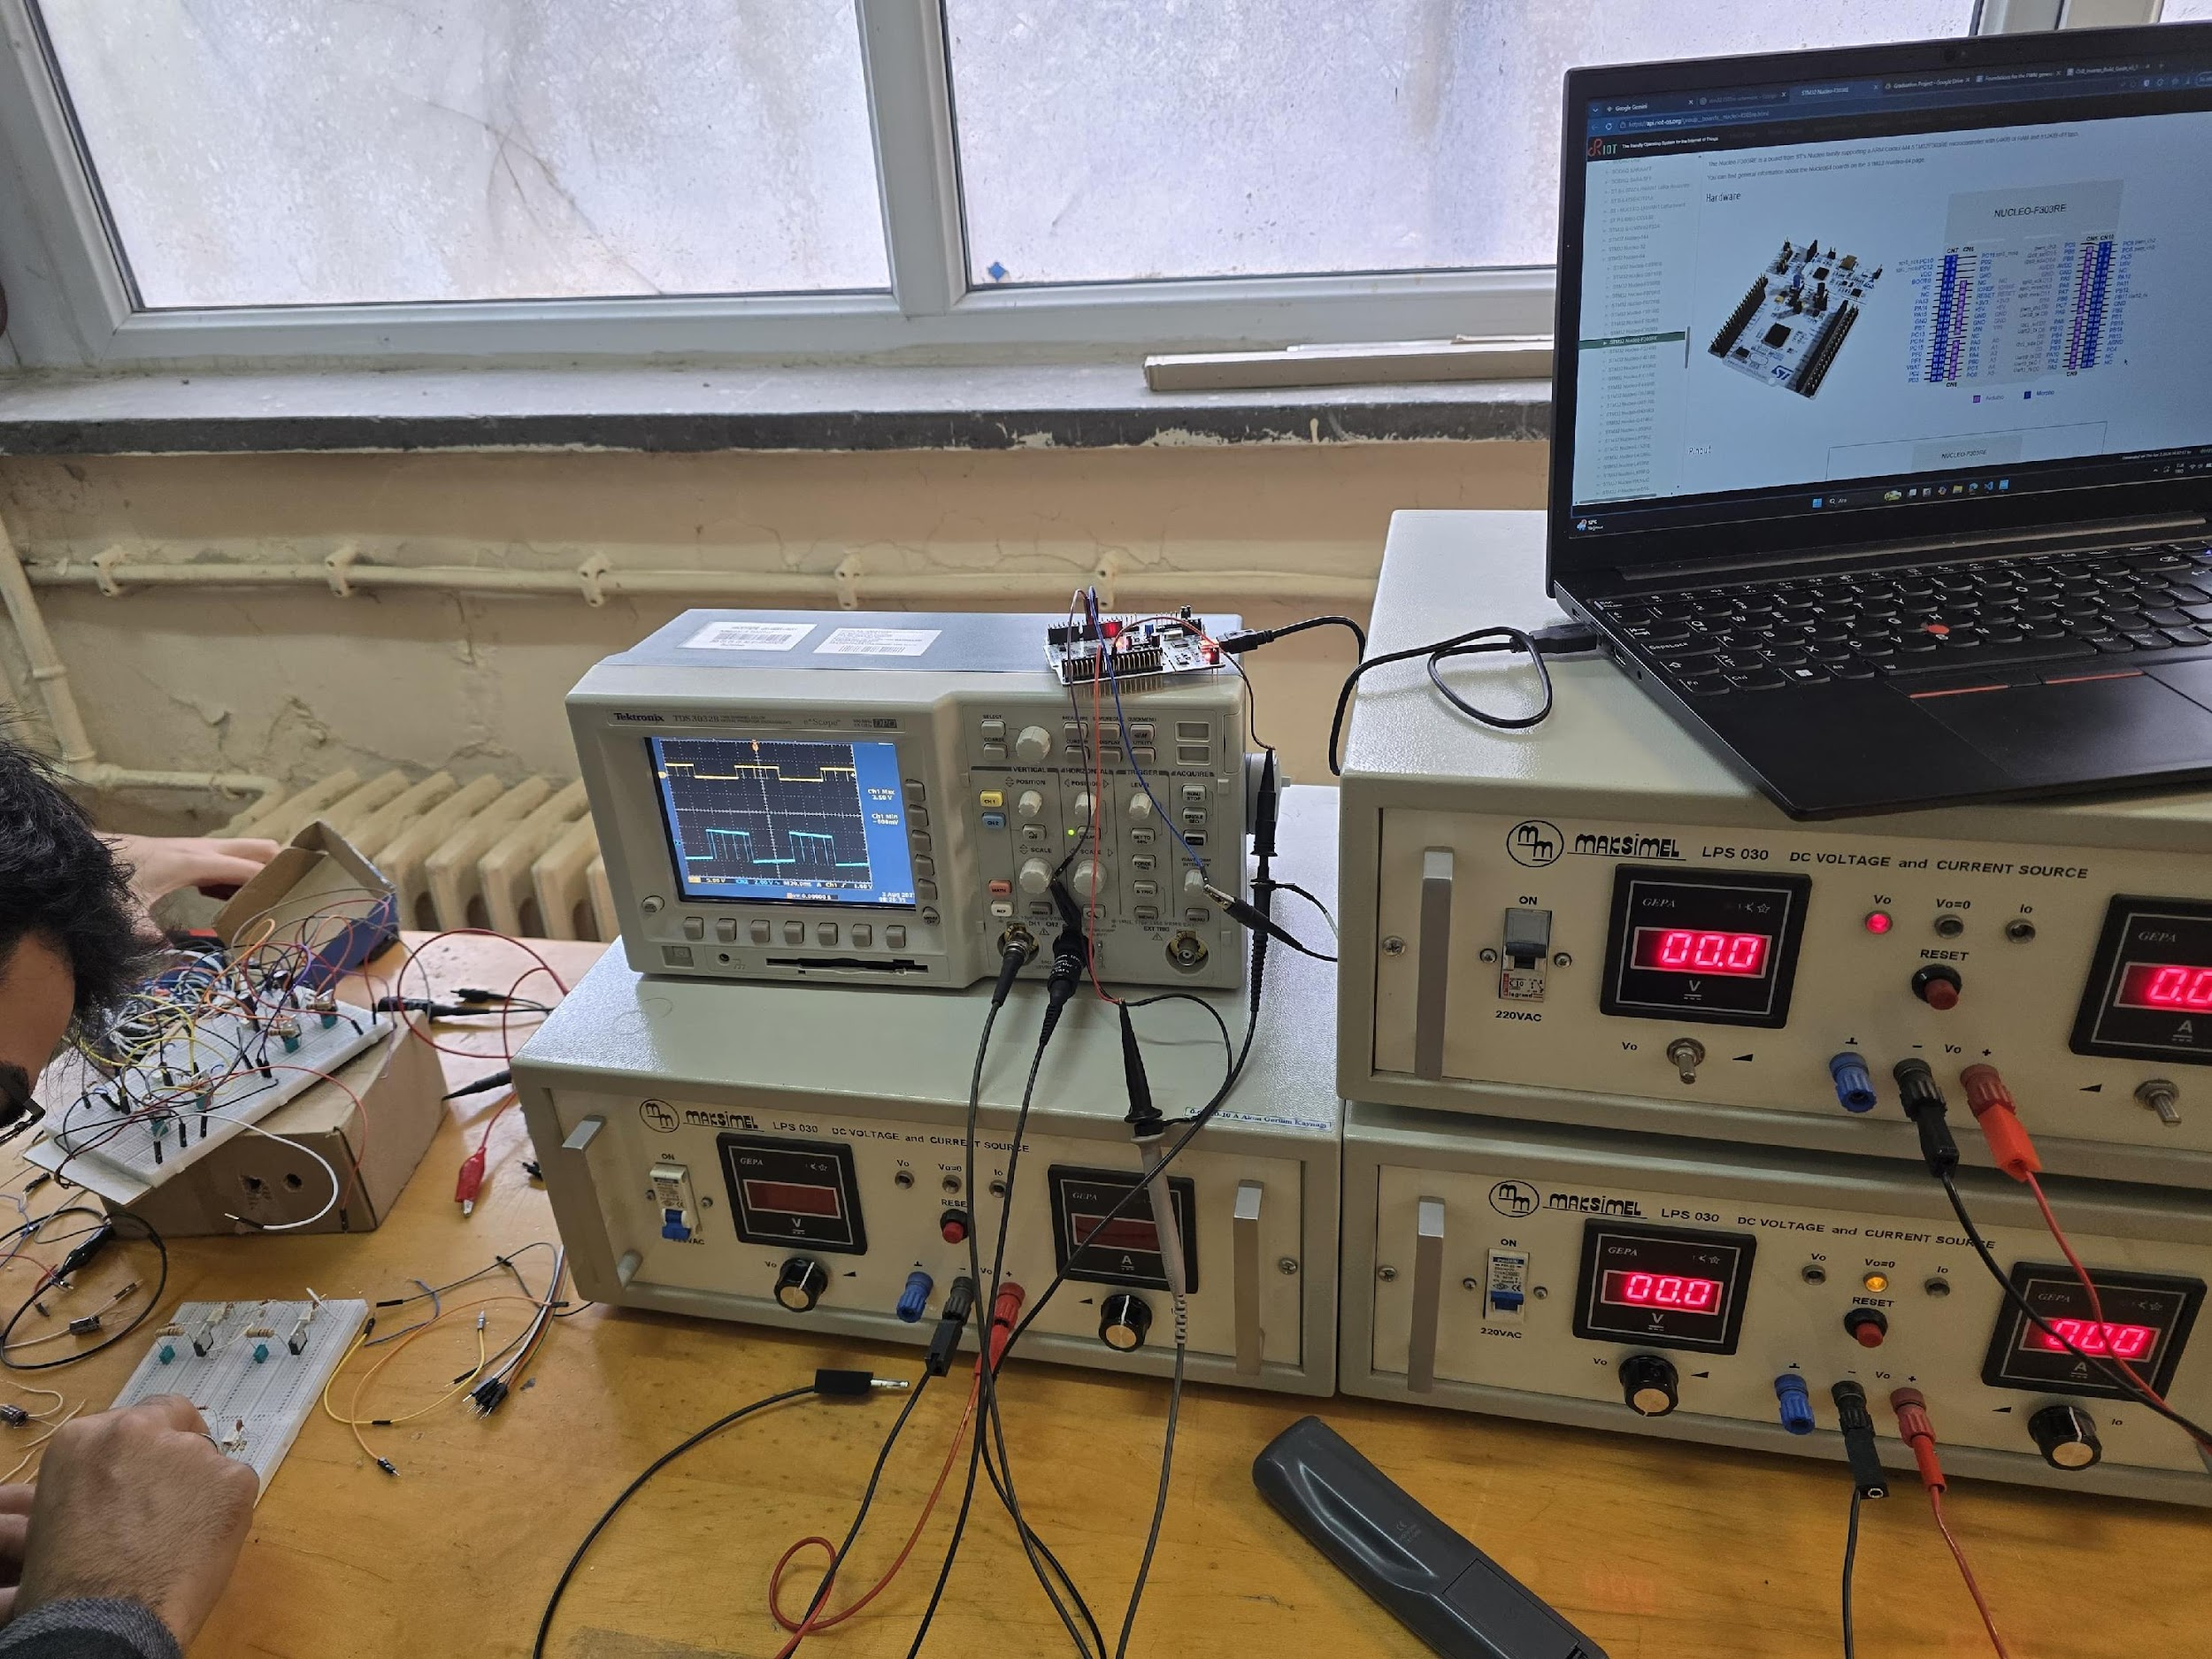
Figure 7. Bench setup used during PWM testing.
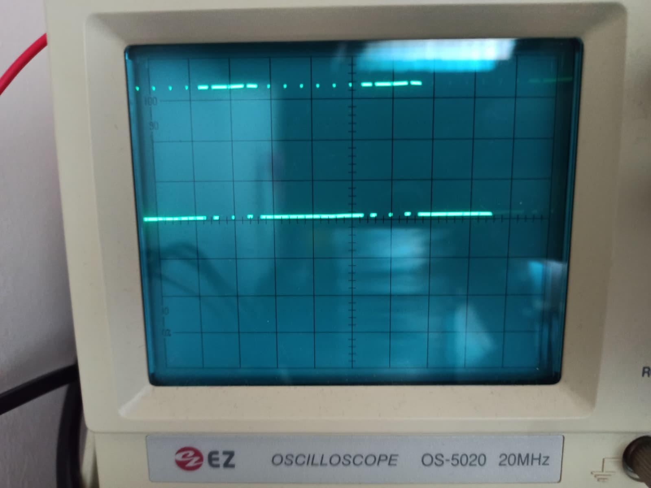
Figure 8. Unipolar SPWM signal captured on the EZ OS-5020 analogue oscilloscope.
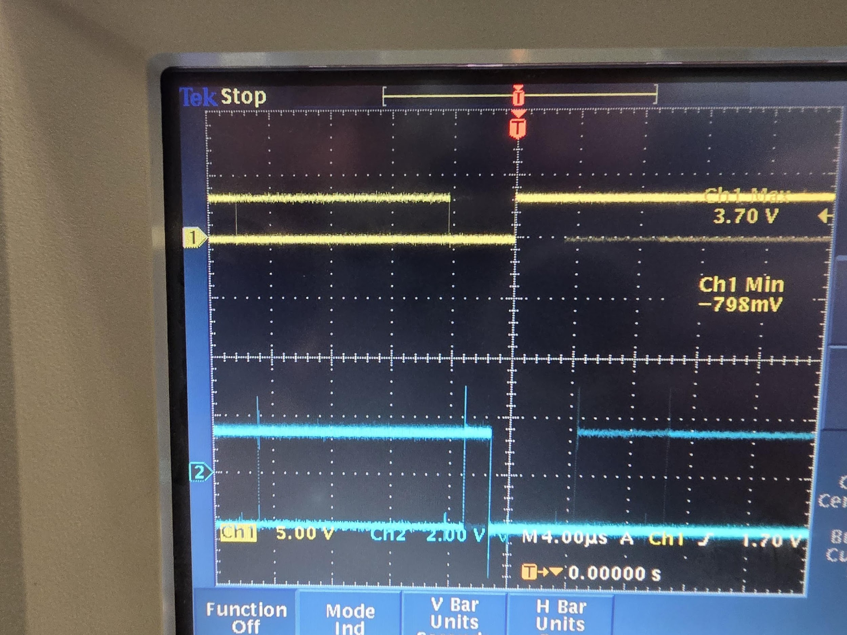
Figure 9. Approximately 1 µs dead-time between complementary PWM channels.
Table 3. Modulation strategy comparison between the original LS-PWM (IPD) design and the adopted Unipolar SPWM implementation.
Aspect | LS-PWM (IPD) | Unipolar SPWM
Reference signals | 1 sine, 4 offset triangular carriers | 2 sines (180° apart), 1 carrier per bridge
Carrier generation | Software table + explicit compare | Centre-aligned timer = inherent triangle
CPU load per period | Higher (4 duty computations) | Lower (2 LUT reads + compare)
Output clarity on scope | Hard to distinguish between carriers | Staircase cleanly resolved
THD (simulation, 5-level) | ≈ 4.9 % | ≈ 4.6 % (estimated)

3.3.2 Evaluation
Evaluating the outcomes of the third iteration, a major design shift was required regarding the modulation strategy on the STM32 microcontroller. Since the immediate scope was focused on testing a 3-level output from a single H-bridge, an In-Phase Disposition Level-Shifted PWM (IPD LS-PWM) approach was initially implemented using two vertically stacked triangular carriers compared against a single 50 Hz sinusoidal reference. While this method is theoretically valid the practical results were unsatisfactory: the modulation pattern was difficult to interpret on the oscilloscope, and at low bus voltages the expected 3-level staircase transitions were heavily obscured by switching ripple. To resolve these clarity and complexity issues the strategy was revised to Unipolar Sinusoidal PWM (SPWM).
This revised approach proved highly efficient; by using a single carrier compared against two 180° offset sinusoidal references we successfully removed an entire software layer. The centre-aligned timers now handle the carrier generation directly in hardware, resulting in a much clearer waveform that is significantly easier to debug.
Beyond the modulation logic the testing phase revealed a critical hardware limitation regarding the switching frequency. Initially the system was operated at a 5 kHz switching frequency. However, this generated an undesirable and highly noticeable audible noise from the power supply. To eliminate this acoustic interference the frequency was increased to 20 kHz, pushing it beyond the human hearing range. Unfortunately, operating at this higher frequency placed excessive stress on the gate-driving circuit, ultimately causing the TLP250 optocouplers to fail. This experience highlighted a vital design trade-off for the next iteration: the switching frequency must be carefully optimised to avoid both audible noise and thermal/electrical component failure.
Finally, while the current Unipolar SPWM setup successfully drives the 3-level output, it must be scaled up for the full 5-level cascaded topology. When integrating the second bridge the current configuration presents a minor weakness: the carriers for the two bridges are presently phase-locked rather than phase-shifted. To optimise the final 5-level design a straightforward firmware upgrade is scheduled for the next term. The system will transition to Phase-Shifted PWM by offsetting the carriers of the two bridges by 90° (ARR / 2 counts). This modification will effectively double the apparent switching frequency at the output without increasing the actual per-MOSFET switching losses, which is expected to yield an additional ~1 % improvement in Total Harmonic Distortion (THD), ensuring strict compliance with IEEE 519-2022.

3.4 Iteration 4 — PCB: Monolithic Layout to Modular Single-Bridge Boards
In parallel with the firmware work, the PCB of the power stage went through its own sequence of iterations. The original ELE 401 plan had been a single large PCB carrying both H-bridges plus the sensing island and controller header — essentially one monolithic board containing the complete inverter. An initial KiCad placement for the single-bridge block of this monolithic board is shown in Figure 10.
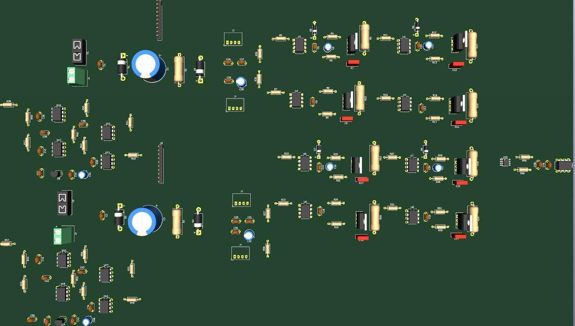
Figure 10. Earliest KiCad placement of the power stage. Both H-bridges, two sensing islands and two 1000 µF bulk capacitors are placed on one panel, but no routing has yet been attempted. At this stage the placement is approximate and serves only to check whether everything fits inside an A4 half-sheet.
As the placement progressed two problems became apparent. First, routing the full ±100 V / 10 A power path on a single two-layer board while also keeping a 2 mm isolation gap between the two floating bridges forced the sensing island for the upper bridge into an awkward corner, where it was difficult to keep the 100 nF bypass capacitors close to their respective IC VDD pins. Second, the single large board made the cost of a single design error high: any re-spin required re-ordering the full panel, and the fabrication time for the larger panel at the preferred manufacturer was noticeably longer than for a smaller board.
The design was therefore restructured into two identical single-bridge modules of roughly 200 mm × 120 mm each, connected at their AC terminals by a short pair of wires rather than being embedded in one panel. Because the two bridges are electrically identical — same schematic, same sensing island, same connector pinout — only one module has to be designed, verified and fabricated. The second module is simply a second copy of the first.

3.4.1 Testing and Results
Converting the schematic into a working layout took several further sub-iterations. An intermediate version, shown in Figures 11 and 12, placed the ACS712 output-current sensor and its MCP3201 ADC directly on every module. This was convenient for a single-module test but was wasteful at the system level: only one of the two modules needs to measure the output current, since the same current flows through both bridges in series.
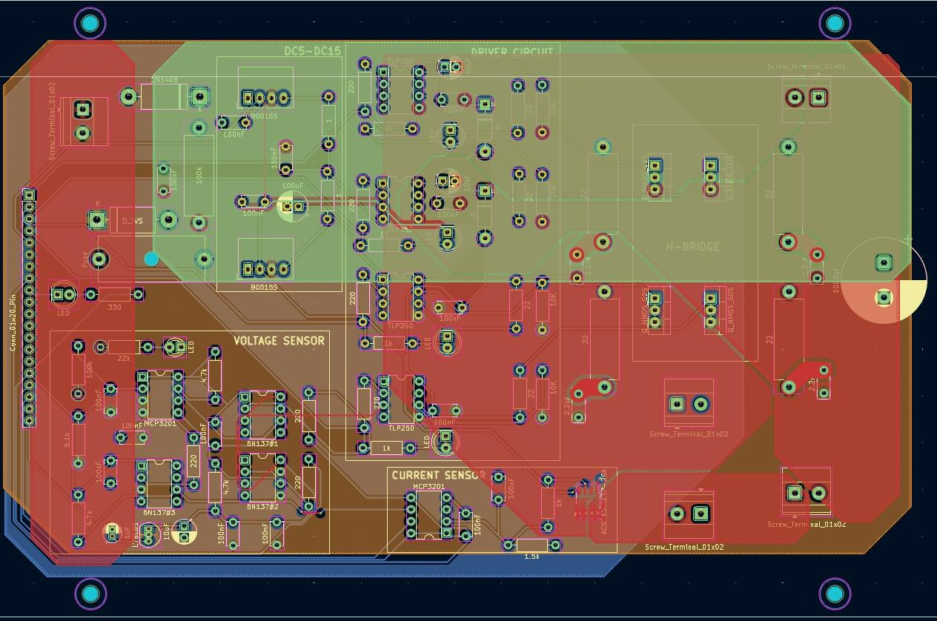
Figure 11. Intermediate KiCad layout of a single module with the output current-sensing block (ACS712 + MCP3201) populated. Copper pours are visible as the orange and red zones; the 2 mm isolation gap between the sensing island (lower-left) and the H-bridge power domain is clearly maintained.
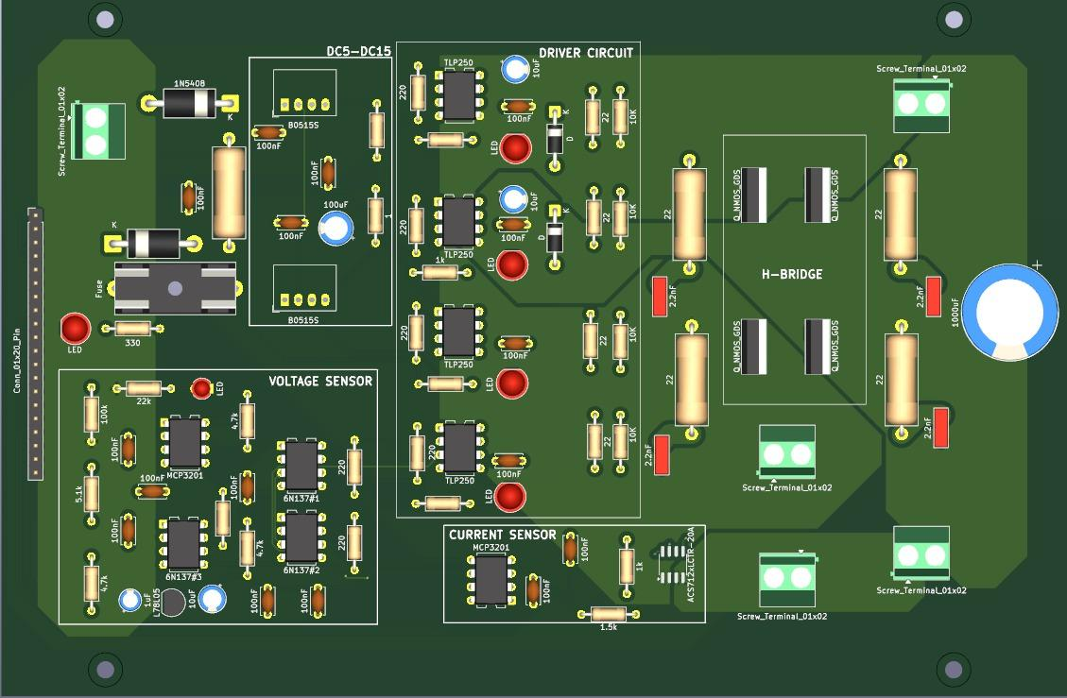
Figure 12. 3D render of the intermediate layout shown in Figure 11. The four TLP250 drivers, the two B0515S modules, the MCP3201 + 6N137 sensing island and the H-bridge MOSFETs with their snubber networks are all visible.
The final single-bridge module, shown in Figure 13, consists of the H-bridge itself, the four gate-drive channels, the isolated +15 V supply, the isolated DC-bus sensing island, and the controller-interface 2×10 header. Every resistor and capacitor value in the schematic matches the group's Build Guide v3.1 bill of materials. In the same step the area previously occupied by the current sensor was re-used to widen the 10 A power path and to improve thermal clearance around the MOSFETs. The back-side copper of the final layout is shown in Figure 14; dedicated pour regions carry the bridge mid-points on the back layer to keep their trace inductance low.
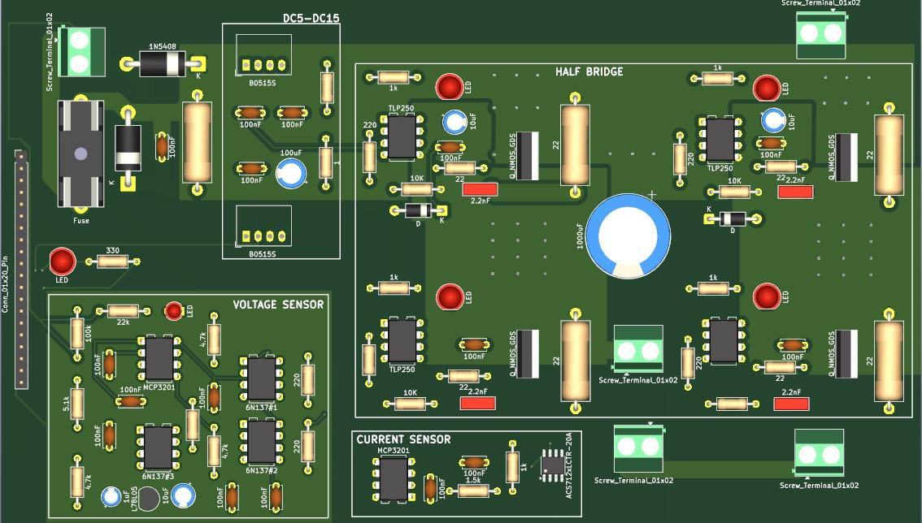
Figure 13. 3D render of the final single-bridge module. The current-sensing block has been removed, freeing area around the MOSFETs and allowing wider copper zones for the 10 A power path. Diagnostic LEDs (green = DC bus OK, yellow = per-channel PWM, red = fault) are populated as DNP options for bring-up.
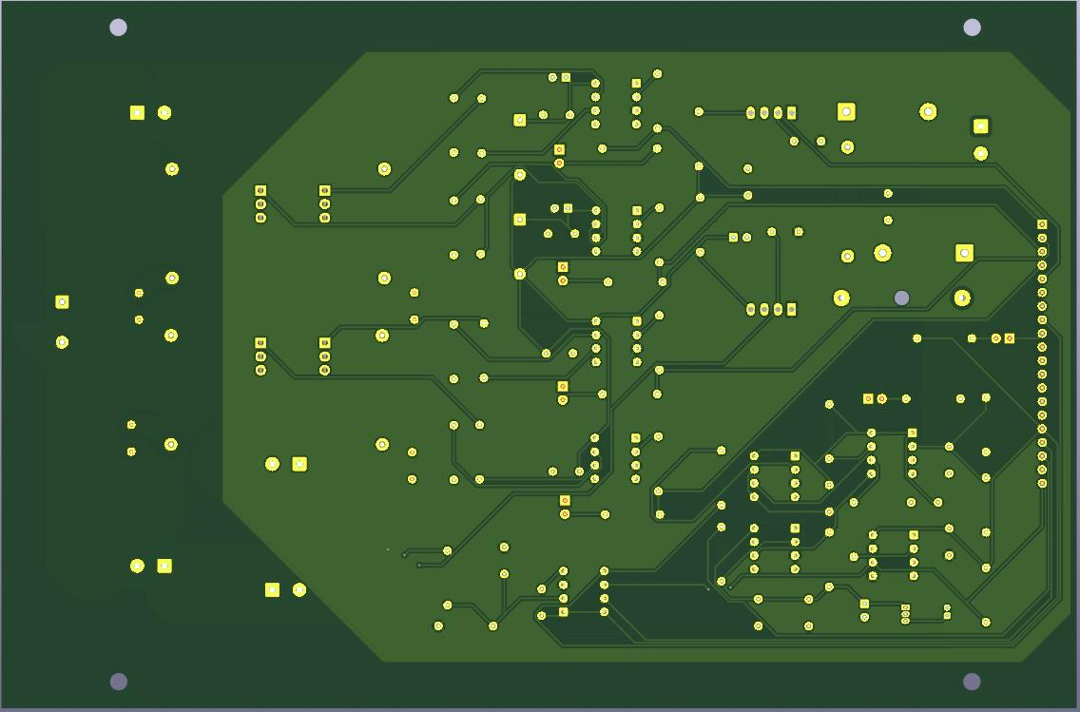
Figure 14. Back-side copper of the final single-bridge module. Dedicated pour regions carry the bridge mid-points and the sensing-island ground, keeping the high-current return path short and the low-voltage signals well separated from the switching nodes.
A further round of consultation with an external PCB-manufacturing engineer (reached through one of the group members' industry contacts) suggested two additional improvements. First, the stack-up was changed from two layers to four layers with internal power/ground planes, which lowers the loop inductance of the switching loop and provides dedicated copper for thermal spreading. Second, it was recommended to parallel three MOSFETs per bridge position rather than using a single device. With three IRFB4110 devices in parallel the effective RDS(on) falls from approximately 4.5 mΩ to approximately 1.5 mΩ; switching and conduction losses drop proportionally per device, and the per-device junction-temperature rise is significantly reduced. The footprint of every H-bridge switch position was updated accordingly; the four-layer / three-parallel variant is the one that will be ordered from the fabricator.
Table 4. PCB design iteration summary.
Sub-iter. | Change | Motivation and outcome
4a | Monolithic board → two identical modules | Lower fabrication cost per re-spin, shorter lead time, simpler verification of a single design.
4b | Current sensor moved from each module to a shared add-on board | Only one current sensor is required since both bridges share the series output current; saves area and cost per module.
4c | Added copper pours and re-routed high-current path | Area freed in 4b is used to widen drain-source connections; reduces trace resistance and spreads heat.
4d | Placement re-work for heatsink clearance | Heatsink envelope checked against mechanical datasheet; MOSFET clusters re-spaced to leave airflow gaps.
4e | 2-layer → 4-layer stack-up | Dedicated internal planes for the 10 A bus; lower loop inductance; better thermal spreading.
4f | Single MOSFET → 3 IRFB4110 in parallel per switch | Effective RDS(on) ≈ 1.5 mΩ; lower conduction and switching losses per device; reduced junction temperature rise.
4g | Diagnostic LEDs added as DNP options | Green LED with 22 kΩ series for the DC-bus-OK indicator, four yellow LEDs with 1 kΩ series for per-channel PWM activity, and one red LED with a 330 Ω pull-up for the active-low FAULT_OUT line. All seven LEDs are populated as Do-Not-Place options on the production stencil and are populated only on the bring-up batch.
4h | SMD ICs respecified as THT equivalents | A late BOM cross-check found that several ICs (78L05, MCP3201, ACS712, decoupling 1 µF) had been ordered in SOIC-8 / SMD packages whose footprints were incompatible with the SOP8-DIP8 adapters previously assumed; replacement THT parts (TO-92 78L05, DIP-8 MCP3201, THT 1 µF / 25 V) were ordered from Motorobit and Direnc.net, with the ACS712 retained as SMD because its SOIC-8 outline is large enough to be hand-soldered.

3.4.2 Evaluation
The PCB iteration sequence has produced a design that is measurably cheaper, thermally safer, and easier to debug than the original monolithic plan. The modular split also opens a clean extension path: cascading three or four identical modules instead of two yields a 7-level or 9-level inverter with no further schematic or layout work. That extension is explicitly intended to be demonstrated at the final exhibition.
The remaining weakness of the design is verification: although every individual sub-circuit has been validated on breadboard in Iterations 1–3, the as-fabricated PCB has not yet been powered on. At the time of writing, Gerbers have been generated, priced at approximately 14 USD per board (plus a one-off engineering fee of approximately 24 USD) at JLCPCB, and are scheduled to be ordered within the first week of May 2026. The remaining work for the spring term is therefore well defined and is grouped below into three concurrent tracks that the four group members will pursue in parallel:
- Hardware bring-up — soldering of the two single-bridge modules, full-voltage (50 V per bridge) power-on tests, characterisation of the bootstrap rails on the PCB, and validation of the closed-loop protection based on the isolated MCP3201 feedback chain.
- Firmware extension to PS-PWM — the present unipolar SPWM implementation is to be upgraded to Phase-Shifted PWM, in which the carriers of TIM1 and TIM8 are offset by ARR / 2 counts. PS-PWM doubles the apparent switching frequency at the output without increasing per-MOSFET losses and is expected to drop the simulated THD from ~4.6 % to under 4 %. The change is purely in the timer initialisation and does not require any hardware modification.
- LC output filter — design and characterisation of the optional pluggable filter board mentioned in §2.6, sized for a cut-off in the 250–325 Hz region, and evaluation of its effect on the measured THD with the cascaded modules under resistive and inductive load.
Each of these tracks is independent of the others and can therefore proceed in parallel after the first power-on, which keeps the critical path of the project short and gives every group member a well-defined deliverable for the final report.

REFERENCES
[1] IEEE Recommended Practice and Requirements for Harmonic Control in Electric Power Systems, IEEE Std. 519-2022, Piscataway, NJ, USA, 2022.
[2] M. H. Rashid, Power Electronics: Circuits, Devices, and Applications, 4th ed. Upper Saddle River, NJ, USA: Pearson, 2014.
[3] J. Rodríguez, J.-S. Lai and F. Z. Peng, "Multilevel inverters: a survey of topologies, controls, and applications," IEEE Trans. Ind. Electron., vol. 49, no. 4, pp. 724–738, Aug. 2002.
[4] Datasheet, "IRFZ44N HEXFET Power MOSFET," International Rectifier / Infineon Technologies, Rev. 1.4, 2001.
[5] Datasheet, "IRFB4110PbF HEXFET Power MOSFET," International Rectifier / Infineon Technologies, Rev. 1.0, 2008.
[6] Datasheet, "TLP250 GaAlAs IRED & Photo-IC Photocoupler," Toshiba Semiconductor, Rev. 2.0, 2006.
[7] Datasheet, "B0505S / B0515S-1W / 1WR3 Isolated 1 W DC/DC Converter," MORNSUN, Rev. E, 2019.
[8] Datasheet, "MCP3201 2.7 V 12-Bit A/D Converter with SPI Serial Interface," Microchip Technology Inc., DS21290F, 2007.
[9] Datasheet, "6N137 High-Speed Optocoupler," Vishay Semiconductors, Rev. 1.7, 2020.
[10] Datasheet, "ACS712 Fully Integrated, Hall-Effect-Based Linear Current Sensor IC," Allegro MicroSystems, Rev. 14, 2017.
[11] STMicroelectronics, "RM0316 — Reference manual: STM32F303xB/C/D/E, STM32F303x6/8, STM32F328x8 and STM32F358xC advanced Arm®-based 32-bit MCUs," Rev. 10, 2021.
[12] D. Holmes and T. Lipo, Pulse Width Modulation for Power Converters: Principles and Practice. Wiley-IEEE Press, 2003.

