Elucidating ligand recognition of reductive dehalogenases the role of hydrophobic active site in organohalogen binding

Supplementary Information

Table S1 The basic information for selected ligands in for molecular dynamics simulation. bp (Boiling Point) is the temperature at which a substance transitions from a liquid to a gas under a given pressure. A lower boiling point indicates that a substance will vaporize more easily at room temperature, implying higher volatility. RT (Room Temperature): 20–25 °C. High Volatility: Substances that evaporate quickly, often indicated by a low boiling point.
Molecular name | Source | Solubility in water (25 °C) | volatility | Molecular weight g/mol
Halogenated methane
Tetrachloromethane | Synthesized | ~ 0.8 g/L (Low) | High (bp ~ 76.7 °C) | 153.82
Trichlorofluoromethane | Synthesized | ~ 1.1 g/L (Low) | High (bp ~ 23.8 °C, volatile liquid at RT) | 137.37
Dichlorodifluoromethane | Synthesized | ~ 0.3 g/L (Very Low) | Gas at RT (bp -29.8 °C, very high vapor pressure) | 120.91
Chlorotrifluoromethane | Synthesized | Very low (tens of mg/L) | Gas at RT (bp -81.4 °C, extremely volatile) | 104.46
Tetrafluoromethane | Synthesized | Extremely low (few mg/L) | Gas at RT (bp -127.8 °C, extremely volatile) | 88.00
Halogenated ethene
Tetrachloroethene | Synthesized | ~ 0.15 g/L (Low) | High (bp ~ 121 °C) | 165.84
Trichlorofluoroethene | Synthesized | Low (likely < 1 g/L) | High (likely bp < 80–100 °C, limited data) | 149.38
Dichlorodifluoroethene | Synthesized | Low | High (likely bp < 60–80 °C, limited data) | 132.92
Chlorotrifluoroethene | Synthesized | Very low (likely < 0.1 g/L) | Gas or very volatile liquid (bp ~ -30 to 0 °C, limited data) | 116.47
Tetrafluoroethene | Synthesized | Very low (gas) | Gas at RT (bp -75 °C, extremely volatile) | 100.02
Halogenated propane
Tetrachloropropane | Synthesized | Low (< 1 g/L) | Moderate to High (liquid at RT, bp often 130–160 °C) | 181.88
Trichlorofluoropropane | Synthesized | Low (< 1 g/L) | Moderate to High (liquid at RT, bp typically < 100–120 °C) | 166.43
Dichlorodifluoropropane | Synthesized | Very low (likely << 1 g/L) | High | 148.97
Chlorotrifluorocpropane | Synthesized | Very low | Could be a gas or a very volatile liquid (bp < ~ 50–60 °C) | 133.52
Tetrafluoropropane | Synthesized | Very low | Often a gas or very volatile liquid (bp -26 °C) | 116.06

Table S2 Molecular mechanics parameters for selected ligands from Figure 1
Molecular name | Parameters | Optimized value | Force constant
Tetrachloromethane | Bonds | Distance r0 (nm) | k (kJ/mol/nm²)
 | C1-Cl2 | 0.180450 | 2.228398E+05
 | C1-Cl3 | 0.180450 | 2.228398E+05
 | C1-Cl4 | 0.180450 | 2.228398E+05
 | C1-Cl5 | 0.180450 | 2.228398E+05
 | Angles | Angle a0 (Deg.) | (kJ/mol/rad²)
 | Cl2-C1-Cl3 | 109.330 | 4.527088E+02
 | Cl2-C1-Cl4 | 109.330 | 4.527088E+02
 | Cl2-C1-Cl5 | 109.330 | 4.527088E+02
 | Cl3-C1-Cl4 | 109.330 | 4.527088E+02
 | Cl3-C1-Cl5 | 109.330 | 4.527088E+02
 | Cl4-C1-Cl5 | 109.330 | 4.527088E+02
Trichlorofluoromethane | Bonds | Distance r0 (nm) | k (kJ/mol/nm²)
 | C1-Cl2 | 0.180450 | 2.228398E+05
 | C1-Cl3 | 0.180450 | 2.228398E+05
 | C1-Cl4 | 0.180450 | 2.228398E+05
 | C1-F5 | 0.134970 | 2.986539E+05
 | Angles | Angle a0 (Deg.) | (kJ/mol/rad²)
 | Cl2-C1-Cl3 | 109.330 | 4.527088E+02
 | Cl2-C1-Cl4 | 109.330 | 4.527088E+02
 | Cl2-C1-F5 | 109.110 | 4.903648E+02
 | Cl3-C1-Cl4 | 109.330 | 4.527088E+02
 | Cl3-C1-F5 | 109.110 | 4.903648E+02
 | Cl4-C1-F5 | 109.110 | 4.903648E+02
Dichlorodifluoromethane | Bonds | Distance r0 (nm) | k (kJ/mol/nm²)
 | C1-Cl2 | 0.180450 | 2.228398E+05
 | C1-F3 | 0.134970 | 2.986539E+05
 | C1-Cl4 | 0.180450 | 2.228398E+05
 | C1-F5 | 0.134970 | 2.986539E+05
 | Angles | Angle a0 (Deg.) | (kJ/mol/rad²)
 | Cl2-C1-F3 | 109.110 | 4.903648E+02
 | Cl2-C1-Cl4 | 109.330 | 4.527088E+02
 | Cl2-C1-F5 | 109.110 | 4.903648E+02
 | F3-C1-Cl4 | 109.110 | 4.903648E+02
 | F3-C1-F5 | 107.360 | 5.932912E+02
 | Cl4-C1-F5 | 109.110 | 4.903648E+02
Chlorotrifluoromethane | Bonds | Distance r0 (nm) | k (kJ/mol/nm²)
 | C1-Cl2 | 0.180450 | 2.228398E+05
 | C1-F3 | 0.134970 | 2.986539E+05
 | C1-F4 | 0.134970 | 2.986539E+05
 | C1-F5 | 0.134970 | 2.986539E+05
 | Angles | Angle a0 (Deg.) | (kJ/mol/rad²)
 | Cl2-C1-F3 | 109.110 | 4.903648E+02
 | Cl2-C1-F4 | 109.110 | 4.903648E+02
 | Cl2-C1-F5 | 109.110 | 4.903648E+02
 | F3-C1-F4 | 107.360 | 5.932912E+02
 | F3-C1-F5 | 107.360 | 5.932912E+02
 | F4-C1-F5 | 107.360 | 5.932912E+02
Tetrafluoromethane | Bonds | Distance r0 (nm) | kd (kJ/mol)
 | C1-F2 | 0.134970 | 2.986539E+05
 | C1-F3 | 0.134970 | 2.986539E+05
 | C1-F4 | 0.134970 | 2.986539E+05
 | C1-F5 | 0.134970 | 2.986539E+05
 | Angles | Angle a0 (Deg.) | (kJ/mol/rad²)
 | F2-C1-F3 | 107.360 | 5.932912E+02
 | F2-C1-F4 | 107.360 | 5.932912E+02
 | F2-C1-F5 | 107.360 | 5.932912E+02
 | F3-C1-F4 | 107.360 | 5.932912E+02
 | F3-C1-F5 | 107.360 | 5.932912E+02
 | F4-C1-F5 | 107.360 | 5.932912E+02
Tetrachloroethene | Bonds | Distance r0 (nm) | k (kJ/mol/nm²)
 | C1-C2 | 0.133430 | 4.764739E+05
 | C1-Cl3 | 0.173080 | 2.688638E+05
 | C1-Cl4 | 0.173080 | 2.688638E+05
 | C2-Cl5 | 0.173080 | 2.688638E+05
 | C2-Cl6 | 0.173080 | 2.688638E+05
 | Angles | Angle a0 (Deg.) | (kJ/mol/rad²)
 | C2-C1-Cl3 | 123.110 | 4.853440E+02
 | C2-C1-Cl4 | 123.110 | 4.853440E+02
 | Cl3-C1-Cl4 | 114.340 | 4.610768E+02
 | C1-C2-Cl5 | 123.110 | 4.853440E+02
 | C1-C2-Cl6 | 123.110 | 4.853440E+02
 | Cl5-C2-Cl6 | 114.340 | 4.610768E+02
 | Dihedrals | Angle a0 (Deg.) | kd (kJ/mol) | Multiplicity
 | Cl3-C1-C2-Cl5 | 180.000 | 27.82360 | 2
 | Cl3-C1-C2-Cl6 | 180.000 | 27.82360 | 2
 | Cl4-C1-C2-Cl5 | 180.000 | 27.82360 | 2
 | Cl4-C1-C2-Cl6 | 180.000 | 27.82360 | 2
 | Improper Dihedrals | Angle a0 (Deg.) | kd (kJ/mol) | Multiplicity
 | C2-Cl3-C1-Cl4 | 180.000 | 4.60240 | 2
 | C1-Cl5-C2-Cl6 | 180.000 | 4.60240 | 2
Trichlorofluoroethene | Bonds | Distance r0 (nm) | k (kJ/mol/nm²)
 | C1-C2 | 0.133430 | 4.764739E+05
 | C1-Cl3 | 0.173080 | 2.688638E+05
 | C1-Cl4 | 0.173080 | 2.688638E+05
 | C2-F5 | 0.133850 | 3.101181E+05
 | C2-Cl6 | 0.173080 | 2.688638E+05
 | Angles | Angle a0 (Deg.) | (kJ/mol/rad²)
 | C2-C1-Cl3 | 123.110 | 4.853440E+02
 | C2-C1-Cl4 | 123.110 | 4.853440E+02
 | Cl3-C1-Cl4 | 114.340 | 4.610768E+02
 | C1-C2-F5 | 122.870 | 5.681872E+02
 | C1-C2-Cl6 | 123.110 | 4.853440E+02
 | F5-C2-Cl6 | 113.162 | 5.000000E+02
 | Dihedrals | Angle a0 (Deg.) | kd (kJ/mol) | Multiplicity
 | Cl3-C1-C2-F5 | 180.000 | 27.82360 | 2
 | Cl3-C1-C2-Cl6 | 180.000 | 27.82360 | 2
 | Cl4-C1-C2-F5 | 180.000 | 27.82360 | 2
 | Cl4-C1-C2-Cl6 | 180.000 | 27.82360 | 2
 | Improper Dihedrals | Angle a0 (Deg.) | kd (kJ/mol) | Multiplicity
 | C2-Cl3-C1-Cl4 | 180.000 | 4.60240 | 2
 | C1-F5-C2-Cl6 | 180.000 | 4.60240 | 2
Dichlorodifluoroethene | Bonds | Distance r0 (nm) | kd (kJ/mol)
 | C1-C2 | 0.133430 | 4.764739E+05
 | C1-F3 | 0.133850 | 3.101181E+05
 | C1-Cl4 | 0.173080 | 2.688638E+05
 | C2-F5 | 0.133850 | 3.101181E+05
 | C2-Cl6 | 0.173080 | 2.688638E+05
 | Angles | Angle a0 (Deg.) | (kJ/mol/rad²)
 | C2-C1-F3 | 122.870 | 5.681872E+02
 | C2-C1-Cl4 | 123.110 | 4.853440E+02
 | F3-C1-Cl4 | 114.661 | 5.000000E+02
 | C1-C2-F5 | 122.870 | 5.681872E+02
 | C1-C2-Cl6 | 123.110 | 4.853440E+02
 | F5-C2-Cl6 | 114.661 | 5.000000E+02
 | Dihedrals | Angle a0 (Deg.) | kd (kJ/mol) | Multiplicity
 | F3-C1-C2-F5 | 180.000 | 27.82360 | 2
 | F3-C1-C2-Cl6 | 180.000 | 27.82360 | 2
 | Cl4-C1-C2-F5 | 180.000 | 27.82360 | 2
 | Cl4-C1-C2-Cl6 | 180.000 | 27.82360 | 2
 | Improper Dihedrals | Angle a0 (Deg.) | kd (kJ/mol) | Multiplicity
 | C2-F3-C1-Cl4 | 180.000 | 4.60240 | 2
 | C1-F5-C2-Cl6 | 180.000 | 4.60240 | 2
Chlorotrifluoroethene | Bonds | Distance r0 (nm) | k (kJ/mol/nm²)
 | C1-C2 | 0.133430 | 4.764739E+05
 | C1-F3 | 0.133850 | 3.101181E+05
 | C1-F4 | 0.133850 | 3.101181E+05
 | C2-F5 | 0.133850 | 3.101181E+05
 | C2-Cl6 | 0.173080 | 2.688638E+05
 | Angles | Angle a0 (Deg.) | (kJ/mol/rad²)
 | C2-C1-F3 | 122.870 | 5.681872E+02
 | C2-C1-F4 | 122.870 | 5.681872E+02
 | F3-C1-F4 | 111.640 | 5.865968E+02
 | C1-C2-F5 | 122.870 | 5.681872E+02
 | C1-C2-Cl6 | 115.602 | 5.000000E+02
 | Dihedrals | Angle a0 (Deg.) | kd (kJ/mol) | Multiplicity
 | F3-C1-C2-F5 | 180.000 | 27.82360 | 2
 | F3-C1-C2-Cl6 | 180.000 | 27.82360 | 2
 | F4-C1-C2-F5 | 180.000 | 27.82360 | 2
 | F4-C1-C2-Cl6 | 180.000 | 27.82360 | 2
 | Improper Dihedrals | Angle a0 (Deg.) | kd (kJ/mol) | Multiplicity
 | C2-F3-C1-F4 | 180.000 | 4.60240 | 2
 | C1-F5-C2-Cl6 | 180.000 | 4.60240 | 2
Tetrafluoroethene | Bonds | Distance r0 (nm) | k (kJ/mol/nm²)
 | C1-C2 | 0.133430 | 4.764739E+05
 | C1-F3 | 0.133850 | 3.101181E+05
 | C1-F4 | 0.133850 | 3.101181E+05
 | C2-F5 | 0.133850 | 3.101181E+05
 | C2-F6 | 0.133850 | 3.101181E+05
 | Angles | Angle a0 (Deg.) | (kJ/mol/rad²)
 | C2-C1-F3 | 122.870 | 5.681872E+02
 | C2-C1-F4 | 122.870 | 5.681872E+02
 | F3-C1-F4 | 111.640 | 5.865968E+02
 | C1-C2-F5 | 122.870 | 5.681872E+02
 | C1-C2-F6 | 122.870 | 5.681872E+02
 | F5-C2-F6 | 111.640 | 5.865968E+02
 | Dihedrals | Angle a0 (Deg.) | kd (kJ/mol) | Multiplicity
 | F3-C1-C2-F5 | 180.000 | 27.82360 | 2
 | F3-C1-C2-F6 | 180.000 | 27.82360 | 2
 | F4-C1-C2-F5 | 180.000 | 27.82360 | 2
 | F4-C1-C2-F6 | 180.000 | 27.82360 | 2
 | Improper Dihedrals | Angle a0 (Deg.) | kd (kJ/mol) | Multiplicity
 | C2-F3-C1-Cl4 | 180.000 | 4.60240 | 2
 | C1-F5-C2-Cl6 | 180.000 | 4.60240 | 2
Tetrachloropropane | Bonds | Distance r0 (nm) | k (kJ/mol/nm²)
 | C1-C2 | 0.153750 | 2.517931E+05
 | C1-C3 | 0.153750 | 2.517931E+05
 | C1-H8 | 0.109690 | 2.766461E+05
 | C1-H9 | 0.109690 | 2.766461E+05
 | C2-Cl4 | 0.180450 | 2.228398E+05
 | C2-Cl5 | 0.180450 | 2.228398E+05
 | C2-Cl6 | 0.180450 | 2.228398E+05
 | C3-Cl7 | 0.180450 | 2.228398E+05
 | C3-H10 | 0.109690 | 2.766461E+05
 | C3-H11 | 0.109690 | 2.766461E+05
 | Angles | Angle a0 (Deg.) | (kJ/mol/rad²)
 | C2-C1-C3 | 111.510 | 5.263472E+02
 | C2-C1-H8 | 109.800 | 3.874384E+02
 | C2-C1-H9 | 109.800 | 3.874384E+02
 | C3-C1-H8 | 109.800 | 3.874384E+02
 | C3-C1-H9 | 109.800 | 3.874384E+02
 | H8-C1-H9 | 107.580 | 3.296992E+02
 | C1-C2-Cl4 | 110.410 | 4.803232E+02
 | C1-C2-Cl5 | 110.410 | 4.803232E+02
 | C1-C2-Cl6 | 110.410 | 4.803232E+02
 | Cl4-C2-Cl5 | 109.330 | 4.527088E+02
 | Cl4-C2-Cl6 | 109.330 | 4.527088E+02
 | Cl5-C2-Cl6 | 109.330 | 4.527088E+02
 | C1-C3-Cl7 | 110.410 | 4.803232E+02
 | C1-C3-H10 | 109.560 | 3.882752E+02
 | C1-C3-H11 | 109.560 | 3.882752E+02
 | Cl7-C3-H10 | 106.780 | 3.355568E+02
 | Cl7-C3-H11 | 106.780 | 3.355568E+02
 | H10-C3-H11 | 108.460 | 3.280256E+02
 | Dihedrals | Angle a0 (Deg.) | kd (kJ/mol) | Multiplicity
 | C2-C1-C3-Cl7 | 0.000 | 12.5000 | 3
 | C2-C1-C3-H10 | 0.000 | 12.5000 | 3
 | C2-C1-C3-H11 | 0.000 | 12.5000 | 3
 | C3-C1-C2-Cl4 | 0.000 | 12.5000 | 3
 | C3-C1-C2-Cl5 | 0.000 | 12.5000 | 3
 | C3-C1-C2-Cl6 | 0.000 | 12.5000 | 3
 | Cl4-C2-C1-H8 | 0.000 | 0.00000 | 3
 | Cl4-C2-C1-H8 | 0.000 | 20.0460 | 1
 | Cl4-C2-C1-H9 | 0.000 | 0.00000 | 3
 | Cl4-C2-C1-H9 | 0.000 | 20.0460 | 1
 | Cl5-C2-C1-H8 | 0.000 | 0.00000 | 3
 | Cl5-C2-C1-H8 | 0.000 | 20.0460 | 1
 | Cl5-C2-C1-H9 | 0.000 | 0.00000 | 3
 | Cl5-C2-C1-H9 | 0.000 | 20.0460 | 1
 | Cl6-C2-C1-H8 | 0.000 | 0.00000 | 3
 | Cl6-C2-C1-H8 | 0.000 | 20.0460 | 1
 | Cl6-C2-C1-H9 | 0.000 | 0.00000 | 3
 | Cl6-C2-C1-H9 | 0.000 | 20.0460 | 1
 | Cl7-C3-C1-H8 | 0.000 | 0.00000 | 3
 | Cl7-C3-C1-H8 | 0.000 | 20.0460 | 1
 | Cl7-C3-C1-H9 | 0.000 | 0.00000 | 3
 | Cl7-C3-C1-H9 | 0.000 | 20.0460 | 1
 | H8-C1-C3-H10 | 0.000 | 12.5000 | 3
 | H8-C1-C3-H11 | 0.000 | 12.5000 | 3
 | H9-C1-C3-H10 | 0.000 | 12.5000 | 3
 | H9-C1-C3-H11 | 0.000 | 12.5000 | 3
Trichlorofluoropropane | Bonds | Distance r0 (nm) | k (kJ/mol/nm²)
 | C1-C2 | 0.153750 | 2.517931E+05
 | C1-C3 | 0.153750 | 2.517931E+05
 | C1-H8 | 0.109690 | 2.766461E+05
 | C1-H9 | 0.109690 | 2.766461E+05
 | C2-Cl4 | 0.180450 | 2.228398E+05
 | C2-F5 | 0.134970 | 2.986539E+05
 | C2-Cl6 | 0.180450 | 2.228398E+05
 | C3-Cl7 | 0.180450 | 2.228398E+05
 | C3-H10 | 0.109690 | 2.766461E+05
 | C3-H11 | 0.109690 | 2.766461E+05
 | Angles | Angle a0 (Deg.) | (kJ/mol/rad²)
 | C2-C1-C3 | 111.510 | 5.263472E+02
 | C2-C1-H8 | 109.800 | 3.874384E+02
 | C2-C1-H9 | 109.800 | 3.874384E+02
 | C3-C1-H8 | 109.800 | 3.874384E+02
 | C3-C1-H9 | 109.800 | 3.874384E+02
 | H8-C1-H9 | 107.580 | 3.296992E+02
 | C1-C2-Cl4 | 110.410 | 4.803232E+02
 | C1-C2-F5 | 109.240 | 5.531248E+02
 | C1-C2-Cl6 | 110.410 | 4.803232E+02
 | Cl4-C2-F5 | 109.110 | 4.903648E+02
 | Cl4-C2-Cl6 | 109.330 | 4.527088E+02
 | F5-C2-Cl6 | 109.110 | 4.903648E+02
 | C1-C3-Cl7 | 110.410 | 4.803232E+02
 | C1-C3-H10 | 109.560 | 3.882752E+02
 | C1-C3-H11 | 109.560 | 3.882752E+02
 | Cl7-C3-H10 | 106.780 | 3.355568E+02
 | Cl7-C3-H11 | 106.780 | 3.355568E+02
 | H10-C3-H11 | 108.460 | 3.280256E+02
 | Dihedrals | Angle a0 (Deg.) | kd (kJ/mol) | Multiplicity
 | C2-C1-C3-Cl7 | 0.000 | 10.5000 | 3
 | C2-C1-C3-H10 | 0.000 | 10.5000 | 3
 | C2-C1-C3-H11 | 0.000 | 10.5000 | 3
 | C3-C1-C2-Cl4 | 0.000 | 10.5000 | 3
 | C3-C1-C2-F5 | 0.000 | 10.5000 | 3
 | C3-C1-C2-Cl6 | 0.000 | 10.5000 | 3
 | Cl4-C2-C1-H8 | 0.000 | 0.00000 | 3
 | Cl4-C2-C1-H8 | 0.000 | 18.0460 | 1
 | Cl4-C2-C1-H9 | 0.000 | 0.00000 | 3
 | Cl4-C2-C1-H9 | 0.000 | 18.0460 | 1
 | F5-C2-C1-H8 | 0.000 | 0.00000 | 3
 | F5-C2-C1-H8 | 0.000 | 12.4960 | 1
 | F5-C2-C1-H9 | 0.000 | 0.00000 | 3
 | F5-C2-C1-H9 | 0.000 | 12.4960 | 1
 | Cl6-C2-C1-H8 | 0.000 | 0.00000 | 3
 | Cl6-C2-C1-H8 | 0.000 | 18.0460 | 1
 | Cl6-C2-C1-H9 | 0.000 | 0.00000 | 3
 | Cl6-C2-C1-H9 | 0.000 | 18.0460 | 1
 | Cl7-C3-C1-H8 | 0.000 | 0.00000 | 3
 | Cl7-C3-C1-H8 | 0.000 | 18.0460 | 1
 | Cl7-C3-C1-H9 | 0.000 | 0.00000 | 3
 | Cl7-C3-C1-H9 | 0.000 | 18.0460 | 1
 | H8-C1-C3-H10 | 0.000 | 10.5000 | 3
 | H8-C1-C3-H11 | 0.000 | 10.5000 | 3
 | H9-C1-C3-H10 | 0.000 | 10.5000 | 3
 | H9-C1-C3-H11 | 0.000 | 10.5000 | 3
Dichlorodifluoropropane | Bonds | Distance r0 (nm) | k (kJ/mol/nm²)
 | C1-C2 | 0.153750 | 2.517931E+05
 | C1-C3 | 0.153750 | 2.517931E+05
 | C1-H8 | 0.109690 | 2.766461E+05
 | C1-H9 | 0.109690 | 2.766461E+05
 | C2-Cl4 | 0.180450 | 2.228398E+05
 | C2-F5 | 0.134970 | 2.986539E+05
 | C2-F6 | 0.134970 | 2.986539E+05
 | C3-Cl7 | 0.180450 | 2.228398E+05
 | C3-H10 | 0.109690 | 2.766461E+05
 | C3-H11 | 0.109690 | 2.766461E+05
 | Angles | Angle a0 (Deg.) | (kJ/mol/rad²)
 | C2-C1-C3 | 111.510 | 5.263472E+02
 | C2-C1-H8 | 109.800 | 3.874384E+02
 | C2-C1-H9 | 109.800 | 3.874384E+02
 | C3-C1-H8 | 109.800 | 3.874384E+02
 | C3-C1-H9 | 109.800 | 3.874384E+02
 | H8-C1-H9 | 107.580 | 3.296992E+02
 | C1-C2-Cl4 | 110.410 | 4.803232E+02
 | C1-C2-F5 | 109.240 | 5.531248E+02
 | C1-C2-F6 | 109.240 | 5.531248E+02
 | Cl4-C2-F5 | 109.110 | 4.903648E+02
 | Cl4-C2-F6 | 109.110 | 4.903648E+02
 | F5-C2-F6 | 107.360 | 5.932912E+02
 | C1-C3-Cl7 | 110.410 | 4.803232E+02
 | C1-C3-H10 | 109.560 | 3.882752E+02
 | C1-C3-H11 | 109.560 | 3.882752E+02
 | Cl7-C3-H10 | 106.780 | 3.355568E+02
 | Cl7-C3-H11 | 106.780 | 3.355568E+02
 | H10-C3-H11 | 108.460 | 3.280256E+02
 | Dihedrals | Angle a0 (Deg.) | kd (kJ/mol) | Multiplicity
 | C2-C1-C3-Cl7 | 0.000 | 8.50000 | 3
 | C2-C1-C3-H10 | 0.000 | 8.50000 | 3
 | C2-C1-C3-H11 | 0.000 | 8.50000 | 3
 | C3-C1-C2-Cl4 | 0.000 | 8.50000 | 3
 | C3-C1-C2-F5 | 0.000 | 8.50000 | 3
 | C3-C1-C2-F6 | 0.000 | 8.50000 | 3
 | Cl4-C2-C1-H8 | 0.000 | 0.00000 | 3
 | Cl4-C2-C1-H8 | 0.000 | 12.0460 | 1
 | Cl4-C2-C1-H9 | 0.000 | 0.00000 | 3
 | Cl4-C2-C1-H9 | 0.000 | 12.0460 | 1
 | F5-C2-C1-H8 | 0.000 | 0.00000 | 3
 | F5-C2-C1-H8 | 0.000 | 9.50000 | 1
 | F5-C2-C1-H9 | 0.000 | 0.00000 | 3
 | F5-C2-C1-H9 | 0.000 | 9.50000 | 1
 | F6-C2-C1-H8 | 0.000 | 0.00000 | 3
 | F6-C2-C1-H8 | 0.000 | 9.50000 | 1
 | F6-C2-C1-H9 | 0.000 | 0.00000 | 3
 | F6-C2-C1-H9 | 0.000 | 9.50000 | 1
 | Cl7-C3-C1-H8 | 0.000 | 0.00000 | 3
 | Cl7-C3-C1-H8 | 0.000 | 12.0460 | 1
 | Cl7-C3-C1-H9 | 0.000 | 0.00000 | 3
 | Cl7-C3-C1-H9 | 0.000 | 12.0460 | 1
 | H8-C1-C3-H10 | 0.000 | 8.50000 | 3
 | H8-C1-C3-H11 | 0.000 | 8.50000 | 3
 | H9-C1-C3-H10 | 0.000 | 8.50000 | 3
 | H9-C1-C3-H11 | 0.000 | 8.50000 | 3
Chlorotrifluoropropane | Bonds | Distance r0 (nm) | k (kJ/mol/nm²)
 | C1-C2 | 0.153750 | 2.517931E+05
 | C1-C3 | 0.153750 | 2.517931E+05
 | C1-H8 | 0.109690 | 2.766461E+05
 | C1-H9 | 0.109690 | 2.766461E+05
 | C2-F4 | 0.134970 | 2.986539E+05
 | C2-F5 | 0.134970 | 2.986539E+05
 | C2-F6 | 0.134970 | 2.986539E+05
 | C3-Cl7 | 0.180450 | 2.228398E+05
 | C3-H10 | 0.109690 | 2.766461E+05
 | C3-H11 | 0.109690 | 2.766461E+05
 | Angles | Angle a0 (Deg.) | (kJ/mol/rad²)
 | C2-C1-C3 | 111.510 | 5.263472E+02
 | C2-C1-H8 | 109.800 | 3.874384E+02
 | C2-C1-H9 | 109.800 | 3.874384E+02
 | C3-C1-H8 | 109.800 | 3.874384E+02
 | C3-C1-H9 | 109.800 | 3.874384E+02
 | H8-C1-H9 | 107.580 | 3.296992E+02
 | C1-C2-F4 | 109.240 | 5.531248E+02
 | C1-C2-F5 | 109.240 | 5.531248E+02
 | C1-C2-F6 | 109.240 | 5.531248E+02
 | F4-C2-F5 | 107.360 | 5.932912E+02
 | F4-C2-F6 | 107.360 | 5.932912E+02
 | F5-C2-F6 | 107.360 | 5.932912E+02
 | C1-C3-Cl7 | 110.410 | 4.803232E+02
 | C1-C3-H10 | 109.560 | 3.882752E+02
 | C1-C3-H11 | 109.560 | 3.882752E+02
 | Cl7-C3-H10 | 106.780 | 3.355568E+02
 | Cl7-C3-H11 | 106.780 | 3.355568E+02
 | H10-C3-H11 | 108.460 | 3.280256E+02
 | Dihedrals | Angle a0 (Deg.) | kd (kJ/mol) | Multiplicity
 | C2-C1-C3-Cl7 | 0.000 | 6.50840 | 3
 | C2-C1-C3-H10 | 0.000 | 6.50840 | 3
 | C2-C1-C3-H11 | 0.000 | 6.50840 | 3
 | C3-C1-C2-F4 | 0.000 | 6.50840 | 3
 | C3-C1-C2-F5 | 0.000 | 6.50840 | 3
 | C3-C1-C2-F6 | 0.000 | 6.50840 | 3
 | F4-C2-C1-H8 | 0.000 | 0.00000 | 3
 | F4-C2-C1-H8 | 0.000 | 7.94960 | 1
 | F4-C2-C1-H9 | 0.000 | 0.00000 | 3
 | F4-C2-C1-H9 | 0.000 | 7.94960 | 1
 | F5-C2-C1-H8 | 0.000 | 0.00000 | 3
 | F5-C2-C1-H8 | 0.000 | 7.94960 | 1
 | F5-C2-C1-H9 | 0.000 | 0.00000 | 3
 | F5-C2-C1-H9 | 0.000 | 7.94960 | 1
 | F6-C2-C1-H8 | 0.000 | 0.00000 | 3
 | F6-C2-C1-H8 | 0.000 | 7.94960 | 1
 | Cl7-C3-C1-H8 | 0.000 | 0.00000 | 3
 | Cl7-C3-C1-H8 | 0.000 | 10.0460 | 1
 | Cl7-C3-C1-H9 | 0.000 | 0.00000 | 3
 | Cl7-C3-C1-H9 | 0.000 | 10.0460 | 1
 | H8-C1-C3-H10 | 0.000 | 6.50840 | 3
 | H8-C1-C3-H11 | 0.000 | 6.50840 | 3
 | H9-C1-C3-H10 | 0.000 | 6.50840 | 3
 | H9-C1-C3-H11 | 0.000 | 6.50840 | 3
Tetrafluoropropane | Bonds | Distance r0 (nm) | k (kJ/mol/nm²)
 | C1-C2 | 0.153750 | 2.517931E+05
 | C1-C3 | 0.153750 | 2.517931E+05
 | C1-H8 | 0.109690 | 2.766461E+05
 | C1-H9 | 0.109690 | 2.766461E+05
 | C2-F4 | 0.134970 | 2.986539E+05
 | C2-F5 | 0.134970 | 2.986539E+05
 | C2-F6 | 0.134970 | 2.986539E+05
 | C3-F7 | 0.134970 | 2.986539E+05
 | C3-H10 | 0.109690 | 2.766461E+05
 | C3-H11 | 0.109690 | 2.766461E+05
 | Angles | Angle a0 (Deg.) | (kJ/mol/rad²)
 | C2-C1-C3 | 111.510 | 5.263472E+02
 | C2-C1-H8 | 109.800 | 3.874384E+02
 | C2-C1-H9 | 109.800 | 3.874384E+02
 | C3-C1-H8 | 109.800 | 3.874384E+02
 | C3-C1-H9 | 109.800 | 3.874384E+02
 | H8-C1-H9 | 107.580 | 3.296992E+02
 | C1-C2-F4 | 109.240 | 5.531248E+02
 | C1-C2-F5 | 109.240 | 5.531248E+02
 | C1-C2-F6 | 109.240 | 5.531248E+02
 | F4-C2-F5 | 107.360 | 5.932912E+02
 | F4-C2-F6 | 107.360 | 5.932912E+02
 | F5-C2-F6 | 107.360 | 5.932912E+02
 | C1-C3-F7 | 109.240 | 5.531248E+02
 | C1-C3-H10 | 109.560 | 3.882752E+02
 | C1-C3-H11 | 109.560 | 3.882752E+02
 | F7-C3-H10 | 107.900 | 4.301152E+02
 | F7-C3-H11 | 107.900 | 4.301152E+02
 | H10-C3-H11 | 108.460 | 3.280256E+02
 | Dihedrals | Angle a0 (Deg.) | kd (kJ/mol) | Multiplicity
 | C2-C1-C3-F7 | 0.000 | 6.50840 | 3
 | C2-C1-C3-H10 | 0.000 | 6.50840 | 3
 | C2-C1-C3-H11 | 0.000 | 6.50840 | 3
 | C3-C1-C2-F4 | 0.000 | 6.50840 | 3
 | C3-C1-C2-F5 | 0.000 | 6.50840 | 3
 | C3-C1-C2-F6 | 0.000 | 6.50840 | 3
 | F4-C2-C1-H8 | 0.000 | 0.00000 | 3
 | F4-C2-C1-H8 | 0.000 | 7.94960 | 1
 | F4-C2-C1-H9 | 0.000 | 0.00000 | 3
 | F4-C2-C1-H9 | 0.000 | 7.94960 | 1
 | F5-C2-C1-H8 | 0.000 | 0.00000 | 3
 | F5-C2-C1-H8 | 0.000 | 7.94960 | 1
 | F5-C2-C1-H9 | 0.000 | 0.00000 | 3
 | F5-C2-C1-H9 | 0.000 | 7.94960 | 1
 | F6-C2-C1-H8 | 0.000 | 0.00000 | 3
 | F6-C2-C1-H8 | 0.000 | 7.94960 | 1
 | F6-C2-C1-H9 | 0.000 | 0.00000 | 3
 | F6-C2-C1-H9 | 0.000 | 7.94960 | 1
 | F7-C3-C1-H8 | 0.000 | 0.00000 | 3
 | F7-C3-C1-H8 | 0.000 | 7.94960 | 1
 | F7-C3-C1-H9 | 0.000 | 0.00000 | 3
 | F7-C3-C1-H9 | 0.000 | 7.94960 | 1
 | H8-C1-C3-H10 | 0.000 | 6.50840 | 3
 | H8-C1-C3-H11 | 0.000 | 6.50840 | 3
 | H9-C1-C3-H10 | 0.000 | 6.50840 | 3
 | H9-C1-C3-H11 | 0.000 | 6.50840 | 3

Table S3 Molecular mechanics parameters of Cobalamin cofactor are calculated at B3LYP/ 6-311G(d,p) level of theory using Gaussian 09.
Cobalamin | Bonds | Distance r0 (nm) | k (kJ/mol/nm²)
 | P1-O10 | 0.168432 | 1.435555E+05
 | P1-O14 | 0.162309 | 2.074604E+05
 | P1-O18 | 0.15065 | 4.547930E+05
 | P1-O22 | 0.149647 | 4.822287E+05
 | C2-C3 | 0.152066 | 1.880194E+05
 | C2-N84 | 0.146062 | 2.060285E+05
 | C2-H90 | 0.109302 | 2.902079E+05
 | C2-H91 | 0.108998 | 2.981623E+05
 | C3-O14 | 0.142911 | 1.872643E+05
 | C3-H92 | 0.109327 | 2.930088E+05
 | C3-H93 | 0.109451 | 2.901647E+05
 | C4-C7 | 0.159338 | 1.078546E+05
 | C4-C44 | 0.1573 | 1.352165E+05
 | C4-C45 | 0.153607 | 1.606226E+05
 | C4-N46 | 0.148781 | 1.163437E+05
 | C5-N6 | 0.148077 | 1.659440E+05
 | C5-C9 | 0.154819 | 1.609055E+05
 | C5-O25 | 0.140729 | 1.785645E+05
 | C5-H94 | 0.109131 | 2.964871E+05
 | N6-C8 | 0.136454 | 2.816376E+05
 | N6-C31 | 0.13937 | 2.428004E+05
 | C7-C11 | 0.158468 | 1.182475E+05
 | C7-C50 | 0.15393 | 1.577023E+05
 | C7-C51 | 0.155797 | 1.402655E+05
 | C8-N13 | 0.131467 | 3.865079E+05
 | C8-H95 | 0.107518 | 3.347700E+05
 | C9-C12 | 0.154772 | 1.552299E+05
 | C9-O29 | 0.139124 | 2.516765E+05
 | C9-H96 | 0.110123 | 2.694010E+05
 | O10-C12 | 0.14213 | 1.990860E+05
 | C11-C15 | 0.151184 | 1.625195E+05
 | C11-C55 | 0.155709 | 1.373060E+05
 | C11-H97 | 0.109134 | 2.896392E+05
 | C12-C16 | 0.153032 | 1.733606E+05
 | C12-H98 | 0.109367 | 2.895782E+05
 | N13-C34 | 0.138106 | 2.628651E+05
 | C15-C19 | 0.145377 | 2.076909E+05
 | C15-N46 | 0.129292 | 4.568943E+05
 | C16-C21 | 0.152365 | 1.938888E+05
 | C16-O25 | 0.14601 | 1.304497E+05
 | C16-H99 | 0.109167 | 2.938909E+05
 | N17-C20 | 0.13261 | 3.426758E+05
 | N17-C34 | 0.134272 | 3.162095E+05
 | C19-C23 | 0.136694 | 3.731029E+05
 | C19-C60 | 0.151465 | 1.874472E+05
 | C20-N24 | 0.134451 | 2.858693E+05
 | C20-H100 | 0.108662 | 3.022795E+05
 | C21-O32 | 0.14234 | 2.061561E+05
 | C21-H101 | 0.109784 | 2.780806E+05
 | C21-H102 | 0.109848 | 2.782120E+05
 | C23-C26 | 0.154198 | 1.427932E+05
 | C23-N47 | 0.140395 | 1.983828E+05
 | N24-C27 | 0.133832 | 3.007531E+05
 | C26-C30 | 0.156792 | 1.297937E+05
 | C26-C61 | 0.153536 | 1.665003E+05
 | C26-C62 | 0.156969 | 1.318175E+05
 | C27-N28 | 0.136993 | 3.274588E+05
 | C27-C31 | 0.140835 | 2.665630E+05
 | N28-H103 | 0.101107 | 4.129947E+05
 | N28-H168 | 0.10217 | 3.769363E+05
 | O29-H104 | 0.100778 | 3.104257E+05
 | C30-C33 | 0.150901 | 1.715259E+05
 | C30-C66 | 0.154975 | 1.538879E+05
 | C30-H105 | 0.109448 | 2.838883E+05
 | C31-C34 | 0.140518 | 2.637235E+05
 | O32-H106 | 0.097091 | 4.502024E+05
 | C33-C35 | 0.139173 | 3.050013E+05
 | C33-N47 | 0.133938 | 3.156975E+05
 | C35-C36 | 0.138883 | 3.115421E+05
 | C35-H107 | 0.108103 | 3.180181E+05
 | C36-C37 | 0.152145 | 1.666174E+05
 | C36-N48 | 0.134982 | 2.934090E+05
 | C37-C38 | 0.155287 | 1.439999E+05
 | C37-C71 | 0.155089 | 1.453897E+05
 | C37-C72 | 0.153364 | 1.641019E+05
 | C38-C39 | 0.151953 | 1.614514E+05
 | C38-C73 | 0.155763 | 1.348903E+05
 | C38-H108 | 0.109134 | 2.894835E+05
 | C39-C40 | 0.137533 | 3.389891E+05
 | C39-N48 | 0.138711 | 2.271734E+05
 | C40-C41 | 0.144538 | 2.314316E+05
 | C40-C78 | 0.151826 | 1.839459E+05
 | C41-C42 | 0.153541 | 1.530316E+05
 | C41-N49 | 0.130544 | 4.130161E+05
 | C42-C43 | 0.157424 | 1.240947E+05
 | C42-C79 | 0.154664 | 1.533576E+05
 | C42-C80 | 0.154748 | 1.493486E+05
 | C43-C44 | 0.154577 | 1.512605E+05
 | C43-C85 | 0.154537 | 1.627429E+05
 | C43-H109 | 0.109041 | 2.903877E+05
 | C44-N49 | 0.149445 | 1.173889E+05
 | C44-H110 | 0.109406 | 2.837580E+05
 | C45-H111 | 0.108831 | 2.989695E+05
 | C45-H112 | 0.108892 | 2.999802E+05
 | C45-H113 | 0.109175 | 2.895167E+05
 | N46-Co89 | 0.186555 | 1.167639E+05
 | N47-Co89 | 0.190632 | 1.005997E+05
 | N48-Co89 | 0.190951 | 9.779004E+04
 | N49-Co89 | 0.188518 | 1.039842E+05
 | C50-H114 | 0.109024 | 2.944928E+05
 | C50-H115 | 0.108737 | 3.004873E+05
 | C50-H116 | 0.108722 | 3.033149E+05
 | C51-C52 | 0.152764 | 1.694560E+05
 | C51-H117 | 0.10941 | 2.866621E+05
 | C51-H118 | 0.108665 | 3.013635E+05
 | C52-O53 | 0.123319 | 5.761214E+05
 | C52-N54 | 0.134646 | 3.573648E+05
 | N54-H119 | 0.101889 | 3.944099E+05
 | N54-H164 | 0.100907 | 4.226893E+05
 | C55-C56 | 0.154076 | 1.600660E+05
 | C55-H120 | 0.109083 | 2.928350E+05
 | C55-H121 | 0.109242 | 2.888968E+05
 | C56-C57 | 0.152807 | 1.658924E+05
 | C56-H122 | 0.10901 | 2.945689E+05
 | C56-H123 | 0.10929 | 2.913081E+05
 | C57-N58 | 0.135765 | 3.343252E+05
 | C57-O59 | 0.122458 | 6.098995E+05
 | N58-H124 | 0.101453 | 4.085304E+05
 | N58-H170 | 0.100915 | 4.210133E+05
 | C60-H125 | 0.109112 | 2.934085E+05
 | C60-H126 | 0.108533 | 3.055404E+05
 | C60-H127 | 0.109327 | 2.887728E+05
 | C61-H128 | 0.108801 | 3.000477E+05
 | C61-H129 | 0.109472 | 2.846938E+05
 | C61-H130 | 0.109025 | 2.972506E+05
 | C62-C63 | 0.152495 | 1.667847E+05
 | C62-H131 | 0.109489 | 2.840276E+05
 | C62-H132 | 0.109169 | 2.931784E+05
 | C63-O64 | 0.121692 | 6.394249E+05
 | C63-N65 | 0.136727 | 3.143421E+05
 | N65-H133 | 0.100558 | 4.363162E+05
 | N65-H163 | 0.100881 | 4.246775E+05
 | C66-C67 | 0.154108 | 1.687397E+05
 | C66-H134 | 0.10926 | 2.884981E+05
 | C66-H135 | 0.109344 | 2.893949E+05
 | C67-C68 | 0.152258 | 1.718023E+05
 | C67-H136 | 0.109085 | 2.943031E+05
 | C67-H137 | 0.109527 | 2.827370E+05
 | C68-O69 | 0.122451 | 6.093408E+05
 | C68-N70 | 0.135609 | 3.380116E+05
 | N70-H138 | 0.100535 | 4.376008E+05
 | N70-H166 | 0.100884 | 4.250134E+05
 | C71-H139 | 0.109291 | 2.910531E+05
 | C71-H140 | 0.10937 | 2.888253E+05
 | C71-H141 | 0.109272 | 2.909100E+05
 | C72-H142 | 0.109286 | 2.908454E+05
 | C72-H143 | 0.109005 | 2.963766E+05
 | C72-H144 | 0.109312 | 2.881649E+05
 | C73-C74 | 0.153547 | 1.766088E+05
 | C73-H145 | 0.109094 | 2.929820E+05
 | C73-H146 | 0.109391 | 2.861840E+05
 | C74-C75 | 0.154089 | 1.541286E+05
 | C74-H147 | 0.109242 | 2.880551E+05
 | C74-H148 | 0.109461 | 2.832516E+05
 | C75-O76 | 0.123483 | 5.630791E+05
 | C75-N77 | 0.133816 | 3.672961E+05
 | N77-H149 | 0.101097 | 4.191717E+05
 | N77-H167 | 0.103433 | 3.405608E+05
 | C78-H150 | 0.108832 | 2.977166E+05
 | C78-H151 | 0.109227 | 2.884495E+05
 | C78-H152 | 0.108941 | 2.958494E+05
 | C79-H153 | 0.109175 | 2.920247E+05
 | C79-H154 | 0.109094 | 2.935363E+05
 | C79-H155 | 0.1093 | 2.897381E+05
 | C80-C81 | 0.153969 | 1.690472E+05
 | C80-H156 | 0.109278 | 2.857072E+05
 | C80-H157 | 0.10897 | 2.939795E+05
 | C81-C82 | 0.152931 | 1.695460E+05
 | C81-H158 | 0.108923 | 2.983662E+05
 | C81-H159 | 0.109558 | 2.813309E+05
 | C82-O83 | 0.123678 | 5.517634E+05
 | C82-N84 | 0.134311 | 3.465324E+05
 | N84-H169 | 0.101772 | 3.992591E+05
 | C85-C86 | 0.153187 | 1.653691E+05
 | C85-H160 | 0.109053 | 2.940828E+05
 | C85-H161 | 0.109366 | 2.857929E+05
 | C86-N87 | 0.133943 | 3.678772E+05
 | C86-O88 | 0.123614 | 5.637013E+05
 | N87-H162 | 0.101998 | 3.893749E+05
 | N87-H165 | 0.101986 | 3.902548E+05
 | Angles | Angle a0 (Deg.) | (kJ/mol/rad²)
 | O10-P1-O14 | 98.125 | 7.930648E+02
 | O10-P1-O18 | 105.602 | 7.033504E+02
 | O10-P1-O22 | 108.162 | 9.804159E+02
 | O14-P1-O18 | 112.129 | 8.038566E+02
 | O14-P1-O22 | 107.043 | 7.638910E+02
 | O18-P1-O22 | 122.875 | 6.885093E+02
 | C3-C2-N84 | 112.252 | 9.125102E+02
 | C3-C2-H90 | 109.314 | 4.323415E+02
 | C3-C2-H91 | 110.19 | 4.222340E+02
 | N84-C2-H90 | 108.197 | 5.472160E+02
 | N84-C2-H91 | 107.729 | 5.637321E+02
 | H90-C2-H91 | 109.087 | 3.191664E+02
 | C2-C3-O14 | 106.168 | 8.362003E+02
 | C2-C3-H92 | 110.453 | 5.500660E+02
 | C2-C3-H93 | 110.538 | 5.589935E+02
 | O14-C3-H92 | 110.53 | 4.489004E+02
 | O14-C3-H93 | 110.296 | 3.834149E+02
 | H92-C3-H93 | 108.844 | 3.222491E+02
 | C7-C4-C44 | 121.037 | 8.998268E+02
 | C7-C4-C45 | 112.297 | 8.945332E+02
 | C7-C4-N46 | 103.098 | 9.249266E+02
 | C44-C4-C45 | 109.682 | 9.405335E+02
 | C44-C4-N46 | 101.667 | 1.140683E+03
 | C45-C4-N46 | 107.433 | 7.887602E+02
 | N6-C5-C9 | 115.299 | 7.084665E+02
 | N6-C5-O25 | 110.334 | 8.497937E+02
 | N6-C5-H94 | 105.918 | 3.573845E+02
 | C9-C5-O25 | 104.961 | 9.724897E+02
 | C9-C5-H94 | 111.643 | 5.263007E+02
 | O25-C5-H94 | 108.598 | 5.567847E+02
 | C5-N6-C8 | 125.134 | 7.948584E+02
 | C5-N6-C31 | 127.714 | 7.943109E+02
 | C8-N6-C31 | 105.077 | 7.006528E+02
 | C4-C7-C11 | 102.567 | 1.050551E+03
 | C4-C7-C50 | 113.111 | 9.399099E+02
 | C4-C7-C51 | 110.566 | 1.026338E+03
 | C11-C7-C50 | 113.081 | 1.011017E+03
 | C11-C7-C51 | 108.23 | 8.874564E+02
 | C50-C7-C51 | 109.076 | 9.806722E+02
 | N6-C8-N13 | 114.692 | 5.761719E+02
 | N6-C8-H95 | 120.439 | 2.530760E+02
 | N13-C8-H95 | 124.868 | 2.419767E+02
 | C5-C9-C12 | 102.53 | 1.124260E+03
 | C5-C9-O29 | 114.014 | 7.789825E+02
 | C5-C9-H96 | 104.775 | 5.449149E+02
 | C12-C9-O29 | 118.994 | 9.906738E+02
 | C12-C9-H96 | 106.108 | 5.217512E+02
 | O29-C9-H96 | 109.232 | 4.994065E+02
 | P1-O10-C12 | 116.142 | 1.273370E+03
 | C7-C11-C15 | 103.167 | 1.044804E+03
 | C7-C11-C55 | 118.016 | 9.506584E+02
 | C7-C11-H97 | 107.912 | 4.435066E+02
 | C15-C11-C55 | 111.066 | 8.780770E+02
 | C15-C11-H97 | 109.359 | 4.210697E+02
 | C55-C11-H97 | 107.091 | 3.208137E+02
 | C9-C12-O10 | 113.025 | 7.431318E+02
 | C9-C12-C16 | 102.149 | 8.425811E+02
 | C9-C12-H98 | 111.731 | 4.942070E+02
 | O10-C12-C16 | 108.536 | 8.998817E+02
 | O10-C12-H98 | 109.882 | 4.243982E+02
 | C16-C12-H98 | 111.273 | 5.452839E+02
 | C8-N13-C34 | 104.493 | 1.211073E+03
 | P1-O14-C3 | 122.755 | 1.047600E+03
 | C11-C15-C19 | 124.416 | 6.994654E+02
 | C11-C15-N46 | 112.686 | 6.122804E+02
 | C19-C15-N46 | 122.853 | 6.163368E+02
 | C12-C16-C21 | 116.194 | 8.558839E+02
 | C12-C16-O25 | 106.695 | 8.381648E+02
 | C12-C16-H99 | 108.792 | 5.282352E+02
 | C21-C16-O25 | 107.672 | 8.423599E+02
 | C21-C16-H99 | 108.562 | 4.321402E+02
 | O25-C16-H99 | 108.714 | 4.768982E+02
 | C20-N17-C34 | 112.88 | 1.304564E+03
 | C15-C19-C23 | 119.925 | 7.514234E+02
 | C15-C19-C60 | 116.428 | 5.946835E+02
 | C23-C19-C60 | 123.641 | 5.572766E+02
 | N17-C20-N24 | 128.607 | 5.216433E+02
 | N17-C20-H100 | 116.342 | 2.204435E+02
 | N24-C20-H100 | 115.041 | 2.244276E+02
 | C16-C21-O32 | 108.798 | 9.686978E+02
 | C16-C21-H101 | 107.719 | 5.422979E+02
 | C16-C21-H102 | 110.429 | 5.709494E+02
 | O32-C21-H101 | 111.084 | 4.642298E+02
 | O32-C21-H102 | 111.225 | 4.622712E+02
 | H101-C21-H102 | 107.528 | 3.532424E+02
 | C19-C23-C26 | 128.141 | 5.669662E+02
 | C19-C23-N47 | 124.315 | 6.161168E+02
 | C26-C23-N47 | 107.535 | 5.730397E+02
 | C20-N24-C27 | 118.799 | 1.293839E+03
 | C5-O25-C16 | 111.253 | 1.515921E+03
 | C23-C26-C30 | 99.511 | 8.575939E+02
 | C23-C26-C61 | 117.404 | 1.009033E+03
 | C23-C26-C62 | 110.653 | 7.690387E+02
 | C30-C26-C61 | 112.594 | 9.845015E+02
 | C30-C26-C62 | 105.766 | 1.034863E+03
 | C61-C26-C62 | 109.967 | 7.586322E+02
 | N24-C27-N28 | 118.954 | 7.274780E+02
 | N24-C27-C31 | 117.578 | 6.218381E+02
 | N28-C27-C31 | 123.457 | 6.563137E+02
 | C27-N28-H103 | 112.095 | 4.148181E+02
 | C27-N28-H168 | 114.594 | 3.959062E+02
 | H103-N28-H168 | 114.864 | 2.602798E+02
 | C9-O29-H104 | 112.483 | 6.526681E+02
 | C26-C30-C33 | 100.215 | 7.987473E+02
 | C26-C30-C66 | 114.437 | 7.080236E+02
 | C26-C30-H105 | 110.639 | 4.956791E+02
 | C33-C30-C66 | 110.403 | 8.903194E+02
 | C33-C30-H105 | 111.818 | 4.708883E+02
 | C66-C30-H105 | 109.138 | 3.281931E+02
 | N6-C31-C27 | 135.991 | 6.778088E+02
 | N6-C31-C34 | 105.808 | 6.321304E+02
 | C27-C31-C34 | 118.182 | 7.445557E+02
 | C21-O32-H106 | 106.483 | 6.277396E+02
 | C30-C33-C35 | 124.46 | 5.999254E+02
 | C30-C33-N47 | 110.393 | 5.300112E+02
 | C35-C33-N47 | 125.137 | 6.467822E+02
 | N13-C34-N17 | 126.314 | 6.083842E+02
 | N13-C34-C31 | 109.92 | 6.561433E+02
 | N17-C34-C31 | 123.753 | 6.894041E+02
 | C33-C35-C36 | 125.226 | 8.084263E+02
 | C33-C35-H107 | 117.272 | 2.666141E+02
 | C36-C35-H107 | 117.456 | 2.617429E+02
 | C35-C36-C37 | 123.635 | 6.897572E+02
 | C35-C36-N48 | 124.601 | 6.502075E+02
 | C37-C36-N48 | 111.665 | 6.008452E+02
 | C36-C37-C38 | 100.631 | 8.354323E+02
 | C36-C37-C71 | 107.63 | 8.439696E+02
 | C36-C37-C72 | 114.677 | 1.000061E+03
 | C38-C37-C71 | 109.142 | 9.124331E+02
 | C38-C37-C72 | 115.36 | 1.028577E+03
 | C71-C37-C72 | 108.912 | 7.490609E+02
 | C37-C38-C39 | 102.467 | 9.017524E+02
 | C37-C38-C73 | 117.309 | 7.383461E+02
 | C37-C38-H108 | 109.301 | 4.717844E+02
 | C39-C38-C73 | 109.128 | 8.424808E+02
 | C39-C38-H108 | 111.988 | 4.380483E+02
 | C73-C38-H108 | 106.731 | 3.167759E+02
 | C38-C39-C40 | 124.137 | 6.673703E+02
 | C38-C39-N48 | 109.083 | 6.450610E+02
 | C40-C39-N48 | 126.379 | 6.239872E+02
 | C39-C40-C41 | 121.307 | 8.112673E+02
 | C39-C40-C78 | 118.133 | 5.668228E+02
 | C41-C40-C78 | 120.424 | 6.418858E+02
 | C40-C41-C42 | 126.024 | 7.361702E+02
 | C40-C41-N49 | 122.701 | 6.720836E+02
 | C42-C41-N49 | 111.225 | 6.312541E+02
 | C41-C42-C43 | 100.917 | 7.628905E+02
 | C41-C42-C79 | 108.659 | 8.053736E+02
 | C41-C42-C80 | 115.721 | 1.087488E+03
 | C43-C42-C79 | 111.975 | 8.946805E+02
 | C43-C42-C80 | 108.917 | 1.064572E+03
 | C79-C42-C80 | 110.374 | 8.204323E+02
 | C42-C43-C44 | 102.987 | 9.242793E+02
 | C42-C43-C85 | 113.048 | 8.465647E+02
 | C42-C43-H109 | 105.769 | 3.978320E+02
 | C44-C43-C85 | 119.585 | 9.964196E+02
 | C44-C43-H109 | 107.253 | 4.769605E+02
 | C85-C43-H109 | 107.304 | 3.873230E+02
 | C4-C44-C43 | 123.332 | 9.106347E+02
 | C4-C44-N49 | 104.475 | 1.065523E+03
 | C4-C44-H110 | 107.663 | 4.666938E+02
 | C43-C44-N49 | 102.486 | 8.682388E+02
 | C43-C44-H110 | 110.458 | 3.990496E+02
 | N49-C44-H110 | 107.123 | 3.929285E+02
 | C4-C45-H111 | 110.775 | 3.730143E+02
 | C4-C45-H112 | 111.302 | 3.946714E+02
 | C4-C45-H113 | 110.636 | 3.687671E+02
 | H111-C45-H112 | 107.958 | 2.301331E+02
 | H111-C45-H113 | 108.322 | 3.276610E+02
 | H112-C45-H113 | 107.723 | 2.969043E+02
 | C4-N46-C15 | 113.911 | 7.872910E+02
 | C4-N46-Co89 | 114.196 | 6.649788E+02
 | C15-N46-Co89 | 131.444 | 6.059782E+02
 | C23-N47-C33 | 110.408 | 8.413863E+02
 | C23-N47-Co89 | 125.038 | 7.224761E+02
 | C33-N47-Co89 | 124.339 | 6.860782E+02
 | C36-N48-C39 | 110.096 | 8.445101E+02
 | C36-N48-Co89 | 124.545 | 7.004622E+02
 | C39-N48-Co89 | 125.089 | 7.326023E+02
 | C41-N49-C44 | 112.824 | 7.901352E+02
 | C41-N49-Co89 | 131.362 | 6.523989E+02
 | C44-N49-Co89 | 115.74 | 6.578457E+02
 | C7-C50-H114 | 110.281 | 4.626413E+02
 | C7-C50-H115 | 113.005 | 4.163972E+02
 | C7-C50-H116 | 111.526 | 4.130193E+02
 | H114-C50-H115 | 107.272 | 2.786366E+02
 | H114-C50-H116 | 106.262 | 2.725392E+02
 | H115-C50-H116 | 108.18 | 3.051526E+02
 | C7-C51-C52 | 113.135 | 8.681520E+02
 | C7-C51-H117 | 110.365 | 4.062121E+02
 | C7-C51-H118 | 109.442 | 4.132621E+02
 | C52-C51-H117 | 107.113 | 4.331677E+02
 | C52-C51-H118 | 108.094 | 5.274265E+02
 | H117-C51-H118 | 108.558 | 2.998336E+02
 | C51-C52-O53 | 122.008 | 4.972214E+02
 | C51-C52-N54 | 114.754 | 6.223406E+02
 | O53-C52-N54 | 123.236 | 5.818226E+02
 | C52-N54-H119 | 120.443 | 3.449566E+02
 | C52-N54-H164 | 117.769 | 3.467546E+02
 | H119-N54-H164 | 119.584 | 2.130291E+02
 | C11-C55-C56 | 113.888 | 9.142743E+02
 | C11-C55-H120 | 110.407 | 4.187521E+02
 | C11-C55-H121 | 109.549 | 4.677927E+02
 | C56-C55-H120 | 109.557 | 3.752307E+02
 | C56-C55-H121 | 107.154 | 3.606391E+02
 | H120-C55-H121 | 105.935 | 3.182121E+02
 | C55-C56-C57 | 111.408 | 1.069468E+03
 | C55-C56-H122 | 111.372 | 3.572945E+02
 | C55-C56-H123 | 108.721 | 3.866658E+02
 | C57-C56-H122 | 111.141 | 5.061981E+02
 | C57-C56-H123 | 106.185 | 5.017308E+02
 | H122-C56-H123 | 107.78 | 2.969424E+02
 | C56-C57-N58 | 115.812 | 6.175420E+02
 | C56-C57-O59 | 121.021 | 4.782882E+02
 | N58-C57-O59 | 123.167 | 5.701091E+02
 | C57-N58-H124 | 121.117 | 3.514522E+02
 | C57-N58-H170 | 116.745 | 3.526002E+02
 | H124-N58-H170 | 118.162 | 2.128804E+02
 | C19-C60-H125 | 109.509 | 4.616257E+02
 | C19-C60-H126 | 111.605 | 4.213901E+02
 | C19-C60-H127 | 113.982 | 3.990707E+02
 | H125-C60-H126 | 106.007 | 2.887618E+02
 | H125-C60-H127 | 106.726 | 2.583418E+02
 | H126-C60-H127 | 108.599 | 2.768339E+02
 | C26-C61-H128 | 112.167 | 4.360127E+02
 | C26-C61-H129 | 109.351 | 4.892936E+02
 | C26-C61-H130 | 112.387 | 3.693263E+02
 | H128-C61-H129 | 107.153 | 2.822453E+02
 | H128-C61-H130 | 107.465 | 3.147577E+02
 | H129-C61-H130 | 108.104 | 2.527828E+02
 | C26-C62-C63 | 115.542 | 8.737360E+02
 | C26-C62-H131 | 107.498 | 3.562327E+02
 | C26-C62-H132 | 109.231 | 4.074954E+02
 | C63-C62-H131 | 111.315 | 5.182966E+02
 | C63-C62-H132 | 105.342 | 4.326983E+02
 | H131-C62-H132 | 107.648 | 3.061862E+02
 | C62-C63-O64 | 121.664 | 4.739955E+02
 | C62-C63-N65 | 115.981 | 5.980666E+02
 | O64-C63-N65 | 122.348 | 5.629960E+02
 | C63-N65-H133 | 122.443 | 3.252481E+02
 | C63-N65-H163 | 117.916 | 3.174387E+02
 | H133-N65-H163 | 118.5 | 1.947276E+02
 | C30-C66-C67 | 113.539 | 1.184738E+03
 | C30-C66-H134 | 109.152 | 4.177106E+02
 | C30-C66-H135 | 109.438 | 4.914680E+02
 | C67-C66-H134 | 108.639 | 4.130074E+02
 | C67-C66-H135 | 108.807 | 4.237318E+02
 | H134-C66-H135 | 107.061 | 2.693186E+02
 | C66-C67-C68 | 110.941 | 8.216443E+02
 | C66-C67-H136 | 110.208 | 4.133746E+02
 | C66-C67-H137 | 110.134 | 3.236166E+02
 | C68-C67-H136 | 106.316 | 4.578156E+02
 | C68-C67-H137 | 111.149 | 5.600419E+02
 | H136-C67-H137 | 107.982 | 3.063992E+02
 | C67-C68-O69 | 121.946 | 4.759962E+02
 | C67-C68-N70 | 116.402 | 6.009582E+02
 | O69-C68-N70 | 121.63 | 5.553310E+02
 | C68-N70-H138 | 122.563 | 3.212505E+02
 | C68-N70-H166 | 118.426 | 3.117460E+02
 | H138-N70-H166 | 118.939 | 1.944965E+02
 | C37-C71-H139 | 111.448 | 4.914337E+02
 | C37-C71-H140 | 109.852 | 3.568353E+02
 | C37-C71-H141 | 111.007 | 4.739558E+02
 | H139-C71-H140 | 108.195 | 2.648470E+02
 | H139-C71-H141 | 108.074 | 2.428399E+02
 | H140-C71-H141 | 108.156 | 3.098036E+02
 | C37-C72-H142 | 110.076 | 4.510235E+02
 | C37-C72-H143 | 112.544 | 4.037501E+02
 | C37-C72-H144 | 110.87 | 4.667523E+02
 | H142-C72-H143 | 108.071 | 2.485219E+02
 | H142-C72-H144 | 106.958 | 2.873480E+02
 | H143-C72-H144 | 108.116 | 2.761284E+02
 | C38-C73-C74 | 117.299 | 8.558335E+02
 | C38-C73-H145 | 108.019 | 4.519373E+02
 | C38-C73-H146 | 108.643 | 3.872270E+02
 | C74-C73-H145 | 106.713 | 4.124409E+02
 | C74-C73-H146 | 109.781 | 3.559946E+02
 | H145-C73-H146 | 105.763 | 3.180639E+02
 | C73-C74-C75 | 112.086 | 1.353913E+03
 | C73-C74-H147 | 112.234 | 3.678724E+02
 | C73-C74-H148 | 110.357 | 4.029828E+02
 | C75-C74-H147 | 110.054 | 5.601038E+02
 | C75-C74-H148 | 105.452 | 4.209255E+02
 | H147-C74-H148 | 106.283 | 2.396052E+02
 | C74-C75-O76 | 120.001 | 4.223831E+02
 | C74-C75-N77 | 115.058 | 4.929713E+02
 | O76-C75-N77 | 124.931 | 5.551938E+02
 | C75-N77-H149 | 119.376 | 3.634727E+02
 | C75-N77-H167 | 122.699 | 3.845976E+02
 | H149-N77-H167 | 115.587 | 2.293581E+02
 | C40-C78-H150 | 111.308 | 4.425176E+02
 | C40-C78-H151 | 113.457 | 3.793885E+02
 | C40-C78-H152 | 110.527 | 4.351667E+02
 | H150-C78-H151 | 107.55 | 2.359329E+02
 | H150-C78-H152 | 106.302 | 2.657326E+02
 | H151-C78-H152 | 107.353 | 2.975927E+02
 | C42-C79-H153 | 110.625 | 4.587489E+02
 | C42-C79-H154 | 111.316 | 4.083190E+02
 | C42-C79-H155 | 111.901 | 4.232018E+02
 | H153-C79-H154 | 107.241 | 2.893766E+02
 | H153-C79-H155 | 108.107 | 2.493993E+02
 | H154-C79-H155 | 107.455 | 2.881014E+02
 | C42-C80-C81 | 115.726 | 9.273527E+02
 | C42-C80-H156 | 106.67 | 4.850288E+02
 | C42-C80-H157 | 110.47 | 3.485172E+02
 | C81-C80-H156 | 107.699 | 3.479596E+02
 | C81-C80-H157 | 110.094 | 4.991634E+02
 | H156-C80-H157 | 105.595 | 2.389441E+02
 | C80-C81-C82 | 112.427 | 1.139240E+03
 | C80-C81-H158 | 112.794 | 4.131821E+02
 | C80-C81-H159 | 111.112 | 4.386046E+02
 | C82-C81-H158 | 109.668 | 4.765557E+02
 | C82-C81-H159 | 105.653 | 4.188782E+02
 | H158-C81-H159 | 104.674 | 2.162847E+02
 | C81-C82-O83 | 120.876 | 5.555998E+02
 | C81-C82-N84 | 115.547 | 6.955717E+02
 | O83-C82-N84 | 123.574 | 5.379132E+02
 | C2-N84-C82 | 122.399 | 7.241501E+02
 | C2-N84-H169 | 117.912 | 3.037043E+02
 | C82-N84-H169 | 118.618 | 3.199349E+02
 | C43-C85-C86 | 115.097 | 1.020867E+03
 | C43-C85-H160 | 112.087 | 3.030852E+02
 | C43-C85-H161 | 108.017 | 3.561455E+02
 | C86-C85-H160 | 107.81 | 5.465926E+02
 | C86-C85-H161 | 106.498 | 5.034253E+02
 | H160-C85-H161 | 106.89 | 2.899652E+02
 | C85-C86-N87 | 115.52 | 6.783558E+02
 | C85-C86-O88 | 120.716 | 5.174412E+02
 | N87-C86-O88 | 123.75 | 5.661122E+02
 | C86-N87-H162 | 122.255 | 3.467472E+02
 | C86-N87-H165 | 121.558 | 3.411342E+02
 | H162-N87-H165 | 116.185 | 2.165290E+02
 | N46-Co89-N47 | 89.705 | 6.900396E+02
 | N46-Co89-N48 | 169.669 | 9.406187E+02
 | N46-Co89-N49 | 83.331 | 7.560495E+02
 | N47-Co89-N48 | 95.306 | 7.416455E+02
 | N47-Co89-N49 | 172.473 | 7.663071E+02
 | N48-Co89-N49 | 92.024 | 7.403389E+02
 | Dihedrals | Angle a0 (Deg.) | k (kJ/mol/rad²)
 | P1-O10-C12-C9 | 91.342 | 8.244285E+02
 | P1-O10-C12-C16 | -156.095 | 7.978024E+02
 | P1-O10-C12-H98 | -34.213 | 3.921597E+02
 | P1-O14-C3-C2 | -165.371 | 6.858432E+02
 | P1-O14-C3-H92 | -45.565 | 4.212973E+02
 | P1-O14-C3-H93 | 74.848 | 4.030740E+02
 | C2-N84-C82-C81 | -176.348 | 7.091876E+02
 | C2-N84-C82-O83 | 3.083 | 4.855882E+02
 | C3-C2-N84-C82 | 101.908 | 5.795064E+02
 | C3-C2-N84-H169 | -66.084 | 1.473763E+02
 | C3-O14-P1-O10 | 61.216 | 6.933571E+02
 | C3-O14-P1-O18 | -49.353 | 6.422580E+02
 | C3-O14-P1-O22 | 173.123 | 6.587319E+02
 | C4-C7-C11-C15 | -19.353 | 1.232727E+03
 | C4-C7-C11-C55 | 103.509 | 9.208501E+02
 | C4-C7-C11-H97 | -135.036 | 5.180777E+02
 | C4-C7-C50-H114 | -175.378 | 4.697651E+02
 | C4-C7-C50-H115 | -55.327 | 4.594416E+02
 | C4-C7-C50-H116 | 66.803 | 4.277601E+02
 | C4-C7-C51-C52 | -175.241 | 1.138305E+03
 | C4-C7-C51-H117 | 64.764 | 4.401069E+02
 | C4-C7-C51-H118 | -54.645 | 4.922830E+02
 | C4-C44-C43-C42 | 146.03 | 1.072576E+03
 | C4-C44-C43-C85 | -87.603 | 8.921094E+02
 | C4-C44-C43-H109 | 34.704 | 4.052133E+02
 | C4-C44-N49-C41 | -149.028 | 6.446664E+02
 | C4-C44-N49-Co89 | 28.204 | 8.737069E+02
 | C4-N46-C15-C11 | 1.837 | 8.652356E+02
 | C4-N46-C15-C19 | -175.803 | 7.122644E+02
 | C4-N46-Co89-N47 | 156.567 | 8.129394E+02
 | C4-N46-Co89-N48 | 37.397 | 8.180320E+01
 | C4-N46-Co89-N49 | -26.296 | 7.331810E+02
 | C5-N6-C8-N13 | 164.545 | 6.079050E+02
 | C5-N6-C8-H95 | -15.148 | 2.479610E+02
 | C5-N6-C31-C27 | 18.319 | 3.530201E+02
 | C5-N6-C31-C34 | -163.402 | 5.769681E+02
 | C5-C9-C12-O10 | 83.244 | 9.752677E+02
 | C5-C9-C12-C16 | -33.169 | 1.316190E+03
 | C5-C9-C12-H98 | -152.202 | 6.035327E+02
 | C5-C9-O29-H104 | -117.996 | 6.157982E+01
 | C5-O25-C16-C12 | -1.194 | 8.489115E+02
 | C5-O25-C16-C21 | 124.202 | 8.171286E+02
 | C5-O25-C16-H99 | -118.367 | 3.993602E+02
 | N6-C5-C9-C12 | -88.062 | 1.175968E+03
 | N6-C5-C9-O29 | 41.925 | 1.200958E+03
 | N6-C5-C9-H96 | 161.294 | 6.647699E+02
 | N6-C5-O25-C16 | 104.296 | 6.821553E+02
 | N6-C8-N13-C34 | -0.572 | 6.219322E+02
 | N6-C31-C27-N24 | -176.904 | 3.975939E+02
 | N6-C31-C27-N28 | 1.916 | 4.544899E+02
 | N6-C31-C34-N13 | -1.078 | 6.076961E+02
 | N6-C31-C34-N17 | 177.644 | 4.837449E+02
 | C7-C4-C44-C43 | 87.2 | 9.108664E+02
 | C7-C4-C44-N49 | -156.885 | 9.713069E+02
 | C7-C4-C44-H110 | -43.225 | 4.783947E+02
 | C7-C4-C45-H111 | -68.28 | 4.588073E+02
 | C7-C4-C45-H112 | 51.843 | 5.387885E+02
 | C7-C4-C45-H113 | 171.577 | 4.615891E+02
 | C7-C4-N46-C15 | -14.734 | 6.416680E+02
 | C7-C4-N46-Co89 | 172.053 | 8.634333E+02
 | C7-C11-C15-C19 | -170.402 | 8.655146E+02
 | C7-C11-C15-N46 | 12.001 | 6.103883E+02
 | C7-C11-C55-C56 | 91.593 | 9.668439E+02
 | C7-C11-C55-H120 | -32.144 | 5.235230E+02
 | C7-C11-C55-H121 | -148.436 | 5.070942E+02
 | C7-C51-C52-O53 | -72.608 | 5.583118E+02
 | C7-C51-C52-N54 | 107.917 | 6.700495E+02
 | C8-N6-C5-C9 | 109.934 | 6.752582E+02
 | C8-N6-C5-O25 | -8.732 | 6.170336E+02
 | C8-N6-C5-H94 | -126.078 | 4.167820E+02
 | C8-N6-C31-C27 | -177.584 | 4.052959E+02
 | C8-N6-C31-C34 | 0.695 | 7.310845E+02
 | C8-N13-C34-N17 | -177.672 | 4.584286E+02
 | C8-N13-C34-C31 | 1.009 | 6.359900E+02
 | C9-C5-N6-C31 | -88.942 | 6.808036E+02
 | C9-C5-O25-C16 | -20.507 | 7.204845E+02
 | C9-C12-C16-C21 | -97.937 | 1.103379E+03
 | C9-C12-C16-O25 | 22.112 | 7.632885E+02
 | C9-C12-C16-H99 | 139.233 | 5.359179E+02
 | O10-C12-C9-O29 | -43.611 | 6.107947E+02
 | O10-C12-C9-H96 | -167.116 | 5.464453E+02
 | O10-C12-C16-C21 | 142.447 | 8.774038E+02
 | O10-C12-C16-O25 | -97.503 | 6.478615E+02
 | O10-C12-C16-H99 | 19.618 | 4.763319E+02
 | C11-C7-C4-C44 | 132.78 | 1.118517E+03
 | C11-C7-C4-C45 | -95.03 | 1.198105E+03
 | C11-C7-C4-N46 | 20.302 | 1.250714E+03
 | C11-C7-C50-H114 | -59.338 | 4.603459E+02
 | C11-C7-C50-H115 | 60.713 | 4.504279E+02
 | C11-C7-C50-H116 | -177.157 | 4.199360E+02
 | C11-C7-C51-C52 | 73.152 | 1.071850E+03
 | C11-C7-C51-H117 | -46.843 | 4.298038E+02
 | C11-C7-C51-H118 | -166.252 | 4.794278E+02
 | C11-C15-C19-C23 | -157.095 | 7.407113E+02
 | C11-C15-C19-C60 | 23.725 | 8.811360E+02
 | C11-C15-N46-Co89 | 173.568 | 6.400593E+02
 | C11-C55-C56-C57 | 75.07 | 1.037869E+03
 | C11-C55-C56-H122 | -49.641 | 4.323987E+02
 | C11-C55-C56-H123 | -168.251 | 4.650431E+02
 | C12-C9-C5-O25 | 33.549 | 1.037407E+03
 | C12-C9-C5-H94 | 151.013 | 5.498309E+02
 | C12-C9-O29-H104 | 3.232 | 6.175544E+01
 | C12-O10-P1-O14 | 171.007 | 8.180716E+02
 | C12-O10-P1-O18 | -73.211 | 7.203659E+02
 | C12-O10-P1-O22 | 60.004 | 7.499719E+02
 | C12-C16-C21-O32 | -80.135 | 7.496442E+02
 | C12-C16-C21-H101 | 159.356 | 6.121674E+02
 | C12-C16-C21-H102 | 42.202 | 6.019000E+02
 | N13-C8-N6-C31 | -0.085 | 5.459720E+02
 | N13-C34-N17-C20 | 178.471 | 5.132810E+02
 | N13-C34-C31-C27 | 177.566 | 5.520197E+02
 | O14-C3-C2-N84 | 58.027 | 9.933982E+02
 | O14-C3-C2-H90 | -62.034 | 5.568892E+02
 | O14-C3-C2-H91 | 178.094 | 4.506472E+02
 | C15-C11-C7-C50 | -141.502 | 9.555475E+02
 | C15-C11-C7-C51 | 97.541 | 1.103899E+03
 | C15-C11-C55-C56 | -149.626 | 9.536542E+02
 | C15-C11-C55-H120 | 86.636 | 5.196315E+02
 | C15-C11-C55-H121 | -29.656 | 5.034422E+02
 | C15-C19-C23-C26 | 170.105 | 8.997389E+02
 | C15-C19-C23-N47 | -8.666 | 5.967293E+02
 | C15-C19-C60-H125 | 33.743 | 4.946729E+02
 | C15-C19-C60-H126 | 150.806 | 4.105838E+02
 | C15-C19-C60-H127 | -85.715 | 4.829229E+02
 | C15-N46-C4-C44 | -140.79 | 6.122117E+02
 | C15-N46-C4-C45 | 104.04 | 6.217329E+02
 | C15-N46-Co89-N47 | -15.146 | 4.473485E+02
 | C15-N46-Co89-N48 | -134.316 | 7.558721E+01
 | C15-N46-Co89-N49 | 161.991 | 4.220817E+02
 | C16-C12-C9-O29 | -160.024 | 7.290647E+02
 | C16-C12-C9-H96 | 76.471 | 6.392152E+02
 | C16-C21-O32-H106 | 179.673 | 9.316803E+01
 | C16-O25-C5-H94 | -140.027 | 4.285187E+02
 | N17-C20-N24-C27 | -1.398 | 4.414519E+02
 | N17-C34-C31-C27 | -3.713 | 4.477929E+02
 | C19-C15-C11-C55 | 62.22 | 9.152085E+02
 | C19-C15-C11-H97 | -55.758 | 4.135211E+02
 | C19-C15-N46-Co89 | -4.072 | 5.523111E+02
 | C19-C23-C26-C30 | -150.773 | 5.558826E+02
 | C19-C23-C26-C61 | -29.061 | 5.448715E+02
 | C19-C23-C26-C62 | 98.275 | 5.332793E+02
 | C19-C23-N47-C33 | 167.525 | 4.752719E+02
 | C19-C23-N47-Co89 | -17.621 | 5.185842E+02
 | C20-N17-C34-C31 | -0.038 | 5.642004E+02
 | C20-N24-C27-N28 | 178.434 | 6.132255E+02
 | C20-N24-C27-C31 | -2.691 | 4.991433E+02
 | C21-C16-C12-H98 | 21.419 | 4.944083E+02
 | C23-C19-C15-N46 | 20.265 | 4.365838E+02
 | C23-C19-C60-H125 | -145.403 | 4.194791E+02
 | C23-C19-C60-H126 | -28.339 | 3.574074E+02
 | C23-C19-C60-H127 | 95.139 | 4.109992E+02
 | C23-C26-C30-C33 | -32.46 | 1.143350E+03
 | C23-C26-C30-C66 | 85.638 | 1.117040E+03
 | C23-C26-C30-H105 | -150.586 | 4.913570E+02
 | C23-C26-C61-H128 | 79.773 | 3.823232E+02
 | C23-C26-C61-H129 | -161.502 | 4.381016E+02
 | C23-C26-C61-H130 | -41.446 | 3.990530E+02
 | C23-C26-C62-C63 | -54.321 | 1.249543E+03
 | C23-C26-C62-H131 | -179.285 | 4.861292E+02
 | C23-C26-C62-H132 | 64.186 | 4.891933E+02
 | C23-N47-C33-C30 | -11.931 | 7.589330E+02
 | C23-N47-C33-C35 | 166.935 | 5.050910E+02
 | C23-N47-Co89-N46 | 24.958 | 6.922708E+02
 | C23-N47-Co89-N48 | -164.091 | 6.517946E+02
 | C23-N47-Co89-N49 | 2.705 | 3.602600E+01
 | N24-C20-N17-C34 | 2.772 | 4.727721E+02
 | N24-C27-N28-H103 | -9.885 | 3.286237E+02
 | N24-C27-N28-H168 | -143.111 | 3.618243E+02
 | N24-C27-C31-C34 | 4.975 | 6.019748E+02
 | O25-C5-N6-C31 | 152.392 | 6.216606E+02
 | O25-C5-C9-O29 | 163.536 | 1.056806E+03
 | O25-C5-C9-H96 | -77.094 | 6.181011E+02
 | O25-C16-C12-H98 | 141.468 | 4.121275E+02
 | O25-C16-C21-O32 | 160.344 | 7.508757E+02
 | O25-C16-C21-H101 | 39.835 | 6.129885E+02
 | O25-C16-C21-H102 | -77.32 | 6.026937E+02
 | C26-C23-C19-C60 | -10.778 | 7.858485E+02
 | C26-C23-N47-C33 | -11.461 | 8.173155E+02
 | C26-C23-N47-Co89 | 163.392 | 9.543934E+02
 | C26-C30-C33-C35 | -149.719 | 6.251648E+02
 | C26-C30-C33-N47 | 29.157 | 7.271412E+02
 | C26-C30-C66-C67 | 177.752 | 8.919481E+02
 | C26-C30-C66-H134 | 56.398 | 4.909045E+02
 | C26-C30-C66-H135 | -60.47 | 4.881396E+02
 | C26-C62-C63-O64 | 78.825 | 5.882032E+02
 | C26-C62-C63-N65 | -100.232 | 6.567624E+02
 | C27-N24-C20-H100 | 179.771 | 3.216320E+02
 | N28-C27-C31-C34 | -176.205 | 7.427550E+02
 | O29-C9-C5-H94 | -79.001 | 5.552328E+02
 | O29-C9-C12-H98 | 80.943 | 4.407689E+02
 | C30-C26-C23-N47 | 28.163 | 7.512640E+02
 | C30-C26-C61-H128 | -165.56 | 4.133208E+02
 | C30-C26-C61-H129 | -46.834 | 4.792907E+02
 | C30-C26-C61-H130 | 73.221 | 4.329430E+02
 | C30-C26-C62-C63 | -161.174 | 1.209296E+03
 | C30-C26-C62-H131 | 73.862 | 4.799152E+02
 | C30-C26-C62-H132 | -42.667 | 4.829013E+02
 | C30-C33-C35-C36 | 178.738 | 5.323644E+02
 | C30-C33-C35-H107 | 1.265 | 2.276038E+02
 | C30-C33-N47-Co89 | 173.172 | 8.467477E+02
 | C30-C66-C67-C68 | 172.584 | 1.050397E+03
 | C30-C66-C67-H136 | 55.107 | 4.676766E+02
 | C30-C66-C67-H137 | -63.928 | 4.583614E+02
 | C31-N6-C5-H94 | 35.046 | 4.188880E+02
 | C31-N6-C8-H95 | -179.778 | 2.369952E+02
 | C31-C27-N28-H103 | 171.31 | 3.164713E+02
 | C31-C27-N28-H168 | 38.084 | 3.471472E+02
 | O32-C21-C16-H99 | 42.815 | 5.061572E+02
 | C33-C30-C26-C61 | -157.573 | 1.086868E+03
 | C33-C30-C26-C62 | 82.306 | 1.140153E+03
 | C33-C30-C66-C67 | -70.11 | 9.884316E+02
 | C33-C30-C66-H134 | 168.536 | 5.187749E+02
 | C33-C30-C66-H135 | 51.669 | 5.156881E+02
 | C33-C35-C36-C37 | -173.279 | 5.217942E+02
 | C33-C35-C36-N48 | 2.8 | 4.261467E+02
 | C33-N47-Co89-N46 | -160.887 | 5.292053E+02
 | C33-N47-Co89-N48 | 10.065 | 5.052214E+02
 | C33-N47-Co89-N49 | 176.861 | 3.545743E+01
 | C34-N13-C8-H95 | 179.106 | 2.249173E+02
 | C34-N17-C20-H100 | -178.41 | 3.215728E+02
 | C35-C33-C30-C66 | 89.249 | 5.702844E+02
 | C35-C33-C30-H105 | -32.465 | 3.748876E+02
 | C35-C33-N47-Co89 | -7.961 | 5.425373E+02
 | C35-C36-C37-C38 | -164.022 | 6.559801E+02
 | C35-C36-C37-C71 | 81.79 | 6.148643E+02
 | C35-C36-C37-C72 | -39.562 | 6.290117E+02
 | C35-C36-N48-C39 | 177.025 | 4.413515E+02
 | C35-C36-N48-Co89 | 2.747 | 4.349741E+02
 | C36-C35-C33-N47 | 0.027 | 4.021647E+02
 | C36-C37-C38-C39 | -23.245 | 1.192061E+03
 | C36-C37-C38-C73 | 96.217 | 1.151142E+03
 | C36-C37-C38-H108 | -142.174 | 4.749645E+02
 | C36-C37-C71-H139 | 56.804 | 4.260584E+02
 | C36-C37-C71-H140 | 176.707 | 4.002619E+02
 | C36-C37-C71-H141 | -63.721 | 4.450657E+02
 | C36-C37-C72-H142 | -173.911 | 4.917057E+02
 | C36-C37-C72-H143 | -53.293 | 4.715243E+02
 | C36-C37-C72-H144 | 67.944 | 4.635487E+02
 | C36-N48-C39-C38 | -10.232 | 7.113545E+02
 | C36-N48-C39-C40 | 176.823 | 4.976488E+02
 | C36-N48-Co89-N46 | 111.115 | 6.945626E+01
 | C36-N48-Co89-N47 | -7.612 | 5.549182E+02
 | C36-N48-Co89-N49 | 174.104 | 5.755338E+02
 | C37-C36-C35-H107 | 4.19 | 2.043661E+02
 | C37-C36-N48-C39 | -6.487 | 6.480293E+02
 | C37-C36-N48-Co89 | 179.235 | 6.343729E+02
 | C37-C38-C39-C40 | -165.112 | 8.104304E+02
 | C37-C38-C39-N48 | 21.75 | 8.729995E+02
 | C37-C38-C73-C74 | -67.506 | 1.105231E+03
 | C37-C38-C73-H145 | 171.951 | 4.710773E+02
 | C37-C38-C73-H146 | 57.669 | 4.978835E+02
 | C38-C37-C36-N48 | 19.45 | 7.515230E+02
 | C38-C37-C71-H139 | -51.569 | 4.450262E+02
 | C38-C37-C71-H140 | 68.333 | 4.169574E+02
 | C38-C37-C71-H141 | -172.095 | 4.658049E+02
 | C38-C37-C72-H142 | -57.65 | 5.005958E+02
 | C38-C37-C72-H143 | 62.968 | 4.796936E+02
 | C38-C37-C72-H144 | -175.795 | 4.714416E+02
 | C38-C39-C40-C41 | -157.991 | 8.007546E+02
 | C38-C39-C40-C78 | 17.78 | 7.278609E+02
 | C38-C39-N48-Co89 | 164.007 | 7.316565E+02
 | C38-C73-C74-C75 | -157.31 | 1.072165E+03
 | C38-C73-C74-H147 | 78.243 | 5.110422E+02
 | C38-C73-C74-H148 | -40.101 | 5.081000E+02
 | C39-C38-C37-C71 | 89.794 | 1.260903E+03
 | C39-C38-C37-C72 | -147.236 | 1.067543E+03
 | C39-C38-C73-C74 | 48.358 | 1.080108E+03
 | C39-C38-C73-H145 | -72.185 | 4.664530E+02
 | C39-C38-C73-H146 | 173.533 | 4.927208E+02
 | C39-C40-C41-C42 | 167.412 | 7.024860E+02
 | C39-C40-C41-N49 | -9.771 | 4.483800E+02
 | C39-C40-C78-H150 | 146.633 | 3.900686E+02
 | C39-C40-C78-H151 | -91.896 | 4.058608E+02
 | C39-C40-C78-H152 | 28.744 | 4.136931E+02
 | C39-N48-Co89-N46 | -62.314 | 6.984614E+01
 | C39-N48-Co89-N47 | 178.959 | 5.808209E+02
 | C39-N48-Co89-N49 | 0.675 | 6.034453E+02
 | C40-C39-C38-C73 | 69.858 | 7.131189E+02
 | C40-C39-C38-H108 | -48.089 | 3.832616E+02
 | C40-C39-N48-Co89 | -8.937 | 5.075003E+02
 | C40-C41-C42-C43 | -158.919 | 6.691710E+02
 | C40-C41-C42-C79 | 83.218 | 6.392138E+02
 | C40-C41-C42-C80 | -41.571 | 6.563080E+02
 | C40-C41-N49-C44 | 177.779 | 5.985620E+02
 | C40-C41-N49-Co89 | 1.102 | 4.317336E+02
 | C41-C40-C39-N48 | 13.946 | 5.684336E+02
 | C41-C40-C78-H150 | -37.557 | 4.086349E+02
 | C41-C40-C78-H151 | 83.914 | 4.259996E+02
 | C41-C40-C78-H152 | -155.446 | 4.346368E+02
 | C41-C42-C43-C44 | -28.657 | 1.326553E+03
 | C41-C42-C43-C85 | -159.104 | 1.228724E+03
 | C41-C42-C43-H109 | 83.764 | 4.585217E+02
 | C41-C42-C79-H153 | 179.93 | 4.522798E+02
 | C41-C42-C79-H154 | -60.94 | 5.191855E+02
 | C41-C42-C79-H155 | 59.318 | 4.779958E+02
 | C41-C42-C80-C81 | -46.086 | 7.723500E+02
 | C41-C42-C80-H156 | -165.858 | 4.348290E+02
 | C41-C42-C80-H157 | 79.854 | 4.589768E+02
 | C41-N49-C44-C43 | -19.355 | 6.135361E+02
 | C41-N49-C44-H110 | 96.928 | 3.526332E+02
 | C41-N49-Co89-N46 | 173.647 | 4.791204E+02
 | C41-N49-Co89-N47 | -163.941 | 2.399092E+01
 | C41-N49-Co89-N48 | 2.904 | 4.508190E+02
 | C42-C41-C40-C78 | -8.263 | 7.228186E+02
 | C42-C41-N49-C44 | 0.223 | 9.065327E+02
 | C42-C41-N49-Co89 | -176.454 | 5.718610E+02
 | C42-C43-C44-N49 | 29.154 | 1.113361E+03
 | C42-C43-C44-H110 | -84.703 | 4.857694E+02
 | C42-C43-C85-C86 | -150.249 | 1.113374E+03
 | C42-C43-C85-H160 | 86.07 | 5.695878E+02
 | C42-C43-C85-H161 | -31.427 | 4.664834E+02
 | C42-C80-C81-C82 | -128.327 | 1.040177E+03
 | C42-C80-C81-H158 | 107.034 | 4.724905E+02
 | C42-C80-C81-H159 | -10.147 | 4.384112E+02
 | C43-C42-C41-N49 | 18.538 | 6.467508E+02
 | C43-C42-C79-H153 | 69.332 | 4.541523E+02
 | C43-C42-C79-H154 | -171.538 | 5.216545E+02
 | C43-C42-C79-H155 | -51.28 | 4.800878E+02
 | C43-C42-C80-C81 | 66.701 | 9.049447E+02
 | C43-C42-C80-H156 | -53.072 | 4.739236E+02
 | C43-C42-C80-H157 | -167.359 | 5.027527E+02
 | C43-C44-C4-C45 | -46.077 | 9.950591E+02
 | C43-C44-C4-N46 | -159.577 | 9.447279E+02
 | C43-C44-N49-Co89 | 157.877 | 8.174911E+02
 | C43-C85-C86-N87 | 62.017 | 6.196909E+02
 | C43-C85-C86-O88 | -116.657 | 5.818814E+02
 | C44-C4-C7-C50 | -105.091 | 9.869405E+02
 | C44-C4-C7-C51 | 17.569 | 9.247484E+02
 | C44-C4-C45-H111 | 69.325 | 4.616833E+02
 | C44-C4-C45-H112 | -170.552 | 5.427591E+02
 | C44-C4-C45-H113 | -50.817 | 4.645003E+02
 | C44-C4-N46-Co89 | 45.997 | 8.109310E+02
 | C44-C43-C42-C79 | 86.759 | 1.073995E+03
 | C44-C43-C42-C80 | -150.887 | 1.252169E+03
 | C44-C43-C85-C86 | 88.258 | 1.262833E+03
 | C44-C43-C85-H160 | -35.423 | 6.062978E+02
 | C44-C43-C85-H161 | -152.92 | 4.908221E+02
 | C44-N49-Co89-N46 | -2.954 | 8.925437E+02
 | C44-N49-Co89-N47 | 19.459 | 2.456057E+01
 | C44-N49-Co89-N48 | -173.697 | 7.990920E+02
 | C45-C4-C7-C50 | 27.099 | 1.048391E+03
 | C45-C4-C7-C51 | 149.759 | 9.784873E+02
 | C45-C4-C44-N49 | 69.838 | 1.067634E+03
 | C45-C4-C44-H110 | -176.501 | 5.006424E+02
 | C45-C4-N46-Co89 | -69.172 | 8.277212E+02
 | N46-C4-C7-C50 | 142.431 | 1.088453E+03
 | N46-C4-C7-C51 | -94.909 | 1.013297E+03
 | N46-C4-C44-N49 | -43.662 | 1.009907E+03
 | N46-C4-C44-H110 | 69.998 | 4.875732E+02
 | N46-C4-C45-H111 | 179.046 | 4.335175E+02
 | N46-C4-C45-H112 | -60.831 | 5.042449E+02
 | N46-C4-C45-H113 | 58.903 | 4.360004E+02
 | N46-C15-C11-C55 | -115.377 | 6.346924E+02
 | N46-C15-C11-H97 | 126.645 | 3.446879E+02
 | N46-C15-C19-C60 | -158.914 | 4.818451E+02
 | N47-C23-C19-C60 | 170.451 | 5.444019E+02
 | N47-C23-C26-C61 | 149.875 | 7.312912E+02
 | N47-C23-C26-C62 | -82.789 | 7.105608E+02
 | N47-C33-C30-C66 | -91.875 | 6.539445E+02
 | N47-C33-C30-H105 | 146.41 | 4.093098E+02
 | N47-C33-C35-H107 | -177.447 | 1.999308E+02
 | N48-C36-C35-H107 | -179.731 | 1.878525E+02
 | N48-C36-C37-C71 | -94.737 | 6.980462E+02
 | N48-C36-C37-C72 | 143.911 | 7.163373E+02
 | N48-C39-C38-C73 | -103.28 | 7.611193E+02
 | N48-C39-C38-H108 | 138.773 | 3.967077E+02
 | N48-C39-C40-C78 | -170.282 | 5.307047E+02
 | N49-C41-C40-C78 | 174.554 | 4.565776E+02
 | N49-C41-C42-C79 | -99.325 | 6.187254E+02
 | N49-C41-C42-C80 | 135.886 | 6.347275E+02
 | N49-C44-C43-C85 | 155.521 | 9.201456E+02
 | N49-C44-C43-H109 | -82.171 | 4.109001E+02
 | C50-C7-C11-C55 | -18.64 | 7.568512E+02
 | C50-C7-C11-H97 | 102.815 | 4.617822E+02
 | C50-C7-C51-C52 | -50.258 | 1.157257E+03
 | C50-C7-C51-H117 | -170.253 | 4.429113E+02
 | C50-C7-C51-H118 | 70.338 | 4.957944E+02
 | C51-C7-C11-C55 | -139.597 | 8.470102E+02
 | C51-C7-C11-H97 | -18.142 | 4.938558E+02
 | C51-C7-C50-H114 | 61.138 | 4.611762E+02
 | C51-C7-C50-H115 | -178.811 | 4.512228E+02
 | C51-C7-C50-H116 | -56.681 | 4.206269E+02
 | C51-C52-N54-H119 | -12.117 | 2.308170E+02
 | C51-C52-N54-H164 | -175.182 | 2.221597E+02
 | O53-C52-C51-H117 | 49.23 | 4.067101E+02
 | O53-C52-C51-H118 | 166.033 | 3.959360E+02
 | O53-C52-N54-H119 | 168.416 | 1.932526E+02
 | O53-C52-N54-H164 | 5.35 | 1.871465E+02
 | N54-C52-C51-H117 | -130.245 | 4.629486E+02
 | N54-C52-C51-H118 | -13.442 | 4.490398E+02
 | C55-C56-C57-N58 | -112.922 | 7.391544E+02
 | C55-C56-C57-O59 | 67.029 | 6.032584E+02
 | C56-C55-C11-H97 | -30.282 | 4.358910E+02
 | C56-C57-N58-H124 | 17.794 | 2.239131E+02
 | C56-C57-N58-H170 | 174.942 | 2.454025E+02
 | C57-C56-C55-H120 | -160.735 | 4.680459E+02
 | C57-C56-C55-H121 | -46.243 | 4.592946E+02
 | N58-C57-C56-H122 | 11.918 | 4.406161E+02
 | N58-C57-C56-H123 | 128.864 | 4.457797E+02
 | O59-C57-C56-H122 | -168.131 | 3.884527E+02
 | O59-C57-C56-H123 | -51.185 | 3.924604E+02
 | O59-C57-N58-H124 | -162.157 | 1.953366E+02
 | O59-C57-N58-H170 | -5.008 | 2.114931E+02
 | C61-C26-C30-C66 | -39.476 | 1.063066E+03
 | C61-C26-C30-H105 | 84.301 | 4.806232E+02
 | C61-C26-C62-C63 | 77.001 | 1.035580E+03
 | C61-C26-C62-H131 | -47.963 | 4.499606E+02
 | C61-C26-C62-H132 | -164.492 | 4.525846E+02
 | C62-C26-C30-C66 | -159.596 | 1.113988E+03
 | C62-C26-C30-H105 | -35.82 | 4.907657E+02
 | C62-C26-C61-H128 | -47.894 | 4.271649E+02
 | C62-C26-C61-H129 | 70.832 | 4.980070E+02
 | C62-C26-C61-H130 | -169.113 | 4.481570E+02
 | C62-C63-N65-H133 | -8.642 | 8.776407E+01
 | C62-C63-N65-H163 | -176.241 | 1.640800E+02
 | O64-C63-C62-H131 | -158.207 | 3.646442E+02
 | O64-C63-C62-H132 | -41.816 | 3.833805E+02
 | O64-C63-N65-H133 | 172.308 | 8.151756E+01
 | O64-C63-N65-H163 | 4.709 | 1.435194E+02
 | N65-C63-C62-H131 | 22.735 | 3.898746E+02
 | N65-C63-C62-H132 | 139.127 | 4.113698E+02
 | C66-C67-C68-O69 | -77.937 | 6.224350E+02
 | C66-C67-C68-N70 | 100.358 | 5.724632E+02
 | C67-C66-C30-H105 | 53.176 | 4.399420E+02
 | C67-C68-N70-H138 | 3.792 | 2.236709E+01
 | C67-C68-N70-H166 | -179.34 | 8.618700E+01
 | C68-C67-C66-H134 | -65.774 | 5.490783E+02
 | C68-C67-C66-H135 | 50.455 | 5.853887E+02
 | O69-C68-C67-H136 | 41.891 | 3.966945E+02
 | O69-C68-C67-H137 | 159.16 | 3.846539E+02
 | O69-C68-N70-H138 | -177.907 | 2.196792E+01
 | O69-C68-N70-H166 | -1.039 | 8.054731E+01
 | N70-C68-C67-H136 | -139.813 | 3.757880E+02
 | N70-C68-C67-H137 | -22.545 | 3.649657E+02
 | C71-C37-C38-C73 | -150.744 | 1.215211E+03
 | C71-C37-C38-H108 | -29.135 | 4.855264E+02
 | C71-C37-C72-H142 | 65.441 | 4.824553E+02
 | C71-C37-C72-H143 | -173.941 | 4.630111E+02
 | C71-C37-C72-H144 | -52.703 | 4.553185E+02
 | C72-C37-C38-C73 | -27.774 | 1.034607E+03
 | C72-C37-C38-H108 | 93.835 | 4.538711E+02
 | C72-C37-C71-H139 | -178.309 | 4.222562E+02
 | C72-C37-C71-H140 | -58.406 | 3.969044E+02
 | C72-C37-C71-H141 | 61.166 | 4.409184E+02
 | C73-C74-C75-O76 | 35.739 | 6.101451E+02
 | C73-C74-C75-N77 | -145.341 | 6.490585E+02
 | C74-C73-C38-H108 | 169.562 | 4.693811E+02
 | C74-C75-N77-H149 | -12.098 | 1.968104E+02
 | C74-C75-N77-H167 | -173.961 | 2.581407E+02
 | C75-C74-C73-H145 | -36.083 | 5.350453E+02
 | C75-C74-C73-H146 | 78.085 | 5.976670E+02
 | O76-C75-C74-H147 | 161.389 | 3.954426E+02
 | O76-C75-C74-H148 | -84.37 | 3.935128E+02
 | O76-C75-N77-H149 | 166.76 | 1.700192E+02
 | O76-C75-N77-H167 | 4.897 | 2.139261E+02
 | N77-C75-C74-H147 | -19.692 | 4.114293E+02
 | N77-C75-C74-H148 | 94.549 | 4.093408E+02
 | C79-C42-C43-C85 | -43.689 | 1.008958E+03
 | C79-C42-C43-H109 | -160.82 | 4.240538E+02
 | C79-C42-C80-C81 | -169.985 | 9.552753E+02
 | C79-C42-C80-H156 | 70.243 | 4.873713E+02
 | C79-C42-C80-H157 | -44.045 | 5.179125E+02
 | C80-C42-C43-C85 | 78.666 | 1.164642E+03
 | C80-C42-C43-H109 | -38.466 | 4.492963E+02
 | C80-C42-C79-H153 | -52.188 | 4.295082E+02
 | C80-C42-C79-H154 | 66.943 | 4.894003E+02
 | C80-C42-C79-H155 | -172.799 | 4.526338E+02
 | C80-C81-C82-O83 | 28.897 | 5.926962E+02
 | C80-C81-C82-N84 | -151.656 | 6.622152E+02
 | C81-C82-N84-H169 | -8.436 | 1.867646E+02
 | C82-C81-C80-H156 | -9.118 | 5.410892E+02
 | C82-C81-C80-H157 | 105.542 | 4.655487E+02
 | C82-N84-C2-H90 | -137.383 | 3.504223E+02
 | C82-N84-C2-H91 | -19.578 | 3.641865E+02
 | O83-C82-C81-H158 | 155.24 | 3.669091E+02
 | O83-C82-C81-H159 | -92.456 | 3.645826E+02
 | O83-C82-N84-H169 | 170.994 | 1.665660E+02
 | N84-C2-C3-H92 | -61.829 | 6.193306E+02
 | N84-C2-C3-H93 | 177.65 | 6.017217E+02
 | N84-C82-C81-H158 | -25.313 | 3.924110E+02
 | N84-C82-C81-H159 | 86.991 | 3.897510E+02
 | C85-C43-C44-H110 | 41.664 | 4.449995E+02
 | C85-C86-N87-H162 | 9.282 | 1.326036E+02
 | C85-C86-N87-H165 | -170.174 | 1.273515E+02
 | C86-C85-C43-H109 | -34.025 | 5.911566E+02
 | N87-C86-C85-H160 | -172.068 | 3.124440E+02
 | N87-C86-C85-H161 | -57.649 | 3.975229E+02
 | O88-C86-C85-H160 | 9.258 | 3.025326E+02
 | O88-C86-C85-H161 | 123.677 | 3.816162E+02
 | O88-C86-N87-H162 | -172.09 | 1.195817E+02
 | O88-C86-N87-H165 | 8.455 | 1.152938E+02
 | Co89-N49-C44-H110 | -85.84 | 4.116638E+02
 | H90-C2-C3-H92 | 178.109 | 4.160270E+02
 | H90-C2-C3-H93 | 57.589 | 4.080065E+02
 | H90-C2-N84-H169 | 54.624 | 1.263672E+02
 | H91-C2-C3-H92 | 58.237 | 3.537279E+02
 | H91-C2-C3-H93 | -62.283 | 3.479129E+02
 | H91-C2-N84-H169 | 172.43 | 1.281133E+02
 | H94-C5-C9-H96 | 40.369 | 4.044232E+02
 | H96-C9-C12-H98 | -42.562 | 4.062463E+02
 | H96-C9-O29-H104 | 125.188 | 5.786703E+01
 | H97-C11-C55-H120 | -154.019 | 3.154580E+02
 | H97-C11-C55-H121 | 89.689 | 3.094176E+02
 | H98-C12-C16-H99 | -101.41 | 3.353150E+02
 | H99-C16-C21-H101 | -77.694 | 4.395132E+02
 | H99-C16-C21-H102 | 165.152 | 4.341954E+02
 | H101-C21-O32-H106 | -61.917 | 8.607397E+01
 | H102-C21-O32-H106 | 57.819 | 8.567141E+01
 | H105-C30-C66-H134 | -68.179 | 3.135837E+02
 | H105-C30-C66-H135 | 174.954 | 3.124531E+02
 | H108-C38-C73-H145 | 49.018 | 2.986438E+02
 | H108-C38-C73-H146 | -65.264 | 3.091975E+02
 | H109-C43-C44-H110 | 163.972 | 2.782345E+02
 | H109-C43-C85-H160 | -157.705 | 3.922978E+02
 | H109-C43-C85-H161 | 84.798 | 3.404688E+02
 | H120-C55-C56-H122 | 74.554 | 2.868856E+02
 | H120-C55-C56-H123 | -44.056 | 3.008995E+02
 | H121-C55-C56-H122 | -170.954 | 2.835738E+02
 | H121-C55-C56-H123 | 70.436 | 2.972583E+02
 | H134-C66-C67-H136 | 176.748 | 3.325084E+02
 | H134-C66-C67-H137 | 57.713 | 3.277723E+02
 | H135-C66-C67-H136 | -67.022 | 3.454857E+02
 | H135-C66-C67-H137 | 173.943 | 3.403756E+02
 | H145-C73-C74-H147 | -160.531 | 3.456507E+02
 | H145-C73-C74-H148 | 81.125 | 3.443022E+02
 | H146-C73-C74-H147 | -46.363 | 3.707458E+02
 | H146-C73-C74-H148 | -164.706 | 3.691948E+02
 | H156-C80-C81-H158 | -133.757 | 3.329788E+02
 | H156-C80-C81-H159 | 109.062 | 3.156851E+02
 | H157-C80-C81-H158 | -19.097 | 3.027484E+02
 | H157-C80-C81-H159 | -136.279 | 2.883845E+02

Table S4 Atom types of the selected ligands, with charges, ℰ and σ.
Ligand | Atom | Atom type | Charge | ℰ (kJ/mol) | σ (nm)
Tetrachloromethane | C1 | c3 | -0.4768470891 | 4.577296E-01 | 3.399670E-01
 | Cl2 | cl | 0.1195681183 | 1.108760E+00 | 3.470941E-01
 | Cl3 | cl | 0.1183789164 | 1.108760E+00 | 3.470941E-01
 | Cl4 | cl | 0.1190935497 | 1.108760E+00 | 3.470941E-01
 | Cl5 | cl | 0.1198065047 | 1.108760E+00 | 3.470941E-01
Trichlorofluoromethane | C1 | c3 | -0.2634723533 | 4.577296E-01 | 3.399670E-01
 | Cl2 | cl | 0.0734566816 | 1.108760E+00 | 3.470941E-01
 | Cl3 | cl | 0.0719224161 | 1.108760E+00 | 3.470941E-01
 | Cl4 | cl | 0.0729213040 | 1.108760E+00 | 3.470941E-01
 | F5 | f | 0.0451719516 | 2.552240E-01 | 3.118146E-01
Dichlorodifluoromethane | C1 | c3 | -0.0015239897 | 4.577296E-01 | 3.399670E-01
 | Cl2 | cl | 0.0191300090 | 1.108760E+00 | 3.470941E-01
 | F3 | f | -0.0184931487 | 2.552240E-01 | 3.118146E-01
 | Cl4 | cl | 0.0185223422 | 1.108760E+00 | 3.470941E-01
 | F5 | f | -0.0176352127 | 2.552240E-01 | 3.118146E-01
Chlorotrifluoromethane | C1 | c3 | 0.3029625383 | 4.577296E-01 | 3.399670E-01
 | Cl2 | cl | -0.0358128520 | 1.108760E+00 | 3.470941E-01
 | F3 | f | -0.0889880773 | 2.552240E-01 | 3.118146E-01
 | F4 | f | -0.0888785089 | 2.552240E-01 | 3.118146E-01
 | F5 | f | -0.0892831000 | 2.552240E-01 | 3.118146E-01
Tetrafluoromethane | C1 | c3 | 0.6850523247 | 4.577296E-01 | 3.399670E-01
 | F2 | f | -0.1712803003 | 2.552240E-01 | 3.118146E-01
 | F3 | f | -0.1710616137 | 2.552240E-01 | 3.118146E-01
 | F4 | f | -0.1714249547 | 2.552240E-01 | 3.118146E-01
 | F5 | f | -0.1712854560 | 2.552240E-01 | 3.118146E-01
Tetrachloroethene | C1 | c2 | 0.0244283873 | 3.598240E-01 | 3.399670E-01
 | C2 | c2 | 0.0231595789 | 1.108760E+00 | 3.470941E-01
 | Cl3 | cl | -0.0118464596 | 1.108760E+00 | 3.470941E-01
 | Cl4 | cl | -0.0123700344 | 1.108760E+00 | 3.470941E-01
 | Cl5 | cl | -0.0115306264 | 1.108760E+00 | 3.470941E-01
 | Cl6 | cl | -0.0118408458 | 1.108760E+00 | 3.470941E-01
Trichlorofluoroethene | C1 | c2 | -0.1222272710 | 3.598240E-01 | 3.399670E-01
 | C2 | c2 | 0.2778824262 | 1.108760E+00 | 3.470941E-01
 | Cl3 | cl | -0.0076027402 | 1.108760E+00 | 3.470941E-01
 | Cl4 | cl | 0.0237807706 | 1.108760E+00 | 3.470941E-01
 | F5 | f | -0.1420374753 | 2.552240E-01 | 3.118146E-01
 | Cl6 | cl | -0.0297957103 | 1.108760E+00 | 3.470941E-01
Dichlorodifluoroethene | C1 | c2 | 0.1288906884 | 3.598240E-01 | 3.399670E-01
 | C2 | c2 | 0.1303143661 | 3.598240E-01 | 3.399670E-01
 | F3 | f | -0.1304644761 | 2.552240E-01 | 3.118146E-01
 | Cl4 | cl | 0.0010970493 | 1.108760E+00 | 3.470941E-01
 | F5 | f | -0.1310184142 | 2.552240E-01 | 3.118146E-01
 | Cl6 | cl | 0.0011807865 | 1.108760E+00 | 3.470941E-01
Chlorotrifluoroethene | C1 | c2 | 0.4132618799 | 3.598240E-01 | 3.399670E-01
 | C2 | c2 | -0.0491462395 | 3.598240E-01 | 3.399670E-01
 | F3 | f | -0.1631267707 | 2.552240E-01 | 3.118146E-01
 | F4 | f | -0.1311873332 | 2.552240E-01 | 3.118146E-01
 | F5 | f | -0.0805543561 | 2.552240E-01 | 3.118146E-01
 | Cl6 | cl | 0.0107528196 | 1.108760E+00 | 3.470941E-01
Tetrafluoroethene | C1 | c2 | 0.2335531635 | 3.598240E-01 | 3.399670E-01
 | C2 | c2 | 0.2298709233 | 3.598240E-01 | 3.399670E-01
 | F3 | f | -0.1164880499 | 2.552240E-01 | 3.118146E-01
 | F4 | f | -0.1161371019 | 2.552240E-01 | 3.118146E-01
 | F5 | f | -0.1154224463 | 2.552240E-01 | 3.118146E-01
 | F6 | f | -0.1153764887 | 2.552240E-01 | 3.118146E-01
Tetrachloropropane | C1 | c3 | -0.01349 | 4.577296E-01 | 3.399670E-01
 | C2 | c3 | -0.30096 | 4.577296E-01 | 3.399670E-01
 | C3 | c3 | -0.04784 | 4.577296E-01 | 3.399670E-01
 | Cl4 | cl | 0.031666 | 1.108760E+00 | 3.470941E-01
 | Cl5 | cl | 0.025323 | 1.108760E+00 | 3.470941E-01
 | Cl6 | cl | 0.031551 | 1.108760E+00 | 3.470941E-01
 | Cl7 | cl | -0.17634 | 1.108760E+00 | 3.470941E-01
 | H8 | hc | 0.1146 | 6.568880E-02 | 2.649533E-01
 | H9 | hc | 0.1146 | 6.568880E-02 | 2.649533E-01
 | H10 | h1 | 0.110449 | 6.568880E-02 | 2.471353E-01
 | H11 | h1 | 0.110449 | 6.568880E-02 | 2.471353E-01
Trichlorofluoropropane | C1 | c3 | -0.095 | 4.577296E-01 | 3.399670E-01
 | C2 | c3 | -0.01423 | 4.577296E-01 | 3.399670E-01
 | C3 | c3 | -0.14011 | 4.577296E-01 | 3.399670E-01
 | Cl4 | cl | -0.02752 | 1.108760E+00 | 3.470941E-01
 | F5 | f | -0.07745 | 2.552240E-01 | 3.118146E-01
 | Cl6 | cl | -0.02722 | 1.108760E+00 | 3.470941E-01
 | Cl7 | cl | -0.15629 | 1.108760E+00 | 3.470941E-01
 | H8 | hc | 0.134817 | 6.568880E-02 | 2.649533E-01
 | H9 | hc | 0.134817 | 6.568880E-02 | 2.649533E-01
 | H10 | h1 | 0.134092 | 6.568880E-02 | 2.471353E-01
 | H11 | h1 | 0.134092 | 6.568880E-02 | 2.471353E-01
Dichlorodifluoropropane | C1 | c3 | -0.07712 | 4.577296E-01 | 3.399670E-01
 | C2 | c3 | 0.30271 | 4.577296E-01 | 3.399670E-01
 | C3 | c3 | -0.10789 | 4.577296E-01 | 3.399670E-01
 | Cl4 | cl | -0.09422 | 1.108760E+00 | 3.470941E-01
 | F5 | f | -0.1563 | 2.552240E-01 | 3.118146E-01
 | F6 | f | -0.1473 | 2.552240E-01 | 3.118146E-01
 | Cl7 | cl | -0.16067 | 1.108760E+00 | 3.470941E-01
 | H8 | hc | 0.101804 | 6.568880E-02 | 2.649533E-01
 | H9 | hc | 0.101804 | 6.568880E-02 | 2.649533E-01
 | H10 | h1 | 0.118599 | 6.568880E-02 | 2.471353E-01
 | H11 | h1 | 0.118599 | 6.568880E-02 | 2.471353E-01
Chlorotrifluoropropane | C1 | c3 | -0.14996 | 4.577296E-01 | 3.399670E-01
 | C2 | c3 | 0.631208 | 4.577296E-01 | 3.399670E-01
 | C3 | c3 | -0.06836 | 4.577296E-01 | 3.399670E-01
 | F4 | f | -0.21823 | 2.552240E-01 | 3.118146E-01
 | F5 | f | -0.22882 | 2.552240E-01 | 3.118146E-01
 | F6 | f | -0.21797 | 2.552240E-01 | 3.118146E-01
 | Cl7 | cl | -0.1648 | 1.108760E+00 | 3.470941E-01
 | H8 | hc | 0.097611 | 6.568880E-02 | 2.649533E-01
 | H9 | hc | 0.097611 | 6.568880E-02 | 2.649533E-01
 | H10 | h1 | 0.11086 | 6.568880E-02 | 2.471353E-01
 | H11 | h1 | 0.11086 | 6.568880E-02 | 2.471353E-01
Tetrafluoropropane | C1 | c3 | -0.30473 | 4.577296E-01 | 3.399670E-01
 | C2 | c3 | 0.559459 | 4.577296E-01 | 3.399670E-01
 | C3 | c3 | 0.325146 | 4.577296E-01 | 3.399670E-01
 | F4 | f | -0.20244 | 2.552240E-01 | 3.118146E-01
 | F5 | f | -0.20194 | 2.552240E-01 | 3.118146E-01
 | F6 | f | -0.20243 | 2.552240E-01 | 3.118146E-01
 | F7 | f | -0.28922 | 2.552240E-01 | 3.118146E-01
 | H8 | hc | 0.137168 | 6.568880E-02 | 2.649533E-01
 | H9 | hc | 0.137168 | 6.568880E-02 | 2.649533E-01
 | H10 | h1 | 0.020905 | 6.568880E-02 | 2.471353E-01
 | H11 | h1 | 0.020905 | 6.568880E-02 | 2.471353E-01

Table S5 Atom types of the cobalamin cofactor, with charges, ℰ and σ.
Cobalamin | Atom | Atom type | Charge | ℰ (kJ/mol) | σ (nm)
 | P1 | p5 | 1.21476 | 8.368000E-01 | 3.741775E-01
 | C2 | c3 | -0.00804 | 4.577296E-01 | 3.399670E-01
 | C3 | c3 | 0.161564 | 4.577296E-01 | 3.399670E-01
 | C4 | c3 | -0.22799 | 4.577296E-01 | 3.399670E-01
 | C5 | c3 | 0.28114 | 4.577296E-01 | 3.399670E-01
 | N6 | na | 0.131089 | 7.112800E-01 | 3.249999E-01
 | C7 | c3 | 0.515853 | 4.577296E-01 | 3.399670E-01
 | C8 | cc | 0.193878 | 3.598240E-01 | 3.399670E-01
 | C9 | c3 | 0.208463 | 4.577296E-01 | 3.399670E-01
 | O10 | os | -0.55322 | 7.112800E-01 | 3.000012E-01
 | C11 | c3 | -0.05206 | 4.577296E-01 | 3.399670E-01
 | C12 | c3 | 0.091287 | 4.577296E-01 | 3.399670E-01
 | N13 | n2 | -0.59793 | 7.112800E-01 | 3.249999E-01
 | O14 | os | -0.41738 | 7.112800E-01 | 3.000012E-01
 | C15 | ce | -0.05706 | 3.598240E-01 | 3.399670E-01
 | C16 | c3 | 0.118575 | 4.577296E-01 | 3.399670E-01
 | N17 | nb | -0.77442 | 7.112800E-01 | 3.249999E-01
 | O18 | o | -0.72034 | 8.786400E-01 | 2.959922E-01
 | C19 | ce | 0.213632 | 3.598240E-01 | 3.399670E-01
 | C20 | ca | 0.614429 | 3.598240E-01 | 3.399670E-01
 | C21 | c3 | 0.221986 | 4.577296E-01 | 3.399670E-01
 | O22 | o | -0.75828 | 8.786400E-01 | 2.959922E-01
 | C23 | c2 | -0.28322 | 3.598240E-01 | 3.399670E-01
 | N24 | nb | -0.79927 | 7.112800E-01 | 3.249999E-01
 | O25 | os | -0.52375 | 7.112800E-01 | 3.000012E-01
 | C26 | c3 | 0.258056 | 4.577296E-01 | 3.399670E-01
 | C27 | ca | 0.896048 | 3.598240E-01 | 3.399670E-01
 | N28 | nh | -0.88742 | 7.112800E-01 | 3.249999E-01
 | O29 | oh | -0.66389 | 8.803136E-01 | 3.066473E-01
 | C30 | c3 | -0.14015 | 4.577296E-01 | 3.399670E-01
 | C31 | ca | -0.64573 | 3.598240E-01 | 3.399670E-01
 | O32 | oh | -0.70218 | 8.803136E-01 | 3.066473E-01
 | C33 | c2 | 0.261148 | 3.598240E-01 | 3.399670E-01
 | C34 | ca | 0.849704 | 3.598240E-01 | 3.399670E-01
 | C35 | c2 | -0.51267 | 3.598240E-01 | 3.399670E-01
 | C36 | c2 | 0.228708 | 3.598240E-01 | 3.399670E-01
 | C37 | c3 | 0.414693 | 4.577296E-01 | 3.399670E-01
 | C38 | c3 | -0.00956 | 4.577296E-01 | 3.399670E-01
 | C39 | c2 | -0.02623 | 3.598240E-01 | 3.399670E-01
 | C40 | c2 | 0.034337 | 3.598240E-01 | 3.399670E-01
 | C41 | c2 | 0.095434 | 3.598240E-01 | 3.399670E-01
 | C42 | c3 | 0.239788 | 4.577296E-01 | 3.399670E-01
 | C43 | c3 | 0.106086 | 4.577296E-01 | 3.399670E-01
 | C44 | c3 | -0.18099 | 4.577296E-01 | 3.399670E-01
 | C45 | c3 | -0.57678 | 4.577296E-01 | 3.399670E-01
 | N46 | nh | 0.084831 | 7.112800E-01 | 3.249999E-01
 | N47 | nh | 0.027701 | 7.112800E-01 | 3.249999E-01
 | N48 | nh | -0.21885 | 7.112800E-01 | 3.249999E-01
 | N49 | nh | -0.11441 | 7.112800E-01 | 3.249999E-01
 | C50 | c3 | -0.41691 | 4.577296E-01 | 3.399670E-01
 | C51 | c3 | -0.31575 | 4.577296E-01 | 3.399670E-01
 | C52 | c | 0.727595 | 3.598240E-01 | 3.399670E-01
 | O53 | o | -0.60029 | 8.786400E-01 | 2.959922E-01
 | N54 | n | -0.8647 | 7.112800E-01 | 3.249999E-01
 | C55 | c3 | -0.1678 | 4.577296E-01 | 3.399670E-01
 | C56 | c3 | -0.2363 | 4.577296E-01 | 3.399670E-01
 | C57 | c | 0.695444 | 3.598240E-01 | 3.399670E-01
 | N58 | n | -0.85899 | 7.112800E-01 | 3.249999E-01
 | O59 | o | -0.56814 | 8.786400E-01 | 2.959922E-01
 | C60 | c3 | -0.32213 | 4.577296E-01 | 3.399670E-01
 | C61 | c3 | -0.44391 | 4.577296E-01 | 3.399670E-01
 | C62 | c3 | -0.35606 | 4.577296E-01 | 3.399670E-01
 | C63 | c | 0.753321 | 3.598240E-01 | 3.399670E-01
 | O64 | o | -0.53067 | 8.786400E-01 | 2.959922E-01
 | N65 | n | -0.93334 | 7.112800E-01 | 3.249999E-01
 | C66 | c3 | 0.062233 | 4.577296E-01 | 3.399670E-01
 | C67 | c3 | -0.34481 | 4.577296E-01 | 3.399670E-01
 | C68 | c | 0.754389 | 3.598240E-01 | 3.399670E-01
 | O69 | o | -0.55782 | 8.786400E-01 | 2.959922E-01
 | N70 | n | -0.92679 | 7.112800E-01 | 3.249999E-01
 | C71 | c3 | -0.41825 | 4.577296E-01 | 3.399670E-01
 | C72 | c3 | -0.50896 | 4.577296E-01 | 3.399670E-01
 | C73 | c3 | -0.15453 | 4.577296E-01 | 3.399670E-01
 | C74 | c3 | -0.07009 | 4.577296E-01 | 3.399670E-01
 | C75 | c | 0.653557 | 3.598240E-01 | 3.399670E-01
 | O76 | o | -0.56462 | 8.786400E-01 | 2.959922E-01
 | N77 | n | -0.86671 | 7.112800E-01 | 3.249999E-01
 | C78 | c3 | -0.47213 | 4.577296E-01 | 3.399670E-01
 | C79 | c3 | -0.46951 | 4.577296E-01 | 3.399670E-01
 | C80 | c3 | -0.02033 | 4.577296E-01 | 3.399670E-01
 | C81 | c3 | -0.19111 | 4.577296E-01 | 3.399670E-01
 | C82 | c | 0.531898 | 3.598240E-01 | 3.399670E-01
 | O83 | o | -0.52126 | 8.786400E-01 | 2.959922E-01
 | N84 | n | -0.41353 | 7.112800E-01 | 3.249999E-01
 | C85 | c3 | -0.54719 | 4.577296E-01 | 3.399670E-01
 | C86 | c | 0.794095 | 3.598240E-01 | 3.399670E-01
 | N87 | n | -0.77769 | 8.786400E-01 | 2.959922E-01
 | O88 | o | -0.6138 | 7.112800E-01 | 3.249999E-01
 | Co89 | UF_Co | 0.236163 | 5.857600E-02 | 2.558661E-01
 | H90 | h1 | 0.071874 | 6.568880E-02 | 2.471353E-01
 | H91 | h1 | 0.071874 | 6.568880E-02 | 2.471353E-01
 | H92 | h1 | 0.041143 | 6.568880E-02 | 2.471353E-01
 | H93 | h1 | 0.041143 | 6.568880E-02 | 2.471353E-01
 | H94 | h2 | 0.074346 | 6.568880E-02 | 2.293173E-01
 | H95 | h5 | 0.119438 | 6.276000E-02 | 2.421463E-01
 | H96 | h1 | 0.033136 | 6.568880E-02 | 2.471353E-01
 | H97 | hc | 0.066511 | 6.568880E-02 | 2.649533E-01
 | H98 | h1 | 0.113745 | 6.568880E-02 | 2.471353E-01
 | H99 | h1 | 0.074742 | 6.568880E-02 | 2.471353E-01
 | H100 | h5 | 0.015122 | 6.276000E-02 | 2.421463E-01
 | H101 | h1 | 0.007655 | 6.568880E-02 | 2.471353E-01
 | H102 | h1 | 0.007655 | 6.568880E-02 | 2.471353E-01
 | H103 | hn | 0.369101 | 6.568880E-02 | 1.069078E-01
 | H104 | ho | 0.454745 | 0.000000E+00 | 0.000000E+00
 | H105 | hc | 0.089523 | 6.568880E-02 | 2.649533E-01
 | H106 | ho | 0.43676 | 0.000000E+00 | 0.000000E+00
 | H107 | ha | 0.168701 | 6.276000E-02 | 2.599642E-01
 | H108 | hc | 0.053206 | 6.568880E-02 | 2.649533E-01
 | H109 | hc | 0.049828 | 6.568880E-02 | 2.649533E-01
 | H110 | h1 | 0.15277 | 6.568880E-02 | 2.471353E-01
 | H111 | hc | 0.210751 | 6.568880E-02 | 2.649533E-01
 | H112 | hc | 0.210751 | 6.568880E-02 | 2.649533E-01
 | H113 | hc | 0.210751 | 6.568880E-02 | 2.649533E-01
 | H114 | hc | 0.104165 | 6.568880E-02 | 2.649533E-01
 | H115 | hc | 0.104165 | 6.568880E-02 | 2.649533E-01
 | H116 | hc | 0.104165 | 6.568880E-02 | 2.649533E-01
 | H117 | hc | 0.071256 | 6.568880E-02 | 2.649533E-01
 | H118 | hc | 0.071256 | 6.568880E-02 | 2.649533E-01
 | H119 | hn | 0.412731 | 6.568880E-02 | 1.069078E-01
 | H120 | hc | 0.090195 | 6.568880E-02 | 2.649533E-01
 | H121 | hc | 0.090195 | 6.568880E-02 | 2.649533E-01
 | H122 | hc | 0.090709 | 6.568880E-02 | 2.649533E-01
 | H123 | hc | 0.090709 | 6.568880E-02 | 2.649533E-01
 | H124 | hn | 0.3809 | 6.568880E-02 | 1.069078E-01
 | H125 | hc | 0.10889 | 6.568880E-02 | 2.649533E-01
 | H126 | hc | 0.10889 | 6.568880E-02 | 2.649533E-01
 | H127 | hc | 0.10889 | 6.568880E-02 | 2.649533E-01
 | H128 | hc | 0.128921 | 6.568880E-02 | 2.649533E-01
 | H129 | hc | 0.128921 | 6.568880E-02 | 2.649533E-01
 | H130 | hc | 0.128921 | 6.568880E-02 | 2.649533E-01
 | H131 | hc | 0.097691 | 6.568880E-02 | 2.649533E-01
 | H132 | hc | 0.097691 | 6.568880E-02 | 2.649533E-01
 | H133 | hn | 0.401712 | 6.568880E-02 | 1.069078E-01
 | H134 | hc | 0.038451 | 6.568880E-02 | 2.649533E-01
 | H135 | hc | 0.038451 | 6.568880E-02 | 2.649533E-01
 | H136 | hc | 0.097891 | 6.568880E-02 | 2.649533E-01
 | H137 | hc | 0.097891 | 6.568880E-02 | 2.649533E-01
 | H138 | hn | 0.406691 | 6.568880E-02 | 1.069078E-01
 | H139 | hc | 0.104738 | 6.568880E-02 | 2.649533E-01
 | H140 | hc | 0.104738 | 6.568880E-02 | 2.649533E-01
 | H141 | hc | 0.104738 | 6.568880E-02 | 2.649533E-01
 | H142 | hc | 0.130749 | 6.568880E-02 | 2.649533E-01
 | H143 | hc | 0.130749 | 6.568880E-02 | 2.649533E-01
 | H144 | hc | 0.130749 | 6.568880E-02 | 2.649533E-01
 | H145 | hc | 0.067 | 6.568880E-02 | 2.649533E-01
 | H146 | hc | 0.067 | 6.568880E-02 | 2.649533E-01
 | H147 | hc | 0.027421 | 6.568880E-02 | 2.649533E-01
 | H148 | hc | 0.027421 | 6.568880E-02 | 2.649533E-01
 | H149 | hn | 0.384715 | 6.568880E-02 | 1.069078E-01
 | H150 | hc | 0.147697 | 6.568880E-02 | 2.649533E-01
 | H151 | hc | 0.147697 | 6.568880E-02 | 2.649533E-01
 | H152 | hc | 0.147697 | 6.568880E-02 | 2.649533E-01
 | H153 | hc | 0.125072 | 6.568880E-02 | 2.649533E-01
 | H154 | hc | 0.125072 | 6.568880E-02 | 2.649533E-01
 | H155 | hc | 0.125072 | 6.568880E-02 | 2.649533E-01
 | H156 | hc | 0.025976 | 6.568880E-02 | 2.649533E-01
 | H157 | hc | 0.025976 | 6.568880E-02 | 2.649533E-01
 | H158 | hc | 0.067038 | 6.568880E-02 | 2.649533E-01
 | H159 | hc | 0.067038 | 6.568880E-02 | 2.649533E-01
 | H160 | hc | 0.161116 | 6.568880E-02 | 2.649533E-01
 | H161 | hc | 0.161116 | 6.568880E-02 | 2.649533E-01
 | H162 | hn | 0.352432 | 6.568880E-02 | 1.069078E-01
 | H163 | hn | 0.412158 | 6.568880E-02 | 1.069078E-01
 | H164 | hn | 0.395418 | 6.568880E-02 | 1.069078E-01
 | H165 | hn | 0.363131 | 6.568880E-02 | 1.069078E-01
 | H166 | hn | 0.424737 | 6.568880E-02 | 1.069078E-01
 | H167 | hn | 0.470501 | 6.568880E-02 | 1.069078E-01
 | H168 | hn | 0.389757 | 6.568880E-02 | 1.069078E-01
 | H169 | hn | 0.287955 | 6.568880E-02 | 1.069078E-01
 | H170 | hn | 0.385775 | 6.568880E-02 | 1.069078E-01

Charges and atom names of selected ligands for molecular dynamics simulations

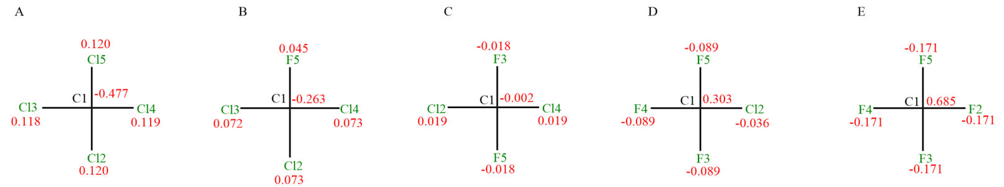
Figure S1 The atom names and charges of halogenated methane.

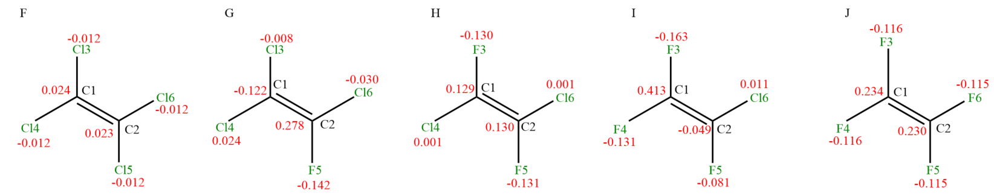
Figure S2 The atom names and charges of halogenated ethene

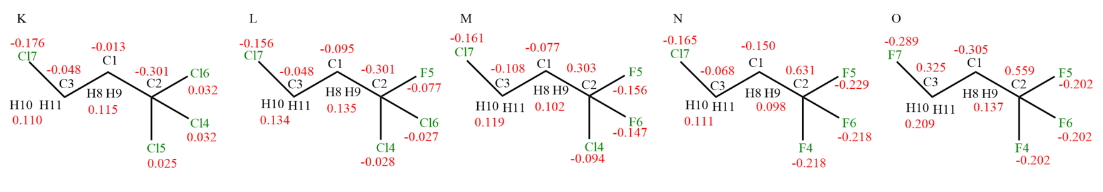
Figure S3 The atom names and charges of halogenated propane

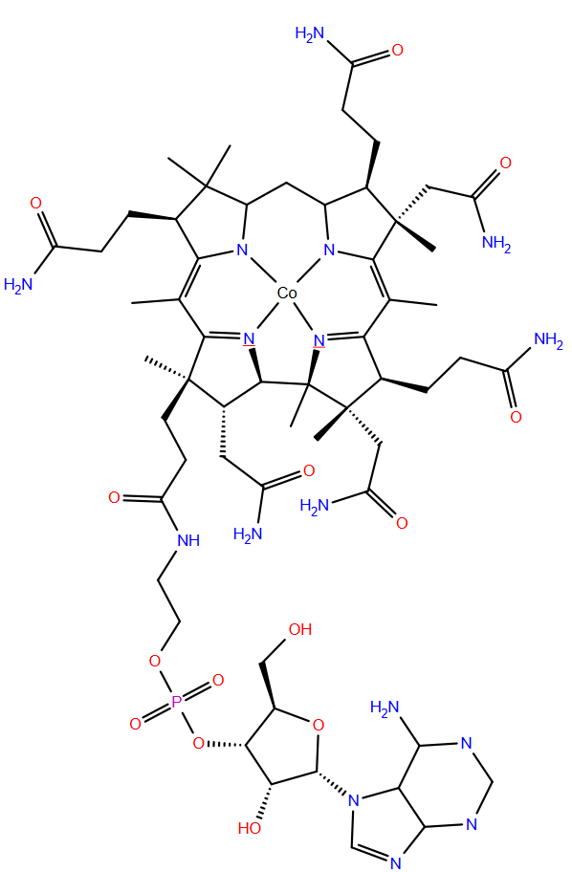
0.896
C27
C78 -0.472
0.148 H150 H151 H152
0.095
C41
0.034
C40
-0.026
C39
-0.470 C79
N46
0.085
-0.114
N49
-0.181
N48
0.236
Co89
N47
0.028
-0.219
-0.513
0.654 C75
H167 0.471
H149 0.385
N77 -0.867
O76 -0.565
12
H147 H148 0.027
-0.070
C74
H145 H146 0.067
-0.155
C73
H108 0.053
-0.010
C38
0.415
C37
0.105 H139 H140 H141
C71 -0.418
0.131 H142 H143 H144
C72 -0.509
0.229
C36
C35
N13 -0.598
H107 0.169
0.261
C33
H105
0.125 H153 H154 H155
0.425 H166
0.407 H138
-0.927 N70
O69 -0.558
12
0.754
C68
C67
-0.345
H137 H136 0.098
H134 H135 0.038
0.062
C66
0.090
-0.140
0.258
0.129 H128 H129 H130
C61 -0.322
C26
C30
H163 0.412
H133 0.402
N65 -0.933
O64 -0.531
12
0.753
C63
C62
-0.356
H131 H132 0.098
0.109 H125 H126 H127
C23
-0.283
C60 -0.322
0.214
C19
-0.057
C15
H170 0.386
H124 0.381
N58 -0.859
-0.568 O59
12
0.695
C57
H122 H123 0.091
C56
-0.236
H120 H121 0.090
-0.168
C55
0.067
H97
C11
-0.052
0.516
O53 -0.600
0.412 H395
0.413 H119
O22
-0.758
C52 0.728
-0.865 N54
H117 H118 0.071
C51 -0.316
0.104 H114 H115 H116
-0.417
C500
O88
-0.614
C7
0.211 H111 H112 H113
-0.228
C4
C43
0.240 C42
0.106
0.153
H110
0.050
H109
C44
-0.577 C45
C86
0.794
H161 H160
0.161
-0.547 C85
-0.191 C81
0.067 H158 H159
C82
12
0.532
-0.521 O83
-0.778 N87
0.352 H162
-0.414 N84
0.288 H169
0.412 H163
-0.008 C2
0.072 H91 H90
C3 0.162
H92 H93 0.041
-0.417 O14
1.215 P1
-0.720 O18
-0.553 O10
0.208 C9
0.114 H98
0.091
C12
C21
0.222
O32 -0.702
H106 0.437
H101 H102 0.008
C16
H99 0.075
0.119
O25
-0.524
N24 -0.799
H168 0.390
H103 0.369
N28 -0.887
0.281
C5
H94
12
0.074
0.033 H96
12
0.131
N6
-0.664 O29
12
0.455 H104
0.194 C8
12
0.119 H95
-0.646
C31
C34
0.850
N17 -0.774
C20 0.614
H100 0.015
-0.020 C80
0.026 H156 H157
Figure S4 The atom names and charges of cobalamin cofactor

Validation of cobalamin cofactor

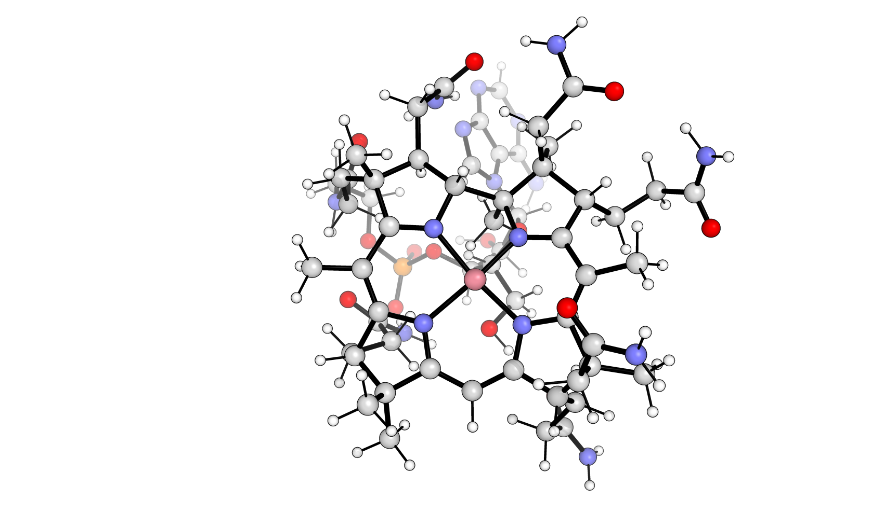
Co
N48
N47
N46
N49

Figure S5 The selected view of the cobalamin cofactor and atoms that are used to validate the structure in MD simulation.

Table S6 Optimized structure of cobalamin cofactor, calculated at B3LYP/ 6-311G(d,p) level of theory using Gaussian 09. The bonds and angles used to validate the geometry in MD simulation.
Optimized structure of Cobalt and nitrogen atom
N46_Co_bond_distance (Å) | 1.86555
N47_Co_bond_distance (Å) | 1.90632
N48_Co_bond_distance (Å) | 1.90951
N49_Co_bond_distance (Å) | 1.88518
angle_N46_Co_N47 (Degree °) | 89.70536
angle_N47_Co_N48 (Degree °) | 95.30555
angle_N48_Co_N49 (Degree °) | 92.02366
angle_N49_Co_N46 (Degree °) | 83.33081

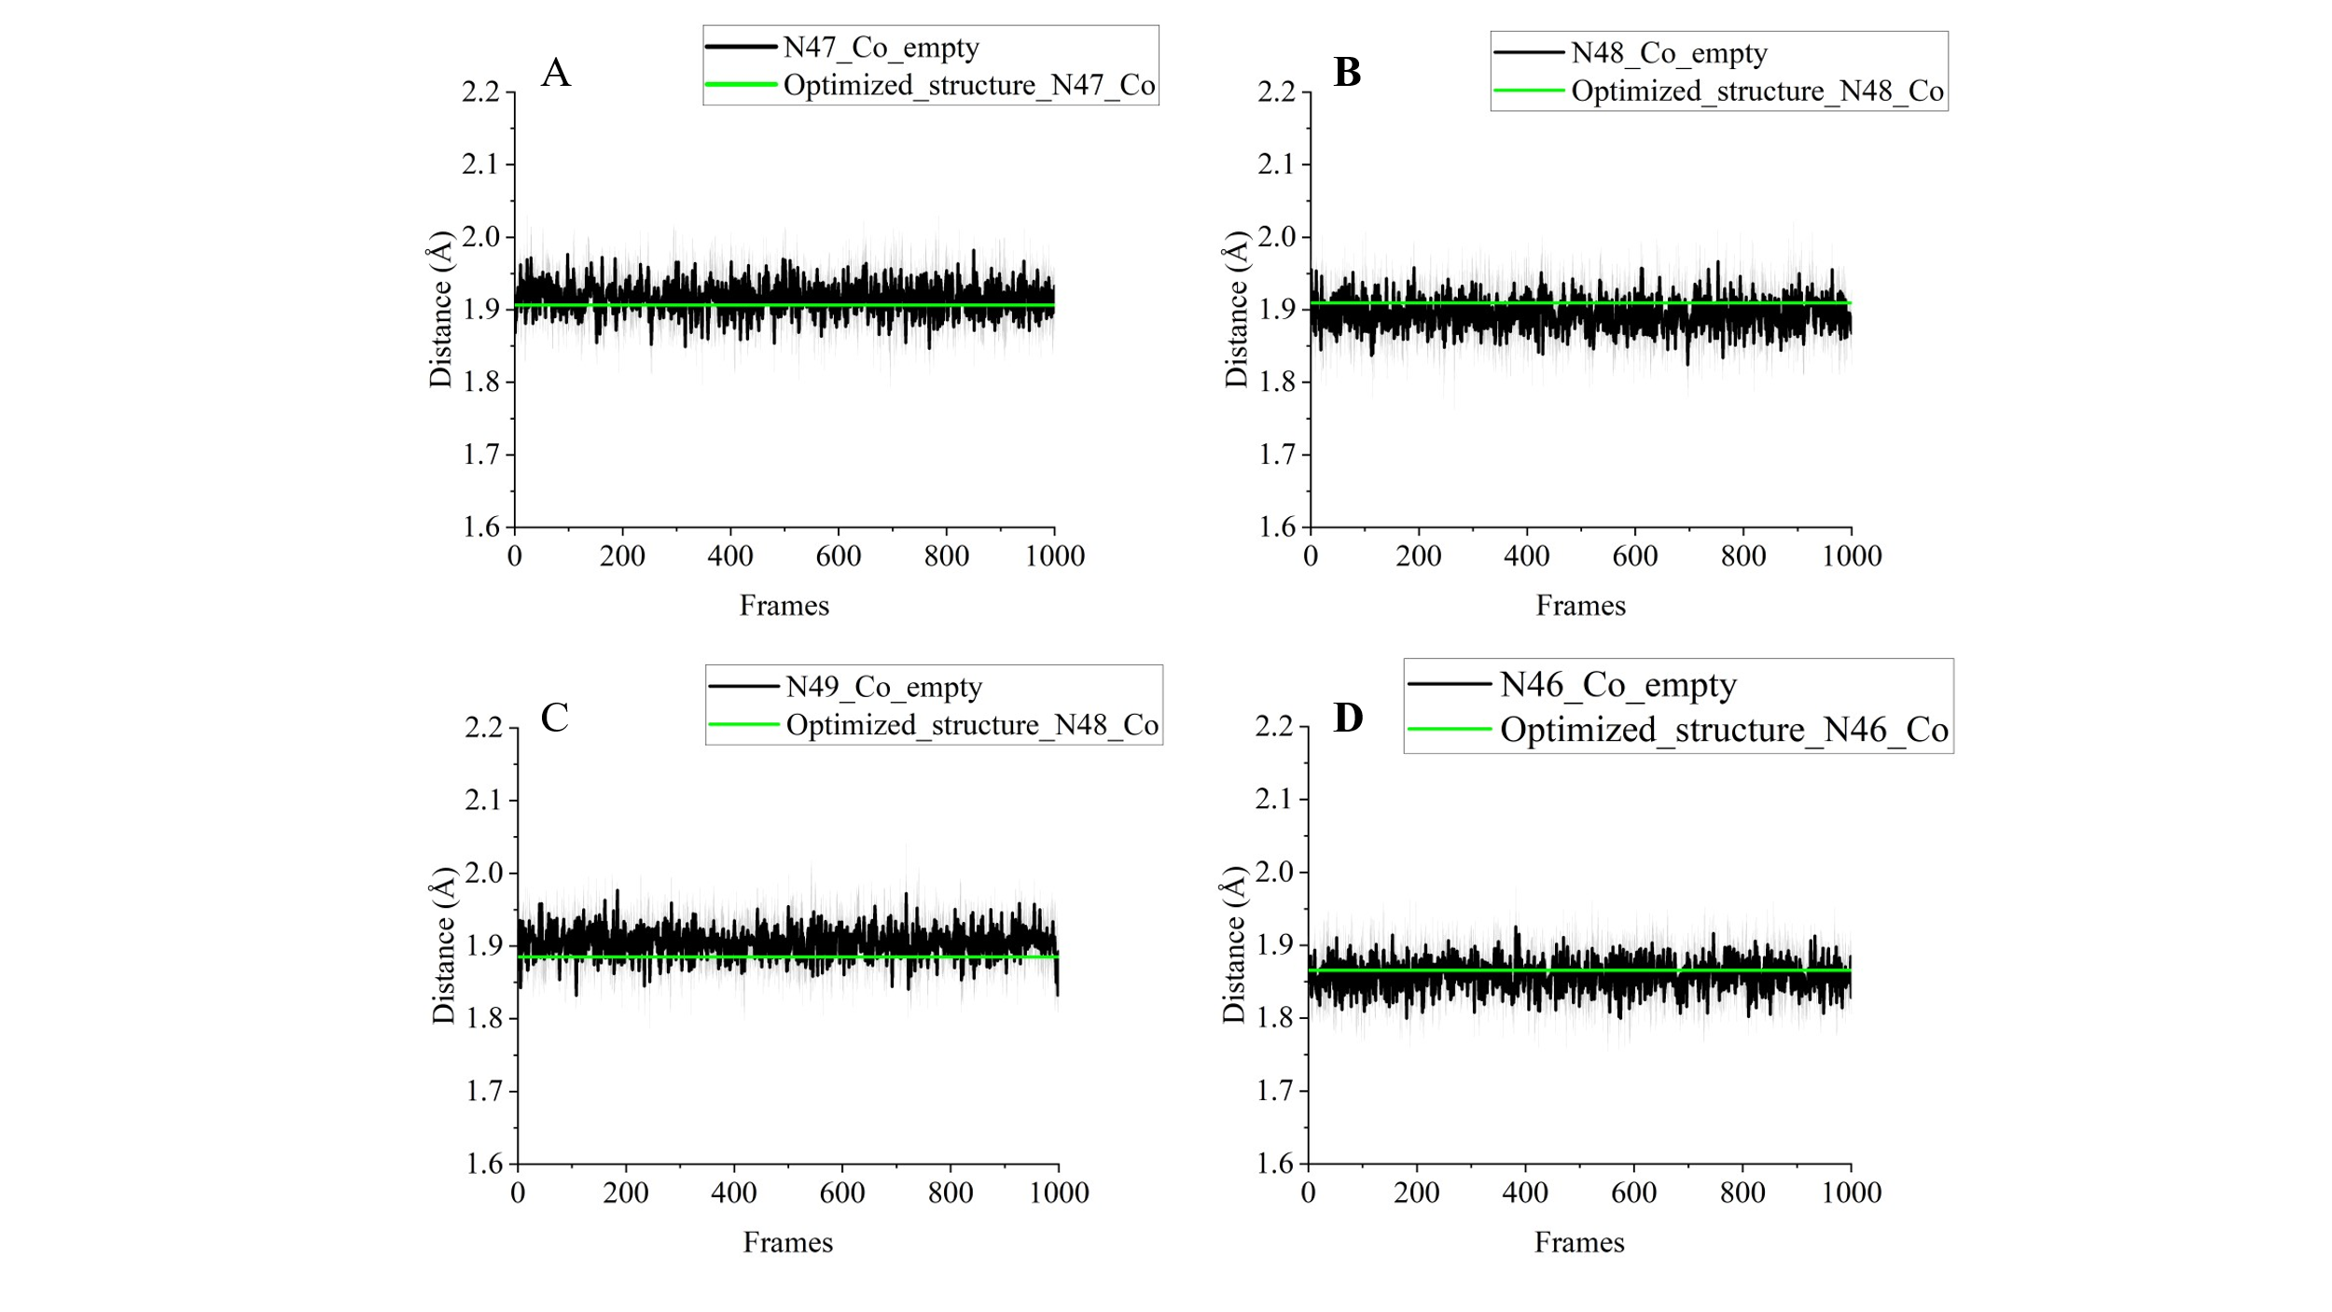
Figure S6 The comparison between the selected bond distances during the MD simulation with the geometry optimized bond distances.

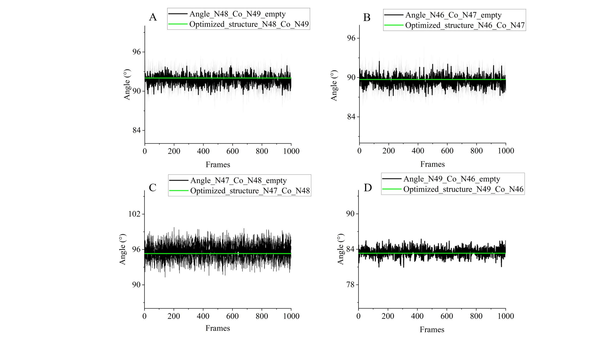
Figure S7 The comparison between the selected angles during the MD simulation with the geometry optimized angles.

Validation of ligands for intermolecular interactions
The main objective of the present study was to prob the binding free energy with molecular dynamics simulations, therefore, to test the validity of the calculation results, the ligand parameters were validated by comparing ligand–water interaction energies calculated using quantum mechanical (QM) methods (B3LYP/6-311G(d,p)) and molecular mechanics (MM) force fields, using identical conformations. Various ligand–water orientations and distances are shown in Figures S8–S10, which include the distance between the carbon atom and halogen atoms of the halogenated ligands and hydrogen atom or oxygen atom, respectively. The distance for each conformation were selected between 2.5 Å to 3.5 Å. The comparative interaction energies from QM and MM are provided in Figures S11–S13. Additionally, torsional profiles of halogenated propane ligands were evaluated using QM and MM methods, and MM dihedral parameters were fitted to QM energy profiles as shown in Figure S14.
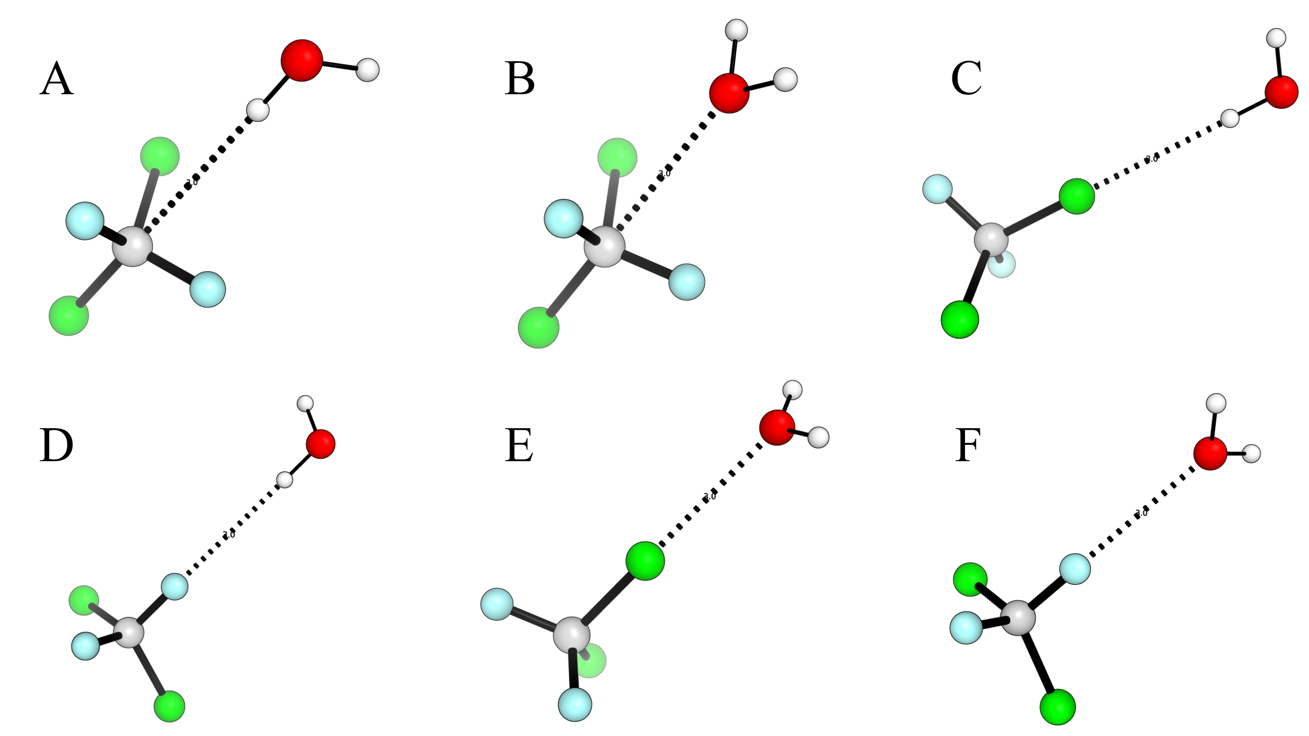
Figure S8 The representative conformations between the halogenated methane (dichlorodifluoromethane, selected as representative) and water molecule. Carbon atom is in grey colour, chlorine atom is in green colour, fluorine atom is in blue colour, hydrogen atom is in white colour and oxygen atom is in red colour. A) The distance between hydron atom of the water molecule and carbon atom, at 2.5, 3.0 & 3.5 Å. B) The distance between oxygen atom of the water molecule and carbon atom, at 2.5, 3.0 & 3.5 Å. C) The distance between hydrogen atom of the water molecule and chlorine atom, at 2.5, 3.0 & 3.5 Å. D) The distance between hydrogen atom of the water molecule and fluorine atom, at 2.5, 3.0 & 3.5 Å. E) The distance between oxygen atom of the water molecule and chlorine atom, at 2.5, 3.0 & 3.5 Å. F) The distance between oxygen atom of the water molecule and fluorine atom, at 2.5, 3.0 & 3.5 Å.

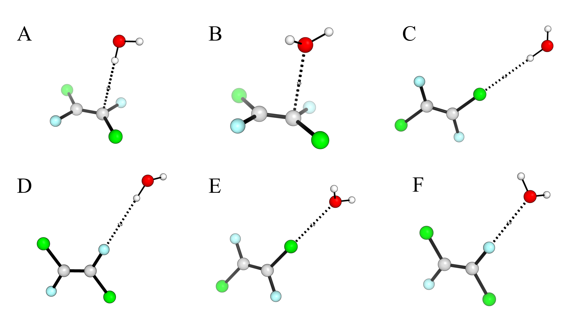
Figure S9 The representative conformations between the halogenated ethene (dichlorodifluoromethane, selected as representative) and water molecule. Carbon atom is in grey colour, chlorine atom is in green colour, fluorine atom is in blue colour, hydrogen atom is in white colour and oxygen atom is in red colour. A) The distance between hydron atom of the water molecule and carbon atom, at 2.5, 3.0 & 3.5 Å. B) The distance between oxygen atom of the water molecule and carbon atom, at 2.5, 3.0 & 3.5 Å. C) The distance between hydrogen atom of the water molecule and chlorine atom, at 2.5, 3.0 & 3.5 Å. D) The distance between hydrogen atom of the water molecule and fluorine atom, at 2.5, 3.0 & 3.5 Å. E) The distance between oxygen atom of the water molecule and chlorine atom, at 2.5, 3.0 & 3.5 Å. F) The distance between oxygen atom of the water molecule and fluorine atom, at 2.5, 3.0 & 3.5 Å.
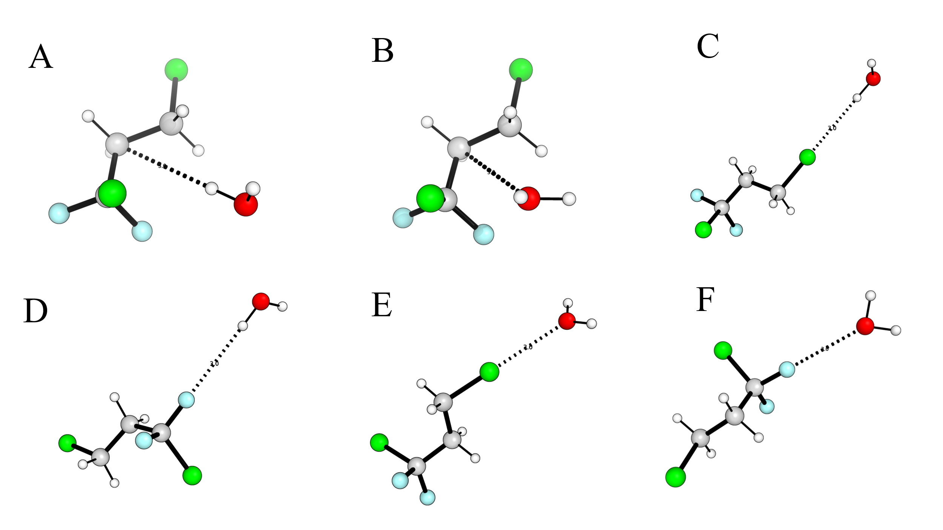
Figure S10 The representative conformations between the halogenated propane (dichlorodifluoromethane, selected as representative) and water molecule. Carbon atom is in grey colour, chlorine atom is in green colour, fluorine atom is in blue colour, hydrogen atom is in white colour and oxygen atom is in red colour. A) The distance between hydron atom of the water molecule and carbon atom, at 2.5, 3.0 & 3.5 Å. B) The distance between oxygen atom of the water molecule and carbon atom, at 2.5, 3.0 & 3.5 Å. C) The distance between hydrogen atom of the water molecule and chlorine atom, at 2.5, 3.0 & 3.5 Å. D) The distance between hydrogen atom of the water molecule and fluorine atom, at 2.5, 3.0 & 3.5 Å. E) The distance between oxygen atom of the water molecule and chlorine atom, at 2.5, 3.0 & 3.5 Å. F) The distance between oxygen atom of the water molecule and fluorine atom, at 2.5, 3.0 & 3.5 Å.

For each ligand, the interaction energies were calculated with quantum mechanics methods, the same level of theory for obtaining the ligand forcefield parameters in the method section, and the molecular mechanics in GROMACS energy. The calculation results were shown in the Figure S16-S18.
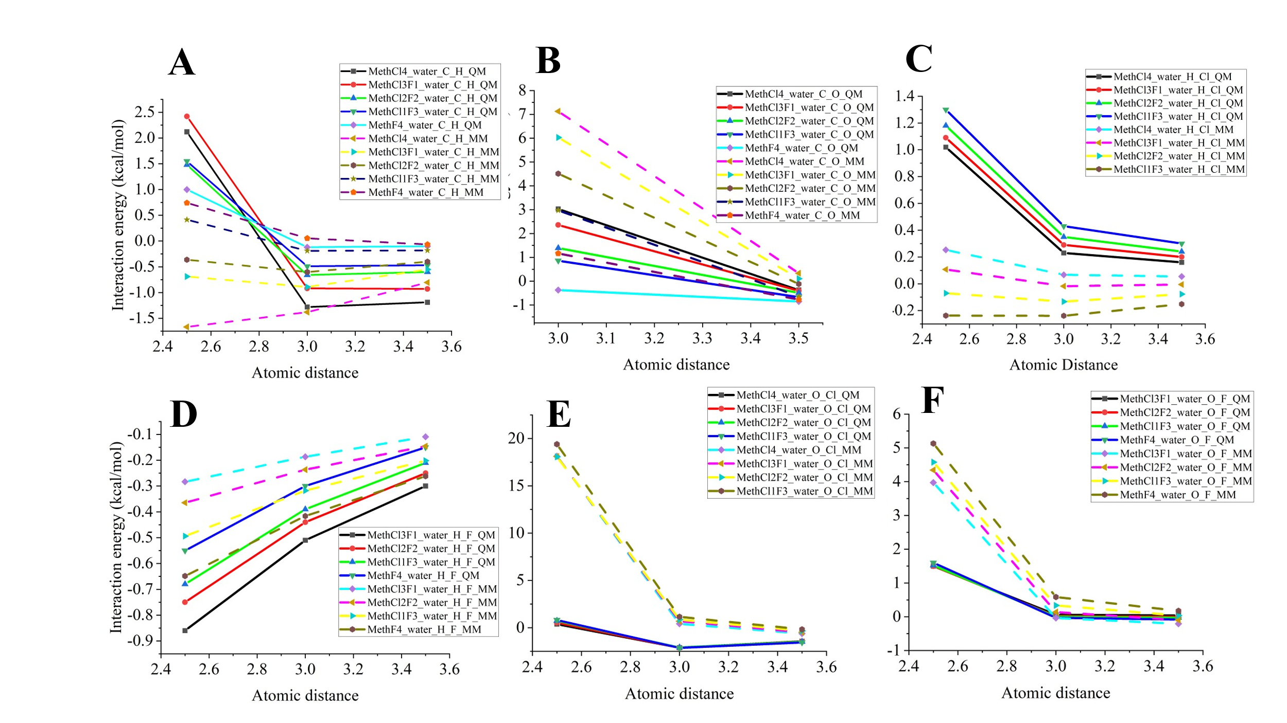
Figure S11 The comparison between quantum mechanics calculated and molecular mechanics calculated interaction energy for halogenated methane and water. The Y axis is the interaction energy kcal/mol, and the X axis is the atomic distance Å. The interaction energies calculated by quantum mechanics method were drawn in solid lines. The dash lines represent the molecular mechanics calculated interaction energies. A) Comparison of interaction energies for carbon atom of halogenated methane and hydron atom of water molecule. B) Comparison of interaction energies for oxygen atom of the water molecule and carbon atom. C) Comparison of interaction energies for hydrogen atom of the water molecule and chlorine atom. D) Comparison of interaction energies for hydrogen atom of the water molecule and fluorine atom. E) Comparison of interaction energies for oxygen atom of the water molecule and chlorine atom. F) Comparison of interaction energies for oxygen atom of the water molecule and fluorine atom.

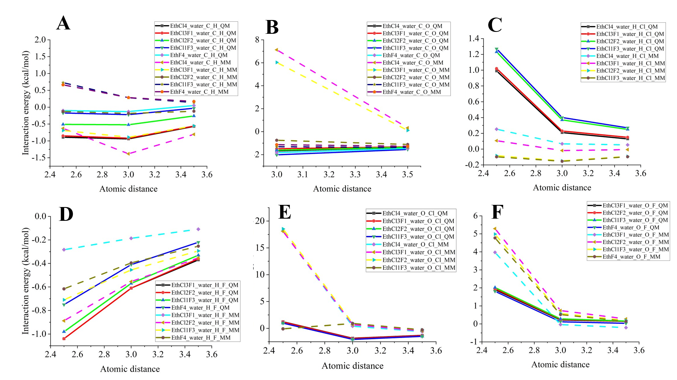
Figure S12 The comparison between quantum mechanics calculated and molecular mechanics calculated interaction energy for halogenated ethene and water. The Y axis is the interaction energy kcal/mol, and the X axis is the atomic distance Å. The interaction energies calculated by quantum mechanics method were drawn in solid lines. The dash lines represent the molecular mechanics calculated interaction energies. A) Comparison of interaction energies for carbon atom of halogenated ethene and hydron atom of water molecule. B) Comparison of interaction energies for oxygen atom of the water molecule and carbon atom. C) Comparison of interaction energies for hydrogen atom of the water molecule and chlorine atom. D) Comparison of interaction energies for hydrogen atom of the water molecule and fluorine atom. E) Comparison of interaction energies for oxygen atom of the water molecule and chlorine atom. F) Comparison of interaction energies for oxygen atom of the water molecule and fluorine atom.

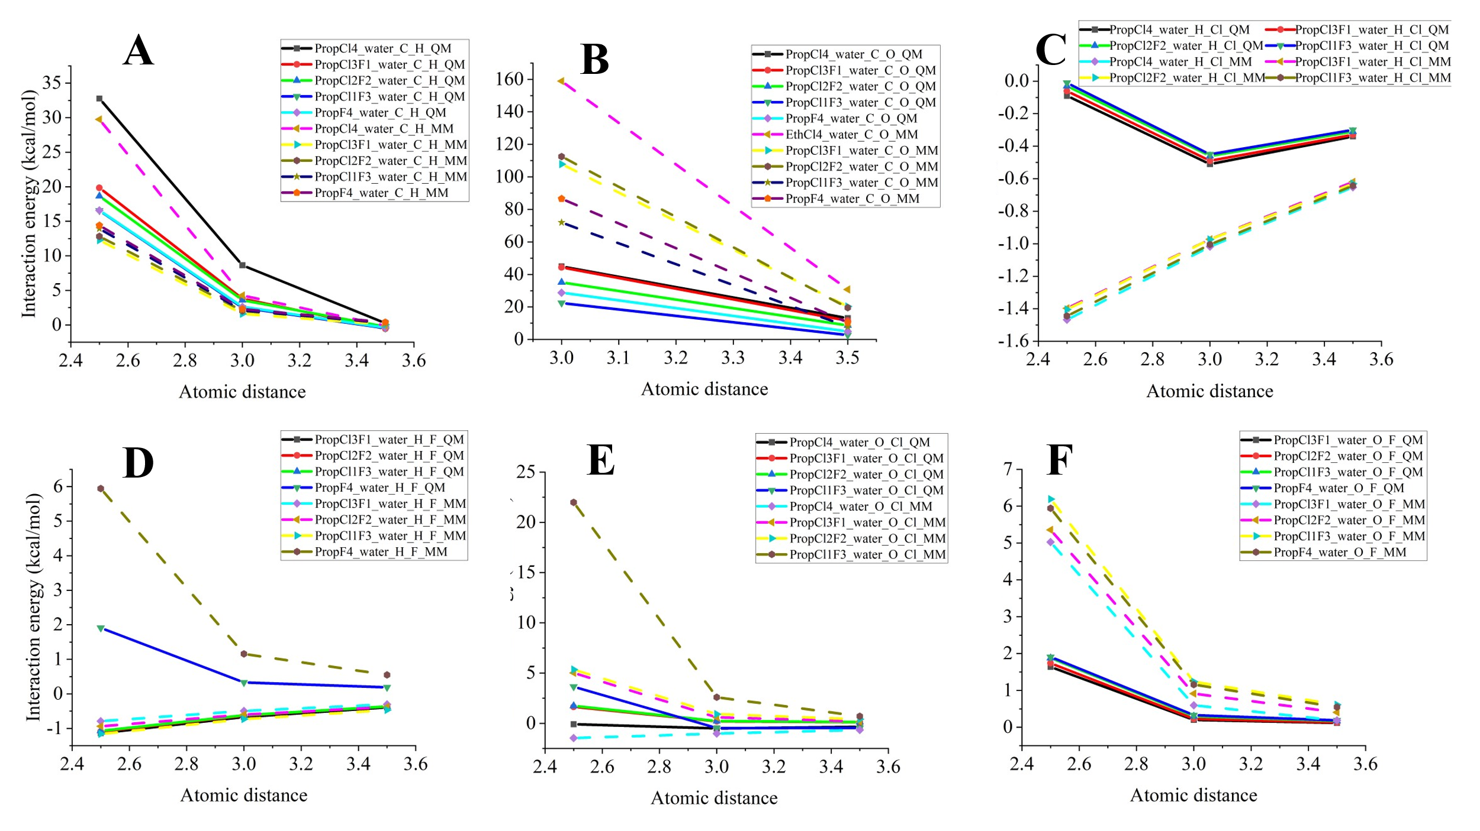
Figure S13 The comparison between quantum mechanics calculated and molecular mechanics calculated interaction energy for halogenated propane and water. The Y axis is the interaction energy kcal/mol, and the X axis is the atomic distance Å. The interaction energies calculated by quantum mechanics method were drawn in solid lines. The dash lines represent the molecular mechanics calculated interaction energies. A) Comparison of interaction energies for carbon atom of halogenated propane and hydron atom of water molecule. B) Comparison of interaction energies for oxygen atom of the water molecule and carbon atom. C) Comparison of interaction energies for hydrogen atom of the water molecule and chlorine atom. D) Comparison of interaction energies for hydrogen atom of the water molecule and fluorine atom. E) Comparison of interaction energies for oxygen atom of the water molecule and chlorine atom. F) Comparison of interaction energies for oxygen atom of the water molecule and fluorine atom.

As shown in the Figure S8-S13, for interaction energies between carbon atom and hydrogen atom (Figure S11-S13, A & D) generally agreed well by comparing the calculation results between quantum mechanics and molecular mechanics. The discrepancies exist for the interaction energies between carbon atom and hydrogen atom (Figure S11-S13 B), hydrogen atom and chlorine atom (Figure S11-S13 C), oxygen atom and chlorine atom (Figure S11-S13 C), oxygen atom and fluorine atom (Figure S11-S13 F). For the carbon atom and hydrogen atom (Figure S11-S13 B), oxygen atom and fluorine atom (Figure S11-S13F), and oxygen atom and chlorine atom (Figure S11-S13 E), the repulsive energies at close distance were higher in molecular mechanics calculated than that of quantum mechanics calculations results, but converged at the longer distances. For the oxygen atom and chlorine atom (Figure S11-S13 E), the higher repulsive energies calculated by molecular mechanics at the close distance (2.5 Å) can be accounted for the incapability for AMBER general atom forcefield (GAFF) to describe the sigma hole effects on the surface of chlorine atom (a positively charged region due to uneven distribution of electrons), which can be properly described in the quantum mechanics calculations. For the interactions energies calculated for hydrogen and chlorine atom (Figure S11-S13 D), the repulsive energies at close distance were lower in molecular mechanics calculated than that of quantum mechanics calculations results, which can also be attributed to the incapability for AMBER GAFF to describe the sigma hole effects on the surface of chlorine atom. Although such the overestimation and underestimation exists, the interaction energies from short to long distance exhibit a consistent trend of interaction energies between quantum calculation and molecular mechanics calculations, indicating a usable forcefield parameters for binding free energy calculation by molecular dynamics simulations.

The torsional energies of the halogenated propane were also validated by comparing with the quantum mechanics energy scan of 24 various dihedrals (Figure S14 F, dihedral of atoms C3-C1-C2-F) with 15 intervals, at the same level of theory for interaction energy calculation above and geometry optimization. Subsequently, 24 conformations were used for the torsional energy calculated by molecular mechanics. The results shown in the Figure 19 indicated an agreement for the torsion energies calculated by quantum mechanics and molecular mechanics.

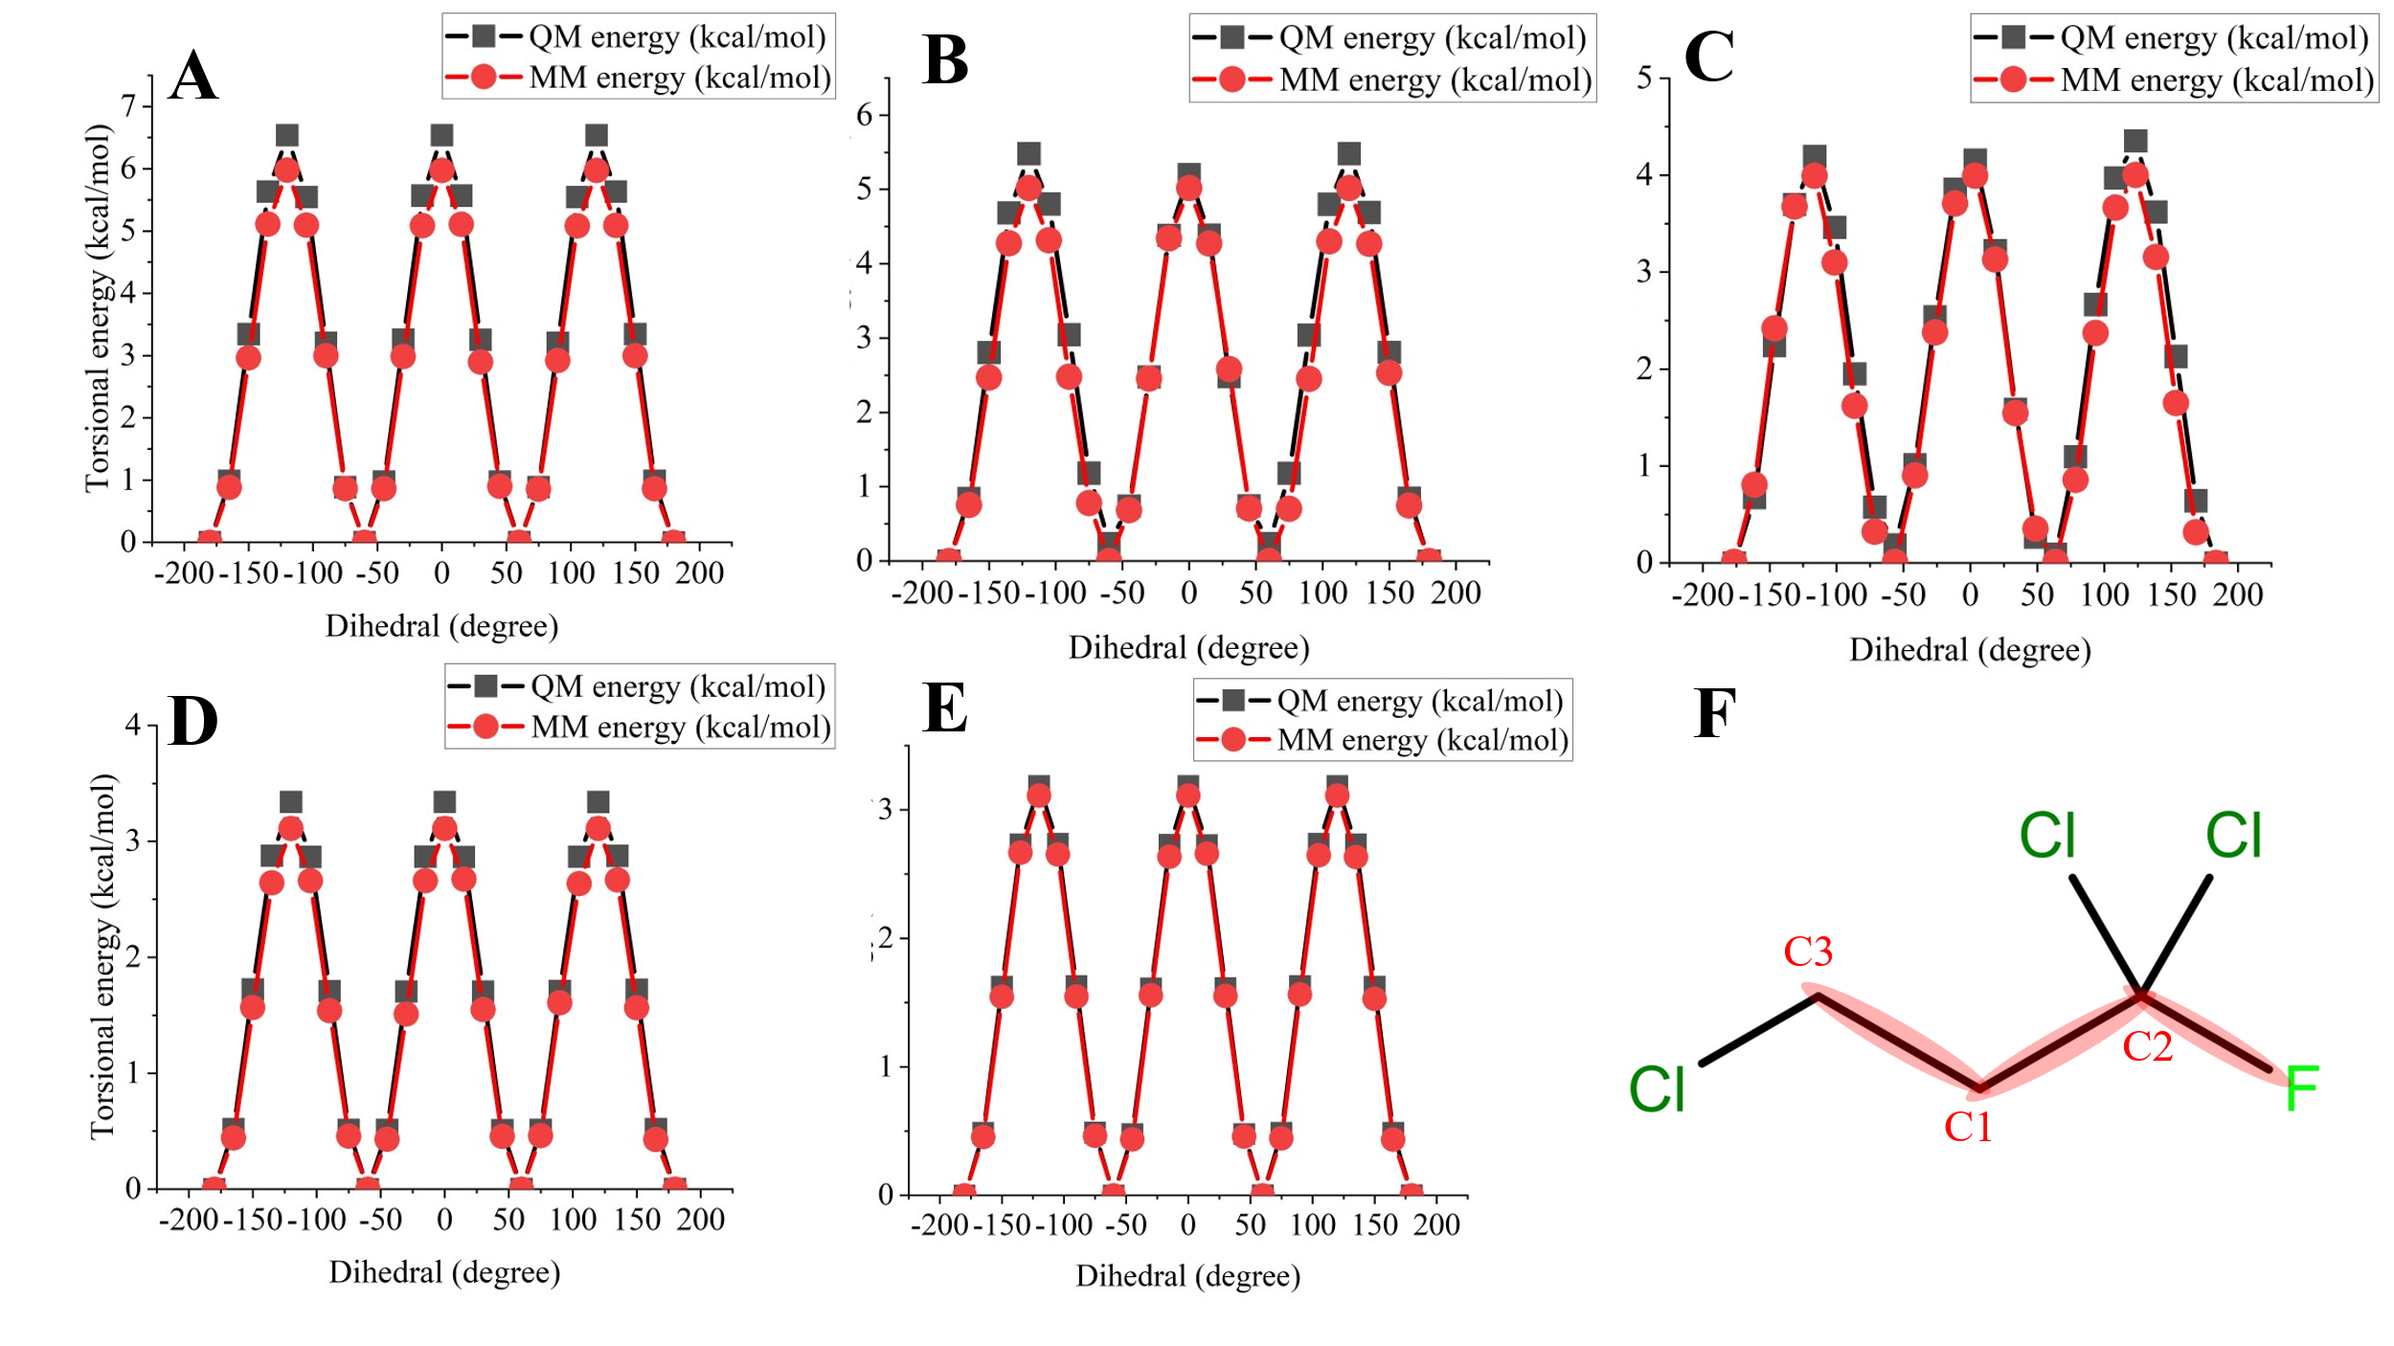
Figure S14 The comparison between quantum mechanics calculated and molecular mechanics calculated torsional energy for halogenated propane. The Y axis is the torsional energy kcal/mol, and the X axis is the dihedral degree. The torsional energies calculated by quantum mechanics method were drawn in black lines and black square. The red colour lines and red cycle represent the molecular mechanics calculated torsional energies. A) Comparison of torsional energies for tetrachloropropane. B) Comparison of torsional energies for trichlorofluoropropane. C) Comparison of torsional energies for dichlorodifluoropropane. D) Comparison of torsional energies for chlorotrfluoropropane. E) Comparison of interaction energies for torsional energies between tetrafluoropropane. F) Illustration of atom selection for dihedral energies calculation, highlighted in red, C3-C1-C2-F.

Supplementary Information for 3.1 validation of MD simulation results
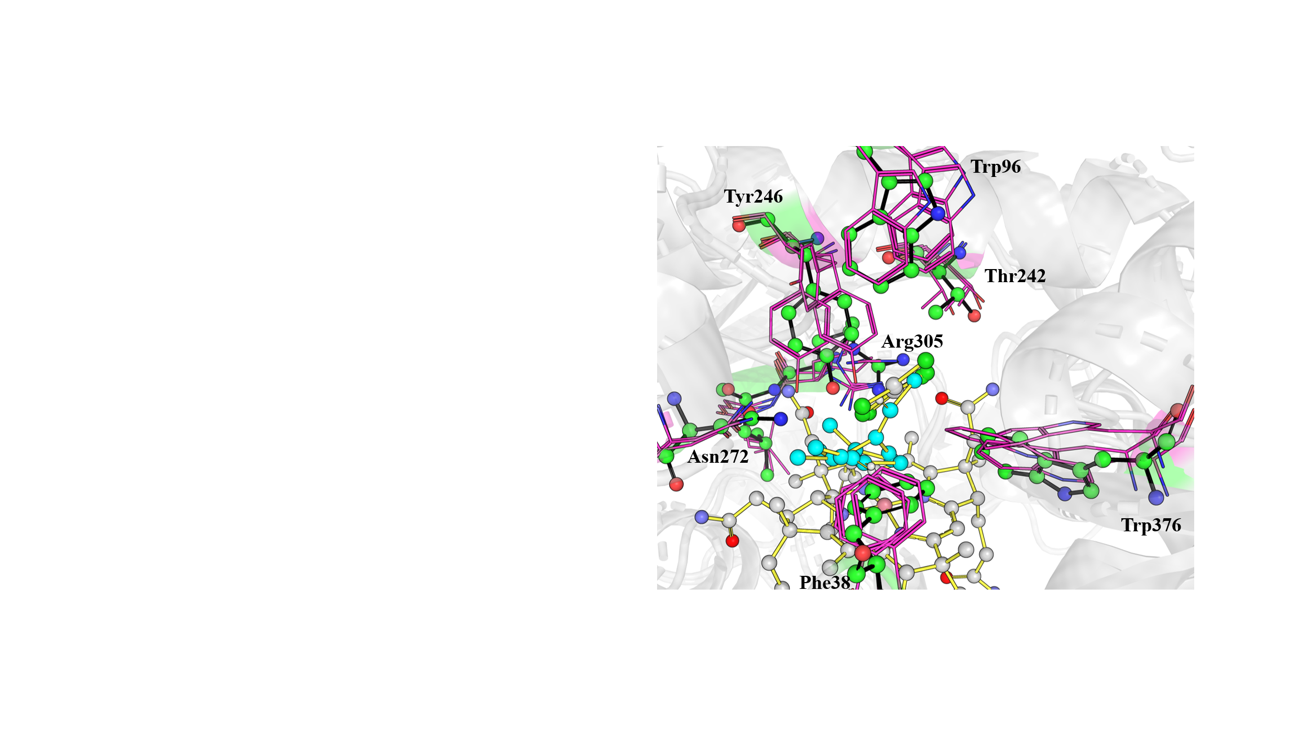
Figure S15 The alignments for between the PceA crystal structure (shown in sticks, with green sphere) chain-B, with trichloroethene associated, and PceA_trichloroethene MD simulation structures (shown in line with purple color), and the trichloroethene ligands (shown in blue sphere).
Supplementary Information for 3.2
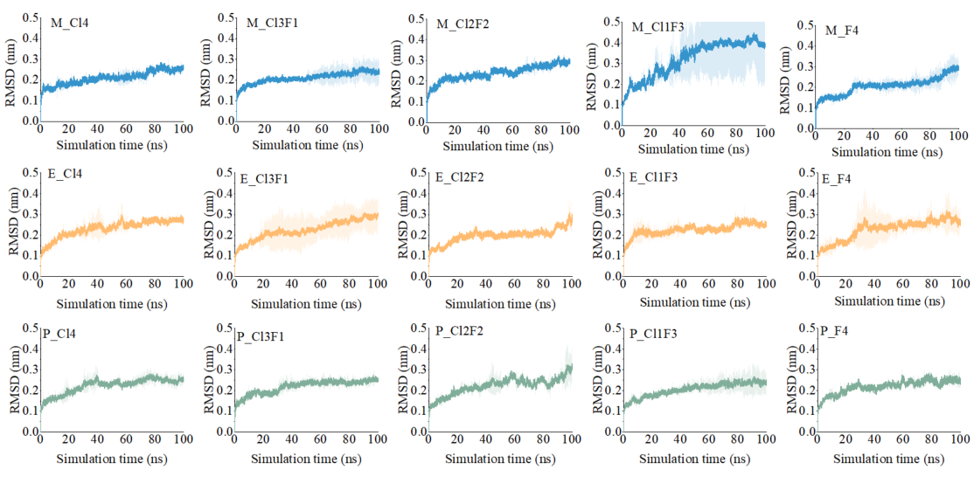
Figure S16 The backbone atoms RMSD of 100 nano-seconds simulation MD trajectories for each ligand. The shaded areas are the standard deviation of three independent simulations.

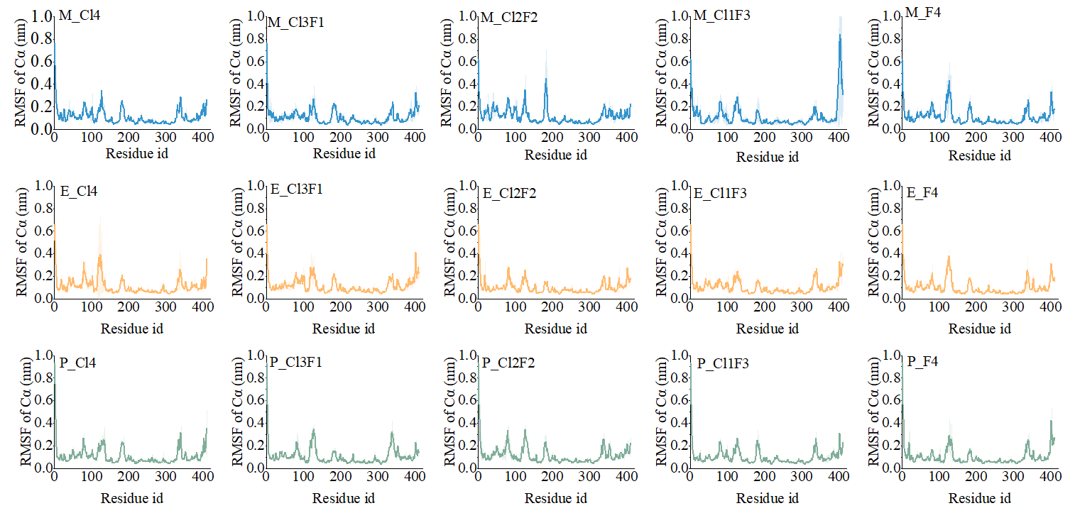
Figure S17 The protein Cα root-mean-square fluctuation (RMSF) from 100ns simulation for three systems halogenated methane (M), halogenated ethene (E) and halogenated propane (P) bound to the five ligands (C14, C13F1, C12F2, C11F3, F4). RMSF was computed for all Cα atoms after backbone alignment to the reference structure (initial conformation). Across all complexes, fluctuations remain low with only transient spikes attributable to flexible loop regions, and no systematic ligand-dependent differences are observed.
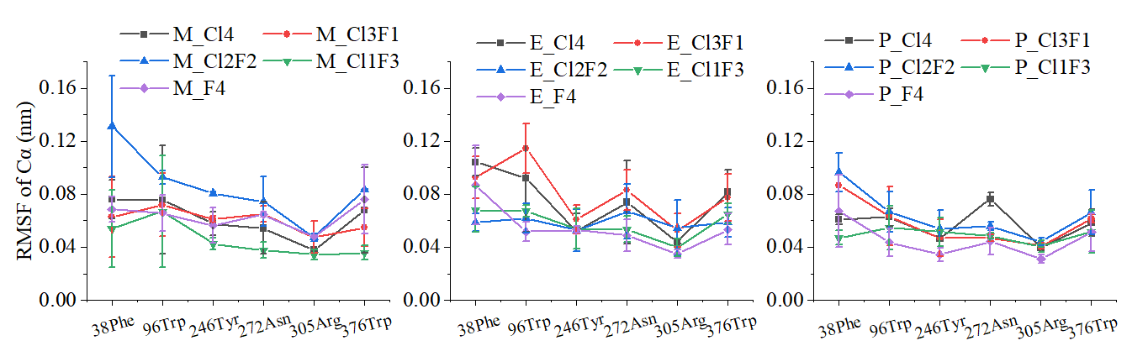
Figure S18 Mean Cα RMSF for key binding-site residues (Phe38, Trp96, Tyr246, Asn272, Arg305, Trp376) for the three systems (left to right: M, E, P) with the five ligands (C14, C13F1, C12F2, C11F3, F4). RMSF values were calculated after least-squares alignment of the protein backbone to the reference structure. Error bars denote the standard deviation (see Methods for details). Overall fluctuations are small (≤ ~0.16–0.17 nm) and show no systematic ligand-dependent trends, indicating a stable active site across complexes.

The MMPBSA binding free energy convergence check, supplementary information for section 3.3

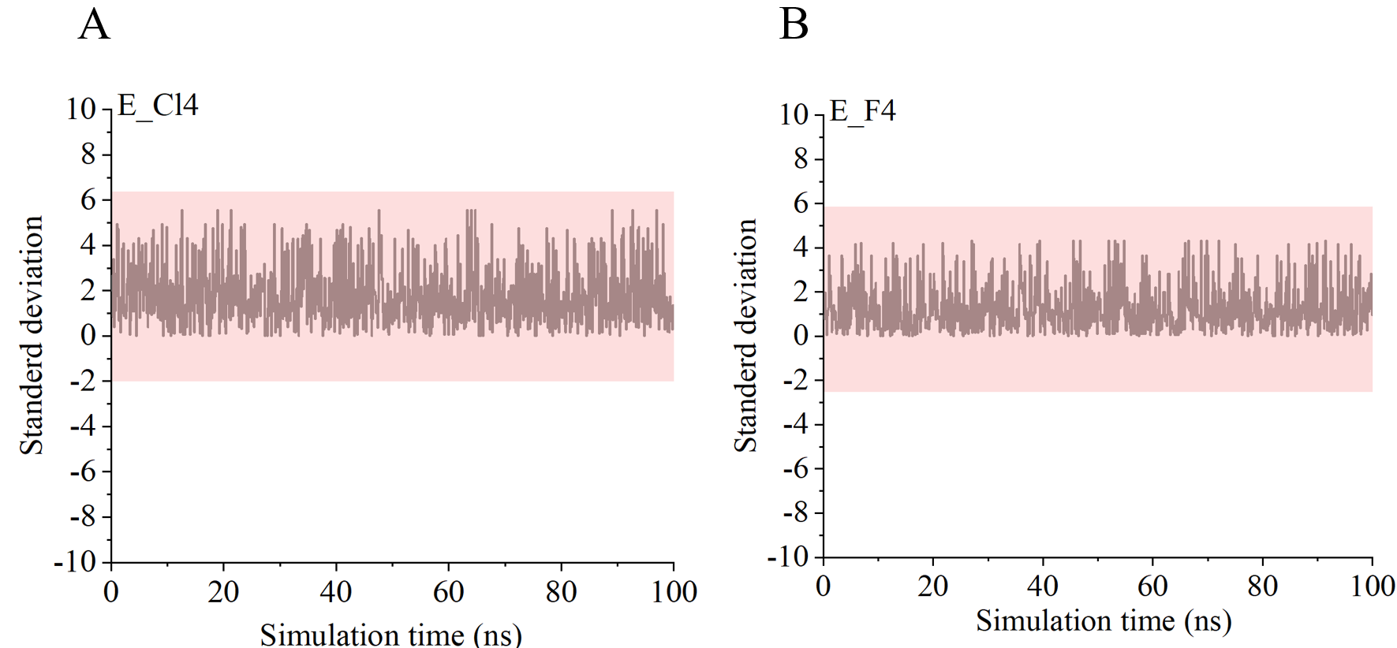
Figure S19 Time series of the per-frame standard deviation of the binding free energy computed by g_mmpbsa for representative systems E_Cl4 (A) and E_F4 (B) with 1000 frames sample evenly from 0–100 ns simulations. The shaded band denotes the benchmark of standard deviation range reported for the example systems in the original g_mmpbsa publication. In both cases, binding free energy standard deviation fluctuates within this envelope for the duration of the production run, indicating sufficient sampling for reliable MM-PBSA estimates. The benchmark of standard deviation range is calculated as the average standard deviation reported from the Supporting Information Table S3 in the original g_mmpbsa publication. https://doi.org/10.1021/ci500020m

The van der Waals contacts between ligands and receptor, supplementary information for Figure 6

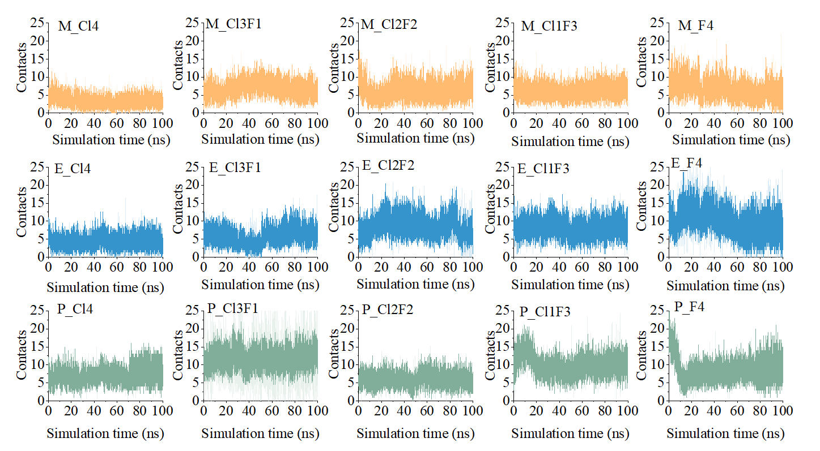
Figure S20 Time evolution of ligand–PceA van der Waals (vdW) contacts.For each system, the trace shows the number of heavy-atom pairs (H excluded) within 3.5 Å (0.35 nm) between the ligand and the receptor computed with gmx mindist over the 100-ns production trajectory (every saved frame). Panels are organized by carbon scaffold—M (methane), E (ethene), P (propane)—and halogenation: Cl4, Cl3F1, Cl2F2, Cl1F3, F4.

