

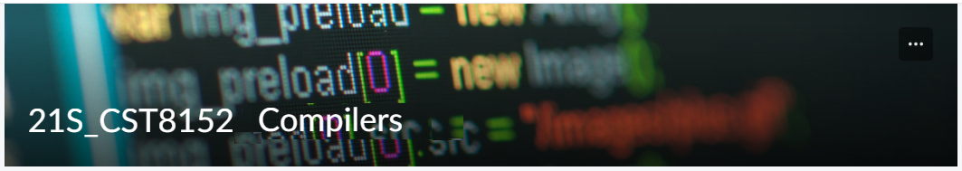

MODEL TASK FOR ASSIGNMENT 2.1 – Garter

Team: [Joshua Fearnall] - Id: [041019251]

- Note: This task is part of the Assignment 2 from Compilers Course. Any problem, contact your lab professor.

PART 1: RE – Regular Expression (1.5 mark)

Lexeme Classes: Define the classes to be used in your regular expression:

Answer:

L = [A-Za-z] Letters
D = [0-9] Digits
U = _ Underscore
Q = “ String Literal delimiter
O = [^LDUQ] Other chars

Define the RE to be used for: variables, literals and keywords:

Answer:

* Variables: L|U[L|D|U]*

* Literals:
String: Q[^Q]*Q
Int: D+

* Keywords: {and, def, else, if, while, import, not, or, return, True, False}

PART 2: TD – Transition Diagram (1.5 marks)

Activity: Starting from the previous lexeme classes and obeying the RE, it is possible to define the automata for your language:

Answer (draw / copy image of the automata):

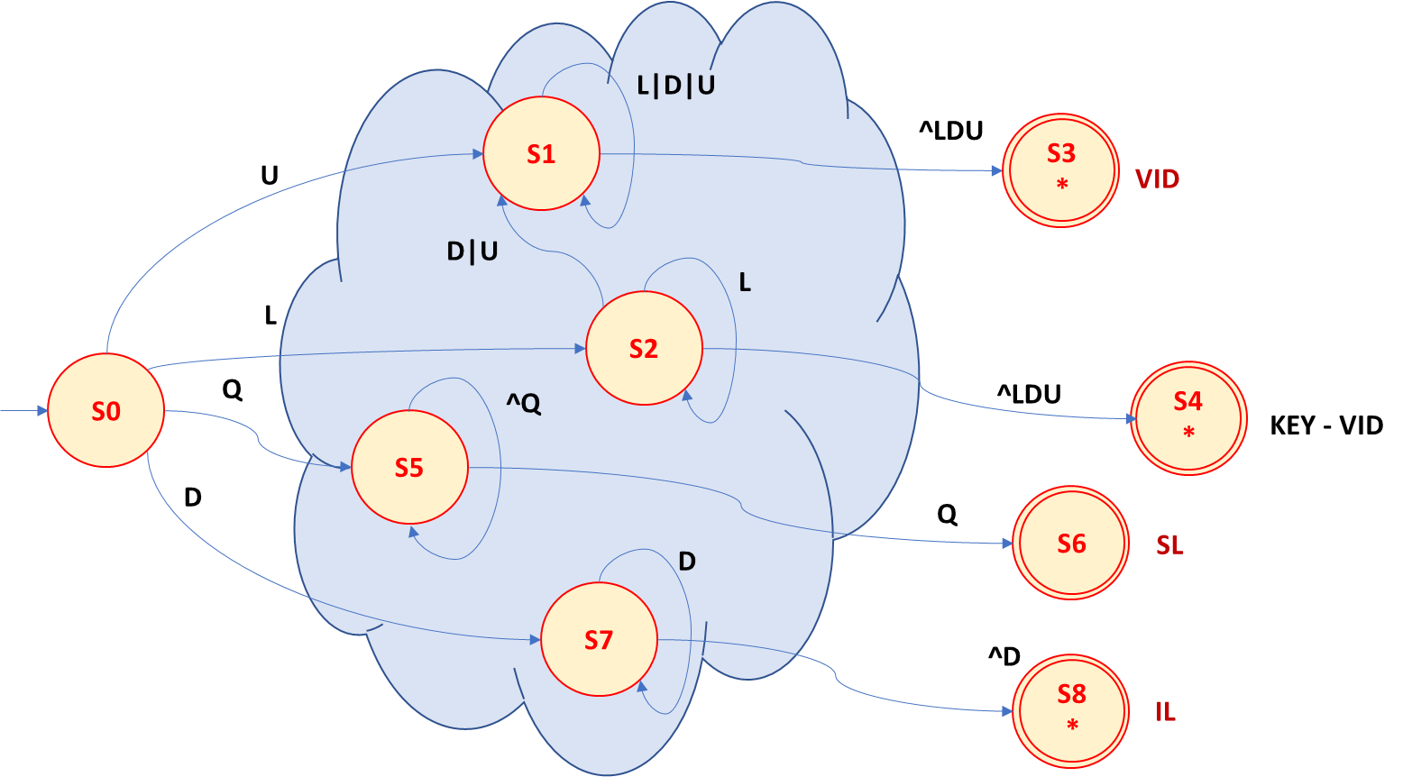

PART 3: TT – Transition Table (2 marks)

Activity: Now, it is possible to define the TT for these lexemes:

Answer (Transition Table):

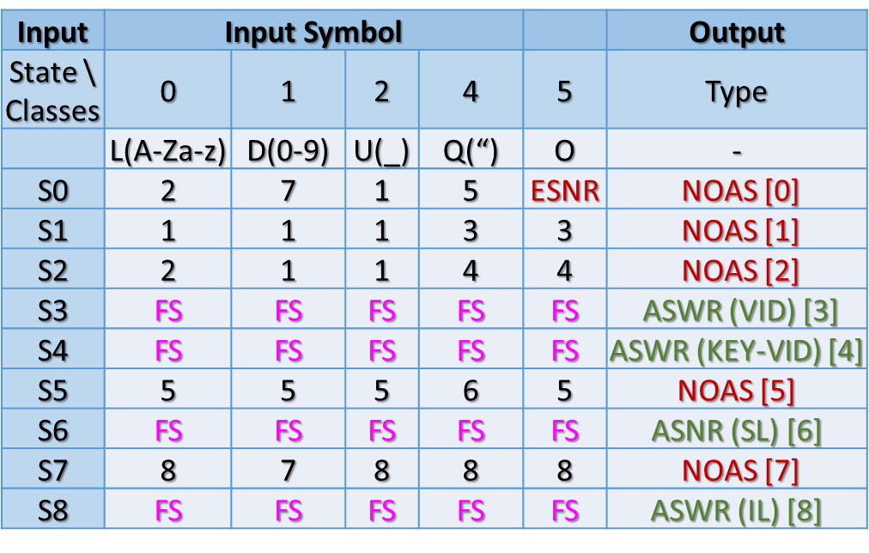

Update: Oct 2nd 2022.

Adapted from resources developed by Prof. Svillen Ranev (Algonquin College, 2019)

