Algonquin College Logo

# SCHOOL OF ADVANCED TECHNOLOGY

### ICT - Applications & Programming

### Computer Engineering Technology – Computing Science



A11

Game Interface

Team:

[Joshua Fearnall] - Id: [041019251]

Game Proposal - NumPuz

***This template is suggested (not mandatory) to answer A11 Specification.***

|  |  |
| --- | --- |
| **Part**  **1** | **GUI Definition** |

**EXPLANATION**

*The purpose of this assignment is to define the elements of the GUI application to be used in your game implementation.*

* ***Example****:*

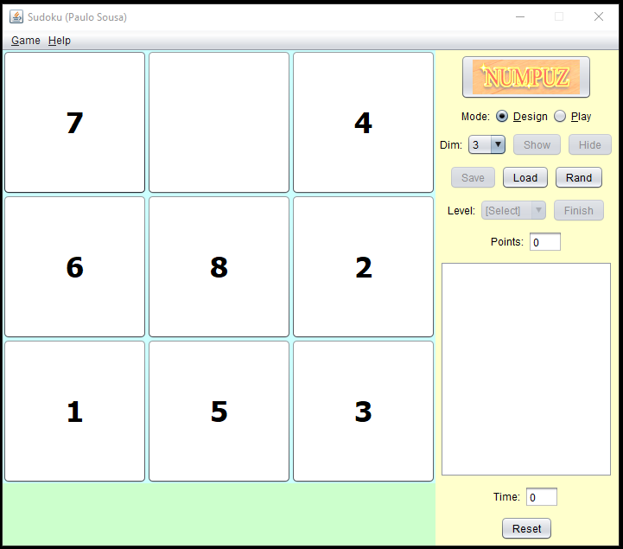

* ***Note****: The professor interface is also a proposal. It means that your own implementation can be different. What does matter is that the game functionality will be respected.*
  1. **Defining the Components**

**List of components**

*Include the list of components that you will use (they can be from Swing or JavaFX).*

JMenuBar, JButton, JFrame, JWindow, JMenuItem, JTextArea, JPanel, JLabel, GridLayout

**Functionalities and Behaviors**

*What are the behaviors and functionalities that you will provide? How these elements are related with functionalities.*

***Example****: The game mode can be selected by RadioButtons, etc.*

Difficulty and game mode (play/create), reset button, saving, loading, and generating a random board will be selected using the JMenu (select menu option > open JWindow with additional options.)

Information will be displayed after selection the info button from the menu using a JWindow and JTextArea.

Game stats (score and time) are displayed in the top of screen using JLabels in the menu

Finally, the Gameplay will take place on the left side of the screen, using buttons in a GridLayout to move the numbers.

**Details**

*Drawn your interface (ex: in an image from Paint / Powerpoint slide, or any sketch tool), describing:*

* *The components;*
* *The properties (ex: size, dimension, color, position, etc)*
* *Additional GUI components (ex: the layout to be used).*

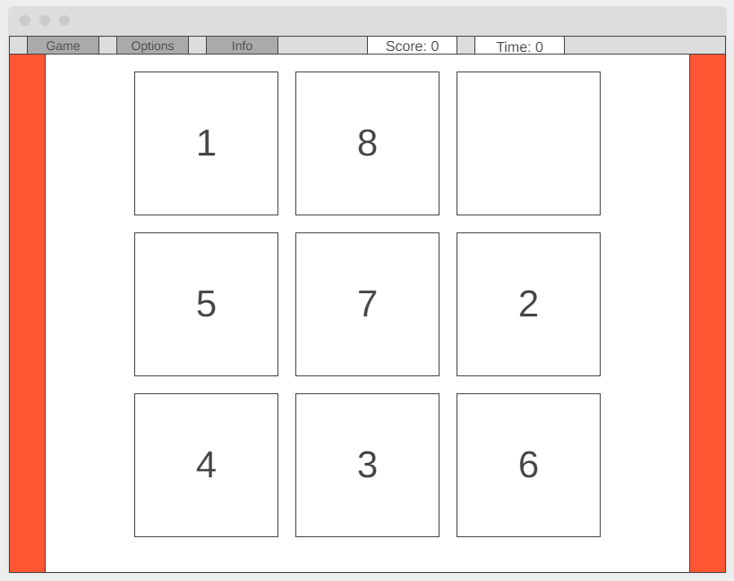

The colors will likely be neutral, using whites, grey, and blacks for the interface. An undetermined color may be used to add something interesting to the layout.

The size of the screen will be 800x600 to keep a 4:3 aspect ratio

The layout will additionally contain an JPanel housing a JMenuBar, JTextArea, and a GridLayout. The remaining controls will be housed in JWindows that are accessed by selecting various menu options.

* 1. **User Manual**

**Basic cycle**

*Create a brief description about how your game can be used.*

***Example****: If you have to design the solution to be saved and played later, how are the stems. Most importantly, how someone can play the* ***NumPuz****.*

* *Note: your process do not need to be followed exactly when you are going to the implementation. For while, it is only a script about how to play.;*

Saving and loading could use csv files, with numbers from 0 to N placed in the order that they will appear in the game. (top to bottom, left to right)

To play the game, the player clicks on a square containing a nonzero value, if the selected square is adjacent to the blank space the two squares swap locations. The player wins the game when they move the tiles in order, from lowest number to highest, top to bottom, left to right. E.g. (1, 2, 3,

4, 5, 6,

7, 8, Empty)

**FINAL SUGGESTIONS**

*Here some ideas to think about your language....*

* *Try to create a game whose execution can be very intuitive (easy to be played).*
* *Remember that this game will be in fact implemented only in the next assignment.*

**References**

*[Include eventual references used here]*

Algonquin College

Fall, 2022