Networking Programming Project

**Summary**

The application is a socket server and client application that allows a server and client to chat. The connection to the server can be closed when the client sends “/q”.

To connect to the server the client must connect with a host of “localhost” and port number of 5000. The application will run until “/q” is entered by the client, which triggers the connection to close. When a connection is established between the server and client. The application uses InputStream and OutputStream. Where the InputStream is used to read the data from the source and the OutputStream is used to for writing information for its destination.

**To run on Command Prompt**

Open two Command Prompt windows. One for the server and another for the client.

Run the server application as,

java Server

The Command Prompt window will show for the server



Run the client application as,

java Client

The Command Prompt window will show for the client



The server can now initiate the chat conversation.



The server and client can pass messages back and forward.

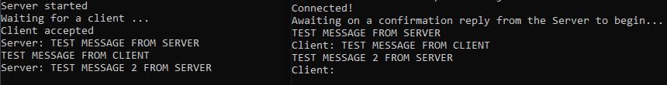

When the client sends “/q”. The server gets the following prompt.



**References**

(no date) *Java socket server examples (TCP/IP)*. Available at: https://www.codejava.net/java-se/networking/java-socket-server-examples-tcp-ip (Accessed: January 15, 2023).

Barhoumi, J. (2021) *Create a chat app with Java sockets*, *Medium*. Nerd For Tech. Available at: https://medium.com/nerd-for-tech/create-a-chat-app-with-java-sockets-8449fdaa933 (Accessed: January 15, 2023).

ramram43210 (2020) *Java socket programming – complete client server chat application program | socket programming*, *YouTube*. YouTube. Available at: https://www.youtube.com/watch?v=HAHxjVO_UWA (Accessed: January 15, 2023).

*Socket programming in Java* (2022) *GeeksforGeeks*. Available at: https://www.geeksforgeeks.org/socket-programming-in-java (Accessed: January 15, 2023).