# Change request log

# Team

Team 2: Michelle Jones and Rangy Samuel

# Change Request

FEMR-208 <https://teamfemr.atlassian.net/browse/FEMR-208>

# Concept Location

|  |  |  |
| --- | --- | --- |
| Step # | Description | Rationale |
| 1 | We ran the system | Can’t fix what we can’t run. |
| 2 | Per announcement in class from Gerry, added current user to trip. | Needed to recreate the bug |
| 3 | Created fake medication "Zeee Lotion" in inventory | Need medication in database in order to prescribe it to fake patient. |
| 4 | Created fake encounter with "John Doe" in Triage | Needed so I can "see" the patient in medical and prescribe medication |
| 5 | Assigned medication to patient in medical, clicked save. Encountered runtime exception | Well I needed to assign a medication to the user so they could have a PDF generated for their prescription... but the run time exception is preventing me from solving the issue, so now I need to investigate that before I can fix this bug. |
| 6 | Per Gerry's instructions, in file app/femr/data/daos/system/MedicationRepository.java changed line so I could prescribe medication to patient.  if (medicationName == null || medicationGenericStrengths == null || conceptMedicationForm == null)  TO  If (medicationName == null) | Since this bug isn't what I am trying to solve, modified the file where the error occurs. I know it isn't good practice, but I can fix FEMR-208 if I can't even prescribe a medication to a patient.  This won't be saved to the branch... |
| 7 | Finally assigned medication to patient in medical and prescribe in pharmacy. Back to Triage to open the patient's history. Viewed the encounter and clicked the "Generate PDF" button.  Saw that the medication is listed without quantity! | Had to recreate the bug as described in JIRA ticket. Now that I have and I understand the issue, I can look further.... |
| 8 | Opened cmd and grep'd for "Generate PDF" to see where in the code this is used. | Find the form, find the logic behind it, same as before. |
| 9 | Examined file app/femr/ui/views/history/indexEncounter.scala.html | File is where the PDF button exists. Inside there is a PDF object that is responsible for acting when the button is clicked. The import for the PDF is @**import** femr.ui.controllers.routes.PDFController |
| 10 | Examined file PDFContoller.java  This file is responsible for creating the PDF with the medications. Line 374 is where the medication is actually being inserted.  Next step is to examine how that data is being retreived... | Since the data is being outputted to a PDF in a different format, there has to be a location in the code where it is manually being converted from the HTML viewable item to the PDF formatted item. Find that and you find where the conversion occurs. Find the conversion and you can find where the prescription quantity isn't being grabbed. |
| 11 | Added break points in PDFController.java on lines 108, 112, 372,374. That way I can see the data from retreival of the prescription to formatting of the string. | Trying to determine if the quantity is already being retreived but not used or if the prescription object doesn't contain the quantity, which would be odd. |
| 12 | Debug at break point 112 shows that the prescription object does contain the amount. | Going further in debug to lines 372 to see how the string is being built. |
| 13 | Debugging at lines 452 and 456 where the medication paragraph is formatted with just the medication name. No quantity is being shown. | Now that I know where the string is being generated, I can modify it to include the quantity of the prescription! |

**Time spent (in minutes):** 1 hr

# Impact Analysis

Use the table below to describe each step you followed when performing impact analysis for this change request. Include as many details as possible, including why classes are visited or why they are discarded from the ones that have to change.

Do not take the impact analysis of your changes lightly. Remember that any small change in the code could lead to large changes in the behavior of the system. Follow the process on impact analysis covered in the class. Describe in details how you followed this process in the change request log. Provide details on how and why you finished the impact analysis process.

|  |  |  |
| --- | --- | --- |
| Step # | Description | Rationale |
| 1 | Examined PDFController.java and PrescriptionItem.java | The line where the PDF is "creating" the mediaction description in the PDF is grabbing the information from the PrescriptionItem object. The way I see it, I can either edit the string in the PDF class or I can create a new getter in PrescriptionItem and change the getter in PDFController.java. The latter requires 2 changes in 2 separate classes, but I believe the code is cleaner. And, if someone doesn't like the formatting of the string, they only have to update the getter instead of manually editing all the locations where that field is being created. That seems like the best choice in the long run. |

**Time spent (in minutes):** 5

# Actualization

Using the table below, describe each step you followed when changing the code. Include as many details as possible, including why classes/methods were modified, added, removed, renamed, etc.

|  |  |  |
| --- | --- | --- |
| Step # | Description | Rationale |
| 1 | Created new getter method in PrescriptionItem.java named getMedicationDetails | This getter will return a stirng with the amount of the medication and the name.  The name of the getter was the best I could come up with, but I am sure someone else in FEMR will disagree and can change the getter name to something else... |
| 2 | Modified lines 452 and 456 in PDFController.java - changed to be prescription.getMedicationDetails() | The PDFController class will now create the PDF using the new getter which has the amount and name as requested to fix the bug. |

**Time spent (in minutes):** 5

# Validation

Using the table below, describe any validation activity (e.g., testing, code inspections, etc.) you performed for this change request. Include the description of each test case, the result (pass/fail) and its rationale.

|  |  |  |
| --- | --- | --- |
| Step # | Description | Rationale |
| 1 | Ran the system in debug mode and generated a PDF. No errors encountered and the string is formatted as requested. | If there was an exception, the debugger would have showed it and I would have scrambled to fix it. But there wasn't! |
| 2 | In cmd prompt, ran "activator clean compile" | Test to see if the change broke anything during compile... it didn't |

**Time spent (in minutes):** 5

# Timing

Summarize the time spent on each phase.

|  |  |
| --- | --- |
| Phase Name | Time (in minutes) |
| Concept location | 60 |
| Impact Analysis | 5 |
| Prefactoring | 0 |
| Actualization | 5 |
| Postfactoring | 0 |
| Verification | 5 |
| Total |  |

# Reverse engineering

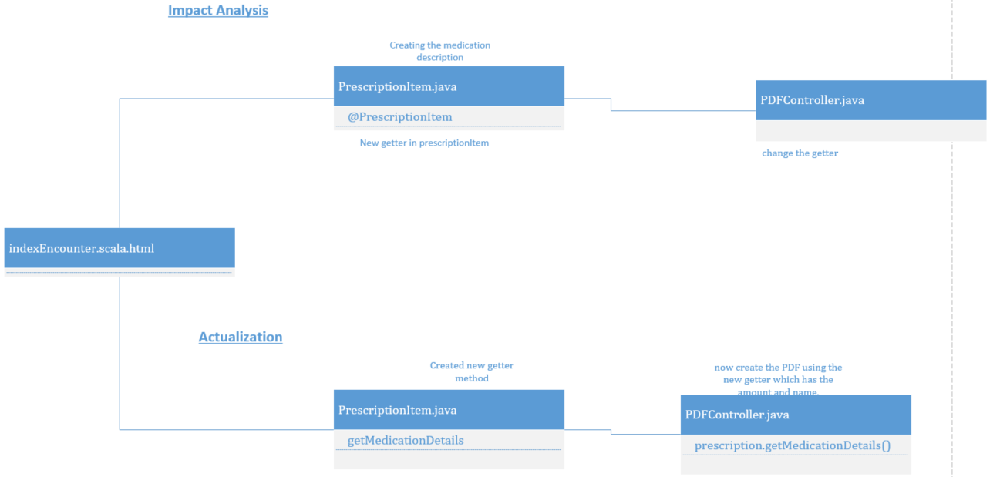

# Conclusions

This change request was challenging to set up correctly. We had trouble getting a patient their medication filled at the pharmacy, until Gerry figured it out and informed the rest of the class. Then, once we had identified the class that the bug was occuring in, our

Classes and methods changed:

* [**femr**](https://github.com/fearlesMICHELLE/femr/tree/FEMR-208)/[app](https://github.com/fearlesMICHELLE/femr/tree/FEMR-208/app)/[femr](https://github.com/fearlesMICHELLE/femr/tree/FEMR-208/app/femr)/[common](https://github.com/fearlesMICHELLE/femr/tree/FEMR-208/app/femr/common)/[models](https://github.com/fearlesMICHELLE/femr/tree/FEMR-208/app/femr/common/models)/**PrescriptionItem.java**
  + Public String:getMedicationDetails()
* Femr/app/femr/ui/controllers/PDFController.java
  + private PdfPTable:getAssessment()