CHAPTER ONE: INTRODUCTION

1.1 Background to the Student Industrial Work Experience Scheme
The Student Industrial Work Experience Scheme provided the practical setting in which I related the architectural knowledge gained at Covenant University to the working methods of a professional creative practice. Before the attachment, most of my design experience had been developed through academic studio work, guided exercises, and university assignments. The internship placed similar skills within a workplace where tasks were received as instructions, developed through a defined workflow, reviewed by supervisors, and related to real projects, sites, presentations, or installations. I completed my industrial attachment at Moe+ Art Architecture from 2 March 2026 to 31 August
2026. The placement documentation recorded the duration as 26 weeks. I was attached to the
Design Team, although my work and observations also brought me into contact with site, installation, fabrication, administration, accounts, and AWCA-related activities. This wider exposure helped me understand that architectural practice involved more than drawing production. It also required design development, modelling, visualisation, documentation, communication, coordination, physical observation, and response to feedback. The attachment was relevant to my architectural education because it allowed me to apply skills in a setting where the quality and usefulness of an output depended on instructions, project information, file organisation, review, and communication with other people. I learned to interpret assigned tasks, work with existing information, receive corrections, and revise my work. I also observed how drawings, digital models, renderings, photographs, maps, site information, and physical conditions supported the communication of architectural ideas. The training also addressed professional expectations that could not be fully reproduced in the classroom. I attended or participated in daily work assignments, internal reviews, presentations, site meetings, and other project discussions. These activities supported my expectation of learning how to communicate with clients and interact with fellow architects. They showed me that professional communication involved both the production of a clear drawing or model and the ability to explain work, listen to comments, ask questions where necessary, and apply feedback accurately.

1.2 Internship Profile and Placement Process

1.2.1 Student and institutional information
My name was Abollo David Obatare, with matriculation number 23CA033819. I was a student of the Department of Architecture, Covenant University, Ota, Ogun State, Nigeria. My academic supervisor was Dr Adedapo Emmanuel. My industrial supervisors were Mr David Johnson and Ms Minima Iroha.
Table 1.1: Internship profile
Student | Abollo David Obatare

Matriculation number - 23CA033819 Institution - Covenant University Department - Department of Architecture Academic supervisor - Dr Adedapo Emmanuel Placement organisation/public creative brand - Moe+ Art Architecture Formal entity used in placement documentation - Moebetter Limited Company address - 59 Raymond Njoku Street, Ikoyi, Lagos State Industrial supervisors - Mr David Johnson and Ms Minima Iroha Placement unit - Design Team Internship period - 2 March 2026-31 August 2026 Duration recorded in the placement documentation - 26 weeks

1.2.2 Placement, application, and selection
I obtained the placement through a personal application and a recommendation. The selection process included a review of my portfolio. I selected Moe+ Art Architecture because I was attracted by the quality of its work and designs and regarded the practice as one of the strong options available to me. The response of the firm during the placement process also encouraged my decision to undertake the attachment there. The portfolio review made me understand that academic work could serve as an early professional means of communication. It presented my interests and abilities before I joined the office and helped the firm assess my readiness to learn. The process therefore connected my university design exercises with the expectations of a professional workplace.

1.2.3 Submission of placement documents
The placement and training records supplied for this report included the internship offer or placement letter, ITF-related documentation, the SIWES logbook, and assessment materials. These documents established the relationship between the student, the university, the training organisation, and the industrial-training process. They also provided a record of the placement period, the assigned unit, supervision, and assessment. I treated the documentation as part of the evidence for this report. Where information appeared in more than one record, I used the confirmed placement information consistently. Where a detail belonged to a specific project or weekly activity, I reserved the detailed account for the relevant later chapter rather than assigning an unsupported date or responsibility in Chapter One.

1.2.4 Commencement of the internship
The internship commenced on 2 March 2026 and ended on 31 August 2026. I joined the Design Team and received assignments under supervision. My initial expectations were to learn a wider range of software, improve my understanding of rendering, learn how to speak to clients, and interact more effectively with fellow architects. The placement gradually introduced me to the technical and interpersonal sides of practice. My software exposure included Rhino 7, Revit 2023, AutoCAD, and Twinmotion. My workplace exposure included instructions, design reviews, presentations, site meetings, project discussions, and feedback. I therefore experienced the internship as a combination of learning by doing, learning by observing, and learning through correction.

1.3 Aims and Objectives of the Training
The general aim of the training was to gain practical experience that connected architectural education with professional practice. The objectives I pursued during the attachment were:
1. To gain practical experience in architectural design and design development.
2. To improve my ability to produce, read, and understand technical drawings.
3. To develop practical competence in Rhino 7, Revit 2023, AutoCAD, and Twinmotion.
4. To understand how models, drawings, maps, renderings, photographs, and site information
supported project development.
5. To observe site conditions and participate in site-related and installation-related
activities.
6. To improve my communication with architects, supervisors, clients, and other project
participants.
7. To understand the relationship between academic architectural knowledge and
professional work.
8. To develop discipline, teamwork, independence after instruction, and the ability
to respond to feedback. These objectives were pursued through design assignments, modelling, drafting, visualisation, context and site documentation, site meetings, installation-related work, presentations, reviews, and interaction with personnel in the office and on project activities. They were not separate from my daily tasks; rather, each assignment provided an opportunity to develop one or more of the intended skills.

1.4 Company Profile

1.4.1 Company identity and location
Moe+ Art Architecture was the public creative identity under which I understood the
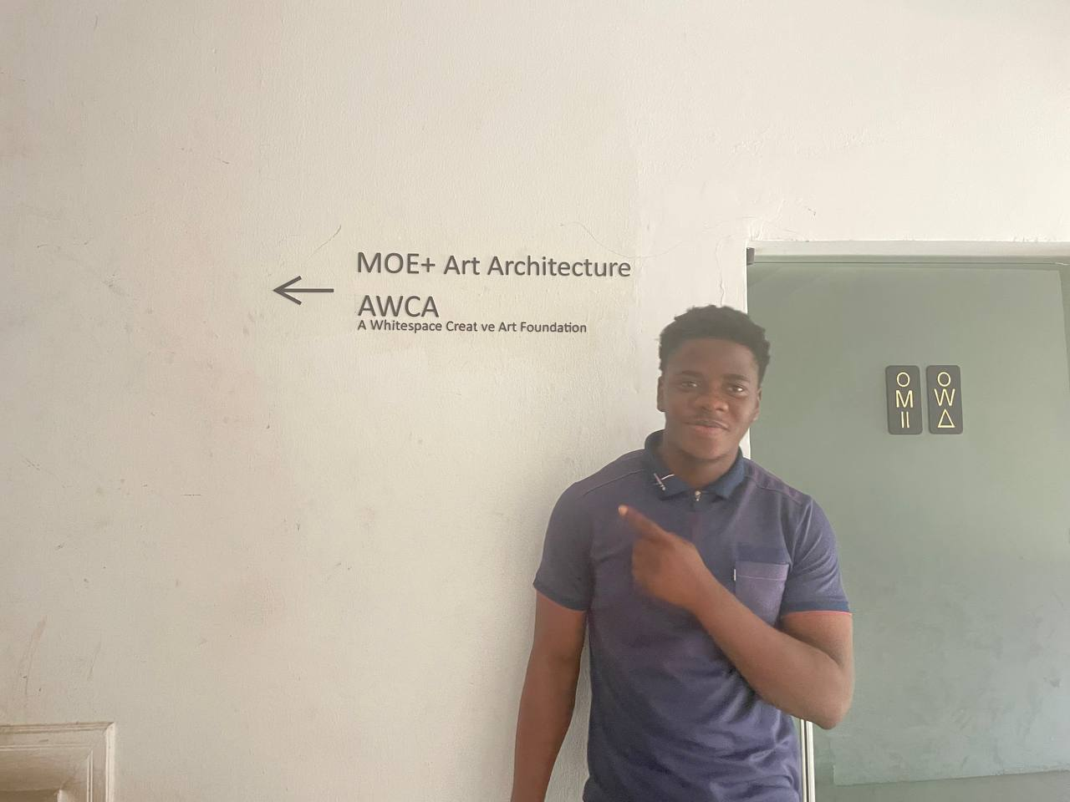
Plate 1.1: Company-identification photograph showing the MOE+ Art Architecture and AWCA wall signage.
practice during my internship. The company-identification material showed the name "MOE+ Art Architecture" together with "AWCA" and "A Whitespace Creative Art Foundation." The placement documentation also used Moebetter Limited as the formal corporate entity associated with the internship offer. In this report, I used Moe+ Art Architecture when discussing the creative practice and retained Moebetter Limited where the formal placement record required the corporate name. The confirmed office address was 59 Raymond Njoku Street, Ikoyi, Lagos State. The address belonged to the placement information used for the report. The office-identification photograph below was included because the location and the organisation names were visible in the image. Art Architecture and AWCA wall signage. The accessible matching photograph is `photo_2026-09-27_20-08-11.jpg`; the clearest user-supplied version will be selected during final layout.]
AWCA wall signage.

1.4.2 History and development
The company information supplied for this report described Moe+ Art Architecture as a Lagos-based creative practice working across architecture, urban design, artistic production, interior and spatial work, and related creative activities. The information stated that the practice was established as a unified entity in 2014 and was led by Creative Director Papa Omotayo. It also described the practice as developing through a strategic merger between MOE Limited and O+O Architects. The supplied description presented the practice as multidisciplinary and collaborative. It connected architectural work with artistic production, design communication, community engagement, and ecological awareness. The relationship between Moe+ Art Architecture and its sister agency, AWCA, was also part of the information supplied for this report. During my attachment, I encountered this wider creative context through the company-identification material and through activities that involved design, modelling, visualisation, installation, and spatial presentation. The full bibliographic details for the company-history material supplied by the student will be verified and entered in the References section when the complete report is assembled. No unsupported company-history source has been added to this draft.

1.4.3 Units and my position in the organisation
Approximately 15 people worked in the company during my attachment, based on the information supplied for the report. The units identified to me were the Design Team, the Accounts Department, and the AWCA Team. I was officially attached to the Design Team and remained in that unit throughout the six-month internship. My position was that of a student trainee assisting with assigned work under supervision. I did not function as a project leader or decision-maker. I carried out or assisted with design-related, documentation-related, and site-related tasks after receiving instructions. My supervisors reviewed my work biweekly, gave feedback, and permitted me to work independently after the task had been explained and understood.
Table 1.2: Units encountered during the attachment
Design Team | My official placement unit and the main area in which I worked.

Accounts Department - A department within the wider office environment with which I interacted. AWCA Team - A related creative team identified within the organisation. Site, installation, and fabrication activities - Areas with which I interacted during project and site-related work.

1.4.4 Services and professional focus
The work I encountered during the internship included architectural design assistance, creative design, technical drawing production, design development, three-dimensional modelling, visualisation, interior and spatial consideration, documentation, site observation, exhibition installation, and project coordination. These activities provided the professional context for the software, drawings, models, photographs, and physical observations recorded in my logbook. The range of work showed me that the architectural process involved several connected forms of representation. A project could be discussed through a brief, developed through sketches or digital models, tested through drawings or visualisations, explained in a presentation, and related to an existing site or physical installation. The practice therefore helped me see software and drawings as parts of a wider process rather than as isolated technical skills.

1.5 Scope and Evidence Used in the Report

1.5.1 Scope of my training
My work covered design assistance, digital modelling, technical drawing, visualisation, context and site documentation, site meetings, presentations, project discussions, exhibition installation, and related site activities. I learned through formal instruction, assigned tasks, observation, tutorials, personal practice, and review. Drawings, models, photographs, and other project materials were shared through the company drive and email within the limits of my assigned responsibilities. The scope of the training did not mean that I assumed responsibility for every project or output encountered in the office. I described myself as a student trainee who assisted with assigned work. I distinguished between work I personally carried out, work I assisted with, work I observed, and reference or training material. This distinction was important for maintaining an accurate account of the internship.

1.5.2 Evidence used
The report was prepared from the following categories of evidence: SIWES logbook entries, including weekly activities, sketches, diagrams, software records, site activities, and supervisor comments. Internship offer or placement documents and ITF-related records. Assessment and supervision material supplied for the training. Screenshots and project records relating to Rhino 7, Revit 2023, AutoCAD, Twinmotion, mapping, and context work. Office, site, installation, and project photographs supplied for the report. Company-identification material, including the confirmed MOE+ Art Architecture logos and the wall-signage photograph. Company and project information supplied by the student for use in describing the placement.
Table 1.3: Evidence categories and their use
Logbook and weekly records | To describe activities, learning, software use, site work, and

supervision. Placement and ITF documents - To confirm the student, organisation, period, duration, unit, and placement records. Digital project records - To discuss modelling, drafting, mapping, visualisation, and design development. Office and site photographs - To describe company identification, facilities, site observation, and installation activities. Supplied company information - To provide the placement context and company profile without extending beyond the supplied facts.

1.5.3 Treatment of images and third-party material
Images were selected only where their identity and relationship to the training could be established. The company-identification photograph was suitable for Chapter One because the MOE+ Art Architecture and AWCA names were visible in the image. The circular MOE+ logo and horizontal MOE+ wordmark were confirmed for the title page. The Covenant University logo was also confirmed for the title page. Project images, third-party precedent images, and material from the logbook will be placed beside the relevant discussion in Chapters Two and Three. An image will not be presented as my own work when it is a reference, precedent, company output, or third-party material. Where an image cannot be mapped confidently, the final report will use an explicit insertion marker rather than an unsupported caption.

1.6 Overview of Projects and Assignments
The projects and assignments recorded during the attachment covered company work, training exercises, and personal practice. The classification below was based on the project clarifications already supplied. Detailed weekly contributions and challenges will be discussed in Chapter Three.

1.6.1 Confirmed company projects
The confirmed company projects included Mekewen House in Victoria Island, the NBC Coca-Cola exhibition at Eko Hotel, the Federal Palace Hotel and Casino floating-restaurant work, Concert Site Design, the Barge Project, the Banana Island model, and the Ikeja context-mapping work. The exact dates of individual project activities were not assigned in this chapter because the logbook provided the primary sequence of weekly work. The NBC Coca-Cola work involved exhibition planning and installation. The Federal Palace Hotel and Casino work involved Rhino 7 modelling and visualisation of a floating restaurant and related site observation. Concert Site Design involved assistance with design for a large covered structure and its site arrangement. The Barge Project remained a separate company project from the Federal Palace floating-restaurant work. The Banana Island model and the Ikeja context-mapping work were treated as company-related work according to the project clarifications supplied.

1.6.2 Training and personal practice exercises
Charles Pictet House was identified as a training exercise involving modelling and visualisation. The high-rise model was also identified as a training exercise. The Starbucks/Revit model and Glass House were identified as personal practice work. In the Glass House exercise, I explored curved forms through concept development, Rhino 7 modelling, and visualisation. These exercises helped me practise digital methods and understand the relationship between design ideas, model development, and visual communication. The distinction between company projects, training exercises, personal practice, and third-party references will be maintained in the later chapters. This will allow the report to describe my learning honestly without presenting a reference image or a practice exercise as a company assignment.

1.6.3 Software and recurring activities
The main software recorded for the training was Rhino 7, Revit 2023, AutoCAD, and Twinmotion. My recurring activities included modelling, drafting, rendering, mapping, context work, site documentation, presentation preparation, installation-related assistance, and participation in reviews or meetings. These activities formed the link between the general objectives of the internship and the detailed work described in the subsequent chapters.

1.7 Organisation of the Report
The report was organised into four chapters followed by the References section. Chapter One introduced the SIWES attachment, presented my placement information, described Moe+ Art Architecture, stated the aims and objectives of the training, explained the evidence used, and outlined the projects and assignments. Chapter Two discussed the facilities available during the attachment. It covered the office resources, computers, software, digital modelling and visualisation resources, physical work areas, site-documentation resources, communication and file-sharing systems, and safety-related resources. Chapter Three discussed my contributions and the challenges recorded during the training. It linked the project activities, software work, site and installation activities, supervision, teamwork, and professional learning to the work I carried out or assisted with. It did not include transport or strike challenges, as those were excluded from the report scope. Chapter Four presented the conclusion and recommendations arising from the attachment. It summarised the knowledge gained and proposed recommendations for the student, the university, and the training organisation where the evidence supported a recommendation. The References section will contain only sources that are verified and used in the final report. Supplied company-history material and official training documents will be completed there after their bibliographic details have been checked.
End of Chapter One.

