Discrete Optimisation

Assignment 1 report

# Introduction

Task: Find the shortest path between given nodes in five different graphs.

The solution for graph task1_test<i>.txt can be found in task1_test<i>_solution.txt. The format is a list of minimum lengths corresponding to node pairs requested.

Three algorithms have been used

* Dijkstra’s algorithm: Used for tests 1, 2, and 3. This is the standard algorithm for the shortest path problem between two nodes. Complexity: O((E+V)log V)
* Breadth-first search: Used for test 5. As this graph in question is a constant-weighted graph we can used BFS, more efficient than Dijkstra’s algorithm. Complexity: O(E+V)
* Bellman-Ford’s algorithm: Used for test 4. This algorithm allows us to take into account negative weights on the graph, which Dijkstra’s algorithm cannot. Complexity: O(EV)

Here are the running times for the 5 tests:

|  |  |  |  |  |  |
| --- | --- | --- | --- | --- | --- |
| Test | 1 | 2 | 3 | 4 | 5 |
| Run time (s) | 0.331 | 3.606 | 98.713 | 2042.488 | 147.535 |

# Algorithm Explanations:

## Dijkstra’algorithm:

A min heap is used to optimise the run time. This allows us to select the node with the minimum distance from the source that is still in the heap in log time instead of linear time.

The implementation used is heapq: <https://docs.python.org/2/library/heapq.html>

Three extra functions have been added to let us use the heap as a priority queue. To use this queue, we add nodes where the priorities are the distance from the source. When a distance needs to be updated, instead of deleting the node from the heap, we add another node and use the dictionary entry finder to map the node to this new distance. We then mark the previous distance as removed. This allows to avoid the complexity of restructuring the heap to delete nodes, but requires additional memory.

Note also that Dijkstra algorithm can only be run on graphs with positive weights. Therefore we initially check to make sure all weights are positive before running the algorithm.

The algorithm is implemented according the following pseudo code:

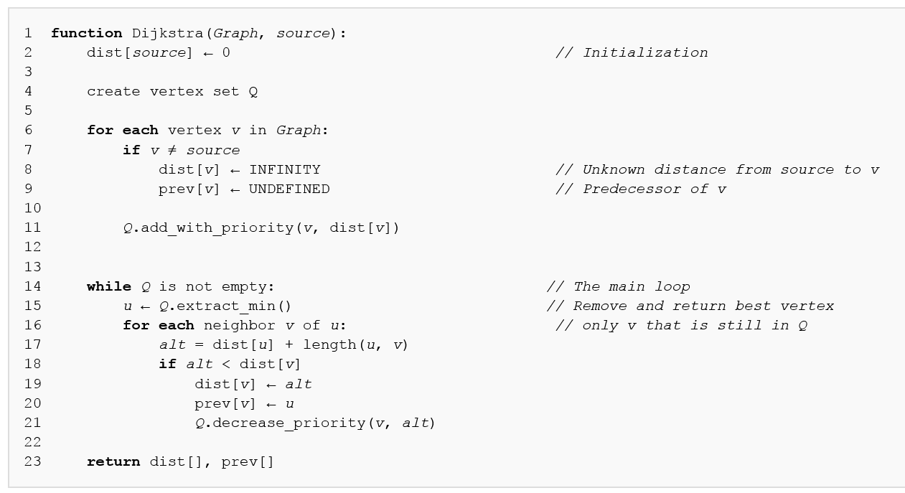

Figure 1: Dijkstra's algorithm (source: https://en.wikipedia.org/wiki/Dijkstra%27s_algorithm)

## Breadth first search

This search only works when all the weights are of the same value. We therefore check this before proceeding.

The algorithm is implemented according to the following code:

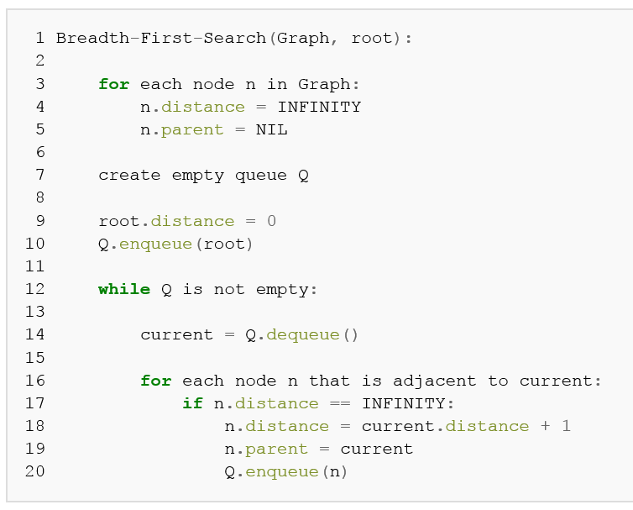

Figure 2: Breadth first search (source: https://en.wikipedia.org/wiki/Breadth-first_search)

For the implementation of the queue, the deque library is used.

## Bellman-Ford

This algorithm can accommodate negative weights. However it cannot deal with negative cycles (a shortest path cannot exist because loop around the negative cycle would reduce the distance infinitely).

The algorithm successively relaxes the edges, by finding on each iteration i the shortest path by using i nodes. If a shortest path can be found on the nth iteration (where n is the number of nodes), then a negative cycle exists.

The algorithm is based on the following pseudo code:

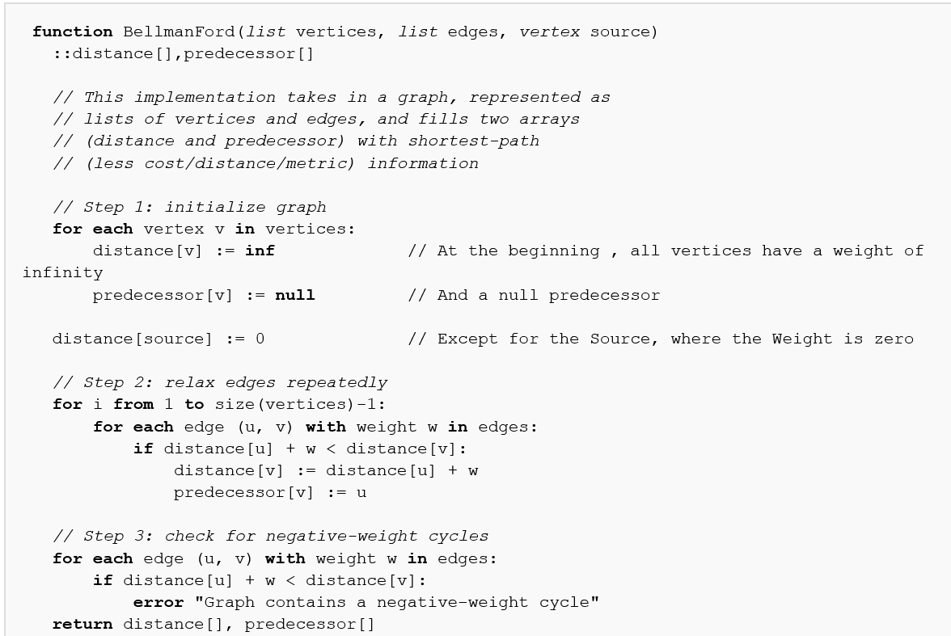

Figure 3: Bellman Ford algorithm (source: https://en.wikipedia.org/wiki/Bellman%E2%80%93Ford_algorithm)