Report: Page Rank Algorithm with MPI

Contents

Explanation of files included in project 1

The Page Rank Algorithm 1

Introduction 1

The equation 1

Sequential algorithm 2

Parallel page rank algorithm explanation 3

Introduction 3

Matrix vector product parallelization 3

Problem initialization and matrix representation 3

Master/slave structure. 3

Scattering the initial matrix 4

The loop 4

Loop synchronization 4

The slave processers 4

Assembling the global result 4

Memory management 4

Application and interpretation 4

Building M 4

# Introduction

This project groups three folders:

* Matrix vector product
* Matrix matrix product
* Page rank algorithm

In each case, the goal was to parallelise the algorithms using MPI. The aim of this report is explain how this has been done and the design choices behind the code.

The explanations on matrix vector and matrix matrix will be brief, only focusing on some specific points, while the explanations for the page rank will be more lengthly.

# Explanation of files included in project

## Matrix vector product

**matrixVectorPruductMpi.c**: source code for matrix vector product in parallel. Generates a random matrix and vector as input and print product to the screen

**matrixVecotrProductMpi_collective.c**: similar to the previous code but uses MPI collective functions to simplify code

**functions.c**: auxiliary functions

## Matrix matrix product

**matrixMatrixMultiplicationMpi.c**: source code for matrix matrix multiplication. Generates two random matrices as input and prints product to screen

**functions.c**: auxiliary functions

## Page rank

**pageRankMpi.c**: contains the source code of the page rage algorithm adapted to parallel computing. Takes as input a matrix in csv format and outputs the result vector in csv.

**Csvparser.c, csvwriter.c**: libraries (found on sourceforge) for reading and writing csv files

**Example_test_matrix.csv /.xlsx**: Represents the input matrix mapping the linking structure if [www.financeutile.com](http://www.financeutile.com). Generated using python code (not included) with the scrapy library to crawl the website and parse the pages.

**Functions1d**.c: contains auxiliary functions, mainly for matrix calculations (generating matrices, calculating norms, matrix addition/multiplication, copying matrices…)

**Pagerank.csv**: the results generated by the algorithm for [www.financeutile.com](http://www.financeutile.com) (i.e. using example_test_matrix.csv as input)

# Matrix vector product

The basic idea is to divide the matrix up into row bands and give each processor a row band with which to do its calculations. Each processor calculates therefore a local result, of the same dimension as the number of rows in the row band. Each of these local results is calculated in parallel.

A potential problem that can be encountered is when the number of row bands (p) doesn’t divide the dimension of the matrix (N). Not all the row bands can be of the same dimension therefore. The idea is to divide the p-1 first bands into equal sizes then make the final band the size needed to complete the coverage.

Firstly there are two cases. If p divides N, then the dimensions of the row bands are simply N/p. If not though the first p-1 bands are set to dimension N/p and the final one is set to dimension   
dim-((dim/p)*(p-1)) to complete the coverage.

The same problem is encountered when receiving each local result from the individual processors. In this case the local result received from the final processor (rank==size-1) is treated separately and in this case the global matrix is filled up starting from the where the first p-1 processors have filled it up ((dim/p)*(p-1)) until the vector is completed.

This way of doing things involves sending the local dimension of each row band to the individual processors beforehand, so that they can allocate the right amount of memory to the row bands and the local results they need to calculate. On the receiving side though, the calculation is the same as the function used can adapt easily to the different dimensions received.

# Matrix matrix product

The algorithm used for the multiplication is the distributed memory algorithm as detailed in *Calcul scientifique parallèle* p.57. The main idea is to divide the matrices up into blocks and attribute each block to an individual processors.

As this is a distributed algorithm, each processor contains in memory only the block it has received. However to calculate the local block result, it needs access to all the blocks on the same row and all the blocks on the same column as its self. Thus the MPI message passing functionality is used so that each block broadcasts itself to its fellow row blocks and column blocks when needed. This therefore allows us to have a memory efficient storage in a distributed fashion.

Technically speaking, this technique requires creating new communicators, one for each row, and one for each columns, which allows the blocks of a same row or column to communicate easily with each other.

The data is localized temporally because each processor needs a given matrix at the same given moment. In a given row, each processor needs first the first block of the row, then the second, etc. Therefore the sending of each block to all the others can all be grouped together and a broadcast is used. As the broadcast is called collectively it synchronized the different processes.

For the spatial localization of the data, the matrix is stored as blocks. This means storing the matrix as follows: AIJ(i,j) = A(i,j,I,J)

In the implementation used, the master process also does local calculations.

# The Page Rank Algorithm

## Introduction

Page rank is an algorithm used by Google Search to rank websites in their search results. The algorithm is based on the links between webpages. It attributes a score to every website based on the number of incoming links from other pages.

For more detail: see <https://en.wikipedia.org/wiki/PageRank>

## The equation

The calculation is as follows:

**R** is the vector containing the page ranks of the webpages (p1, p2, …pN)  
**d** is a damping factor  
**N** is the total number of pages  
**l(pi,pj)** is a normalized coefficient that represents a link between pj and pi

Solving this equation for R gives us the page rank of all webpages.

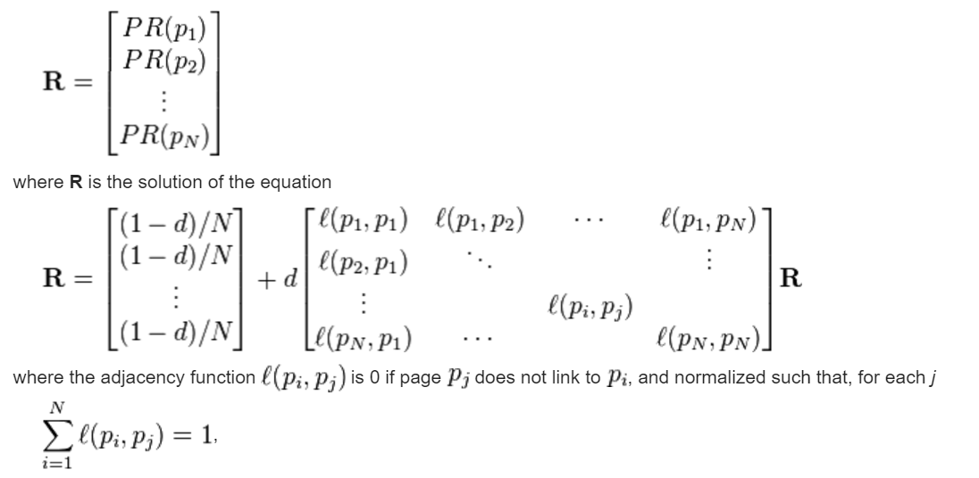

Figure : The Equation to Solve (source: wikipedia)

This equation can be written as:

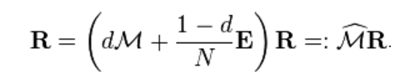

Where M is column stochastic, R a probability distribution, and E the matrix consisting of ones. The page rank is thus the principal eigenvector of M_hat. We will use **the power iteration** method to solve this eigenvector problem

## Sequential algorithm

The parallel algorithm used is based on the following sequential algorithm (taken from Wikipedia). This code uses the power iteration method to solve v = M_hat * v for v. The basic idea is that by taking a random v and multiplying it successively by M_hat, the result will converge towards the principal eigenvector of M_hat. For more information see: <https://en.wikipedia.org/wiki/Power_iteration>

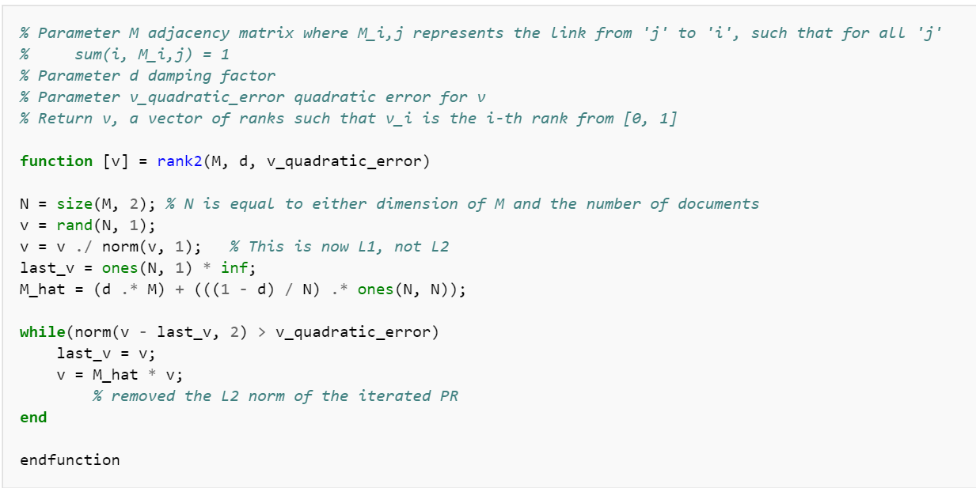

# Parallel page rank algorithm explanation

## Introduction

The power iteration method involves successively multiplying v by M_hat until convergence (as defined by v_quadratic_error). It is this matrix vector multiplication that we will parallelise using MPI. As this operation is done many times during the algorithm, the time gained on large calculations will be substantial.

## Matrix vector product parallelization

The idea is to cut the matrix up into row bands. Each row band is then sent to a separate processor, which executes the local multiplication of the row band and the vector v to give a local result. These calculations are carried out in parallel. The local results are then reassembled to get the global result of the multiplication.

## Problem initialization and matrix representation

Matrices are represented by 1 dimensional arrays. This facilitates the sending of rows with MPI (spatial localization). Memory is allocated dynamically with malloc, and the coefficient types are doubles.

Functions contains basic matrix operations used for initializing the problem. These functions are all sequential. The initialization involves importing the matrix M, calculating M_hat, and generating v.

### Master/slave structure.

The master (rank 0) is responsible for initialising the problem, cutting it up into different parts and distributing the work to the slave processers. It is also responsible for reassembling the different local results once they have been received from the slave processers. The slave processors simply take care of the local matrix vector products with the sub matrices received from the master. As such the code if divided into two parts: (rank == 0) and (rank !=0) i.e. master and slaves.

In this particular implementation the master process does not do any local calculations but this could be a potential improvement that would simplify the code. As the distributing of the tasks can’t be done in parallel with the local calculations anyway, this would make sense.

## Scattering the initial matrix

As the matrices are stored in one dimensional arrays, it is easy to send row bands to the slave processors. An Mpi_send command starting at the first coefficient to send with the number of coefficients to send does the job nicely.

## The loop

The loop is controlled by the master process. It continues until the difference between v and last_v (L2 norm) is smaller than v_quadratic_error. The loop consists of updating last_v to v and of multiplying v by M_hat. This multiplication is done in parallel. The new v is distributed to the slave processes in every iteration.

## Loop synchronization

The master and slaves each have their own while loop. The loop Boolean is used to synchronise the two. The master does the check of when to stop the loop (norm(v-last_v)<v_quadratic_error), and then sends to message to the slaves to tell them to stop when needed.

## The slave processers

The processers are responsible for executing the local matrix vector multiplications. They receive data from the master, execute the calculation and send the result back. These commands are executed in a loop until the master exits the loop.

## Assembling the global result

On every iteration, the master processes receives the local results from the slaves and assembles them into a global result. The local results are received in the order of the processers, making the reassembling relatively easy.

## Memory management

Variables are freed as soon as they are no longer needed. For example, M and E are freed after M_hat has been calculated. M_hat is freed once it has been divided into row bands and sent out to the individual processers. Note also that M_hat, M and E are only allocated (and freed) in the master process.

## Limits

Currently p must divide N. This case is accounted for in matrixVectorProductmpi.c but has not yet been transposed to pagerankmpi.c

The vector v is stored completely in each process. The memory management could be optimized by using mpi message passing. This would lead to a more distributed algorithm memory-wise.

# Application and interpretation

Sebastien Baur and I have applied this algorithm to a real life application. We used the website [www.financeutile.com](http://www.financeutile.com) to demonstrate the algorithm and calculate the page rank of all of its pages (70 in total).

To do this, we crawled the website using the scrapy library for python and parsed the pages to extract the external links. This allowed us to build the adjacency matrix for the website. From this we were able to generate the matrix M used for the input to the algorithm.

The calculation and results can be found in example_test_matrix.xlsx

## Building M

M = (K-1A)T

Where K is the diagonal matrix with the outgoing degrees of each page as diagonal coefficients and A is the adjacency matrix of the website (1 if pi links to pj and 0 otherwise).

Results interpretation