Feature Flag Documentation and Custom Fields
Define documentation fields once per project, then fill in their values for each flag and environment.

1 Configure fields for the project
Only users with permission to edit the current project (UpdateProjectSettings) can add, edit, or remove field definitions.
- Open Organization → Projects.
- Find the project and select Custom fields.
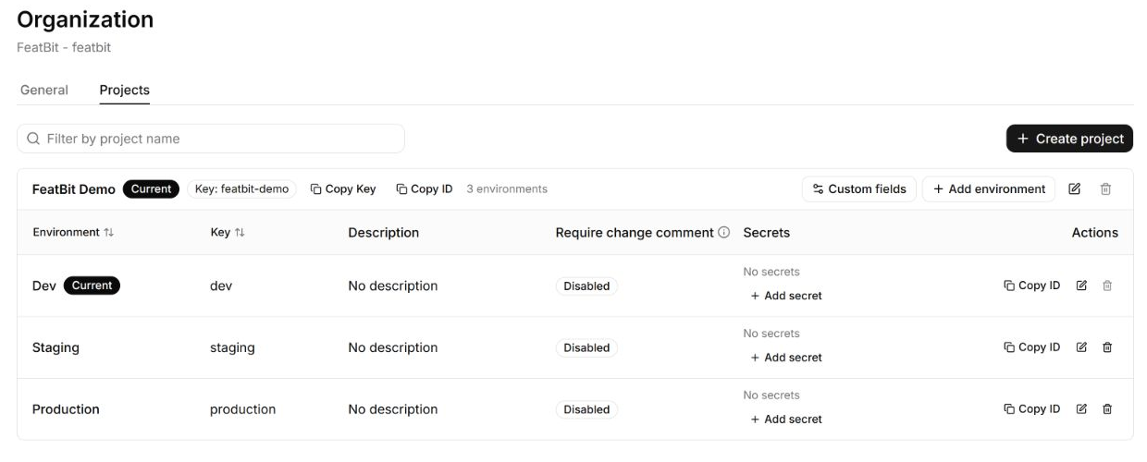
Open the project's Custom fields configuration.
- Select + Custom Field to create a field, or the settings icon beside an existing field to edit it.
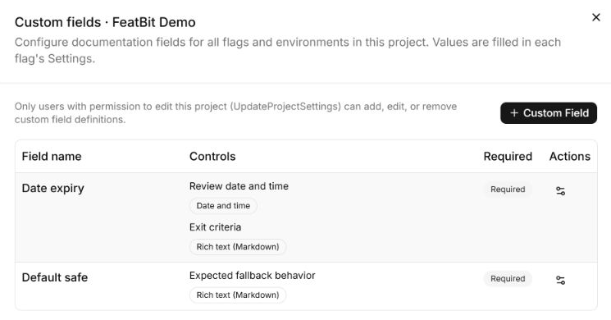
Project field definitions and the required project editing permission.
- Enter a Field name and choose whether it is Required.
- Select Add control, enter its label, and choose Date and time, Numeric value, Checkbox, or Rich text (Markdown). One field can contain multiple controls.
- Select Save field.
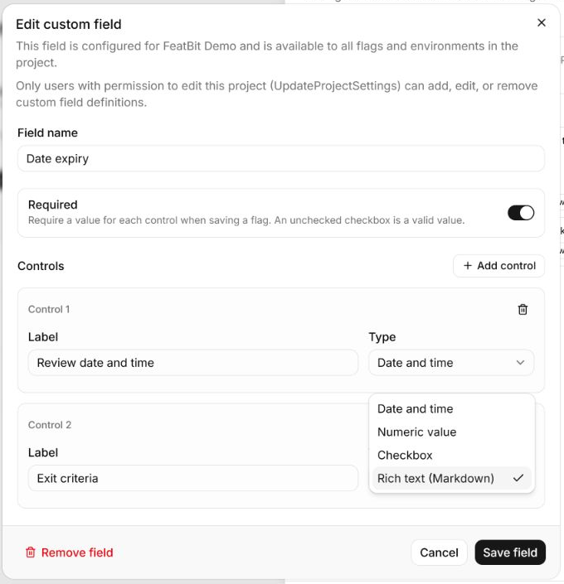
Configure the field name, required status, and control types.
Definitions apply to all flags and environments in this project. Required controls must be completed when saving a flag. Other projects use their own definitions.

2 Write the flag's description
- Select the project and environment, open the flag, and select Settings → Description.
- Use Write to edit and Preview to check the formatted text. Headings, lists, emphasis, links, code, and line breaks make operating procedures easier to read.
- Select Review & save, review the changes, and save them.
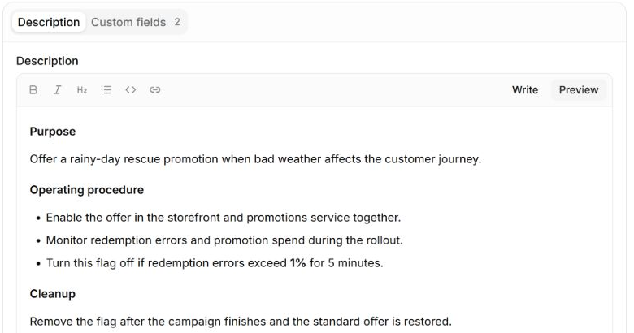
Formatted Description within the existing flag Settings page.

3 Fill in the custom fields
- In the same Settings page, select Custom fields.
- Fill in the controls configured for this project. Markdown controls open in Preview; select Edit to change the text.
- Select Review & save, review the changes, and save them.
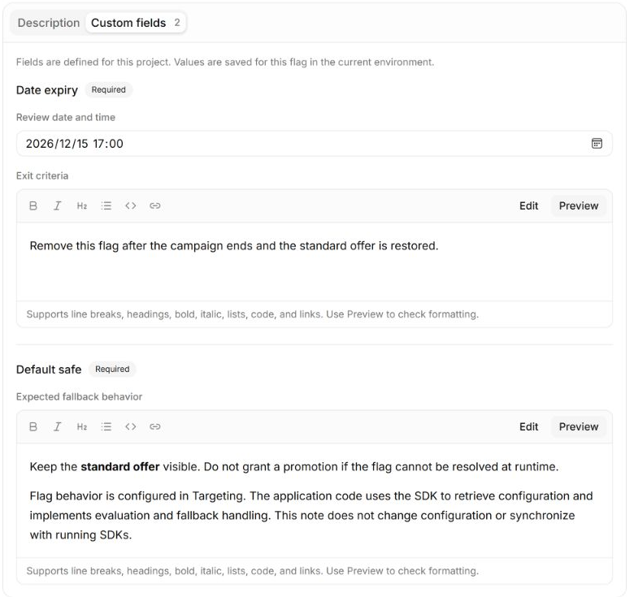
Date expiry and Default safe, filled in for this flag and environment.
The example uses Date expiry for a review date/time and exit criteria, and Default safe for expected fallback behavior. Names and control combinations are configurable. Flag editors fill in values here; they do not change field definitions.
- Expiry is a record: it does not automatically turn the flag off.
- Default safe is documentation: flag behavior is configured in Targeting. The application retrieves configuration through the SDK and implements fallback handling in its code. This text does not change configuration or synchronize with running SDKs.
Field definitions are shared across the project. Description and custom field values are saved separately for each flag and environment.

Applications and subprojects with Tags
Use existing Tags to identify applications within a project. A shared flag can carry multiple application tags, such as app:web-storefront and app:promotions-api, without duplicating the flag across projects.
To keep labels consistent and reduce unauthorized changes, tag creation should be restricted through permissions to designated users, such as PMs. Changes to the tags assigned to a flag should also be limited to authorized users. Tags provide application labels and filtering within the existing project; they do not introduce a separate sub-project hierarchy.

4 Compare and copy between environments
- Open Feature Flags → Compare.
- Select the target environment and choose Apply. The current environment is the source.
- Select Review differences for the flag.
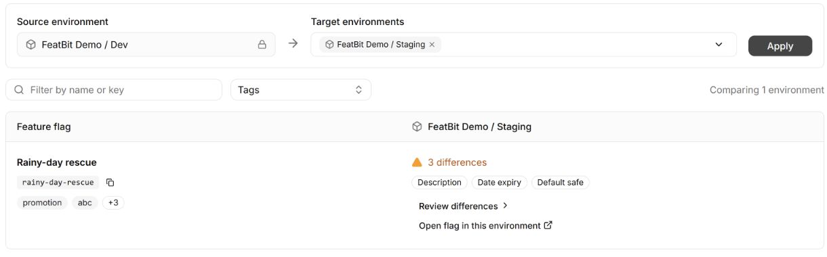
Compare Dev with Staging and open Review differences.
- Review the source and target values. Each setting is marked Different or No difference; matching settings cannot be selected for copying.
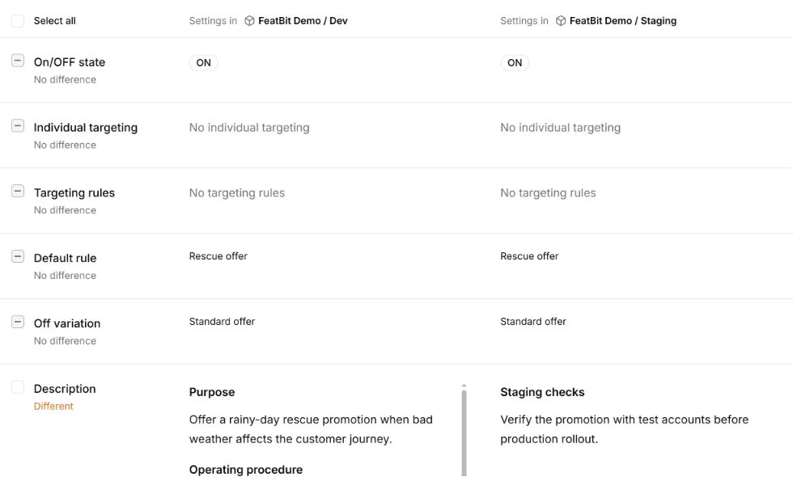
Different and No difference are shown for individual settings.
- Select Description and/or the custom fields to copy. Check the After copy preview and selected setting count.
- Select Copy settings to overwrite those values in the target environment.
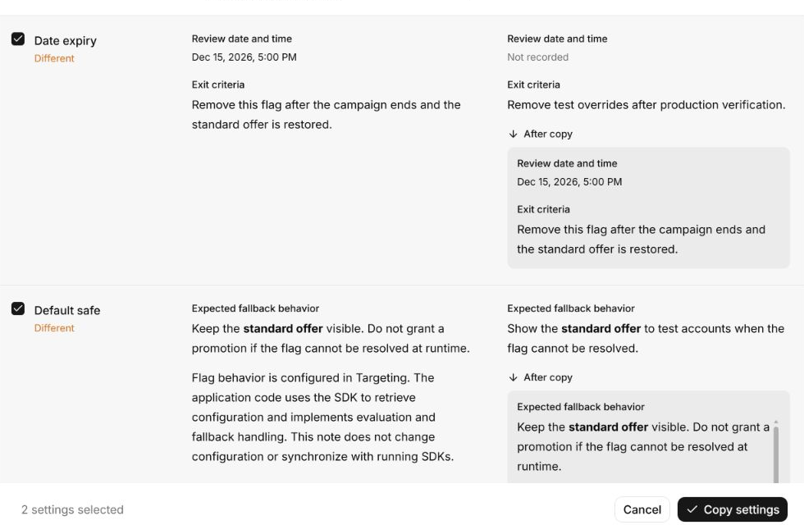
Date expiry and Default safe are selected, with After copy previews and the Copy settings action.
Only saved values are compared and copied. Each custom field copies all of its controls together. Unselected settings and project field definitions are preserved. Copying documentation follows the existing copy permissions and requires Update flag description (UpdateFlagDescription) permission on the target flag.

5 Audit and automation
All operations must have audit logs and REST API support, with the same permissions and validation as the interface, so teams can automate workflows or use AI agents. Changes must record the actor, time, scope, and before/after values.

