

COMP1531: GourmetBurgers Assignment

2019 Session One

Team: Banana

z5142003 – Tong Zheng

z5206677 – Andrew Wong

z5210581 – Weiting Han (Catherine)

User Stories

# 1) As a customer I want to make and view my GourmetBurgers orders online

|  |  |
| --- | --- |
| **ID** | US1 |
| **Name** | Browse food items |
| **Description**  As a customer I want to browse the menu so that I can decide what I want to order  **Acceptance Criteria**   * Items will be displayed in a grid format * Overflowing descriptions of items will be shortened to an ellipsis * The price of each item will be displayed next to the food item * If there are not enough ingredients for a burger or wrap, that main will be disabled * Items that are out of stock will be disabled | |
| **Priority** | 3 (High) |
| **Points** | 10 story points *(1 pt = 2 hours)* |

|  |  |
| --- | --- |
| **ID** | US2 |
| **Name** | Add food items |
| **Description**  As a customer I want to add food items to my order so that I can pay and receive my order  **Acceptance Criteria**   * Each available menu item will have an [Add to Order] button * If the [Add to Order] button is pressed, the item will be added into the order * If an item is customisable, a [Customise] button will appear next to the [Add to Order] button * If a [Customise] button is pressed, a customisation modal will be displayed * When the order is updated, the price total will be updated and shown * Unavailable items will be unable to be added to the order | |
| **Priority** | 3 (High) |
| **Points** | 8 story points *(1 pt = 2 hours)* |
| **ID** | US3 |
| **Name** | Search food items |
| **Description**  As a customer I want to search for items in the menu so that I can quickly find what I want to order  **Acceptance Criteria**   * A search box will be present in the menu to allow customers to type in their food query * Search scope will be by name * If there are no search results, a "No items found" warning message will appear * The search will return only food items (mains, sides, drink) | |
| **Priority** | 1 (Low) |
| **Points** | 5 story points *(1 pt = 2 hours)* |

|  |  |
| --- | --- |
| **ID** | US4 |
| **Name** | Customise main meal |
| **Description**  As a customer I want to customise my meal ingredients so that I can eat what I want to my liking  **Acceptance Criteria**   * When the [Customise] button is pressed, a meal customisation modal will appear * The ingredients will be listed in a list format * The price of each ingredient will be displayed next to the ingredient * A modifiable quantity of each ingredient will be shown * When the ingredient quantities are updated, a subtotal will be displayed * The quantity of an ingredient will be limited to the maximum allowed limit. * Additional costs are added for ingredient quantities past the default quantity * Ingredient quantities below the standard quantity do not affect the price * If an ingredient is out of stock, the ingredient will be greyed out and be unselectable * If the ingredient quantities are all zero, the [Add to Order] button will be disabled * When the [Add to Order] button is pressed, the item will be added to the order * When the item is added to the order, the customisation modal will disappear | |
| **Priority** | 2 (Medium) |
| **Points** | 12 story points *(1 pt = 2 hours)* |
| **ID** | US5 |
| **Name** | Checkout Order |
| **Description**  As a customer I want to review and pay for my order so that I can receive my food  **Acceptance Criteria**   * Each food item will have the item price displayed * An overall total price will be displayed on the page * When the [Place Order] button is pressed, the order will be created in the system * When the order is successfully placed, the Order ID will be shown to the customer * When the order is successfully placed, the stock levels for each item will be decremented respective to their quantity type | |
| **Priority** | 3 (High) |
| **Points** | 12 story points *(1 pt = 2 hours)* |

|  |  |
| --- | --- |
| **ID** | US6 |
| **Name** | Order Status |
| **Description**  As a customer I want to view my order's progress so that I can pick up my order when it is finished  **Acceptance Criteria**   * The customer will be prompted to enter in their Order ID * If the Order ID does not exist, an "Order does not exist" message will be displayed * A valid order will show the order status, price, date, and a summary of the ordered food * Status message will be: "Preparing" / "Ready for Pickup" * If the page is refreshed, the order will be rechecked | |
| **Priority** | 2 (Medium) |
| **Points** | 6 story points *(1 pt = 2 hours)* |

# 2) As a staff member I want to manage the online orders and inventory levels

|  |  |
| --- | --- |
| **ID** | US7 |
| **Name** | Manage Order |
| **Description**  As a kitchen staff I want to manage orders so that the customer will get their ordered food  **Acceptance Criteria**   * The order dashboard will display the order ID and summary of food for each order * The orders will be arranged so that the earlier orders will appear at the top * When the [Complete Order] button is pressed, the status for that order is set to completed * When the [Complete Order] button is pressed, the order will be removed from the order queue | |
| **Priority** | 3 (High) |
| **Points** | 6 story points *(1 pt = 2 hours)* |

|  |  |
| --- | --- |
| **ID** | US8 |
| **Name** | Manage Inventory |
| **Description**  As an inventory maintainer I want to manage inventory levels so that customers can order what is available  **Acceptance Criteria**   * Each item will have a field where the stock level can be modified * The quantity type (eg. pc, mL, g) will be displayed next to the stock level * When the stock level of an item falls to or below 30%, a warning will appear * If the stock level of an item is zero, the item will be marked as unavailable * Each item will have a [Disable]/[Enable] button to toggle the availability of that item * If the stock of a disabled item is replenished, the item will be automatically re-enabled * When the [Update] button is pressed, the stock levels in the system will be updated | |
| **Priority** | 2 (Medium) |
| **Points** | 10 story points *(1 pt = 2 hours)* |

Class Diagram

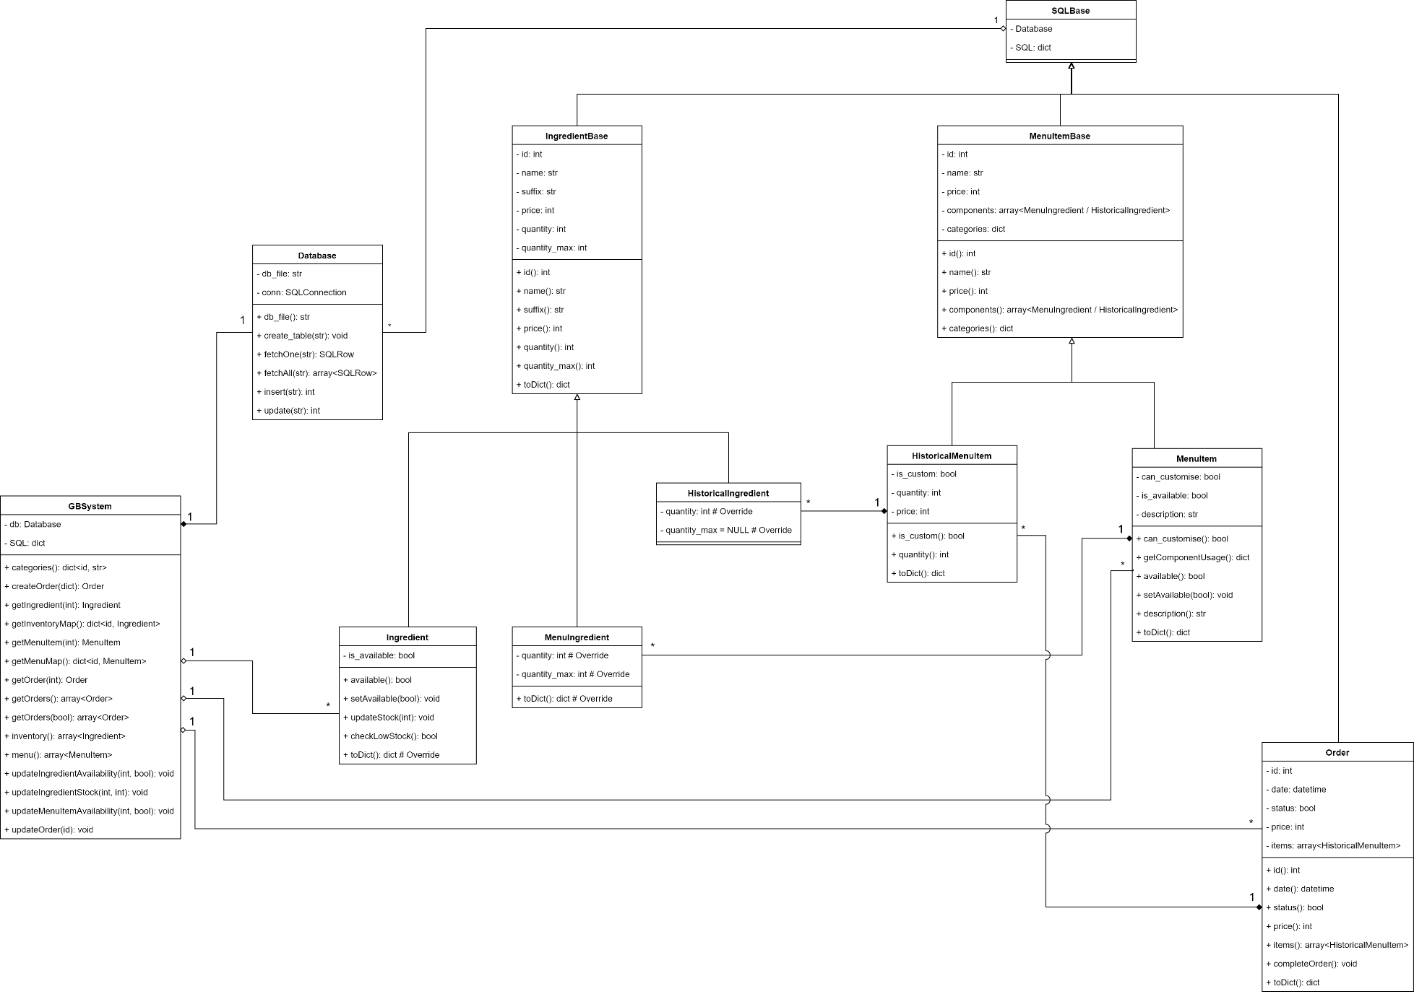

Entity Relationship (ER) Diagram

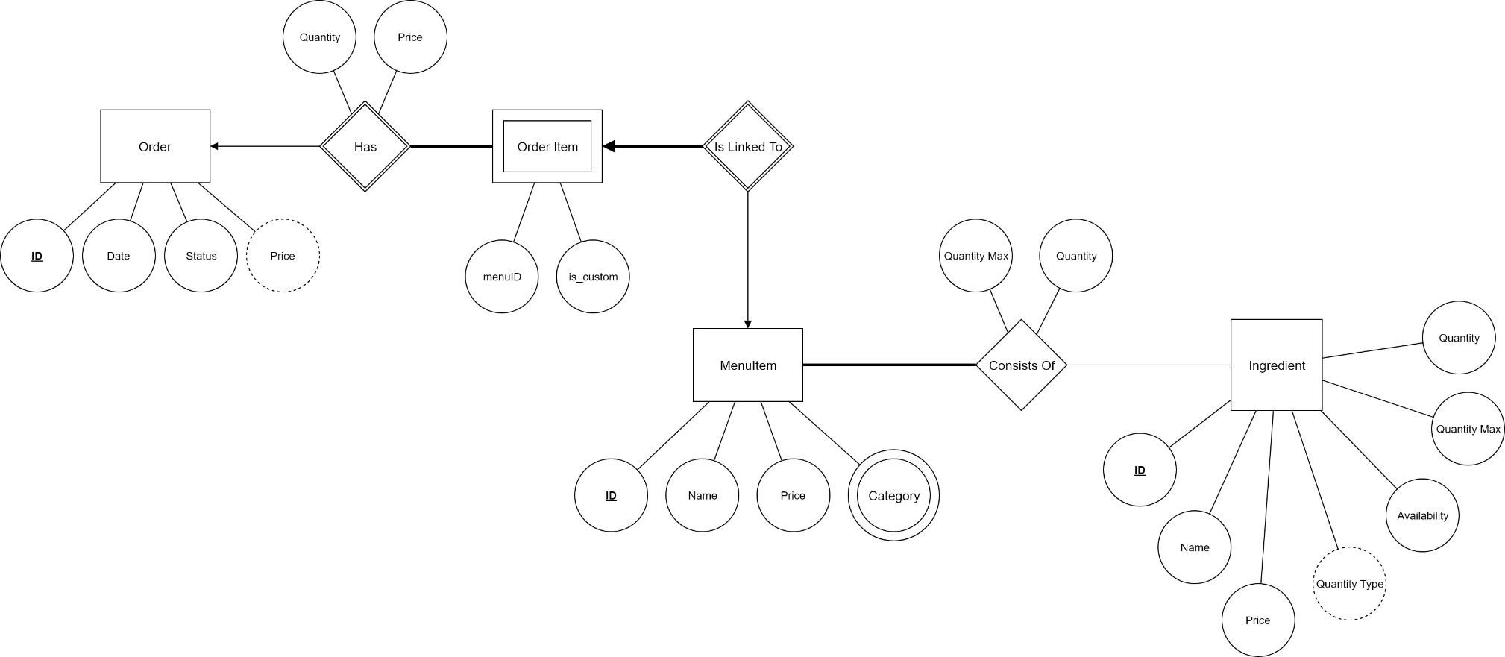

Log Book

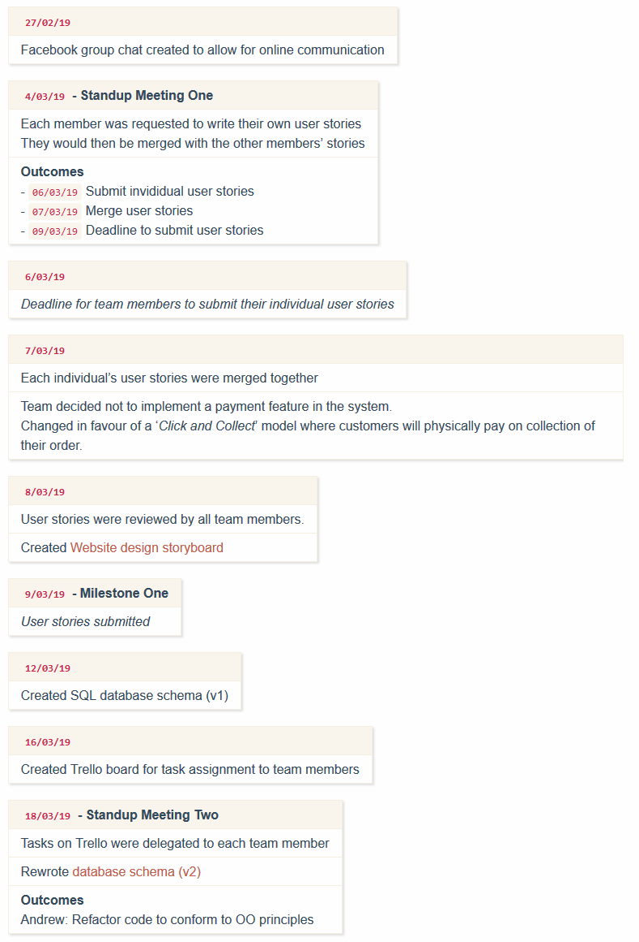

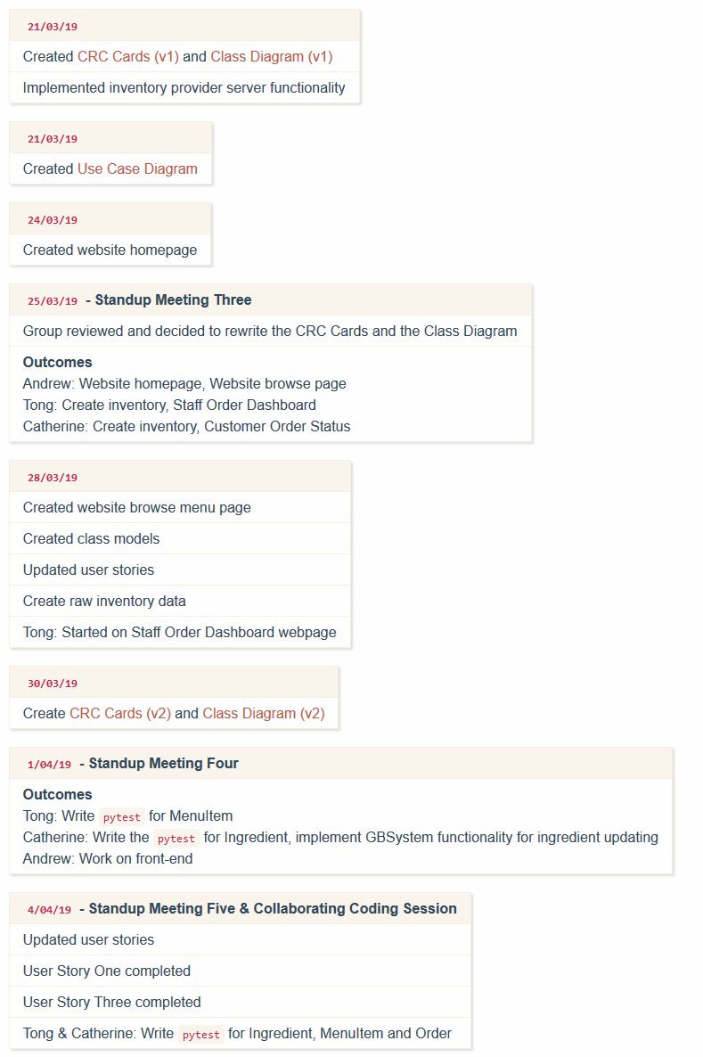

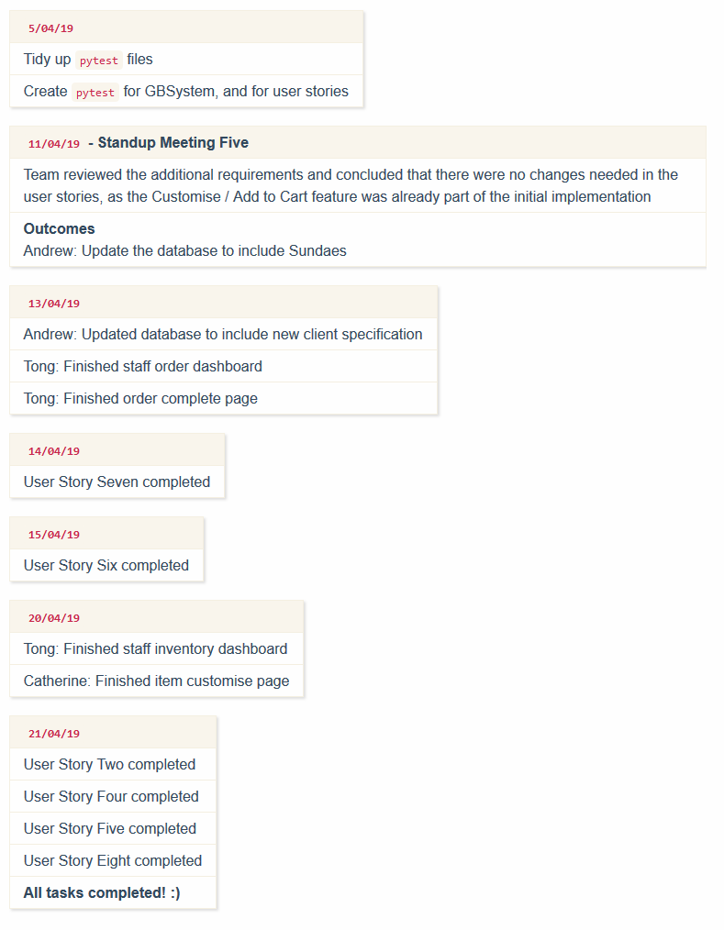

Artefacts

*Velocity Chart*

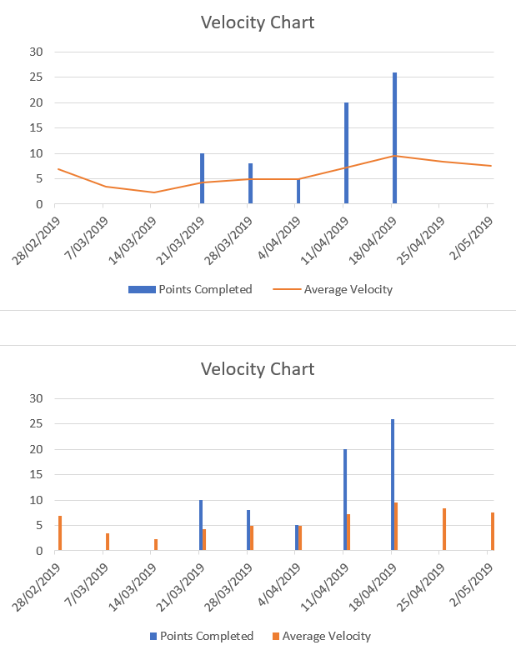

*CRC Cards*

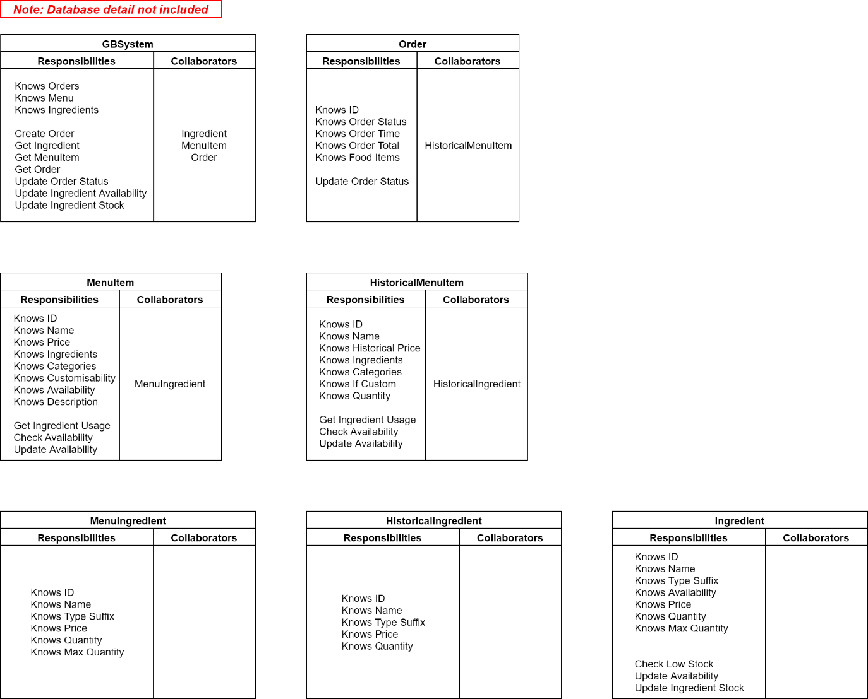

*Use Case Diagram*

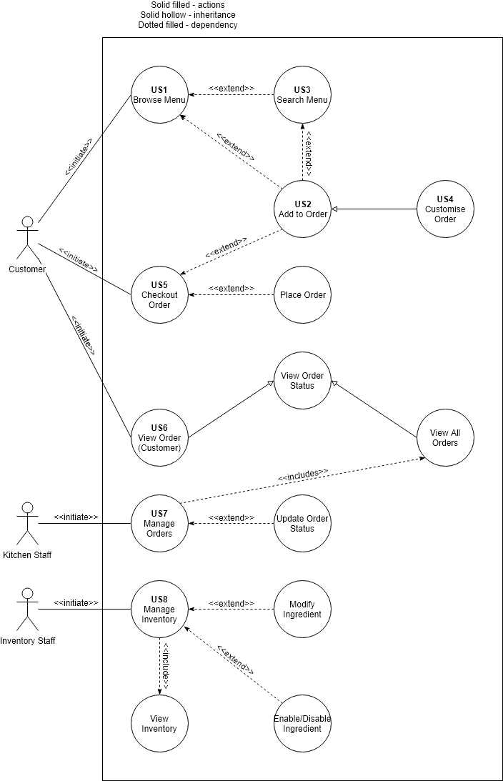

*Database Schema*

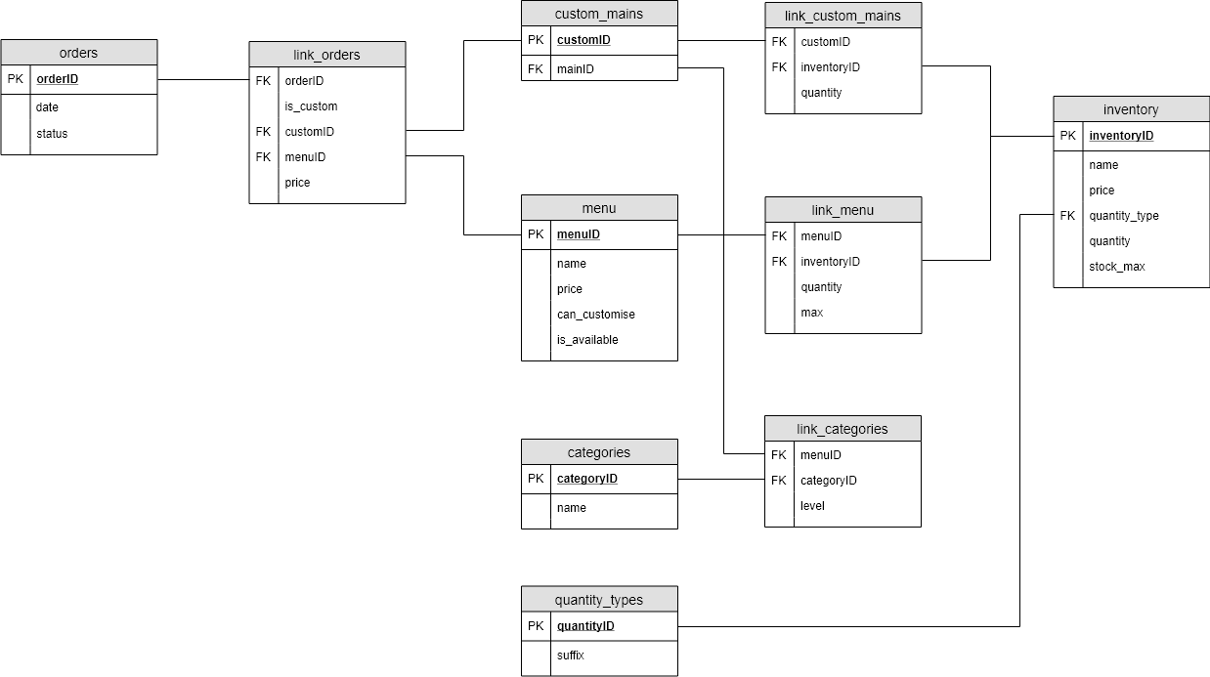

*Website Design Mockup*

