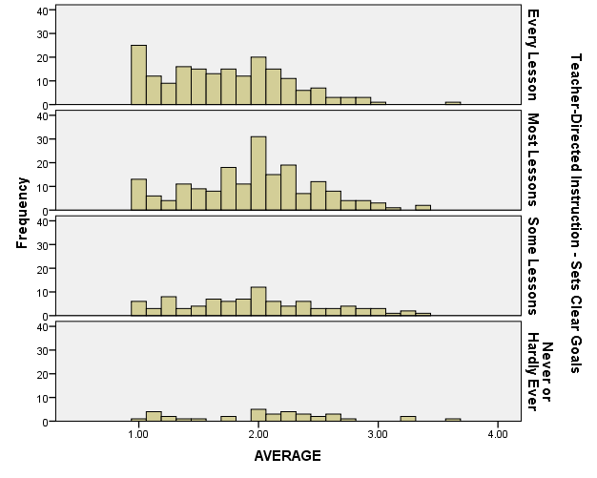

There are four rows in this histogram based on if teacher use the teaching skill in the classroom, so first row means teachers use the skill every lesson, second row means use the skill most lessons, third row means use the skill some lessons and the last row means never or hardly ever use the skill in the classroom. The AVERAGE means students’ average confidence: 1= very confident; 2=confident; 3=not very confident; 4=not at all confident.

It shows how students feel confidence when their teachers use the teaching skill in different frequencies.

The red color means very confident student

The yellow color means confident student

The light green means not very confident student

The dark green means not at all confident student

Different columns mean different confident variables.

It shows the confidence structure in different confident variables.

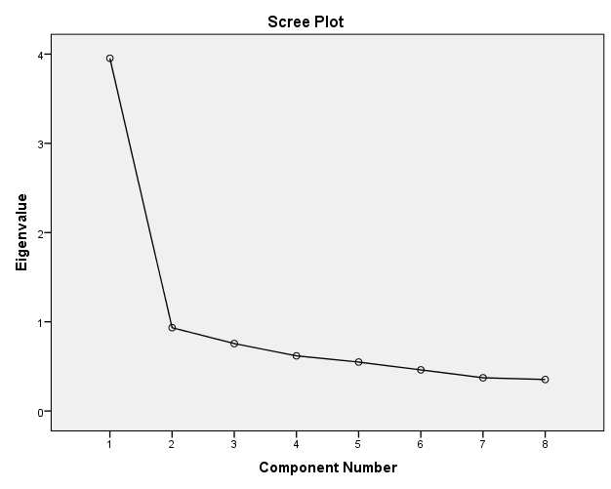

There are eight confident variables in my dataset, so I am trying to combine eight variables as one confident variable. This scree plot shows the component number by using factor analysis; it looks like the slope of this curve levels out after just two factors.