Concepts:
Git is the version control system running on your machine.
GitHub is the cloud platform where Git repositories are hosted, reviewed, and collaborated on. Repositories are the main unit of storage and collaboration in GitHub.
Repository
A repository stores your project code, history, branches, pull requests, and related collaboration artifacts.
Branch
A branch is an isolated line of development used to build a feature, fix a bug, or experiment safely without disturbing the main code line
Commit
A commit is a saved snapshot of changes with a message
Pull Request
A pull request is GitHub’s review-and-merge mechanism. It lets you propose changes, discuss them, review them, and then merge them into the target branch.
Fork
A fork is your own copy of another repository, commonly used when you do not have direct write access to the original repository
Merge
Merging brings changes from one branch into another. In GitHub, anyone with push access can merge an approved pull request.
GitHub Actions
GitHub Actions is GitHub’s CI/CD platform for automating builds, tests, and deployments through workflow YAML files.
The most important real-life workflow
Standard flow
- Create or clone repository
- Create a new branch from main
- Make code changes
- git add
- git commit
- git push
- Create Pull Request in GitHub
- Review comments / fix comments
- Re-push to same branch
- Merge PR
- Delete branch
Download and install git.
https://git-scm.com/install/windows
Once Git is installed, execute the following command:
1. Setup & Config:
>git –version → Check Git installation version
> git config --global user.name "Name" → Set global username
>git config --global user.email "email" → Set global email
> git config --local user.name "Name" → Set email for current repo only
> git config list config list
- Branch-related flags
-m vs -M:
git branch -m old new
git branch -M new
-m rename branch (fails if target exists)
-M → force rename (overwrites if exists)
-d vs -D
git branch -d feature1
git branch -D feature1
-d → delete (safe, only if merged)
-D → force delete (even if not merged)
2. Push-related flags:
-u:
git push -u origin main
Sets upstream tracking
After this → just git push works
-f / --force
git push -f
Force push (overwrites remote history). Avoid if beginners to the project. Dangerous (use carefully)
--force-with-lease
git push --force-with-lease
Safer force push, Prevents overwriting others’ work
3. Checkout / Switch:
-b
git checkout -b feature/login
git switch -c feature/login
4. Commit-related:
git commit -m "message" Add commit message inline
git commit -a -m "msg" Auto-stage modified files (not new files)
5. Add-related:
git add -A Add all changes (new + modified + deleted)
git add . Add changes in current directory (not always full repo)
6. Log-related:
git log –oneline Compact commit history
git log --oneline –graph Visual branch graph
7. Clone / Fetch:
git clone --branch dev <repo> Clone specific branch
Exercise 1:
- Create local repo, create remote repo, push the local code to remote, create PR and approve.
- Create feature/branch1, make updates, push the code to remote, delete branch.
- Create feature/branch2, make updates, push the code to remote, delete branch.
C:\Users\murug>cd C:\Training\Git
C:\Training\Git>mkdir git-demo
C:\Training\Git>cd git-demo
C:\Training\Git\git-demo>echo "Hello GitHub" > app.txt
C:\Training\Git\git-demo>git init
C:\Training\Git\git-demo>git status
C:\Training\Git\git-demo>git add .
C:\Training\Git\git-demo>git commit -m "Initial commit"
C:\Training\Git\git-demo>git remote add origin https://github.com/<your-gitrepo>/git-demo.git
C:\Training\Git\git-demo>git branch -M main
C:\Training\Git\git-demo>git push -u origin main
You can see the local code in GitHub.
Now, make some changes and push to remote. Create PR in GitHub and merge. Delete the local branch and the remote branch.
C:\Training\Git\git-demo>git checkout -b feature/login
C:\Training\Git\git-demo>git branch
C:\Training\Git\git-demo>echo "Login feature added" >> app.txt
C:\Training\Git\git-demo>git status
C:\Training\Git\git-demo>git add .
C:\Training\Git\git-demo>git commit -m "Added Login Feature"
C:\Training\Git\git-demo>git push origin feature/login
C:\Training\Git\git-demo>git checkout main
C:\Training\Git\git-demo>git merge feature/login
C:\Training\Git\git-demo>git branch -d feature/login
C:\Training\Git\git-demo>git push origin --delete feature/login

Raising PR
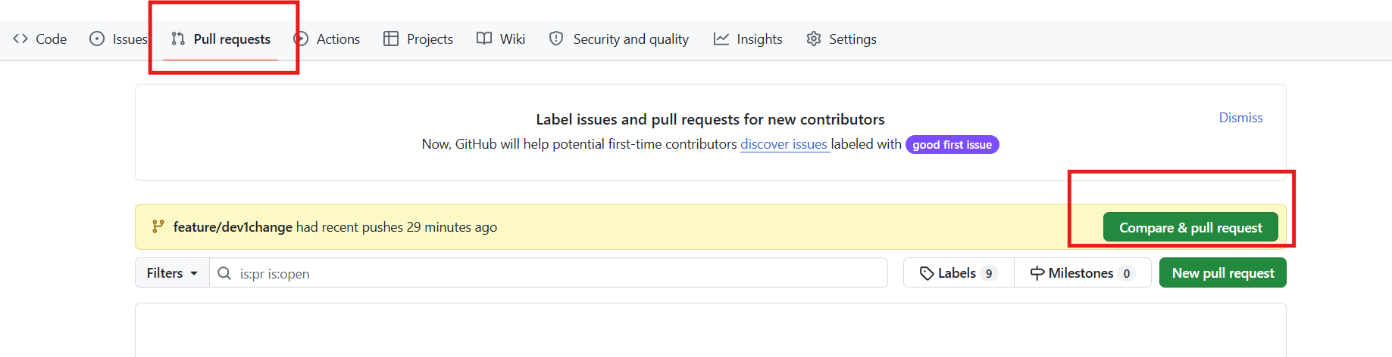
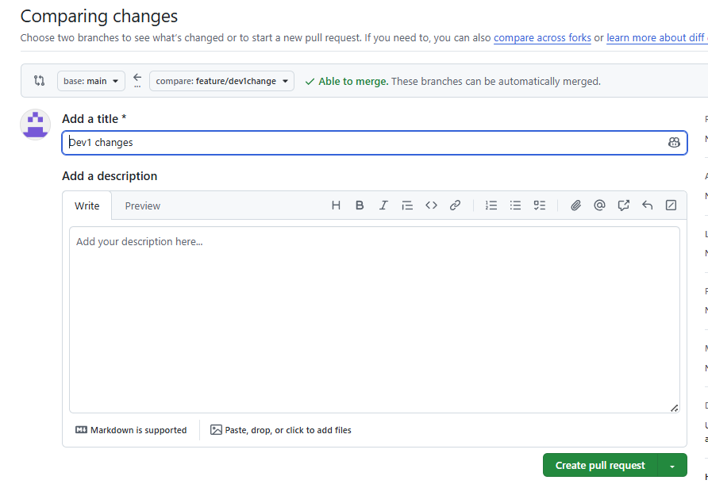
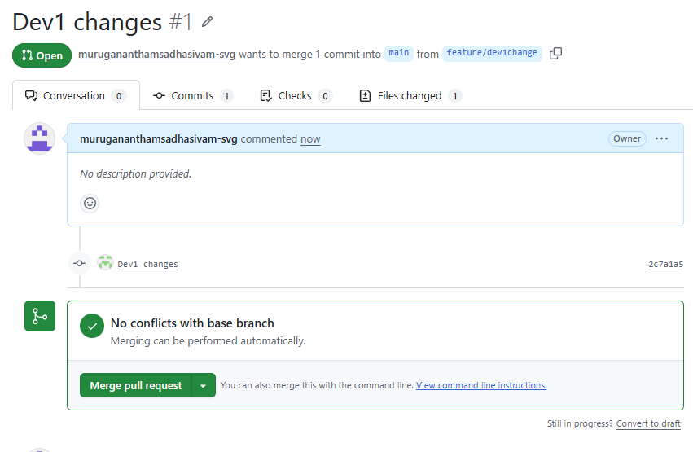

Click on Merge Pull Request and confirm Merge.
Repeat:
C:\Training\Git\git-demo>git checkout -b feature/logout
C:\Training\Git\git-demo>git branch
C:\Training\Git\git-demo>echo "Logout feature added" >> app.txt
C:\Training\Git\git-demo>git status
C:\Training\Git\git-demo>git add .
C:\Training\Git\git-demo>git commit -m "Added Logout Feature"
C:\Training\Git\git-demo>git push origin feature/logout
C:\Training\Git\git-demo>git checkout main
C:\Training\Git\git-demo>git merge feature/logout
C:\Training\Git\git-demo>git branch -d feature/logout
C:\Training\Git\git-demo>git push origin --delete feature/logout
Exercise 2:
Resolving conflicts as 2 developers.
- Normal flow
- Resolving conflict
Follow the folder structure as
C:\Training\Git\Ex2

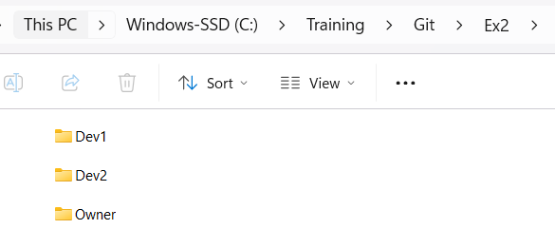
C:\Users\murug>cd C:\Training\Git\Ex2\Owner
C:\Training\Git\Ex2\Owner>mkdir git-demo1
C:\Training\Git\Ex2\Owner>cd git-demo1
C:\Training\Git\Ex2\Owner\git-demo1>git init
C:\Training\Git\Ex2\Owner\git-demo1>echo "Version 1 - Main File" >> app.txt
C:\Training\Git\Ex2\Owner\git-demo1>git add .
C:\Training\Git\Ex2\Owner\git-demo1>git commit -m "initial commit"
C:\Training\Git\Ex2\Owner\git-demo1>git remote add origin https://github.com/<user>/git-demo1.git
C:\Training\Git\Ex2\Owner\git-demo1>git branch -M main
C:\Training\Git\Ex2\Owner\git-demo1>git push -u origin main
Once the repo is ready in GitHub, add collaborators in
https://github.com/murugananthamsadhasivam-svg/git-demo1/settings
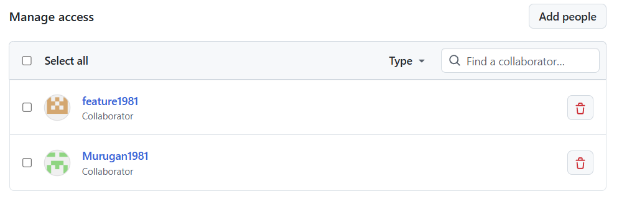

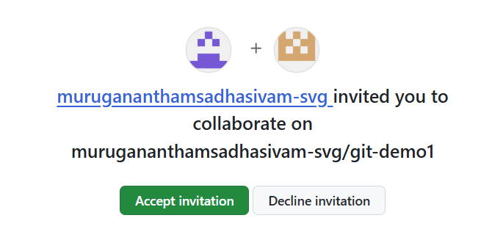
Once the developers accept the invitation, they can contribute to the project.

- Setting up Dev1
Open another command prompt for better clarity:
C:\Users\murug>cd C:\Training\Git\Ex2\Dev1
C:\Training\Git\Ex2\Dev1>git clone https://github.com/murugananthamsadhasivam-svg/git-demo1.git
C:\Training\Git\Ex2\Dev1>cd git-demo1
C:\Training\Git\Ex2\Dev1\git-demo1>git status
C:\Training\Git\Ex2\Dev1\git-demo1>git config user.name "DEV1"
C:\Training\Git\Ex2\Dev1\git-demo1>git config user.email dev1@gmail.com
C:\Training\Git\Ex2\Dev1\git-demo1>git config list
C:\Training\Git\Ex2\Dev1\git-demo1>git checkout -b feature/dev1change
C:\Training\Git\Ex2\Dev1\git-demo1>echo "developer1 updates the code" >> app.txt
C:\Training\Git\Ex2\Dev1\git-demo1>git add .
C:\Training\Git\Ex2\Dev1\git-demo1>git commit -m "Dev1 changes"
C:\Training\Git\Ex2\Dev1\git-demo1>git push origin feature/dev1change

Follow the steps above to complete PR and Merge.
C:\Training\Git\Ex2\Dev1\git-demo1>git checkout main
C:\Training\Git\Ex2\Dev1\git-demo1>git merge feature/dev1change
C:\Training\Git\Ex2\Dev1\git-demo1>git branch -d feature/dev1change
C:\Training\Git\Ex2\Dev1\git-demo1>git push origin --delete feature/dev1change
- Setting up Dev2
C:\Training\Git\Ex2\Dev2>git clone https://github.com/<user>/git-demo1.git
C:\Training\Git\Ex2\Dev2>cd git-demo1
C:\Training\Git\Ex2\Dev2\git-demo1>git config user.name "DEV2"
C:\Training\Git\Ex2\Dev2\git-demo1>git config user.email dev2@gmail.com
C:\Training\Git\Ex2\Dev2\git-demo1>git config list
C:\Training\Git\Ex2\Dev2\git-demo1>git checkout -b feature/dev2change
C:\Training\Git\Ex2\Dev2\git-demo1>echo "feature/dev2change developer2 updates the code" >> app.txt
C:\Training\Git\Ex2\Dev2\git-demo1>git add .
C:\Training\Git\Ex2\Dev2\git-demo1>git commit -m "Dev2 Changes"
C:\Training\Git\Ex2\Dev2\git-demo1>git push origin feature/dev2change
Complete PR flow.
C:\Training\Git\Ex2\Dev2\git-demo1>git checkout main
C:\Training\Git\Ex2\Dev2\git-demo1>git merge feature/dev2change
C:\Training\Git\Ex2\Dev2\git-demo1>git branch -d feature/dev2change
C:\Training\Git\Ex2\Dev2\git-demo1>git push origin --delete feature/dev2change
For manual PR creation, make additional changes with the same branch and push.
Now PR in GitHub needs to be created manually to merge
Hitting the conflict and how to resolve:
Dev1 starts new work but does not merge immediately
C:\Training\Git\Ex2\Dev1\git-demo1>git checkout main
C:\Training\Git\Ex2\Dev1\git-demo1>git pull origin main
C:\Training\Git\Ex2\Dev1\git-demo1>git checkout -b feature/dev1-work2
C:\Training\Git\Ex2\Dev1\git-demo1>echo "feature/dev1-work2, Dev1 Work2" >>app.txt
C:\Training\Git\Ex2\Dev1\git-demo1>git add .
C:\Training\Git\Ex2\Dev1\git-demo1>git commit -m "Dev1 Work2"
C:\Training\Git\Ex2\Dev1\git-demo1>git push origin feature/dev1-work2

Dev2 clones the code and creates branch, updates locally. Before developer 2 merges/ completes the PR, Dev1 will complete PR.
C:\Training\Git\Ex2\Dev2\git-demo1>git pull origin main
C:\Training\Git\Ex2\Dev2\git-demo1>git status
C:\Training\Git\Ex2\Dev2\git-demo1>git checkout -b feature/dev2-work2
C:\Training\Git\Ex2\Dev2\git-demo1>echo "feature/dev2-work2, Dev2 Work2" >>app.txt
C:\Training\Git\Ex2\Dev2\git-demo1>git add .
C:\Training\Git\Ex2\Dev2\git-demo1>git commit -m "Dev2 Work2"

Dev1 completes PR before Developer 2 merges the code.
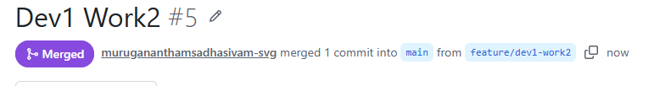

C:\Training\Git\Ex2\Dev2\git-demo1>git push origin feature/dev2-work2
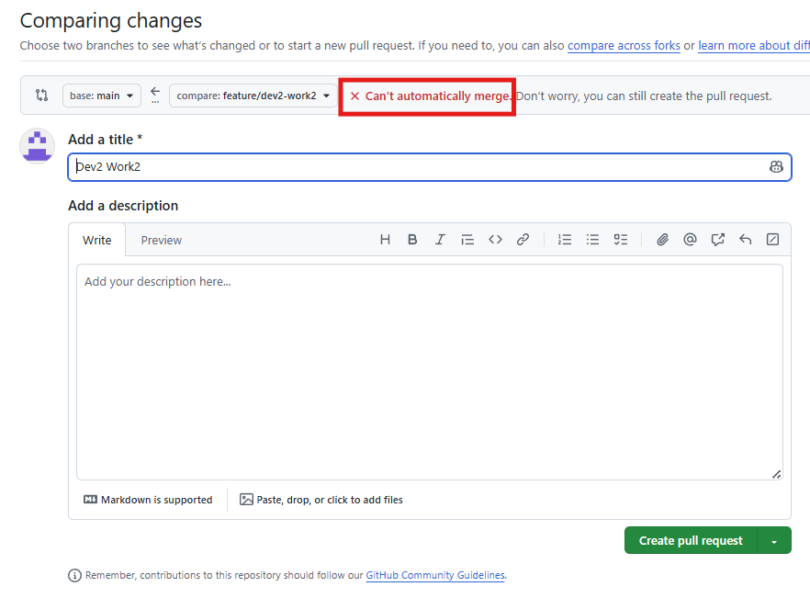
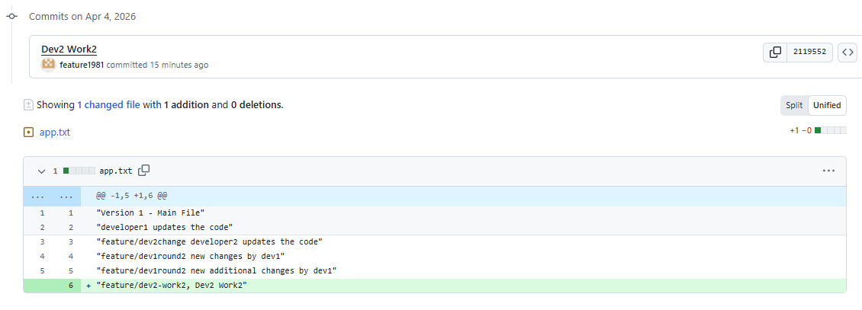
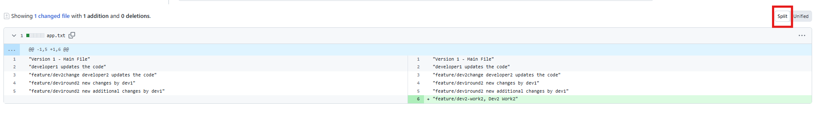
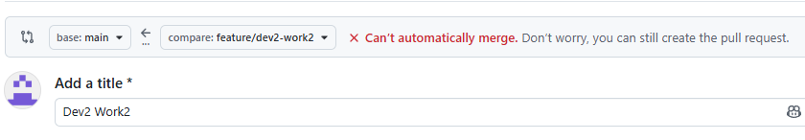
Click on create pull request.
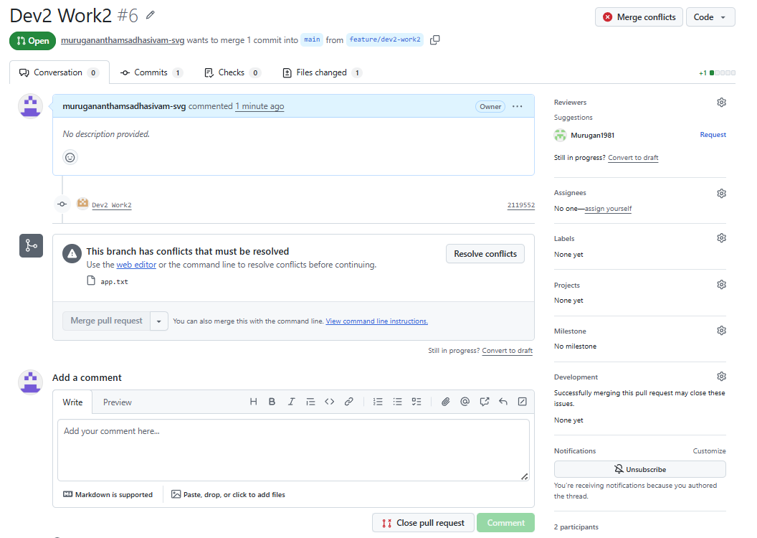
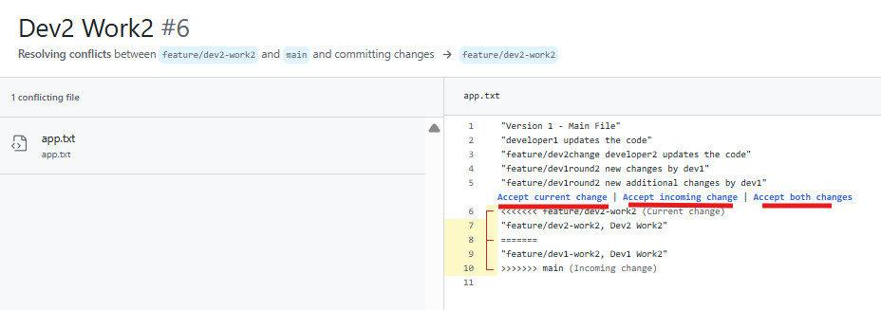

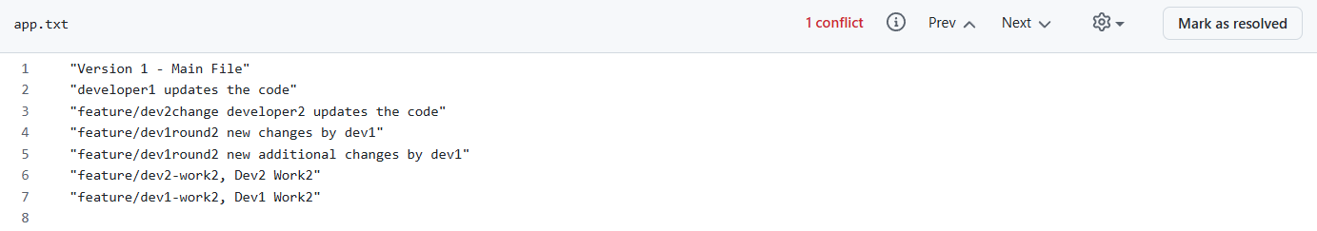
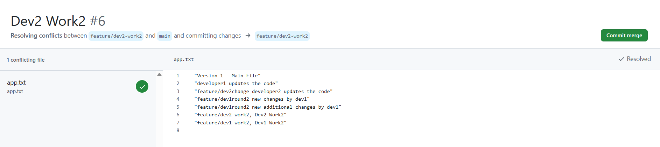
Delete the branch for both dev1 and dev2.

Merge Pull request Confirm Merge
Introduce conflict again for Developer2 to fix it locally and then push.
Dev1:
C:\Training\Git\Ex2\Dev1\git-demo1>git pull origin main
C:\Training\Git\Ex2\Dev1\git-demo1>git checkout -b feature/dev1-work3
C:\Training\Git\Ex2\Dev1\git-demo1>echo "Option 2 - Dev 1 Work 3 updates for conflict resolving" >> app.txt
C:\Training\Git\Ex2\Dev1\git-demo1>git add .
C:\Training\Git\Ex2\Dev1\git-demo1>git commit -m "Option 2 - Dev1 Work3"
C:\Training\Git\Ex2\Dev1\git-demo1>git push origin feature/dev1-work3
- Don’t complete PR. Let Developer 2 pulls the code and then merge it with master.

Dev2:
C:\Training\Git\Ex2\Dev2\git-demo1>git pull origin main
C:\Training\Git\Ex2\Dev2\git-demo1>git checkout -b feature/dev2-work3
C:\Training\Git\Ex2\Dev2\git-demo1>echo "dev2-work3, Option 2, Updates for conflict resolving" >> app.txt
C:\Training\Git\Ex2\Dev2\git-demo1>git add .
C:\Training\Git\Ex2\Dev2\git-demo1>git commit -m "dev2-work3, option2"
- Owner completes Dev 1 PR. 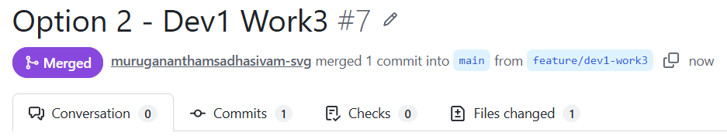
- Dev1 deletes local and remote branch.
Dev2:
C:\Training\Git\Ex2\Dev2\git-demo1>git push origin feature/dev2-work3
Click on compare & Pull request.
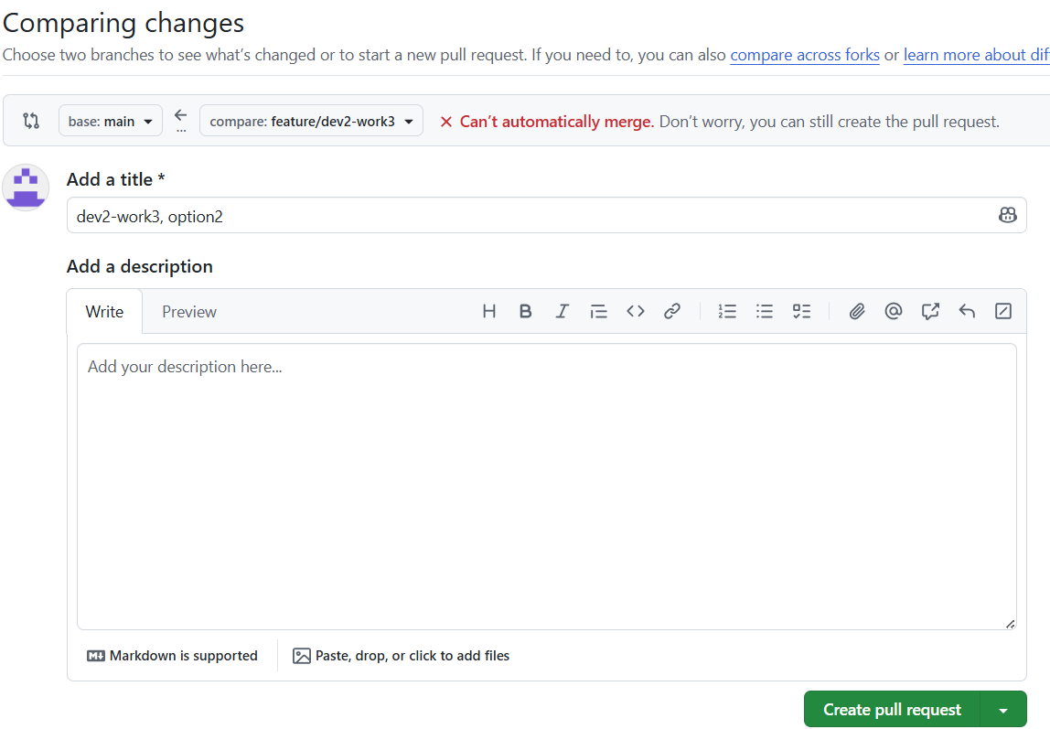
Click on create pull request.
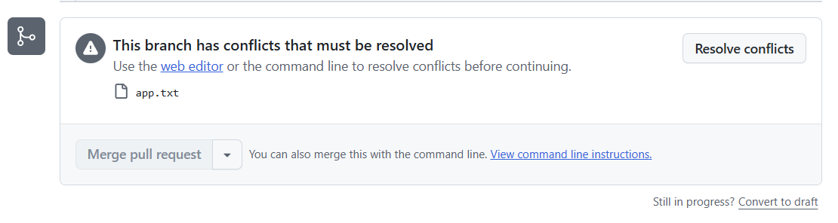
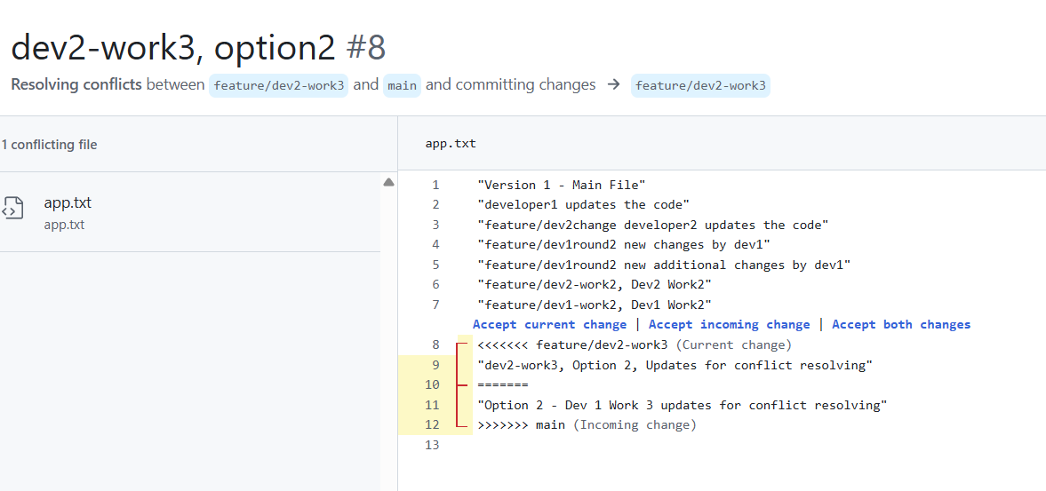
Option 2 to fix this locally and then push the changes.
C:\Training\Git\Ex2\Dev2\git-demo1>git fetch origin
C:\Training\Git\Ex2\Dev2\git-demo1>git merge origin/main
Auto-merging app.txt
CONFLICT (content): Merge conflict in app.txt
Automatic merge failed; fix conflicts and then commit the result.
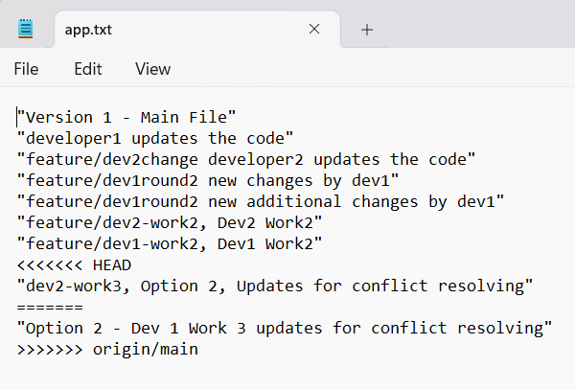
Make updates and resolve conflict
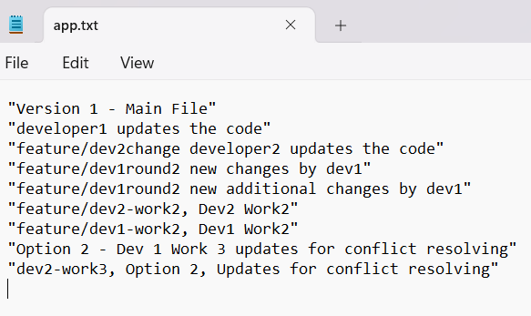
C:\Training\Git\Ex2\Dev2\git-demo1>git add .
C:\Training\Git\Ex2\Dev2\git-demo1>git commit -m "Conflict resolved locally"
C:\Training\Git\Ex2\Dev2\git-demo1>git push origin feature/dev2-work3
No merge conflict now.
Owner merges the code.
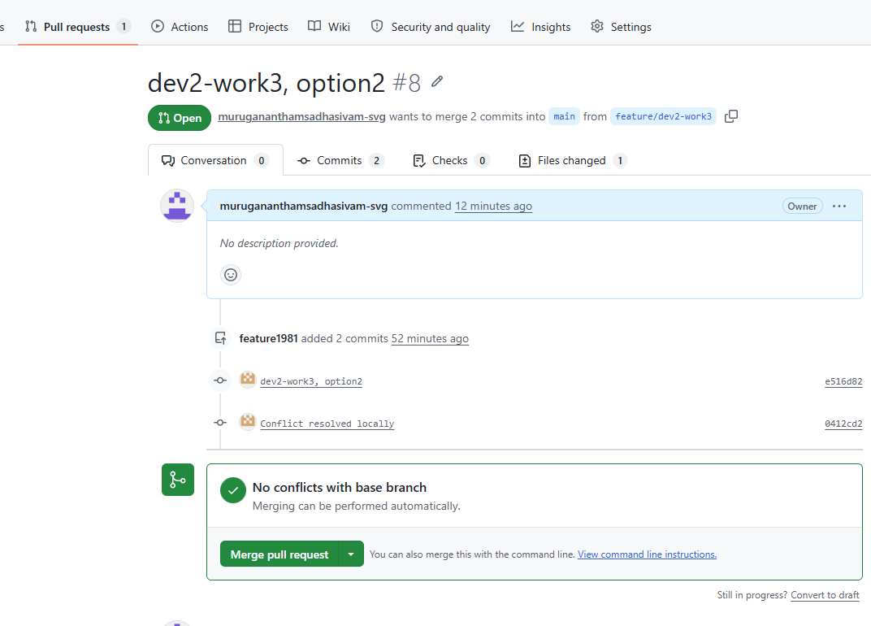
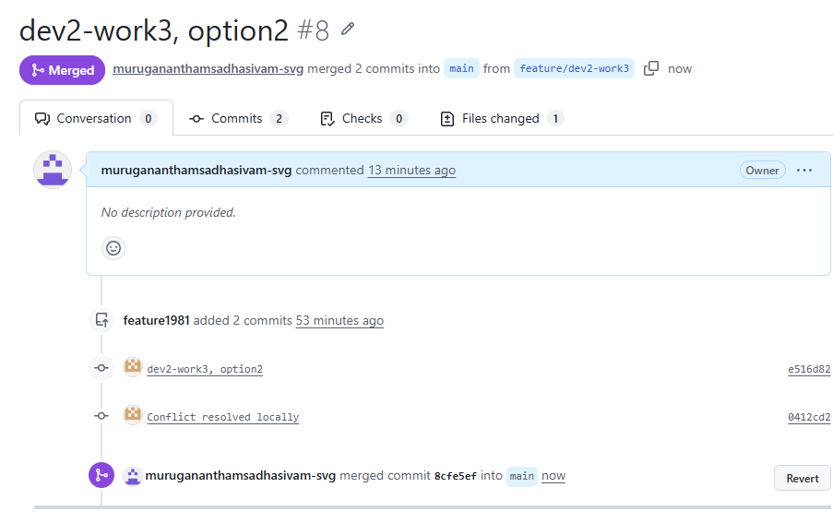

Option 3: Dev2 rebases onto latest main
This is cleaner history-wise [advanced]
DEV1:
C:\Training\Git\Ex2\Dev1\git-demo1>git pull origin main
C:\Training\Git\Ex2\Dev1\git-demo1>git checkout -b feature/dev-work4
C:\Training\Git\Ex2\Dev1\git-demo1>echo "Option 3 - Dev 1 Work 4" >>app.txt
C:\Training\Git\Ex2\Dev1\git-demo1>git add .
C:\Training\Git\Ex2\Dev1\git-demo1>git commit -m "Option 3 - Dev 1 Work 4"
C:\Training\Git\Ex2\Dev1\git-demo1>git push origin feature/dev-work4
C:\Training\Git\Ex2\Dev1\git-demo1>git checkout main
C:\Training\Git\Ex2\Dev1\git-demo1>git merge feature/dev-work4
C:\Training\Git\Ex2\Dev1\git-demo1>git branch -d feature/dev-work4
C:\Training\Git\Ex2\Dev1\git-demo1>git push origin --delete feature/dev-work4
Make another change by Dev1 and don’t complete PR to introduce conflict.
C:\Training\Git\Ex2\Dev1\git-demo1>git pull origin main
C:\Training\Git\Ex2\Dev1\git-demo1>git checkout -b feature/dev1-work5
C:\Training\Git\Ex2\Dev1\git-demo1>echo "Option 3 - Dev 1 - Work 5" >> app.txt
C:\Training\Git\Ex2\Dev1\git-demo1>git add .
C:\Training\Git\Ex2\Dev1\git-demo1>git commit -m "Option 3 Dev1-Work5"
C:\Training\Git\Ex2\Dev1\git-demo1>git push origin feature/dev1-work5
DON’T complete PR until Dev 2 pulls the code.
DEV2:
C:\Training\Git\Ex2\Dev2\git-demo1>git pull origin main
C:\Training\Git\Ex2\Dev2\git-demo1>git checkout -b feature/dev2-work5
C:\Training\Git\Ex2\Dev2\git-demo1>echo "Option 3, Dev2-Work5" >>app.txt
C:\Training\Git\Ex2\Dev2\git-demo1>git add .
C:\Training\Git\Ex2\Dev2\git-demo1>git commit -m "Option3 Dev2 Work5"
C:\Training\Git\Ex2\Dev2\git-demo1>git push origin feature/Dev2-work5
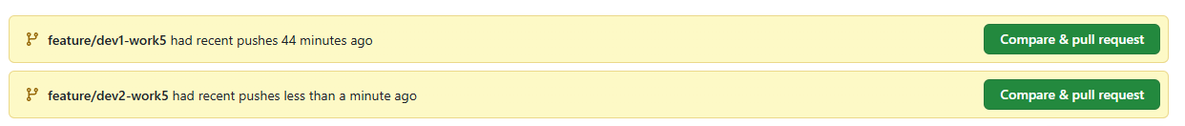
Complete the dev1 PR first.
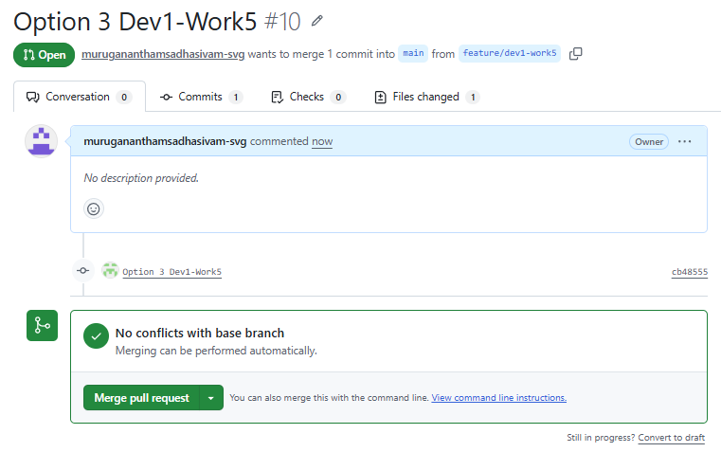
C:\Training\Git\Ex2\Dev1\git-demo1>git checkout main
C:\Training\Git\Ex2\Dev1\git-demo1>git merge feature/dev1-work5
C:\Training\Git\Ex2\Dev1\git-demo1>git branch -d feature/dev1-work5
C:\Training\Git\Ex2\Dev1\git-demo1>git push origin --delete feature/dev1-work5
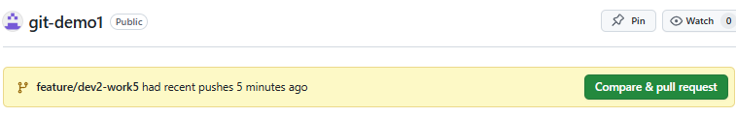

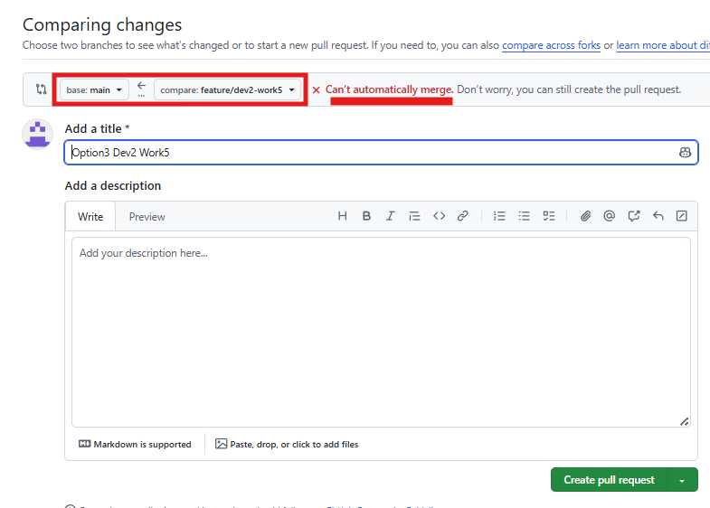
DEV2:
C:\Training\Git\Ex2\Dev2\git-demo1>git fetch origin
C:\Training\Git\Ex2\Dev2\git-demo1>git rebase origin/main
Auto-merging app.txt
CONFLICT (content): Merge conflict in app.txt
error: could not apply fdb4294... Option3 Dev2 Work5
hint: Resolve all conflicts manually, mark them as resolved with
hint: "git add/rm <conflicted_files>", then run "git rebase --continue".
hint: You can instead skip this commit: run "git rebase --skip".
hint: To abort and get back to the state before "git rebase", run "git rebase --abort".
hint: Disable this message with "git config set advice.mergeConflict false"
Could not apply fdb4294... # Option3 Dev2 Work5

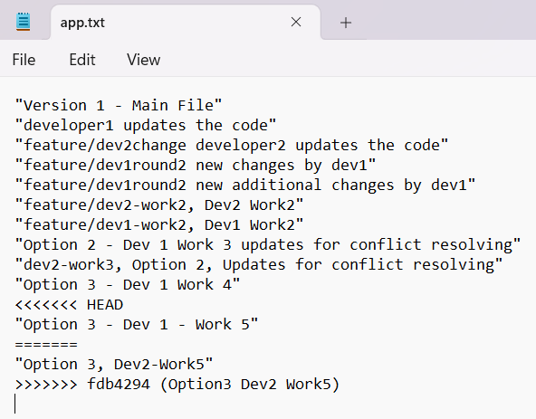
We need to resolve the conflict manually.
C:\Training\Git\Ex2\Dev2\git-demo1> git add .
C:\Training\Git\Ex2\Dev2\git-demo1>git rebase –continue
git push --force-with-lease origin feature/dev2-work5
C:\Training\Git\Ex2\Dev2\ git-demo1>git push --force-with-lease origin feature/dev2-work5
Go to GitHub and complete the PR.

