SQL:
SQL Structured Query Language
can execute queries against a database
can retrieve data from a database
can insert records in a database
can update records in a database
can delete records from a database
can create new databases
can create new tables in a database
can create stored procedures in a database
can create views in a database
can set permissions on tables, procedures, and views
RDBMS
Relational Database Management System
MS SQL Server, IBM DB2, Oracle, MySQL, and Microsoft Access.
SELECT column1, column2, ...
FROM table_name;

SELECT DISTINCT statement is used to return only distinct (unique) values.
SELECT DISTINCT column1, column2, ...
FROM table_name;
SELECT COUNT(DISTINCT Country) FROM Customers;
SELECT column1, column2, ... FROM table_name WHERE condition;
Operators:
Operator | Description
= | Equal
> | Greater than
< | Less than
>= | Greater than or equal
<= | Less than or equal
<> | Not equal. Note: In some versions of SQL this operator may be written as !=
BETWEEN | Between a certain range
LIKE | Search for a pattern
IN | To specify multiple possible values for a column

ORDER BY
SELECT column1, column2, ...
FROM table_name
ORDER BY column1, column2, ... ASC|DESC;
Default [if none mentioned] Ascending
SELECT column1, column2, ...
FROM table_name
ORDER BY column1 ASC, column2 DESC;

AND
SELECT column1, column2, ...
FROM table_name
WHERE condition1 AND condition2 AND condition3 ...;
OR:
SELECT column1, column2, ...
FROM table_name
WHERE condition1 OR condition2 OR condition3 ...;
AND vs OR:
The AND operator displays a record if all the conditions are TRUE.
The OR operator displays a record if any of the conditions are TRUE.
SQL NOT Operator:
SELECT column1, column2, ...
FROM table_name
WHERE NOT condition;
NOT LIKE
NOT BETWEEN
NOT IN
IS NOT NULL
NOT EXISTS

SELECT * FROM Customers
WHERE CustomerName NOT LIKE 'A%';
SELECT * FROM Customers
WHERE CustomerID NOT BETWEEN 10 AND 60;
SELECT * FROM Customers
WHERE City NOT IN ('Paris', 'London');
SELECT * FROM Customers
WHERE NOT CustomerID > 50;
SELECT * FROM Customers
WHERE NOT CustomerId < 50;
INSERT INTO:
Single Value:
INSERT INTO table_name (column1, column2, column3, ...)
VALUES (column1_value1, column2_value1, column3_value1, ...);
INSERT INTO table_name
VALUES (value1, value2, value3, ...);
Multiple Values:
INSERT INTO tablename
VALUES
(column1_value1, column2_value1, column3_value1),
(column1_value2, column2_value2, column3_value2),
(column1_value3, column2_value3, column3_value3);
NULL Value:
If a field in a table is optional, it is possible to insert or update a record without adding any value to this field. This way, the field will be saved with a NULL value.
IS NULL
IS NOT NULL
SELECT column_names
FROM table_name
WHERE column_name IS NULL;
SELECT column_names
FROM table_name
WHERE column_name IS NOT NULL;
UPDATE:
UPDATE table_name
SET column1 = value1, column2 = value2, ...
WHERE condition;
If you omit the WHERE clause, ALL records will be updated!
DELETE:
DELETE FROM table_name WHERE condition; - > specific records.
Delete All Records DELETE FROM table_name; [ No where condition]
DROP:
DROP TABLE table_name;
SELECT TOP / LIMIT
SELECT TOP number|percent column_name(s)
FROM table_name
WHERE condition;
SQL Aggregate Functions
An aggregate function is a function that performs a calculation on a set of values, and returns a single value.
Aggregate functions are often used with the GROUP BY clause of the SELECT statement. The GROUP BY clause splits the result-set into groups of values and the aggregate function can be used to return a single value for each group.
MIN():- returns the smallest value of a column
SELECT MIN(column_name) as aliasname
FROM table_name
WHERE condition;
SELECT MIN(Price) AS SmallestPrice, CategoryID
FROM Products
GROUP BY CategoryID;
MAX(): - returns the largest value of a column
SELECT MAX(column_name)
FROM table_name
WHERE condition;
COUNT(): - returns the number of rows in a set
SELECT COUNT([DISTINCT] column_name | *)
FROM table_name
WHERE condition;
- COUNT(*) - Counts the total number of rows in a table (including NULL values).
- COUNT(columnname) - Counts all non-null values in the column.
- COUNT(DISTINCT columnname) - Counts only the unique, non-null values in the column.
SUM(): - returns the sum of a numerical column
SELECT SUM(column_name)
FROM table_name
WHERE condition;
SELECT OrderID, SUM(Quantity) AS [Total Quantity]
FROM OrderDetails
GROUP BY OrderID;
SELECT SUM(Price * Quantity)
FROM OrderDetails
LEFT JOIN Products ON OrderDetails.ProductID = Products.ProductID;
AVG() - returns the average value of a numerical column
SELECT AVG(Price)
FROM Products;
SELECT AVG(column_name)
FROM table_name
WHERE condition;
LIKE:
SELECT column1, column2, ...
FROM table_name
WHERE columnN LIKE pattern;
SELECT * FROM Customers
WHERE city LIKE '%on%';
SELECT * FROM Customers
WHERE city LIKE 'l_nd__';

Wildcards: to substitute one or more characters in a string
Symbol | Description | PostgreSQL
% | Represents zero or more characters | Yes
_ | Represents a single character | Yes
[] | Represents any single character within the brackets * | NO
^ | Represents any character not in the brackets * | NO
- | Represents any single character within the specified range * | NO
{} | Represents any escaped character ** | NO

Microsoft Access Wildcards
Symbol | Description | Example
* | Represents zero or more characters | bl* finds bl, black, blue, and blob
? | Represents a single character | h?t finds hot, hat, and hit
[] | Represents any single character within the brackets | h[oa]t finds hot and hat, but not hit
! | Represents any character not in the brackets | h[!oa]t finds hit, but not hot and hat
- | Represents any single character within the specified range | c[a-b]t finds cat and cbt
# | Represents any single numeric character | 2#5 finds 205, 215, 225, 235, 245, 255, 265, 275, 285, and 295

IN:
SELECT column_name(s)
FROM table_name
WHERE column_name IN (value1, value2, ...);
SELECT * FROM Customers
WHERE CustomerID IN (SELECT CustomerID FROM Orders);

NOT IN:
SELECT * FROM Customers
WHERE Country NOT IN ('Germany', 'France', 'UK');
SELECT * FROM Customers
WHERE CustomerID NOT IN (SELECT CustomerID FROM Orders);

BETWEEN:
SELECT column_name(s)
FROM table_name
WHERE column_name BETWEEN value1 AND value2;
Aliases:
SELECT column_name AS alias_name
FROM table_name;

JOIN:
SELECT Orders.OrderID, Customers.CustomerName, Orders.OrderDate
FROM Orders
INNER JOIN Customers ON Orders.CustomerID=Customers.CustomerID;
(INNER) JOIN: Returns only rows that have matching values in both tables
LEFT (OUTER) JOIN: Returns all rows from the left table, and only the matched rows from the right table
RIGHT (OUTER) JOIN: Returns all rows from the right table, and only the matched rows from the left table
FULL (OUTER) JOIN: Returns all rows when there is a match in either the left or right table

Inner Join:
SELECT Products.ProductID, Products.ProductName, Categories.CategoryName
FROM Products
INNER JOIN Categories ON Products.CategoryID = Categories.CategoryID;
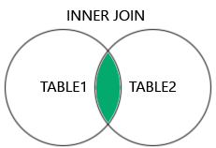
Use Case:
Validating referential integrity
Only clean / valid data for reporting
Validation:
Are all orders linked to valid customers?
LEFT JOIN: 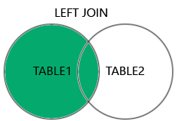
SELECT column_name(s)
FROM table1
LEFT JOIN table2
ON table1.column_name = table2.column_name;
Use Case:
- Detect missing references
- Identify data defects
Validation:
Orphan records
ETL load issues
Missing dimension records
RIGHT JOIN:
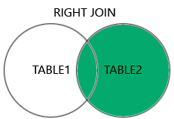
SELECT column_name(s)
FROM table1
RIGHT JOIN table2
ON table1.column_name = table2.column_name;
Use Case:
- Identify inactive customers
Validation:
"Which master records are not used?"
Coverage validation
FULL JOIN:
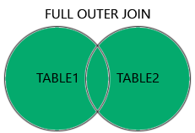

SELECT column_name(s) FROM table1 FULL JOIN table2
ON table1.column_name = table2.column_name
WHERE condition;
Use Case:
  - Missing in target
  - Extra in target
  - Data reconciliation
  - ETL validation
Self Join:
SELECT column_name(s)
FROM table1 T1, table1 T2
WHERE condition;
Use Case:
- Hierarchical data
- Parent-child relationships
- Org structure
- Dependency chains
- Recursive relationships

LEFT JOIN → defect identification
FULL JOIN → data reconciliation
INNER JOIN → business reporting
UNION:
To combine the result-set of two or more SELECT statements
UNION operator automatically removes duplicate rows from the result set.
SELECT column_name(s) FROM table1
UNION
SELECT column_name(s) FROM table2;

UNION ALL:
The UNION ALL operator is used to combine the result-set of two or more SELECT statements.
The UNION ALL operator includes all rows from each statement, including any duplicates.

SELECT column_name(s) FROM table1
UNION ALL
SELECT column_name(s) FROM table2;
GROUP BY:
to group rows that have the same values into summary rows

How to find all the tables in the database:
SELECT table_name
FROM information_schema.tables
WHERE table_schema='public'
AND table_type='BASE TABLE';
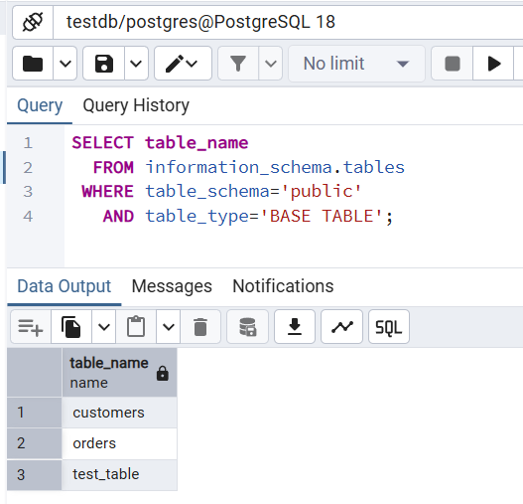
To know more about the specific TABLE:
SELECT *
FROM information_schema.columns
WHERE table_name = 'test_table';
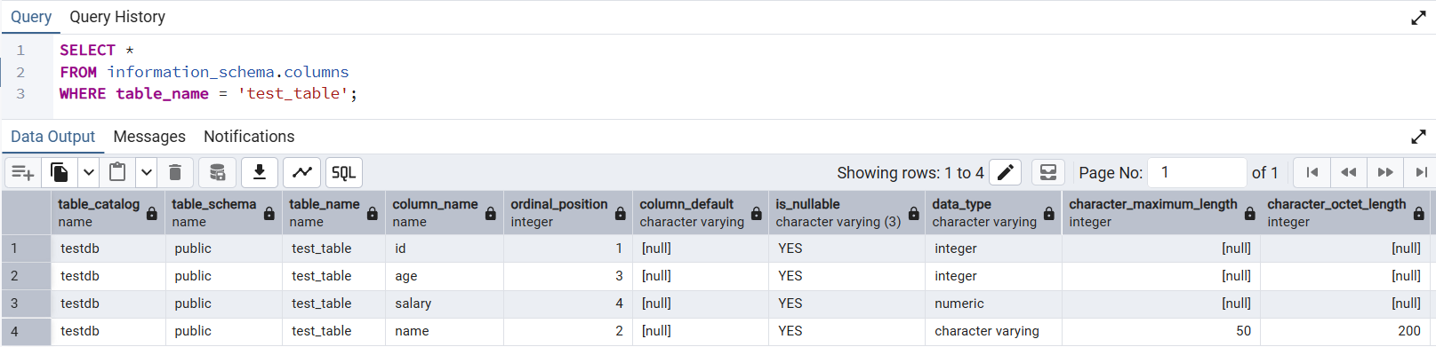

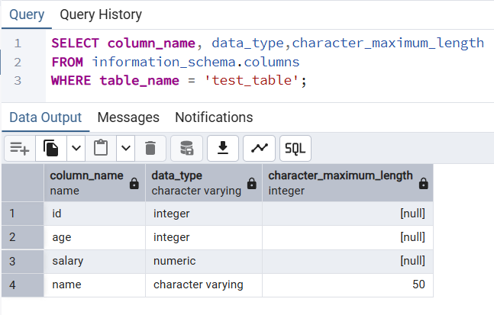

This is similar to
SHOW TABLES;
DESCRIBE Table_name in MySQL, Databricks

