ProcuraMed
Example:
Test Case 2: Purchase Request Submission Test
Code
import os
import pathlib
import pytest
from selenium import webdriver
from selenium.webdriver.common.by import By
from selenium.webdriver.support.ui import WebDriverWait
from selenium.webdriver.support import expected_conditions as EC
from selenium.webdriver.chrome.options import Options
from selenium.webdriver.support.ui import Select
# Paths and configuration
BASE_DIR = pathlib.Path(__file__).resolve().parent.parent
SCREENSHOT_DIR = BASE_DIR / "test-results" / "screenshots"
SCREENSHOT_DIR.mkdir(parents=True, exist_ok=True)
# Test Configuration - configurable via environment variables
BASE_URL = os.environ.get("BASE_URL", "http://localhost:3000")
LOGIN_URL = f"{BASE_URL}/login"
CREATE_REQ_URL = f"{BASE_URL}/staff/create-request"
REQUESTS_LIST_URL = f"{BASE_URL}/staff/requests"
STAFF_USERNAME = os.environ.get("TEST_STAFF_USERNAME", "test_staff")
STAFF_PASSWORD = os.environ.get("TEST_STAFF_PASSWORD", "TestStaff@2026")
HEADLESS_MODE = os.environ.get("HEADLESS", "true").lower() in ("true", "1", "yes")
class TestPurchaseRequest:
"""
Test Case 2: ProcuraMed Purchase Request Submission Test Suite
Covers end-to-end requisition creation, item specification, submission verification,
and form field validation error handling.
"""
def setup_method(self, method):
"""Setup Chrome WebDriver before each test execution."""
options = Options()
if HEADLESS_MODE:
options.add_argument("--headless=new")
options.add_argument("--window-size=1920,1080")
options.add_argument("--no-sandbox")
options.add_argument("--disable-dev-shm-usage")
options.add_argument("--disable-gpu")
options.add_argument("--ignore-certificate-errors")
self.driver = webdriver.Chrome(options=options)
self.driver.maximize_window()
self.wait = WebDriverWait(self.driver, 12)
def teardown_method(self, method):
"""Tear down and close the WebDriver session after each test."""
if hasattr(self, "driver") and self.driver:
self.driver.quit()
def click_element(self, element):
"""Helper to reliably scroll and click element across animations."""
self.driver.execute_script("arguments[0].scrollIntoView({block: 'center'});", element)
try:
element.click()
except Exception:
self.driver.execute_script("arguments[0].click();", element)
def login_as_staff(self):
"""Helper to perform authenticated login as Department Staff."""
driver = self.driver
wait = self.wait
driver.get(LOGIN_URL)
username_field = wait.until(EC.visibility_of_element_located((By.NAME, "username")))
username_field.clear()
username_field.send_keys(STAFF_USERNAME)
password_field = wait.until(EC.visibility_of_element_located((By.NAME, "password")))
password_field.clear()
password_field.send_keys(STAFF_PASSWORD)
login_btn = wait.until(EC.element_to_be_clickable((By.CSS_SELECTOR, "button[type='submit']")))
self.click_element(login_btn)
wait.until(EC.url_contains("/staff/dashboard"))
def test_submit_purchase_request_success(self):
"""
Test Case 2: Submit a valid Purchase Requisition.
Steps:
1. Login as authorized Department Staff.
2. Navigate to Create Purchase Requisition page.
3. Fill Step 1 Requisition Details (Title, Priority, Clinical Justification).
4. Fill Step 2 Item Specifications (Product Name, Category, Quantity, Unit Price, Specs).
5. Review Requisition Summary in Step 3 and submit.
6. Verify confirmation alert and automatic redirection to My Requisitions list.
"""
driver = self.driver
wait = self.wait
# Step 1: Login as staff requester
self.login_as_staff()
driver.save_screenshot(str(SCREENSHOT_DIR / "tc2_step1_staff_dashboard.png"))
# Step 2: Open Create Purchase Requisition Form
driver.get(CREATE_REQ_URL)
wait.until(EC.url_contains("/staff/create-request"))
form_heading = wait.until(
EC.visibility_of_element_located((By.XPATH, "//h2[contains(text(), 'Step 1: General Requisition Details')]"))
)
assert form_heading.is_displayed(), "Create Requisition form failed to load"
driver.save_screenshot(str(SCREENSHOT_DIR / "tc2_step2_create_form_loaded.png"))
# Step 3: Enter Step 1 General Requisition Details
title_val = "Automated Procurement - Emergency Surgical Gloves Replenishment"
title_input = wait.until(
EC.visibility_of_element_located((By.XPATH, "//input[contains(@placeholder, 'Monthly Replenishment')]"))
)
title_input.clear()
title_input.send_keys(title_val)
priority_select_elem = wait.until(
EC.visibility_of_element_located((By.XPATH, "//label[contains(text(), 'Priority Level')]/following::select[1]"))
)
Select(priority_select_elem).select_by_value("HIGH")
justification_val = "Emergency stock replenishment required for Operation Theatre surgical procedures."
justification_input = wait.until(EC.visibility_of_element_located((By.TAG_NAME, "textarea")))
justification_input.clear()
justification_input.send_keys(justification_val)
driver.save_screenshot(str(SCREENSHOT_DIR / "tc2_step3_step1_details_entered.png"))
next_btn_1 = wait.until(EC.element_to_be_clickable((By.XPATH, "//button[contains(., 'Next: Add Items & Specs')]")))
self.click_element(next_btn_1)
# Step 4: Enter Step 2 Multi-Item Specifications
wait.until(
EC.visibility_of_element_located((By.XPATH, "//h2[contains(text(), 'Step 2: Add Requisition Items')]"))
)
item_name_input = wait.until(
EC.visibility_of_element_located((By.XPATH, "//input[contains(@placeholder, 'Surgical Gloves')]"))
)
item_name_input.clear()
item_name_input.send_keys("Nitrile Surgical Gloves Powder-Free (Box of 100)")
category_elem = wait.until(
EC.visibility_of_element_located((By.XPATH, "//label[contains(text(), 'Category')]/following::select[1]"))
)
wait.until(lambda d: len(Select(category_elem).options) > 1)
Select(category_elem).select_by_visible_text("Medical Consumables")
qty_input = wait.until(
EC.visibility_of_element_located((By.XPATH, "//label[contains(text(), 'Quantity')]/following::input[1]"))
)
qty_input.clear()
qty_input.send_keys("50")
price_input = wait.until(
EC.visibility_of_element_located((By.XPATH, "//label[contains(text(), 'Estimated Unit Price')]/following::input[1]"))
)
price_input.clear()
price_input.send_keys("450.00")
specs_input = wait.until(
EC.visibility_of_element_located((By.XPATH, "//input[contains(@placeholder, 'Nitrile, textured grip')]"))
)
specs_input.clear()
specs_input.send_keys("Medical grade nitrile, powder-free, hypoallergenic, ISO certified.")
driver.save_screenshot(str(SCREENSHOT_DIR / "tc2_step4_item_specs_entered.png"))
next_btn_2 = wait.until(EC.element_to_be_clickable((By.XPATH, "//button[contains(., 'Next: Review Requisition')]")))
self.click_element(next_btn_2)
# Step 5: Review & Submit
wait.until(
EC.visibility_of_element_located((By.XPATH, "//h2[contains(text(), 'Step 3: Review Requisition Before Submission')]"))
)
driver.save_screenshot(str(SCREENSHOT_DIR / "tc2_step5_review_summary.png"))
submit_btn = wait.until(EC.element_to_be_clickable((By.XPATH, "//button[contains(., 'Submit Requisition')]")))
self.click_element(submit_btn)
# Step 6: Verify Confirmation Banner
success_banner = wait.until(
EC.visibility_of_element_located((By.XPATH, "//div[contains(@class, 'bg-emerald-50')]"))
)
assert "Purchase Requisition submitted successfully" in success_banner.text, (
f"Expected success message, got: {success_banner.text}"
)
driver.save_screenshot(str(SCREENSHOT_DIR / "tc2_step6_submission_confirmation.png"))
# Step 7: Verify Redirection to My Requisitions and entry in list
wait.until(EC.url_contains("/staff/requests"))
requisition_row = wait.until(
EC.visibility_of_element_located((By.XPATH, "//table//tbody//tr[1]"))
)
driver.save_screenshot(str(SCREENSHOT_DIR / "tc2_step7_requisition_in_list.png"))
assert "Submitted" in requisition_row.text, f"Requisition status not 'Submitted': {requisition_row.text}"
def test_purchase_request_validation_errors(self):
"""
Negative Test: Attempt proceeding with empty required fields.
Verify that proper validation error messages appear for Title and Justification.
"""
driver = self.driver
wait = self.wait
self.login_as_staff()
driver.get(CREATE_REQ_URL)
wait.until(EC.url_contains("/staff/create-request"))
# Click Next without filling mandatory fields
next_btn_1 = wait.until(EC.element_to_be_clickable((By.XPATH, "//button[contains(., 'Next: Add Items & Specs')]")))
self.click_element(next_btn_1)
title_error = wait.until(
EC.visibility_of_element_located((By.XPATH, "//*[contains(text(), 'Requisition title / purpose is required.')]"))
)
justification_error = wait.until(
EC.visibility_of_element_located((By.XPATH, "//*[contains(text(), 'Reason and justification are required.')]"))
)
driver.save_screenshot(str(SCREENSHOT_DIR / "tc2_validation_errors_displayed.png"))
assert title_error.is_displayed(), "Title validation error not shown"
assert justification_error.is_displayed(), "Justification validation error not shown"

Screenshot
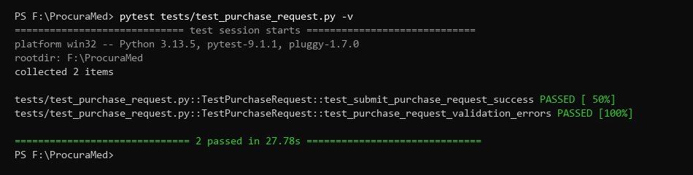
Figure 1 : Purchase Request Submission Test successfully (Pytest Results)
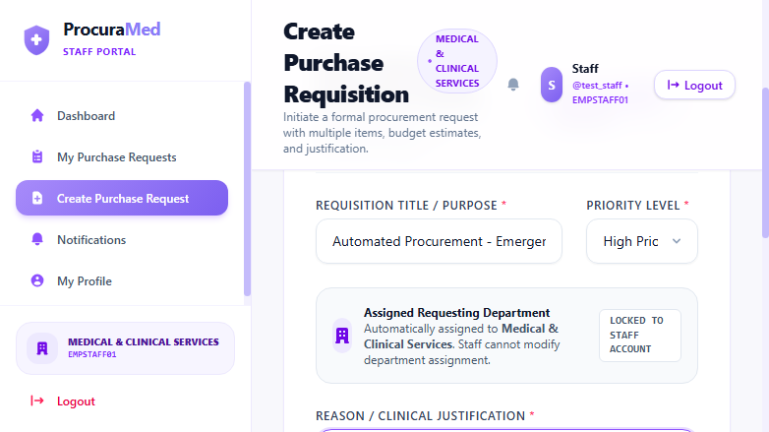
Figure 2 : Step 1 - General Requisition Details Entered

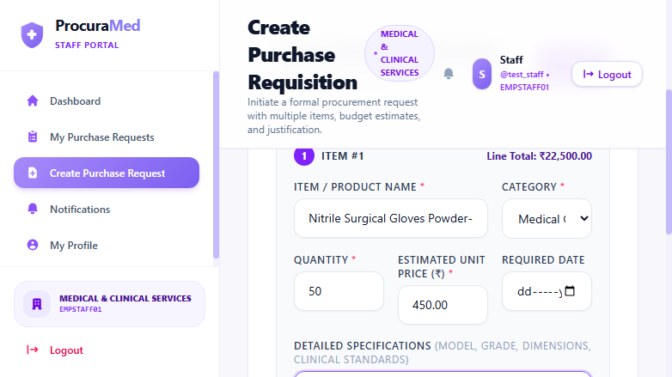
Figure 3 : Step 2 - Item Specifications and Budget Details Entered
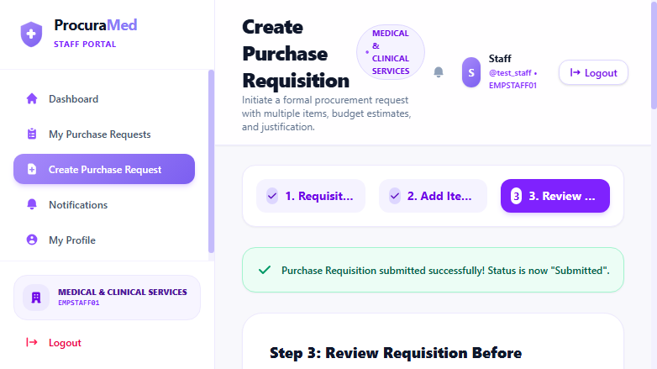
Figure 4 : Step 3 - Requisition Submission Confirmation Notification

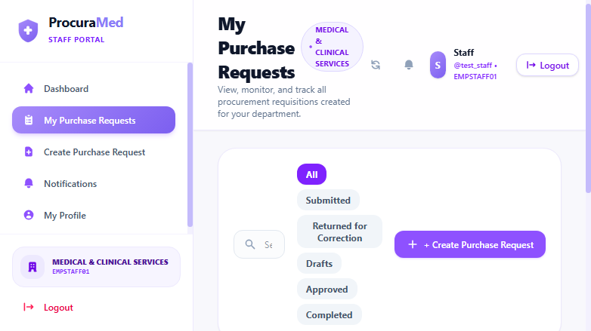
Figure 5 : Verified Requisition Entry with Status 'Submitted' in My Requisitions List
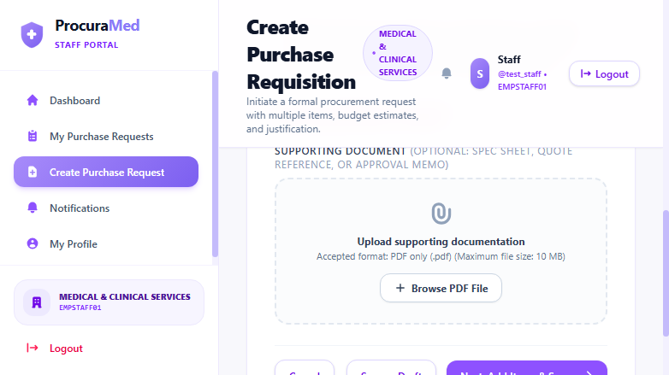
Figure 6 : Required Form Field Validation Alerts

Test Report
Test Case 2
Project Name: ProcuraMed
Purchase Request Submission Test Case
Test Case ID: Test_2 |  |  | Test Designed By: QA Automation Engineer
Test Priority(Low/Medium/High): High |  |  | Test Designed Date: 22/10/2026
Module Name: Purchase Requisition |  |  | Test Executed By : QA Automation Engineer
Test Title : verify creation and submission of purchase request with valid item specifications. |  |  | Test Execution Date: 22/10/2026
Description: User has valid requester credentials and enters complete item specifications for procurement.
Pre-Condition :Authorized Department Staff user is logged into ProcuraMed portal
Step | Test Step | Test Data | Expected Result | Actual Result | Status(Pass/Fail)
1 | Navigate to Create Purchase Requisition page | N/A | Display Create Purchase Requisition form | Create Purchase Requisition form displayed | pass
2 | Enter general requisition details | Title: Automated Procurement...  Priority: HIGH  Justification: Emergency stock... | Requisition details accepted; proceed to item specifications | Requisition details accepted; proceed to item specifications | pass
3 | Enter item specifications | Item: Nitrile Surgical Gloves  Category: Medical Consumables  Qty: 50, Unit Price: 450.00 | Item details added to requisition list | Item details added to requisition list | pass
4 | Review requisition and click submit button | N/A | Purchase requisition submitted successfully; confirmation message displayed and listed under My Requisitions | Purchase Requisition submitted successfully! Status is now "Submitted"; listed under My Requisitions | pass
Post-Condition: Requisition record is saved in database with status 'SUBMITTED' and assigned unique requisition tracking number.

Test Report – Negative Test Cases
Test Case 2.1: Required Field Validation
Project Name: ProcuraMed
Purchase Request Field Validation Test Cases
Test Case ID: Test_2_Neg |  |  | Test Designed By: QA Automation Engineer
Test Priority(Low/Medium/High): Medium |  |  | Test Designed Date: 22/10/2026
Module Name: Purchase Requisition |  |  | Test Executed By : QA Automation Engineer
Test Title : verify validation error messages when mandatory fields are omitted. |  |  | Test Execution Date: 22/10/2026
Description: Verify form validation prevents submission when required title and clinical justification fields are omitted.
Pre-Condition :User is on the ProcuraMed Create Purchase Requisition page
Step | Test Step | Test Data | Expected Result | Actual Result | Status(Pass/Fail)
1 | Navigate to Create Purchase Requisition page | N/A | Display Create Purchase Requisition form | Form loaded successfully | pass
2 | Attempt proceeding with blank Title and Justification fields | Title: [Empty]  Justification: [Empty] | Validation error messages displayed: 'Requisition title / purpose is required.' and 'Reason and justification are required.' | Validation errors displayed correctly; navigation to Step 2 blocked | pass
Post-Condition: Form submission is blocked; no invalid requisition is committed to database.

