ProcuraMed
Example:
Test Case 1: Login Test
Code
import os
import pathlib
import pytest
from selenium import webdriver
from selenium.webdriver.common.by import By
from selenium.webdriver.support.ui import WebDriverWait
from selenium.webdriver.support import expected_conditions as EC
from selenium.webdriver.chrome.options import Options
# Paths and configuration
BASE_DIR = pathlib.Path(__file__).resolve().parent.parent
SCREENSHOT_DIR = BASE_DIR / "test-results" / "screenshots"
SCREENSHOT_DIR.mkdir(parents=True, exist_ok=True)
# Test Configuration - configurable via environment variables
BASE_URL = os.environ.get("BASE_URL", "http://localhost:3000")
LOGIN_URL = f"{BASE_URL}/login"
TEST_USERNAME = os.environ.get("TEST_USERNAME", "test_admin")
TEST_PASSWORD = os.environ.get("TEST_PASSWORD", "TestAdmin@2026")
HEADLESS_MODE = os.environ.get("HEADLESS", "true").lower() in ("true", "1", "yes")
class TestLogin:
"""
Test Case 1: ProcuraMed User Login Automation Test Suite
Covers both positive authentication and negative validation scenarios.
"""
def setup_method(self, method):
"""Setup Chrome WebDriver before each test execution."""
options = Options()
if HEADLESS_MODE:
options.add_argument("--headless=new")
options.add_argument("--window-size=1920,1080")
options.add_argument("--no-sandbox")
options.add_argument("--disable-dev-shm-usage")
options.add_argument("--disable-gpu")
options.add_argument("--ignore-certificate-errors")
self.driver = webdriver.Chrome(options=options)
self.driver.maximize_window()
self.wait = WebDriverWait(self.driver, 12)
def teardown_method(self, method):
"""Tear down and close the WebDriver session after each test."""
if hasattr(self, "driver") and self.driver:
self.driver.quit()
def click_button(self, element):
"""Helper to reliably click button across animation frames."""
self.driver.execute_script("arguments[0].scrollIntoView({block: 'center'});", element)
try:
element.click()
except Exception:
self.driver.execute_script("arguments[0].click();", element)
def test_valid_user_login(self):
"""
Test Step: Navigate to login page, enter valid username & password,
submit form, and verify successful redirection to Admin Dashboard.
"""
driver = self.driver
wait = self.wait
# Step 1: Navigate to the login page
driver.get(LOGIN_URL)
username_field = wait.until(EC.visibility_of_element_located((By.NAME, "username")))
driver.save_screenshot(str(SCREENSHOT_DIR / "step1_login_page_displayed.png"))
assert "Sign In to ProcuraMed" in driver.page_source, "Login page failed to load"
# Step 2: Enter valid username
username_field.clear()
username_field.send_keys(TEST_USERNAME)
# Step 3: Enter valid password
password_field = wait.until(EC.visibility_of_element_located((By.NAME, "password")))
password_field.clear()
password_field.send_keys(TEST_PASSWORD)
driver.save_screenshot(str(SCREENSHOT_DIR / "step2_credentials_entered.png"))
# Step 4: Click on login button
login_btn = wait.until(EC.element_to_be_clickable((By.CSS_SELECTOR, "button[type='submit']")))
self.click_button(login_btn)
# Step 5: Verify successful login and landing on Admin Dashboard
wait.until(EC.url_contains("/admin/dashboard"))
dashboard_heading = wait.until(
EC.visibility_of_element_located((By.XPATH, "//h1[contains(text(), 'System Administrator Dashboard')]"))
)
driver.save_screenshot(str(SCREENSHOT_DIR / "step3_admin_dashboard_success.png"))
assert "/admin/dashboard" in driver.current_url, f"Expected dashboard URL, got: {driver.current_url}"
assert dashboard_heading.is_displayed(), "System Administrator Dashboard heading not visible"
def test_invalid_password_error(self):
"""
Negative Test: Attempt login with valid username but incorrect password.
Verify that an appropriate error alert message is displayed.
"""
driver = self.driver
wait = self.wait
driver.get(LOGIN_URL)
username_field = wait.until(EC.visibility_of_element_located((By.NAME, "username")))
username_field.clear()
username_field.send_keys(TEST_USERNAME)
password_field = wait.until(EC.visibility_of_element_located((By.NAME, "password")))
password_field.clear()
password_field.send_keys("WrongPassword@999")
login_btn = wait.until(EC.element_to_be_clickable((By.CSS_SELECTOR, "button[type='submit']")))
self.click_button(login_btn)
# Verify error alert appearance
error_alert = wait.until(
EC.visibility_of_element_located((By.CSS_SELECTOR, "div.bg-rose-50"))
)
driver.save_screenshot(str(SCREENSHOT_DIR / "step4_invalid_password_error.png"))
assert "Incorrect password. Please try again." in error_alert.text, (
f"Expected password error message, found: {error_alert.text}"
)
def test_nonexistent_user_error(self):
"""
Negative Test: Attempt login with a non-existent username.
Verify that 'No account found with the given username.' is displayed.
"""
driver = self.driver
wait = self.wait
driver.get(LOGIN_URL)
username_field = wait.until(EC.visibility_of_element_located((By.NAME, "username")))
username_field.clear()
username_field.send_keys("unknown_user_9999")
password_field = wait.until(EC.visibility_of_element_located((By.NAME, "password")))
password_field.clear()
password_field.send_keys("RandomPass@123")
login_btn = wait.until(EC.element_to_be_clickable((By.CSS_SELECTOR, "button[type='submit']")))
self.click_button(login_btn)
error_alert = wait.until(
EC.visibility_of_element_located((By.CSS_SELECTOR, "div.bg-rose-50"))
)
driver.save_screenshot(str(SCREENSHOT_DIR / "step5_nonexistent_user_error.png"))
assert "No account found with the given username." in error_alert.text, (
f"Expected user not found error message, found: {error_alert.text}"
)

Screenshot
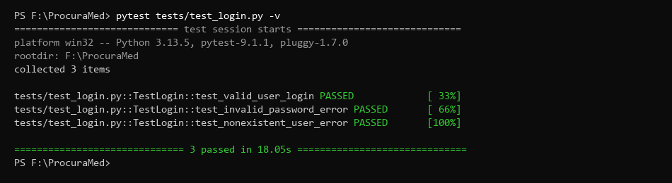
Figure 1 : Login Test successfully (Pytest Execution Results)
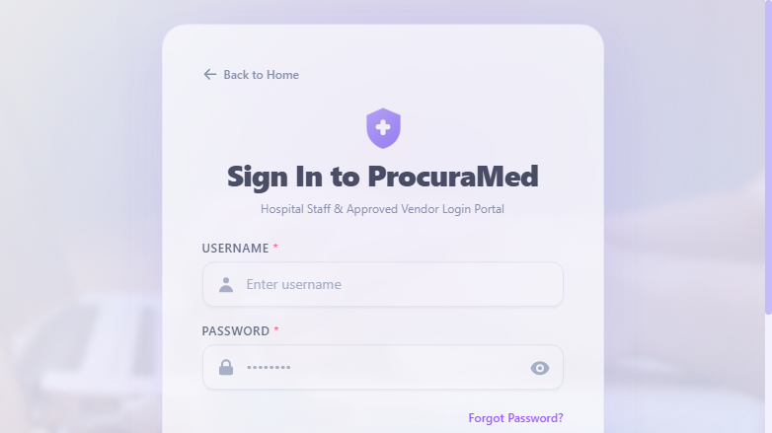
Figure 2 : ProcuraMed Login Page
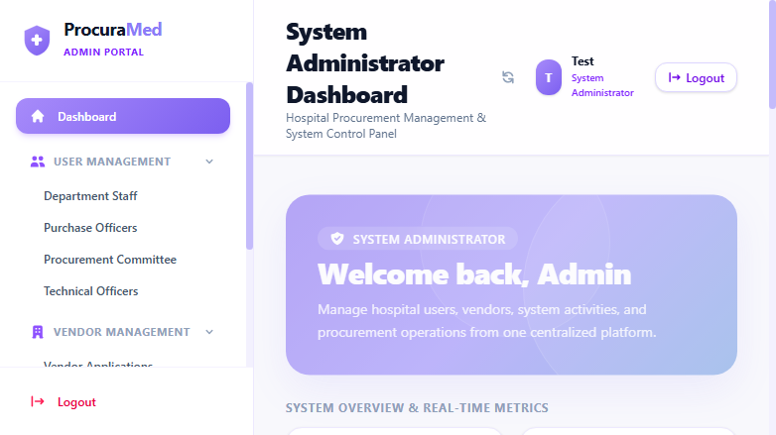
Figure 3 : System Administrator Dashboard after Successful Login
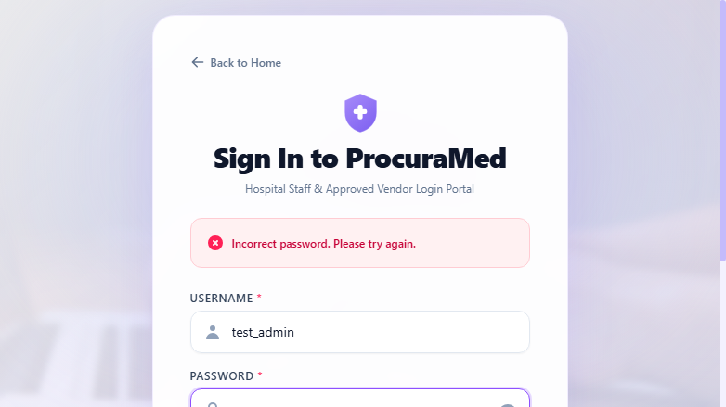
Figure 4 : Login Validation Error Message on Invalid Password

Test Report
Test Case 1
Project Name: ProcuraMed
Login Test Case
Test Case ID: Test_1 |  |  | Test Designed By: QA Automation Engineer
Test Priority(Low/Medium/High): High |  |  | Test Designed Date: 21/10/2026
Module Name: Login page |  |  | Test Executed By : QA Automation Engineer
Test Title : verify login with valid username and password. |  |  | Test Execution Date: 21/10/2026
Description: User has valid username and password.
Pre-Condition :User has valid username and password
Step | Test Step | Test Data | Expected Result | Actual Result | Status(Pass/Fail)
1 | Navigate to the login page |  | Display login page | Login page displayed | pass
2 | Valid username entered | Username: test_admin | Admin should enter the main page | Admin entered to the main page | pass
3 | Valid password entered | Password: [Configured via ENV]
4 | Click on login button
Post-Condition: Username and password is checked with database values for successful login

Test Report – Negative Test Cases
Test Case 1.1: Invalid Password & Non-Existent User Tests
Project Name: ProcuraMed
Login Negative Validation Test Cases
Test Case ID: Test_1_Neg |  |  | Test Designed By: QA Automation Engineer
Test Priority(Low/Medium/High): Medium |  |  | Test Designed Date: 21/10/2026
Module Name: Login page |  |  | Test Executed By : QA Automation Engineer
Test Title : verify login with invalid credentials displays error message. |  |  | Test Execution Date: 21/10/2026
Description: Verify system security checks and proper error banner presentation on invalid credentials.
Pre-Condition :User is on the ProcuraMed portal login page
Step | Test Step | Test Data | Expected Result | Actual Result | Status(Pass/Fail)
1 | Valid username with incorrect password entered | Username: test_admin  Password: WrongPassword@999 | Display error: 'Incorrect password. Please try again.' | Error alert displayed: 'Incorrect password. Please try again.' | pass
2 | Unregistered username entered | Username: unknown_user_9999  Password: RandomPass@123 | Display error: 'No account found with the given username.' | Error alert displayed: 'No account found with the given username.' | pass
Post-Condition: System rejects unauthenticated access; no JWT token is generated.

