ProcuraMed
Example:
Test Case 5: Vendor Registration / Application Test
Code
import os
import sys
import pathlib
import time
import pytest
from reportlab.pdfgen import canvas
from selenium import webdriver
from selenium.webdriver.common.by import By
from selenium.webdriver.support.ui import WebDriverWait
from selenium.webdriver.support import expected_conditions as EC
from selenium.webdriver.chrome.options import Options
# Paths and configuration
BASE_DIR = pathlib.Path(__file__).resolve().parent.parent
if str(BASE_DIR) not in sys.path:
sys.path.insert(0, str(BASE_DIR))
SCREENSHOT_DIR = BASE_DIR / "test-results" / "screenshots"
SCREENSHOT_DIR.mkdir(parents=True, exist_ok=True)
BASE_URL = os.environ.get("BASE_URL", "http://localhost:3000")
REGISTER_URL = f"{BASE_URL}/vendor-register"
HEADLESS_MODE = os.environ.get("HEADLESS", "true").lower() in ("true", "1", "yes")
# Ensure valid sample certificate PDF exists for upload testing
CERT_PATH = BASE_DIR / "test-results" / "sample_vendor_license.pdf"
def ensure_sample_certificate():
"""Generate a valid PDF certificate if not present for file upload verification."""
CERT_PATH.parent.mkdir(parents=True, exist_ok=True)
if not CERT_PATH.exists():
c = canvas.Canvas(str(CERT_PATH))
c.drawString(100, 750, "GOVERNMENT OF HEALTH & FAMILY WELFARE")
c.drawString(100, 730, "Medical Device Manufacturer & Wholesale License")
c.drawString(100, 700, "License No: MD-LIC-2026-98745")
c.drawString(100, 680, "Entity: Apex LifeCare Solutions Pvt Ltd")
c.drawString(100, 660, "Validity: 2026 - 2031")
c.drawString(100, 640, "Certified for Hospital Procurement Supply.")
c.save()
return CERT_PATH
class TestVendorRegistration:
"""
Test Case 5: Vendor Registration / Application Test Suite
Validates the vendor supplier registration workflow:
- Required field validation when mandatory information is omitted
- Successful submission with valid vendor company information, supplier categories,
products description, and valid business license certificate PDF
- Verification of confirmation screen, pending approval status, and database record
"""
@classmethod
def setup_class(cls):
"""Ensure sample test certificate PDF is available."""
cls.cert_file = ensure_sample_certificate()
# Initialize Django settings for database verification
import django
os.environ.setdefault('DJANGO_SETTINGS_MODULE', 'backend.settings')
django.setup()
def setup_method(self, method):
"""Setup Chrome WebDriver before each test execution."""
options = Options()
if HEADLESS_MODE:
options.add_argument("--headless=new")
options.add_argument("--window-size=1920,1080")
options.add_argument("--no-sandbox")
options.add_argument("--disable-dev-shm-usage")
options.add_argument("--disable-gpu")
options.add_argument("--ignore-certificate-errors")
self.driver = webdriver.Chrome(options=options)
self.driver.maximize_window()
self.wait = WebDriverWait(self.driver, 12)
def teardown_method(self, method):
"""Tear down and close the WebDriver session after each test."""
if hasattr(self, "driver") and self.driver:
self.driver.quit()
def click_element(self, element):
"""Helper to reliably scroll and click element across animations."""
self.driver.execute_script("arguments[0].scrollIntoView({block: 'center'});", element)
try:
element.click()
except Exception:
self.driver.execute_script("arguments[0].click();", element)
def test_vendor_registration_missing_fields_validation(self):
"""
Negative Test: Submit vendor registration form without entering required fields.
Verify that appropriate validation error messages appear for all mandatory fields:
Company Name, Contact Person, Business Email, Phone, Address, Categories, and Products.
"""
driver = self.driver
wait = self.wait
driver.get(REGISTER_URL)
wait.until(EC.visibility_of_element_located((By.XPATH, "//h1[contains(., 'Vendor Supplier Application')]")))
# Click Submit Application without entering any data
submit_btn = wait.until(
EC.presence_of_element_located((By.XPATH, "//button[@type='submit' and contains(., 'Submit Application')]"))
)
self.click_element(submit_btn)
# Verify validation error messages
company_err = wait.until(
EC.visibility_of_element_located((By.XPATH, "//*[contains(text(), 'Company name is required')]"))
)
email_err = wait.until(
EC.visibility_of_element_located((By.XPATH, "//*[contains(text(), 'Business Email is required')]"))
)
cat_err = wait.until(
EC.visibility_of_element_located((By.XPATH, "//*[contains(text(), 'At least one supplier category must be selected')]"))
)
driver.save_screenshot(str(SCREENSHOT_DIR / "tc5_validation_errors.png"))
assert "Company name is required" in company_err.text, f"Unexpected error: {company_err.text}"
assert "Business Email is required" in email_err.text, f"Unexpected error: {email_err.text}"
assert "At least one supplier category must be selected" in cat_err.text, f"Unexpected error: {cat_err.text}"
def test_vendor_registration_success(self):
"""
Positive Test: Complete vendor registration application with valid dummy data.
Verify:
1. Form opens successfully at /vendor-register.
2. Enter valid Company Information (Company Name, Contact Person, Email, Phone, Address).
3. Select Supplier Categories (Biomedical Equipment).
4. Enter Products/Services description.
5. Upload Business License / Registration Certificate PDF.
6. Submit application and verify confirmation screen ('Application Submitted Successfully!').
7. Verify company details and status badge 'Pending Admin Approval'.
8. Verify database persistence with status 'PENDING'.
"""
driver = self.driver
wait = self.wait
# Step 1: Navigate to Vendor Registration page
driver.get(REGISTER_URL)
heading = wait.until(EC.visibility_of_element_located((By.XPATH, "//h1[contains(., 'Vendor Supplier Application')]")))
assert heading.is_displayed(), "Registration heading not visible"
driver.save_screenshot(str(SCREENSHOT_DIR / "tc5_step1_registration_page_loaded.png"))
# Prepare unique test vendor data
timestamp = int(time.time())
unique_company = f"Apex LifeCare Solutions {timestamp}"
unique_email = f"apexlifecare.{timestamp}@gmail.com"
contact_person = "Rajesh Sharma"
phone_number = "9876543210"
address_text = "Plot 42, Healthcare Technology Park, Whitefield, Bengaluru, Karnataka 560066"
products_desc = (
"Supplier of high-precision diagnostic and biomedical monitoring equipment, "
"ICU life-support sensors, and hospital calibration apparatus."
)
# Step 2: Enter Company Information
company_input = wait.until(EC.visibility_of_element_located((By.NAME, "company_name")))
company_input.clear()
company_input.send_keys(unique_company)
contact_input = driver.find_element(By.NAME, "contact_person")
contact_input.clear()
contact_input.send_keys(contact_person)
email_input = driver.find_element(By.NAME, "email")
email_input.clear()
email_input.send_keys(unique_email)
phone_input = driver.find_element(By.NAME, "phone")
phone_input.clear()
phone_input.send_keys(phone_number)
address_input = driver.find_element(By.NAME, "address")
address_input.clear()
address_input.send_keys(address_text)
driver.save_screenshot(str(SCREENSHOT_DIR / "tc5_step2_company_info_entered.png"))
# Step 3: Select Supplier Category (Biomedical Equipment)
biomed_cb = wait.until(
EC.presence_of_element_located((By.XPATH, "//label[contains(., 'Biomedical Equipment')]//input[@type='checkbox']"))
)
driver.execute_script("arguments[0].scrollIntoView({block: 'center'});", biomed_cb)
driver.execute_script("arguments[0].click();", biomed_cb)
assert biomed_cb.is_selected(), "Biomedical Equipment checkbox was not selected"
driver.save_screenshot(str(SCREENSHOT_DIR / "tc5_step3_categories_selected.png"))
# Step 4: Enter Products/Services description and Upload Certificate PDF
products_input = driver.find_element(By.NAME, "products_services_offered")
products_input.clear()
products_input.send_keys(products_desc)
file_input = driver.find_element(By.CSS_SELECTOR, "input[type='file']")
file_input.send_keys(str(self.cert_file.resolve()))
time.sleep(1)
driver.save_screenshot(str(SCREENSHOT_DIR / "tc5_step4_products_and_certificate_uploaded.png"))
# Step 5: Submit Application
submit_btn = wait.until(
EC.presence_of_element_located((By.XPATH, "//button[@type='submit' and contains(., 'Submit Application')]"))
)
self.click_element(submit_btn)
# Step 6: Verify Confirmation Screen
success_heading = wait.until(
EC.visibility_of_element_located((By.XPATH, "//h2[contains(., 'Application Submitted Successfully!')]"))
)
assert success_heading.is_displayed(), "Success heading not displayed"
status_badge = wait.until(
EC.visibility_of_element_located((By.XPATH, "//*[contains(text(), 'Pending Admin Approval')]"))
)
assert status_badge.is_displayed(), "Status badge not displayed"
comp_display = driver.find_element(By.XPATH, f"//*[contains(text(), '{unique_company}')]")
assert comp_display.is_displayed(), "Company name not displayed on success card"
driver.save_screenshot(str(SCREENSHOT_DIR / "tc5_step5_application_submitted_confirmation.png"))
# Step 7: Verify Database Persistence
from vendors.models import VendorApplication
app_record = VendorApplication.objects.filter(email=unique_email).first()
assert app_record is not None, f"VendorApplication record not found for {unique_email}"
assert app_record.company_name == unique_company, f"Expected {unique_company}, got {app_record.company_name}"
assert app_record.status == "PENDING", f"Expected PENDING status, got {app_record.status}"
assert app_record.phone == phone_number

Screenshot
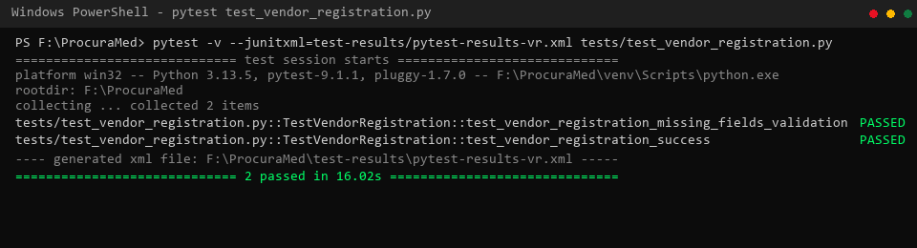
Figure 1 : Vendor Registration/Application Test successfully (Pytest Execution Results)
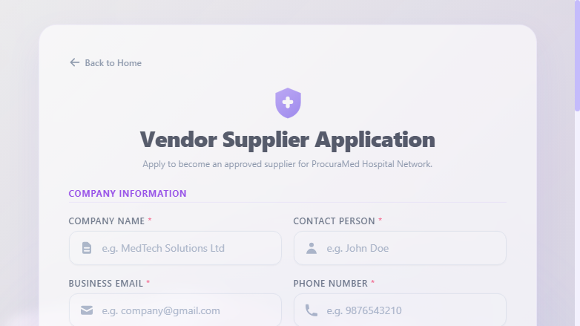
Figure 2 : Vendor Supplier Application Registration Page Loaded

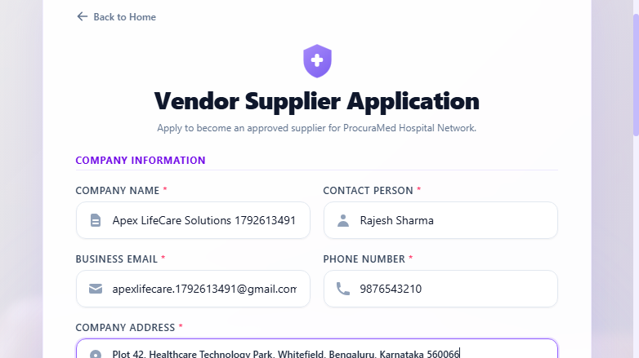
Figure 3 : Company Information Details Entered (Company Name, Contact Person, Email, Phone, Address)
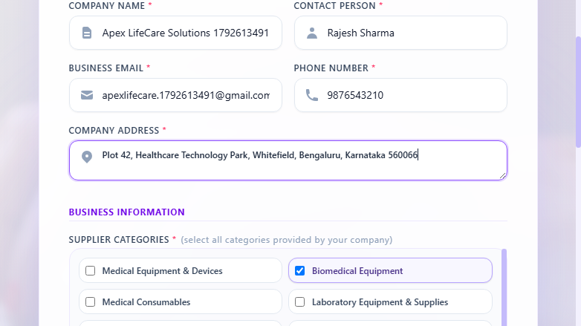
Figure 4 : Supplier Categories Selected (Biomedical Equipment)

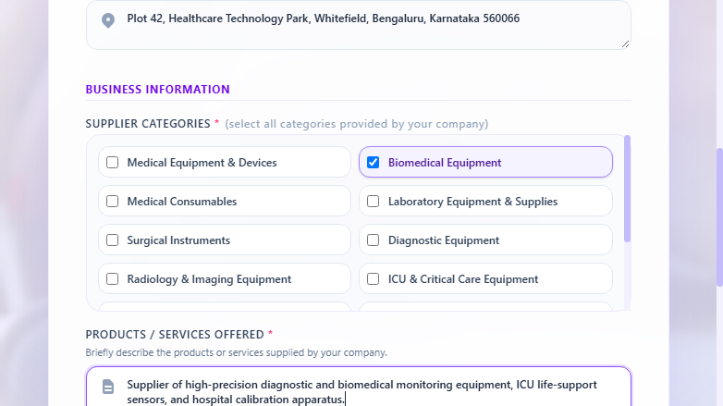
Figure 5 : Products/Services Offered Description Entered and Business License PDF Certificate Uploaded
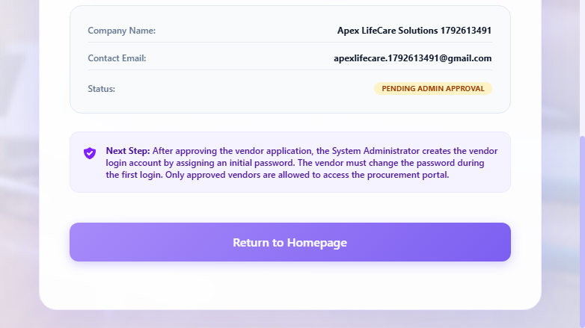
Figure 6 : Vendor Application Submitted Successfully with Status 'Pending Admin Approval'

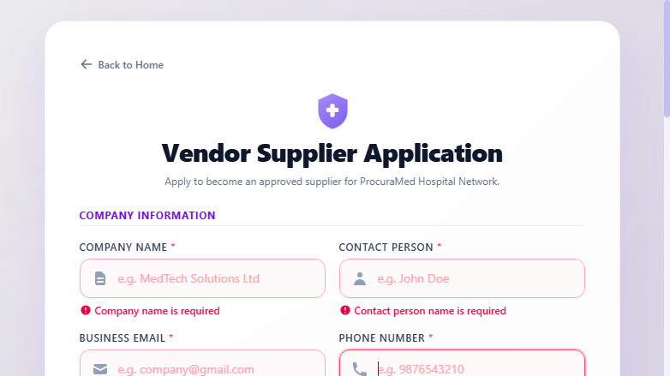
Figure 7 : Required Form Field Validation Alerts when Mandatory Information is Omitted

Test Report
Test Case 5
Project Name: ProcuraMed
Vendor Registration / Application Test Case
Test Case ID: Test_5 |  |  | Test Designed By: QA Automation Engineer
Test Priority(Low/Medium/High): High |  |  | Test Designed Date: 22/10/2026
Module Name: Vendor Management |  |  | Test Executed By : QA Automation Engineer
Test Title : verify vendor supplier registration application submission with valid company details and business certificate. |  |  | Test Execution Date: 22/10/2026
Description: Prospective healthcare vendor accesses registration portal, enters company and contact details, selects eligible supplier categories, provides products/services scope, uploads valid registration certificate PDF, and submits application for administrator review.
Pre-Condition : Vendor Registration portal (/vendor-register) is online and accessible without requiring active login session.
Step | Test Step | Test Data | Expected Result | Actual Result | Status(Pass/Fail)
1 | Navigate to Vendor Registration page | URL: /vendor-register | Display Vendor Supplier Application form with company and business info sections | Vendor Supplier Application page loaded successfully | pass
2 | Enter valid Company Information | Company: Apex LifeCare Solutions  Contact: Rajesh Sharma  Email: apexlifecare@gmail.com  Phone: 9876543210  Address: Plot 42, Tech Park, Bengaluru | Company details accepted without validation errors | Company details accepted without validation errors | pass
3 | Select applicable Supplier Categories | Category: Biomedical Equipment | Category selected; checkbox checked with visual styling | Category selected; checkbox checked with visual styling | pass
4 | Enter Products/Services description and upload valid certificate PDF | Description: Supplier of diagnostic & biomedical devices  File: sample_vendor_license.pdf | Products description accepted and valid PDF file attached | Products description accepted and valid PDF file attached | pass
5 | Click Submit Application for Approval button | N/A | Application submitted to backend API; confirmation view displayed | Form submitted successfully via multipart request | pass
6 | Verify confirmation screen, company details, and pending approval status | N/A | Display 'Application Submitted Successfully!' banner, company details, and status 'Pending Admin Approval' | Confirmation screen displayed with status 'Pending Admin Approval' and company information | pass
Post-Condition: Vendor application record saved in database with status 'PENDING', uploaded certificate stored, and application queued for System Administrator review and approval.

Test Report – Negative Test Cases
Test Case 5.1: Required Fields Validation
Project Name: ProcuraMed
Vendor Registration Field Validation Test Cases
Test Case ID: Test_5_Neg |  |  | Test Designed By: QA Automation Engineer
Test Priority(Low/Medium/High): Medium |  |  | Test Designed Date: 22/10/2026
Module Name: Vendor Management |  |  | Test Executed By : QA Automation Engineer
Test Title : verify form validation error alerts when mandatory registration fields are omitted. |  |  | Test Execution Date: 22/10/2026
Description: Verify registration form prevents blank submission and presents field validation error messages when mandatory company details, categories, or certificate are omitted.
Pre-Condition : User is on the ProcuraMed Vendor Supplier Application page (/vendor-register).
Step | Test Step | Test Data | Expected Result | Actual Result | Status(Pass/Fail)
1 | Navigate to Vendor Registration page | URL: /vendor-register | Display Vendor Supplier Application form with empty inputs | Registration form loaded with clean inputs | pass
2 | Attempt submitting application without entering any mandatory data | All Fields: [Blank] | Validation error messages displayed: 'Company name is required', 'Business Email is required', 'At least one supplier category must be selected' | Validation error messages displayed correctly; submission blocked | pass
Post-Condition: Application submission is blocked; no incomplete vendor record is committed to database.

