Fiona Barnett

Brother Clements

CSE 170

17 October 2022

HEALTH

Health is the current state of your overall wellbeing. This means how well you are mentally and physically. Good health means you are productive and actively work on these areas. Bad health means these areas of your life are neglected.

Rating -- ½

WORK

Work is something you get done to achieve something in the end. Whether it’s a career to support your family, parenting to raise your kids right, cooking to feed the family. It essentially involves action and effort in order to get the intended goal met and achieved.

Rating -- ¼

PLAY

Play is what brings joy. Spending time with family, going on vacation, skiing, or anything that I do without the intent of getting something done that needs to be done. It is a great change of scenery and keeps your mind at rest. If you lack any play in your life, you will be depressed and overworked.

Rating -- ½

LOVE

Love is commitment. It’s for those that are closest to me like my family. With love I have a sense of belonging and importance to those in my life and vice versa. My love is more than just those closest to me, however. It stretches to my friends, roommates, ward members, or those in need. Anything I feel I am committed to and cherish deeply, even talents, is what love is to me.

Rating – FULL

WORK VIEW

Work is my ability to get something done and efficiently. It is important for income to support oneself; however, it is much more than just for the money. If we work for only money most of our life would be spent when we are not happy. Work is something that you enjoy exceling in and have a desire to grow more in. That’s why it is so important you choose your work to be something that pays well but something you can also enjoy. Work often gives one a sense of purpose; it helps us set goals and push ourselves and from it we can acquire new skills. To someone else, your work might seem like a waste of time which is why work is unique for everyone. If we were all interested in the same thing there would be less productivity globally speaking. Work is a motivator that can not only challenge but also reward you with future opportunities and money to support yourself and your family. It is vital, and many also forget how vital it also is to enjoy it too.

LIFEVIEW

For me, my beliefs, morals, and values are held very close to me. The gospel, my family, my passions, and understanding my worth are always what I find most important. When something in my life conflicts with what I stand for, I must defend what I know and leave the situation or see if others can respect who I am. It is not easy, and it will never be easy to stand up what you now to be true and who you are. I keep the gospel my family closest and never let things of the world separate myself from it. For me, good is what brings pure joy; not the temporary instant gratification you get from worldly temptations. Good is following Christ’s gospel and actively living and striving to be the best version of yourself by looking to the atonement. I think that my values are spiritually strengthening and complements each other. Family and church go hand in hand in my life and it doesn’t contradict my other standards and values.

WORKVIEW & LIFEVIEW

Work and life complement each other when we feel pure joy and the Holy Ghost wherever we go. I feel that when you notice your surroundings are absent of the spirit, that is when something is not right. I should be able to comfortably be at home and go to work as who I am and not try to had and change anything I know myself to be. My workplace, through not as comforting as a home naturally, should still be a place where I feel accepted and appreciated. Work and life can clash when we feel we have to prioritize one over the other at times and feel like both are fighting for attention in your life. Both however, when working together smoothly should motivate you in a positive way where you feel a need to be a better version of yourself every day.

GOOD TIME JOURNAL

What was the engagement and energy

1. Ate some fruit; from the fridge, during lunch, informal (happened randomly)
   1. Low engagement
   2. High energy
2. Watched a show with roommates, in apartment, food, dark night, cozy, informal
   1. High engagement
   2. High energy
3. Worked ahead in my classes; formal, in apartment, alone, on computer
   1. High engagement
   2. Low energy
4. Talked with family over the phone; informal, while walking campus, cell phone
   1. High engagement
   2. High energy
5. Ate dinner at the bishop’s; formal, cozy, Idaho Falls, casually structured
   1. High engagement
   2. Low energy
6. Went on a long drive; informal, nighttime, from Rexburg to IF, roommate in car
   1. High engagement
   2. Low energy
7. Scored perfect on a test; informal, in apartment, quiet, focused
   1. High engagement
   2. High energy
8. Binged on Netflix; informal, on my bed, late at night, on my computer
   1. Low engagement
   2. High energy
9. Talked to roommate; informal, in the living area of apartment, positive
   1. High engagement
   2. High energy
10. Did the dishes; in the kitchen, by myself, hot water
    1. Low engagement
    2. Low energy

JOURNAL REFLECTIONS

I was surprised to find how much energy I get spending time with my room mates versus going to my FHE activity for the week at the bishop’s house. Usually, I am not too energized in group or social situations, but I have grown comfortable around my room mates and enjoy talking to them.

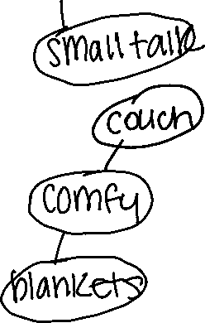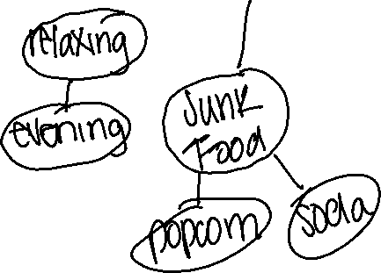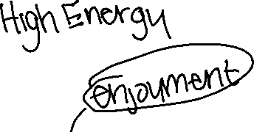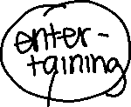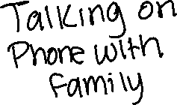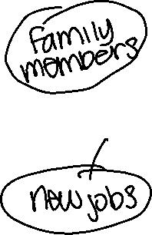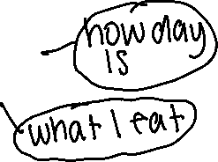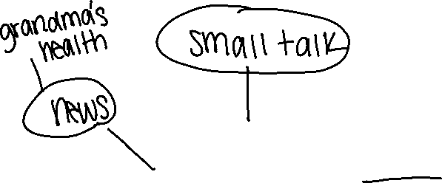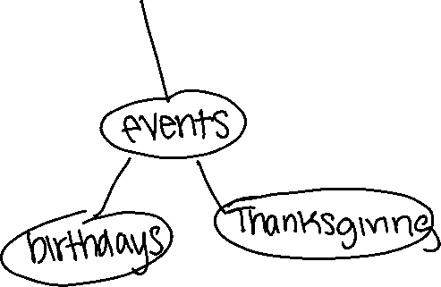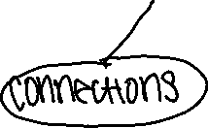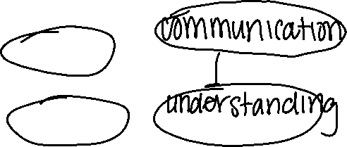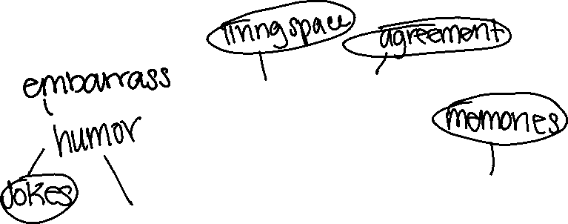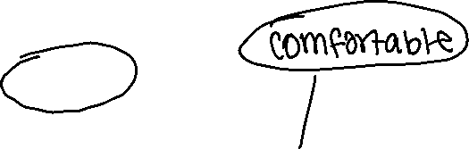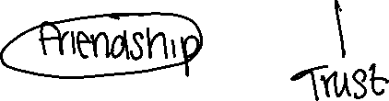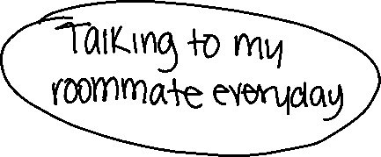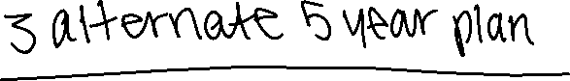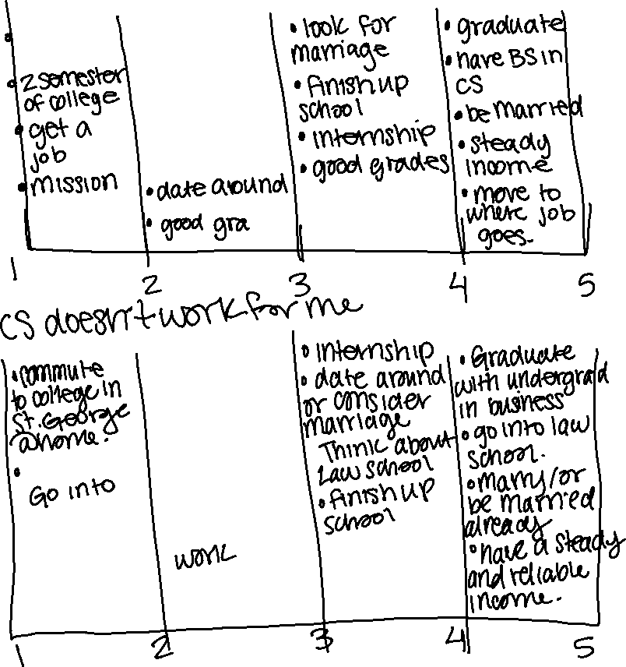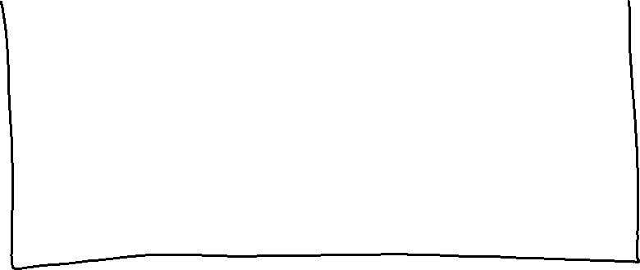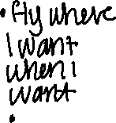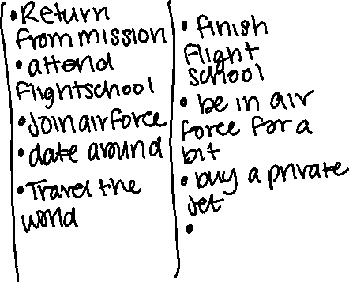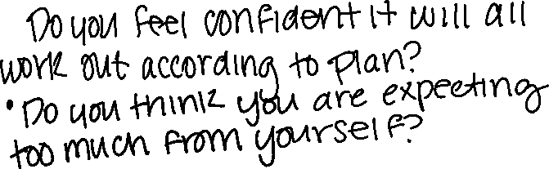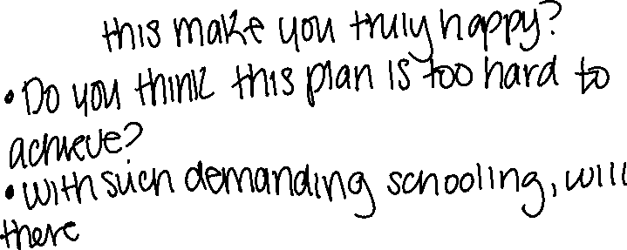

Gauge Each Plan

Plan 1: 90%

* Resources: time, money, devotion, computer
* Likeability: hot, excited
* Confidence: certain
* Coherence: work match life views

Plan 2: 70%

* Resources: time, money, devotion
* Likeability: cold, apathetic
* Confidence: uncertain
* Coherence: work doesn’t match life views

Plan 3: 60%

* Resources: money, time, motivation, commitment
* Likeability: hot, excited
* Confidence: uncertain yet content
* Coherence: work matches life views