#include <iostream>

#include <string>

#include <fstream>

using namespace std;

void main() {

ifstream ifile;

ifile.open("mhs.txt");

string Nim,Nama,Nim1;

int Donasi,No=1,Total;

cout << "Laporan Donasi Liga Merah Maroon\n";

cout << "-------------------------------------------\n";

cout << "No.\tNim\t\tNama\tDonasi\n";

cout << "-------------------------------------------\n";

ifile >> Nim >> Nama >> Donasi;

Nim1=Nim;

Total=Donasi;

while (ifile) {

cout << No << "\t" << Nim << "\t" << Nama << "\t" << Donasi << "\n";

ifile >> Nim >> Nama >> Donasi;

if(Nim1!=Nim|| ifile.eof()) {

cout << "Total donasi Sebesar........"<< Total << "\n\n";

Nim1=Nim;

Total=0;

};

No++;

Total = Total + Donasi;

}; cout << "-------------------------------------------\n";

ifile.close();

cout << "\n\n";

system("pause");

}

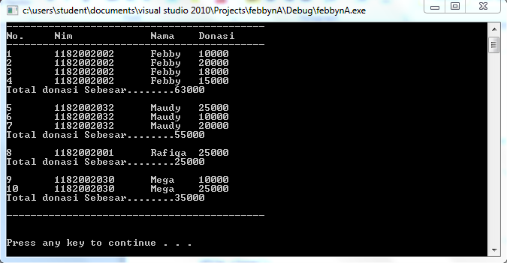

Kesimpulan :