**Nama : Febby Novanti Azhara**

**NIM : 1182002002**

**Tugas Pemrograman Berorientasi Objek – Penggunaan GUI pada Java untuk Membuat Form Pendaftaran**

**Form :**

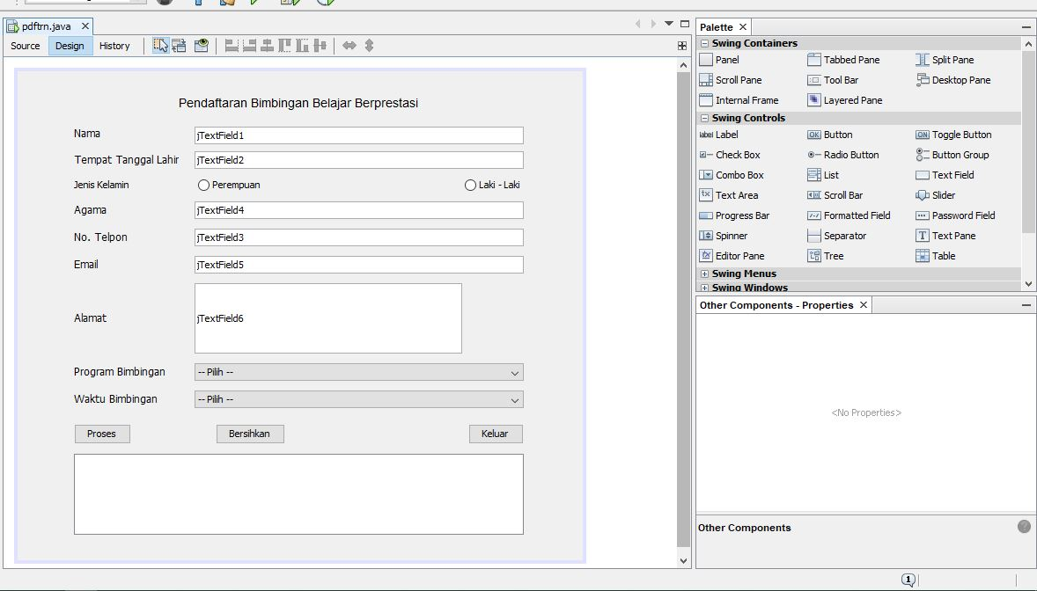

Nama = txtnama

Tempat Tanggal Lahir = txtTTL

Jenis kelamin (Perempuan) = jRadioButtonPR

Jenis kelamin (Laki - Laki) = jRadioButtonLK

Agama = txtagama

No telpon = txtNOP

Email = txtemail

Alamat = txtalamat

Program Bimbingan = jComboBoxprog

Waktu Bimbingan = jComboBoxWaktu

Proses = jButtonProses

Bersihkan = jButtonBersihkan

Keluar = jButtonKeluar

**Kode :**

/*

* To change this license header, choose License Headers in Project Properties.

* To change this template file, choose Tools | Templates

* and open the template in the editor.

*/

/**

*

* @author user

*/

public class pdftrn extends javax.swing.JFrame {

/**

* Creates new form pdftrn

*/

public pdftrn() {

initComponents();

}

/**

* This method is called from within the constructor to initialize the form.

* WARNING: Do NOT modify this code. The content of this method is always

* regenerated by the Form Editor.

*/

@SuppressWarnings("unchecked")

// <editor-fold defaultstate="collapsed" desc="Generated Code">

private void initComponents() {

jRadioButton5 = new javax.swing.JRadioButton();

buttonGroup1 = new javax.swing.ButtonGroup();

jLabel1 = new javax.swing.JLabel();

jLabel2 = new javax.swing.JLabel();

jLabel3 = new javax.swing.JLabel();

jLabel4 = new javax.swing.JLabel();

jLabel5 = new javax.swing.JLabel();

jLabel6 = new javax.swing.JLabel();

jLabel7 = new javax.swing.JLabel();

jLabel8 = new javax.swing.JLabel();

jLabel9 = new javax.swing.JLabel();

jButtonProses = new javax.swing.JButton();

jButtonBersihkan = new javax.swing.JButton();

jButtonKeluar = new javax.swing.JButton();

txtnama = new javax.swing.JTextField();

txtTTL = new javax.swing.JTextField();

txtNOP = new javax.swing.JTextField();

txtagama = new javax.swing.JTextField();

txtemail = new javax.swing.JTextField();

txtalamat = new javax.swing.JTextField();

jLabel10 = new javax.swing.JLabel();

jRadioButtonPR = new javax.swing.JRadioButton();

jRadioButtonLK = new javax.swing.JRadioButton();

jComboBoxWaktu = new javax.swing.JComboBox<>();

jComboBoxprog = new javax.swing.JComboBox<>();

jScrollPane1 = new javax.swing.JScrollPane();

txtoutput = new javax.swing.JTextPane();

jRadioButton5.setText("jRadioButton5");

setDefaultCloseOperation(javax.swing.WindowConstants.EXIT_ON_CLOSE);

jLabel1.setFont(new java.awt.Font("Arial", 0, 14)); // NOI18N

jLabel1.setText("Pendaftaran Bimbingan Belajar Berprestasi");

jLabel2.setFont(new java.awt.Font("Tahoma", 0, 12)); // NOI18N

jLabel2.setText("Nama");

jLabel3.setFont(new java.awt.Font("Tahoma", 0, 12)); // NOI18N

jLabel3.setText("Tempat Tanggal Lahir");

jLabel4.setFont(new java.awt.Font("Tahoma", 0, 12)); // NOI18N

jLabel4.setText("Agama");

jLabel5.setFont(new java.awt.Font("Tahoma", 0, 12)); // NOI18N

jLabel5.setText("No. Telpon");

jLabel6.setFont(new java.awt.Font("Tahoma", 0, 12)); // NOI18N

jLabel6.setText("Email");

jLabel7.setFont(new java.awt.Font("Tahoma", 0, 12)); // NOI18N

jLabel7.setText("Alamat");

jLabel8.setFont(new java.awt.Font("Tahoma", 0, 12)); // NOI18N

jLabel8.setText("Program Bimbingan");

jLabel9.setFont(new java.awt.Font("Tahoma", 0, 12)); // NOI18N

jLabel9.setText("Waktu Bimbingan");

jButtonProses.setText("Proses");

jButtonProses.addActionListener(new java.awt.event.ActionListener() {

public void actionPerformed(java.awt.event.ActionEvent evt) {

jButtonProsesActionPerformed(evt);

}

});

jButtonBersihkan.setText("Bersihkan");

jButtonBersihkan.addActionListener(new java.awt.event.ActionListener() {

public void actionPerformed(java.awt.event.ActionEvent evt) {

jButtonBersihkanActionPerformed(evt);

}

});

jButtonKeluar.setText("Keluar");

jButtonKeluar.addActionListener(new java.awt.event.ActionListener() {

public void actionPerformed(java.awt.event.ActionEvent evt) {

jButtonKeluarActionPerformed(evt);

}

});

txtnama.setText("jTextField1");

txtTTL.setText("jTextField2");

txtNOP.setText("jTextField3");

txtagama.setText("jTextField4");

txtemail.setText("jTextField5");

txtalamat.setText("jTextField6");

jLabel10.setText("Jenis Kelamin");

buttonGroup1.add(jRadioButtonPR);

jRadioButtonPR.setText("Perempuan");

jRadioButtonPR.addActionListener(new java.awt.event.ActionListener() {

public void actionPerformed(java.awt.event.ActionEvent evt) {

jRadioButtonPRActionPerformed(evt);

}

});

buttonGroup1.add(jRadioButtonLK);

jRadioButtonLK.setText("Laki - Laki");

jComboBoxWaktu.setModel(new javax.swing.DefaultComboBoxModel<>(new String[] { "-- Pilih --", "Senin - Kamis, 10:00 - 13:00", "Senin - Kamis, 15:00 - 18:00", "Selasa - Jumat, 10:00 - 13:00", "Selasa - Jumat, 15:00 - 18:00" }));

jComboBoxprog.setModel(new javax.swing.DefaultComboBoxModel<>(new String[] { "-- Pilih --", "IPA", "IPS", "IPC" }));

jComboBoxprog.addActionListener(new java.awt.event.ActionListener() {

public void actionPerformed(java.awt.event.ActionEvent evt) {

jComboBoxprogActionPerformed(evt);

}

});

jScrollPane1.setViewportView(txtoutput);

javax.swing.GroupLayout layout = new javax.swing.GroupLayout(getContentPane());

getContentPane().setLayout(layout);

layout.setHorizontalGroup(

layout.createParallelGroup(javax.swing.GroupLayout.Alignment.LEADING)

.addGroup(javax.swing.GroupLayout.Alignment.TRAILING, layout.createSequentialGroup()

.addGap(64, 64, 64)

.addGroup(layout.createParallelGroup(javax.swing.GroupLayout.Alignment.TRAILING)

.addComponent(jScrollPane1)

.addGroup(javax.swing.GroupLayout.Alignment.LEADING, layout.createSequentialGroup()

.addComponent(jLabel5)

.addGap(76, 76, 76)

.addComponent(txtNOP))

.addGroup(javax.swing.GroupLayout.Alignment.LEADING, layout.createSequentialGroup()

.addComponent(jLabel4)

.addGap(100, 100, 100)

.addComponent(txtagama))

.addGroup(javax.swing.GroupLayout.Alignment.LEADING, layout.createSequentialGroup()

.addComponent(jLabel6)

.addGap(110, 110, 110)

.addComponent(txtemail))

.addGroup(javax.swing.GroupLayout.Alignment.LEADING, layout.createSequentialGroup()

.addGroup(layout.createParallelGroup(javax.swing.GroupLayout.Alignment.LEADING)

.addComponent(jLabel7)

.addComponent(jLabel9)

.addComponent(jLabel8)

.addComponent(jButtonProses))

.addGroup(layout.createParallelGroup(javax.swing.GroupLayout.Alignment.LEADING)

.addGroup(layout.createSequentialGroup()

.addGap(57, 57, 57)

.addComponent(jButtonBersihkan)

.addPreferredGap(javax.swing.LayoutStyle.ComponentPlacement.RELATED, javax.swing.GroupLayout.DEFAULT_SIZE, Short.MAX_VALUE)

.addComponent(jButtonKeluar))

.addGroup(layout.createSequentialGroup()

.addGap(33, 33, 33)

.addGroup(layout.createParallelGroup(javax.swing.GroupLayout.Alignment.LEADING)

.addComponent(jComboBoxWaktu, 0, javax.swing.GroupLayout.DEFAULT_SIZE, Short.MAX_VALUE)

.addComponent(jComboBoxprog, 0, javax.swing.GroupLayout.DEFAULT_SIZE, Short.MAX_VALUE)

.addGroup(layout.createSequentialGroup()

.addComponent(txtalamat, javax.swing.GroupLayout.PREFERRED_SIZE, 304, javax.swing.GroupLayout.PREFERRED_SIZE)

.addGap(0, 70, Short.MAX_VALUE))))))

.addGroup(javax.swing.GroupLayout.Alignment.LEADING, layout.createSequentialGroup()

.addGroup(layout.createParallelGroup(javax.swing.GroupLayout.Alignment.LEADING)

.addComponent(jLabel3)

.addComponent(jLabel10)

.addComponent(jLabel2))

.addGap(18, 18, 18)

.addGroup(layout.createParallelGroup(javax.swing.GroupLayout.Alignment.LEADING)

.addComponent(txtnama)

.addComponent(txtTTL)

.addGroup(layout.createSequentialGroup()

.addComponent(jRadioButtonPR)

.addPreferredGap(javax.swing.LayoutStyle.ComponentPlacement.RELATED, javax.swing.GroupLayout.DEFAULT_SIZE, Short.MAX_VALUE)

.addComponent(jRadioButtonLK)))

.addGap(0, 0, 0)))

.addGap(67, 67, 67))

.addGroup(layout.createSequentialGroup()

.addGap(183, 183, 183)

.addComponent(jLabel1)

.addContainerGap(javax.swing.GroupLayout.DEFAULT_SIZE, Short.MAX_VALUE))

);

layout.setVerticalGroup(

layout.createParallelGroup(javax.swing.GroupLayout.Alignment.LEADING)

.addGroup(layout.createSequentialGroup()

.addGap(28, 28, 28)

.addComponent(jLabel1)

.addGap(18, 18, 18)

.addGroup(layout.createParallelGroup(javax.swing.GroupLayout.Alignment.LEADING)

.addComponent(jLabel2)

.addComponent(txtnama, javax.swing.GroupLayout.PREFERRED_SIZE, javax.swing.GroupLayout.DEFAULT_SIZE, javax.swing.GroupLayout.PREFERRED_SIZE))

.addGap(8, 8, 8)

.addGroup(layout.createParallelGroup(javax.swing.GroupLayout.Alignment.BASELINE)

.addComponent(jLabel3)

.addComponent(txtTTL, javax.swing.GroupLayout.PREFERRED_SIZE, javax.swing.GroupLayout.DEFAULT_SIZE, javax.swing.GroupLayout.PREFERRED_SIZE))

.addPreferredGap(javax.swing.LayoutStyle.ComponentPlacement.UNRELATED)

.addGroup(layout.createParallelGroup(javax.swing.GroupLayout.Alignment.BASELINE)

.addComponent(jLabel10)

.addComponent(jRadioButtonPR)

.addComponent(jRadioButtonLK))

.addPreferredGap(javax.swing.LayoutStyle.ComponentPlacement.UNRELATED)

.addGroup(layout.createParallelGroup(javax.swing.GroupLayout.Alignment.BASELINE)

.addComponent(jLabel4)

.addComponent(txtagama, javax.swing.GroupLayout.PREFERRED_SIZE, javax.swing.GroupLayout.DEFAULT_SIZE, javax.swing.GroupLayout.PREFERRED_SIZE))

.addPreferredGap(javax.swing.LayoutStyle.ComponentPlacement.UNRELATED)

.addGroup(layout.createParallelGroup(javax.swing.GroupLayout.Alignment.BASELINE)

.addComponent(jLabel5)

.addComponent(txtNOP, javax.swing.GroupLayout.PREFERRED_SIZE, javax.swing.GroupLayout.DEFAULT_SIZE, javax.swing.GroupLayout.PREFERRED_SIZE))

.addPreferredGap(javax.swing.LayoutStyle.ComponentPlacement.UNRELATED)

.addGroup(layout.createParallelGroup(javax.swing.GroupLayout.Alignment.BASELINE)

.addComponent(jLabel6)

.addComponent(txtemail, javax.swing.GroupLayout.PREFERRED_SIZE, javax.swing.GroupLayout.DEFAULT_SIZE, javax.swing.GroupLayout.PREFERRED_SIZE))

.addPreferredGap(javax.swing.LayoutStyle.ComponentPlacement.UNRELATED)

.addGroup(layout.createParallelGroup(javax.swing.GroupLayout.Alignment.BASELINE)

.addComponent(jLabel7)

.addComponent(txtalamat, javax.swing.GroupLayout.PREFERRED_SIZE, 80, javax.swing.GroupLayout.PREFERRED_SIZE))

.addPreferredGap(javax.swing.LayoutStyle.ComponentPlacement.UNRELATED)

.addGroup(layout.createParallelGroup(javax.swing.GroupLayout.Alignment.BASELINE)

.addComponent(jLabel8)

.addComponent(jComboBoxprog, javax.swing.GroupLayout.PREFERRED_SIZE, javax.swing.GroupLayout.DEFAULT_SIZE, javax.swing.GroupLayout.PREFERRED_SIZE))

.addPreferredGap(javax.swing.LayoutStyle.ComponentPlacement.UNRELATED)

.addGroup(layout.createParallelGroup(javax.swing.GroupLayout.Alignment.BASELINE)

.addComponent(jLabel9)

.addComponent(jComboBoxWaktu, javax.swing.GroupLayout.PREFERRED_SIZE, javax.swing.GroupLayout.DEFAULT_SIZE, javax.swing.GroupLayout.PREFERRED_SIZE))

.addGap(18, 18, 18)

.addGroup(layout.createParallelGroup(javax.swing.GroupLayout.Alignment.BASELINE)

.addComponent(jButtonProses)

.addComponent(jButtonBersihkan)

.addComponent(jButtonKeluar))

.addPreferredGap(javax.swing.LayoutStyle.ComponentPlacement.UNRELATED)

.addComponent(jScrollPane1, javax.swing.GroupLayout.PREFERRED_SIZE, 92, javax.swing.GroupLayout.PREFERRED_SIZE)

.addContainerGap(29, Short.MAX_VALUE))

);

pack();

}// </editor-fold>

private void jButtonBersihkanActionPerformed(java.awt.event.ActionEvent evt) {

txtnama.setText("");

txtTTL.setText("");

txtemail.setText("");

txtagama.setText("");

txtalamat.setText("");

txtNOP.setText("");

txtoutput.setText("");

}

private void jButtonKeluarActionPerformed(java.awt.event.ActionEvent evt) {

dispose();

}

private void jButtonProsesActionPerformed(java.awt.event.ActionEvent evt) {

String jenkel = "", p , waktu;

if (jRadioButtonPR.isSelected()) {

jenkel = "Perempuan";

} else if (jRadioButtonLK.isSelected()) {

jenkel = "Laki - Laki";

}

waktu = jComboBoxWaktu.getSelectedItem().toString();

p = jComboBoxprog.getSelectedItem().toString();

txtoutput.setText("Nama: " + txtnama.getText() + "\nTempat Tanggal Lahir\t: " + txtTTL.getText() + "\nJenis Kelamin\t: " + jenkel

+ "\nAgama\t: " + txtagama.getText() + "\nNo. Telpona\t: " + txtNOP.getText() + "\nEmail\t: " + txtemail.getText()

+ "\nAlamat\t: " + txtalamat.getText() + "\nProgram Bimbingan\t: " + p + "\nWaktu Bimbingan\t: " + waktu );

}

private void jComboBoxprogActionPerformed(java.awt.event.ActionEvent evt) {

// TODO add your handling code here:

}

private void jRadioButtonPRActionPerformed(java.awt.event.ActionEvent evt) {

// TODO add your handling code here:

}

/**

* @param args the command line arguments

*/

public static void main(String args[]) {

/* Set the Nimbus look and feel */

//<editor-fold defaultstate="collapsed" desc=" Look and feel setting code (optional) ">

/* If Nimbus (introduced in Java SE 6) is not available, stay with the default look and feel.

* For details see http://download.oracle.com/javase/tutorial/uiswing/lookandfeel/plaf.html

*/

try {

for (javax.swing.UIManager.LookAndFeelInfo info : javax.swing.UIManager.getInstalledLookAndFeels()) {

if ("Nimbus".equals(info.getName())) {

javax.swing.UIManager.setLookAndFeel(info.getClassName());

break;

}

}

} catch (ClassNotFoundException ex) {

java.util.logging.Logger.getLogger(pdftrn.class.getName()).log(java.util.logging.Level.SEVERE, null, ex);

} catch (InstantiationException ex) {

java.util.logging.Logger.getLogger(pdftrn.class.getName()).log(java.util.logging.Level.SEVERE, null, ex);

} catch (IllegalAccessException ex) {

java.util.logging.Logger.getLogger(pdftrn.class.getName()).log(java.util.logging.Level.SEVERE, null, ex);

} catch (javax.swing.UnsupportedLookAndFeelException ex) {

java.util.logging.Logger.getLogger(pdftrn.class.getName()).log(java.util.logging.Level.SEVERE, null, ex);

}

//</editor-fold>

/* Create and display the form */

java.awt.EventQueue.invokeLater(new Runnable() {

public void run() {

new pdftrn().setVisible(true);

}

});

}

// Variables declaration - do not modify

private javax.swing.ButtonGroup buttonGroup1;

private javax.swing.JButton jButtonBersihkan;

private javax.swing.JButton jButtonKeluar;

private javax.swing.JButton jButtonProses;

private javax.swing.JComboBox<String> jComboBoxWaktu;

private javax.swing.JComboBox<String> jComboBoxprog;

private javax.swing.JLabel jLabel1;

private javax.swing.JLabel jLabel10;

private javax.swing.JLabel jLabel2;

private javax.swing.JLabel jLabel3;

private javax.swing.JLabel jLabel4;

private javax.swing.JLabel jLabel5;

private javax.swing.JLabel jLabel6;

private javax.swing.JLabel jLabel7;

private javax.swing.JLabel jLabel8;

private javax.swing.JLabel jLabel9;

private javax.swing.JRadioButton jRadioButton5;

private javax.swing.JRadioButton jRadioButtonLK;

private javax.swing.JRadioButton jRadioButtonPR;

private javax.swing.JScrollPane jScrollPane1;

private javax.swing.JTextField txtNOP;

private javax.swing.JTextField txtTTL;

private javax.swing.JTextField txtagama;

private javax.swing.JTextField txtalamat;

private javax.swing.JTextField txtemail;

private javax.swing.JTextField txtnama;

private javax.swing.JTextPane txtoutput;

// End of variables declaration

private String program() {

throw new UnsupportedOperationException("Not supported yet."); //To change body of generated methods, choose Tools | Templates.

}

}

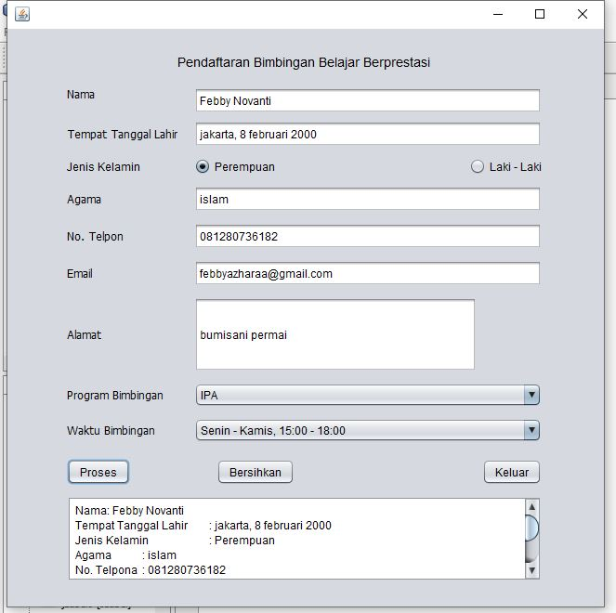**Output :**

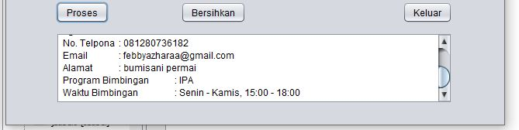

**Penjelasan :**

* Untuk membuat check box pada jenis kelamin pertama letakkan jRadioButtonPR dan jRadioButtonLK sesuai pada di form desain. Kemudian letakkan komponen ButtonGroup1 di form design. ButtonGroup1 ini bersifat invisible, ia hanya muncul pada table inpector dibagian other component. Klik kanan pada jRadioButton(pada masing – masing button perempuan dan laki - laki) kemudian pilih properties dan setting buttogroup menjadi ButtonGroup1. Hal ini menyebabkan JRadioButton (perempuan dan laki - laki) tergabung dalam satu group (diikat oleh ButtonGroup1). Sehingga, jika button Laki - laki terpilih (aktif/true), maka button perempuan tidak, demikian juga sebaliknya. Namun, jika button laki - laki dan button perempuan tidak diikat oleh ButtonGroup1 maka keduanya adalah independent, sehingga bisa dipilih dua-duanya atau di non-aktifkan kedua-duanya secara bersamaan.

Sumber :

<https://www.intika34.com/2017/02/belajar-netbeans-membuat-form-biodata-sederhana-dengan-java-swing.html>