**NIM : 1182002002**

**Nama : Febby Novanti Azhara**

**Select…Case statements**

Public Class Form1

Private Sub Button1_Click(ByVal sender As System.Object, ByVal e As System.EventArgs) Handles Button1.Click

Dim n As Integer = Val(TextBox1.Text)

Select Case n

Case 1 To 5

Label3.Text = n & " is a number between 1 and 5"

Case 6, 7, 8

Label3.Text = n & " is a number between 6 and 8"

Case 9 To 10

Label3.Text = n & " equal 9 or 10"

Case Else

Label3.Text = n & " not between 1 and 10"

End Select

TextBox1.Clear()

TextBox1.Focus()

End Sub

End Class

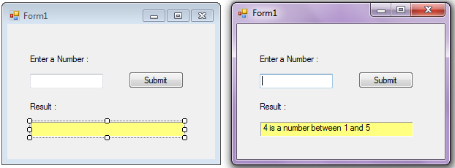

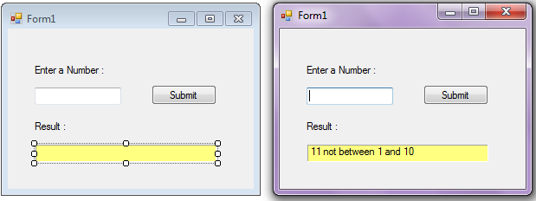

**Do…Loop Until statements**

Public Class Form1

Private Sub Button1_Click(ByVal sender As System.Object, ByVal e As System.EventArgs) Handles Button1.Click

Dim counter As Integer = 1

Do

LabelResult.Text &= counter & " "

counter += 1

Loop Until counter > 10

End Sub

End Class

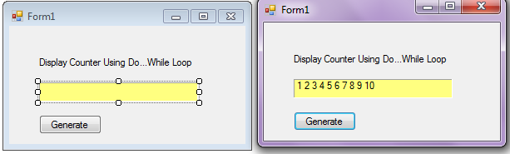

**Implementasi Check Box**

Public Class Form1

Dim total As Integer = 0

Private Sub TextBox1_TextChanged(ByVal sender As System.Object, ByVal e As System.EventArgs) Handles TextBox1.TextChanged

If TextBox1.Text <> String.Empty Then

cbEnable(True)

Else

cbenable(False)

End If

End Sub

Private Sub cbEnable(ByVal s As Boolean)

CheckBox1.Enabled = s

CheckBox2.Enabled = s

CheckBox3.Enabled = s

End Sub

Private Sub CheckBox1_CheckedChanged(ByVal sender As System.Object, ByVal e As System.EventArgs) Handles CheckBox1.CheckedChanged

If CheckBox1.Checked = True Then

total += Label2.Text

Else

total -= Label2.Text

End If

Label6.Text = "$" & total

End Sub

Private Sub CheckBox2_CheckedChanged(ByVal sender As System.Object, ByVal e As System.EventArgs) Handles CheckBox2.CheckedChanged

If CheckBox2.Checked = True Then

total += Label3.Text

Else

total -= Label3.Text

End If

Label6.Text = "$" & total

End Sub

Private Sub CheckBox3_CheckedChanged(ByVal sender As System.Object, ByVal e As System.EventArgs) Handles CheckBox3.CheckedChanged

If CheckBox3.Checked = True Then

total += Label4.Text

Else

total -= Label4.Text

End If

Label6.Text = "$" & total

End Sub

Private Sub Form1_Load(ByVal sender As System.Object, ByVal e As System.EventArgs) Handles MyBase.Load

Label6.Text = "$" & total

End Sub

End Class

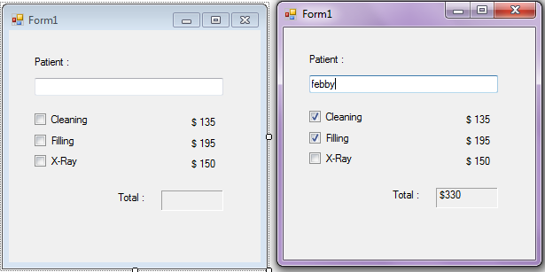

**Tugas Praktikum 4**

Public Class Form1

Dim total As Integer = 0

Private Sub Form1_Load(ByVal sender As System.Object, ByVal e As System.EventArgs) Handles MyBase.Load

TextBox1.Enabled = False

TextBox2.Enabled = False

TextBox3.Enabled = False

TextBox4.Enabled = False

TextBox5.Enabled = False

End Sub

Private Sub CheckBox1_CheckedChanged(ByVal sender As System.Object, ByVal e As System.EventArgs) Handles CheckBox1.CheckedChanged

If CheckBox1.Checked = True Then

TextBox1.Enabled = True

End If

End Sub

Private Sub CheckBox2_CheckedChanged(ByVal sender As System.Object, ByVal e As System.EventArgs) Handles CheckBox2.CheckedChanged

If CheckBox2.Checked = True Then

TextBox2.Enabled = True

End If

End Sub

Private Sub CheckBox3_CheckedChanged(ByVal sender As System.Object, ByVal e As System.EventArgs) Handles CheckBox3.CheckedChanged

If CheckBox3.Checked = True Then

TextBox3.Enabled = True

End If

End Sub

Private Sub CheckBox4_CheckedChanged(ByVal sender As System.Object, ByVal e As System.EventArgs) Handles CheckBox4.CheckedChanged

If CheckBox4.Checked = True Then

TextBox4.Enabled = True

End If

End Sub

Private Sub CheckBox5_CheckedChanged(ByVal sender As System.Object, ByVal e As System.EventArgs) Handles CheckBox5.CheckedChanged

If CheckBox5.Checked = True Then

TextBox5.Enabled = True

End If

End Sub

Private Sub TextBox1_TextChanged(ByVal sender As System.Object, ByVal e As System.EventArgs) Handles TextBox1.TextChanged

Label11.Text = Val(TextBox1.Text) * 50000

total = Val(Label11.Text) + Val(Label12.Text) + Val(Label13.Text) + Val(Label14.Text) + Val(Label15.Text)

Label17.Text = total

End Sub

Private Sub TextBox2_TextChanged(ByVal sender As System.Object, ByVal e As System.EventArgs) Handles TextBox2.TextChanged

Label12.Text = Val(TextBox2.Text) * 45000

total = Val(Label11.Text) + Val(Label12.Text) + Val(Label13.Text) + Val(Label14.Text) + Val(Label15.Text)

Label17.Text = total

End Sub

Private Sub TextBox3_TextChanged(ByVal sender As System.Object, ByVal e As System.EventArgs) Handles TextBox3.TextChanged

Label13.Text = Val(TextBox3.Text) * 55000

total = Val(Label11.Text) + Val(Label12.Text) + Val(Label13.Text) + Val(Label14.Text) + Val(Label15.Text)

Label17.Text = total

End Sub

Private Sub TextBox4_TextChanged(ByVal sender As System.Object, ByVal e As System.EventArgs) Handles TextBox4.TextChanged

Label14.Text = Val(TextBox4.Text) * 65000

total = Val(Label11.Text) + Val(Label12.Text) + Val(Label13.Text) + Val(Label14.Text) + Val(Label15.Text)

Label17.Text = total

End Sub

Private Sub TextBox5_TextChanged(ByVal sender As System.Object, ByVal e As System.EventArgs) Handles TextBox5.TextChanged

Label15.Text = Val(TextBox5.Text) * 40000

total = Val(Label11.Text) + Val(Label12.Text) + Val(Label13.Text) + Val(Label14.Text) + Val(Label15.Text)

Label17.Text = total

End Sub

Private Sub Button1_Click(ByVal sender As System.Object, ByVal e As System.EventArgs) Handles Button1.Click

CheckBox1.Checked = False

CheckBox2.Checked = False

CheckBox3.Checked = False

CheckBox4.Checked = False

CheckBox5.Checked = False

TextBox1.Text = ""

TextBox2.Text = ""

TextBox3.Text = ""

TextBox4.Text = ""

TextBox5.Text = ""

Label11.Text = ""

Label12.Text = ""

Label13.Text = ""

Label14.Text = ""

Label15.Text = ""

End Sub

End Class

